Practical – 7
GitHub Link: https://github.com/Akshaykashyap0121/Node-js-AKSHAY

- Goal: Dynamically imports ESM files with JSON import assertions and fallback.
- Tasks: Implement dynamicImport(file) that:
Supports .mjs, .js, ESM modules.
Allows importing JSON using assert {type: “json”}
Provides graceful fallback if module exports a default or named export.

Project Structure:
- dynamic_import.mjs:
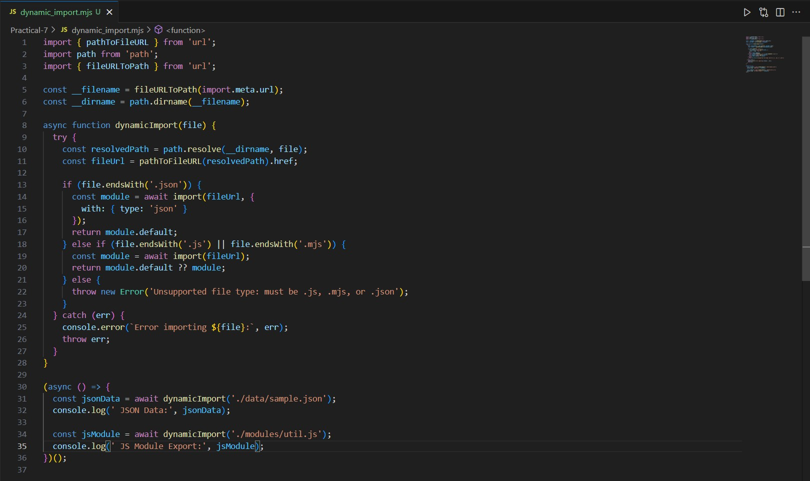
- data/sample.json:
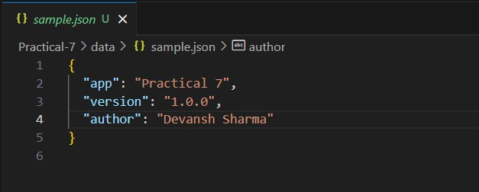
Output:
