# Implementation of an Automatic Waste Segregator System using Arduino Uno

-**By Akshay Kelagade**

# Table of content

1. About the Waste Segregator System
   1. Description
   2. State of art
   3. 5W’s & 1H and S.W.O.T analysis
2. Requirements
   1. High level requirements
   2. Low level requirements
3. Block Diagram and Blocks explanation
   1. Block Diagram
   2. Sensors
   3. Actuators
4. Architecture
   1. Behavioural Diagram
      1. Flow chart
   2. Structural Diagram
      1. Block Diagram
5. Test plan and Output
   1. High level test plan
6. Applications
7. Output
8. Conclusion

# 1 About the Waste Segregator

## Description

In this project, a cost effective Automated Waste Segregator system for the segregation of waste at the household level is implemented. The proposed segregator system segregates the waste into two types, viz. wet and dry. Here, Arduino Uno board is used as the main controller and various sensors are used to detect each type of waste, which is segregated and thrown into the respective bins. Using this automatic waste segregator system, the separated wastes can be sent directly for recycling.

## 1.2 State of art

* The main focus of this project is to detect the different types of the waste and throw the waste into their respective bin. Rain sensor is used to detect the wet waste and LDR sensor is used to detect the dry waste ,when the waste is detected servo rotates and throw the waste to the bin. If the bin is full then it display a message saying the bin is full. By combining all these features a final product is made known as Waste Segregator. As the technology is increasing rapidly these kind of automations are very useful in our daily lives.

## 1.3 5W’s 1H

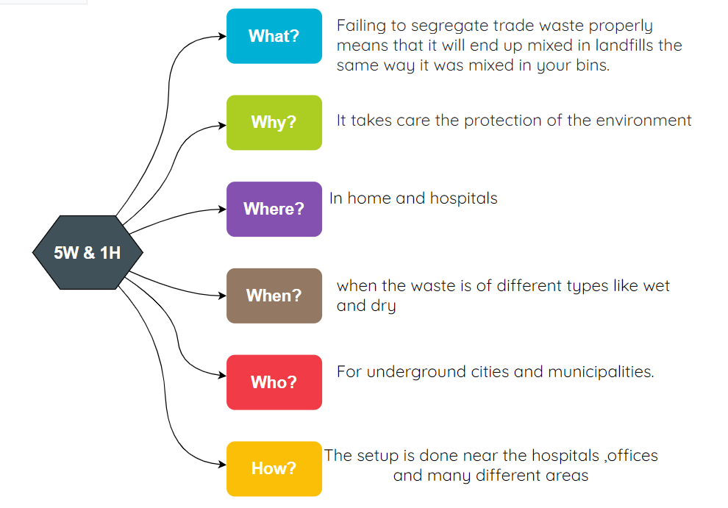

## Swot Analysis

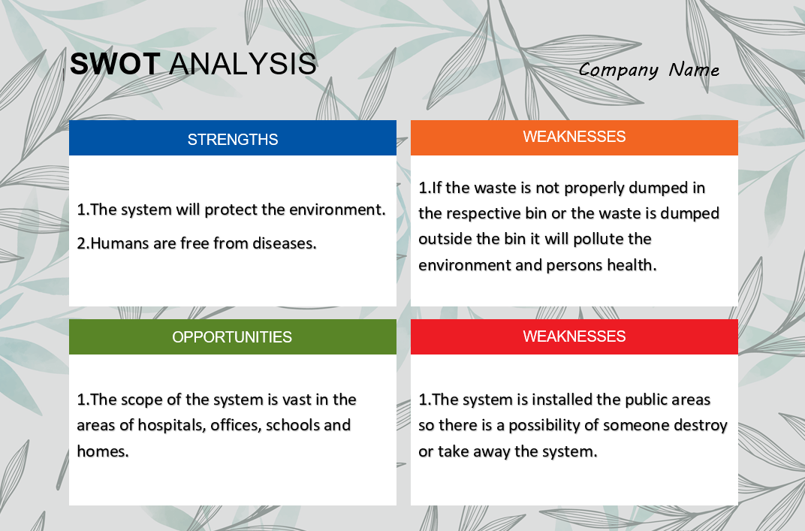

# 2 Requirements

## 2.1 High Level Requirements

|  |  |  |
| --- | --- | --- |
| ID | High Level Requirements | Status |
| HLR1 | The system should segregate the waste into wet and dry | Implemented |
| HLR2 | The system should display a message when the bin is full | Implemented |
| HLR3 | system should open the lid when person come nears to it | Implemented |

2.2 Low Level Requirements

|  |  |  |
| --- | --- | --- |
| ID | High Level Requirements | Status |
| LLR1 | when sensor detects the waste, servo motor is used to differentiate the waste as wet and dry and dumps the waste into their respective bins | Implemented |
| LLR2 | Ultrasonic sensor is used to detect the waste in the bin if the bin is full, then a message is displayed in the LCD | Implemented |
| LLR3 | ultrasonic sensor should sense if anyone come close and servo motor should open the door | Implemented |

# 3 Block Diagram and Blocks explanation

## 3.1 BLOCK DIAGRAM

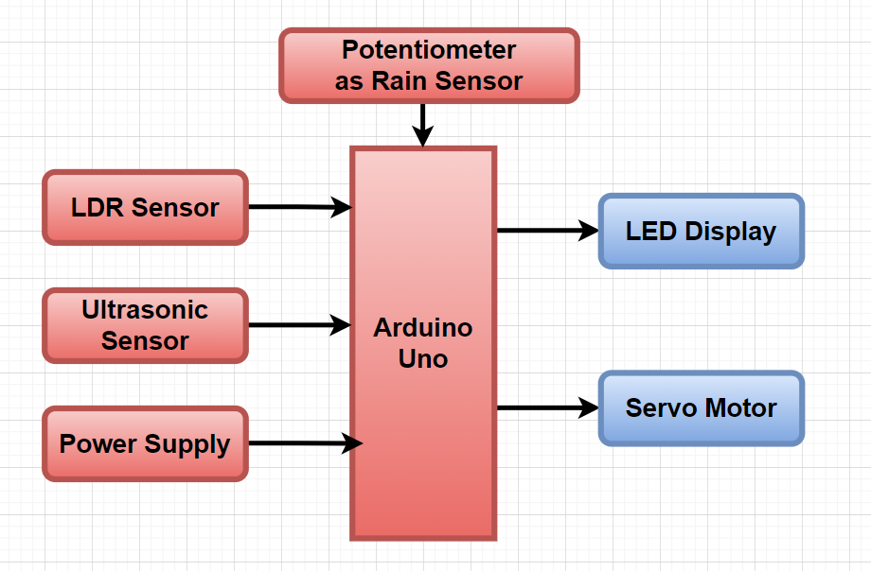

## 3.2 SENSORS

## Rain sensor

The rain sensor is used to detect the wet waste.

## LDR Sensor

Laser Transmitter module acts as the source of light. This sensor is used to detects the dry waste.

## Ultrasonic Sensor

This sensor is used to detect the waste in the bin if the bin is full then it sends the message to microcontroller.

## 3.3 ACTUATORS

## Servo Motor

The servo motor is used to rotate the upper circular disc, and drops the waste in the wet bin.

# LCD Display

The LCD display prints a message when the bin is full.

# 4 Architecture

## 4.1 Behavioral Diagram

### 4.1.1 Flow Chart

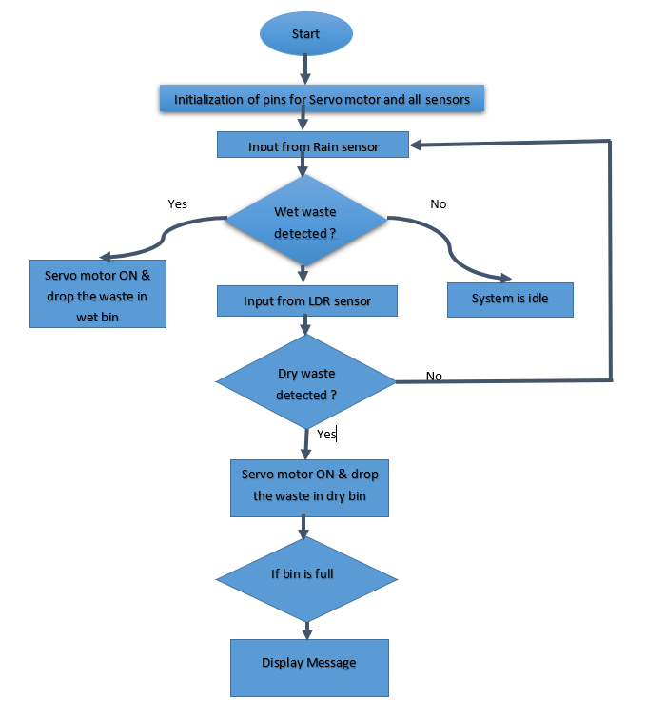

## 4.2 Structural Diagram

### 4.2.1 High Level Use Case Structural Diagram

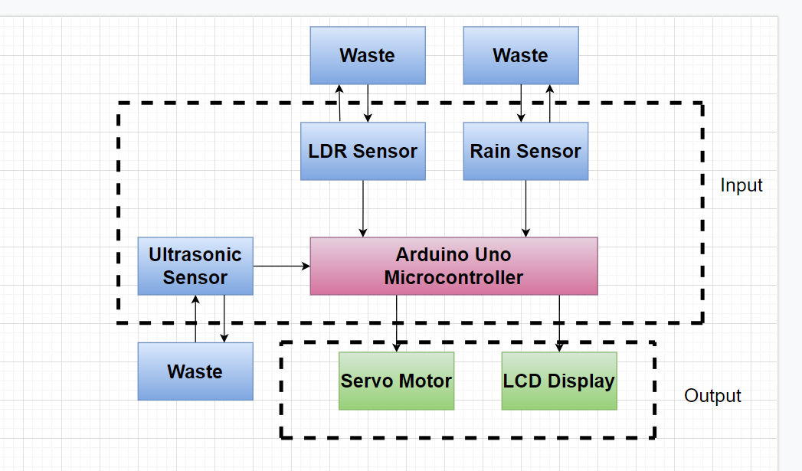

# 5 Test plan and output

# 5.1 HIGH LEVEL TEST PLAN

|  |  |  |  |  |  |
| --- | --- | --- | --- | --- | --- |
| Test ID | Description | Input | Expected output | Actual Output | Passed Or Not |
| HLR1 | Rain Sensor | Sensor Value <5 | Servo motor rotates to 180 degrees | Servo motor rotates to 180 degrees | ✅ |
| HLR1 | LDR Sensor | Sensor Value <5 | Servo motor rotates to 90 degrees | Servo motor rotates to 90 degrees | ✅ |
| HLR2 | Ultrasonic Sensor | Distance>=30cm | Display message | Display message | ✅ |
| HLR3 | Ultrasonic Sensor | Distance<30cm | Servo motor rotates to 180 degrees | Servo motor rotates to 180 degrees | ✅ |

# 6 Application

* In underground cities.
* In municipalities.
* In clean India mission.
* Reducing human time and effort
* Promotes health and sanitation
* Protects the environment
* Makes dumping garbage more clean

7 Output

* Subsystem 1

Detecting wet waste

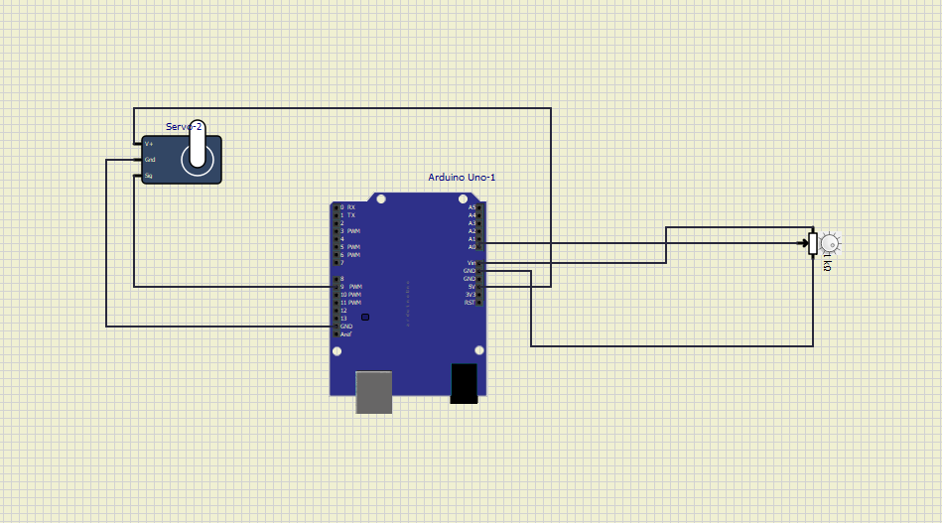

In this subsystem potentiometer is used as rain sensor. When sensor value comes less than 5, then servo motor rotates to 180 degrees, dump the waste in wet bin and come backs to normal position.

* Subsystem 2

Detecting dry waste

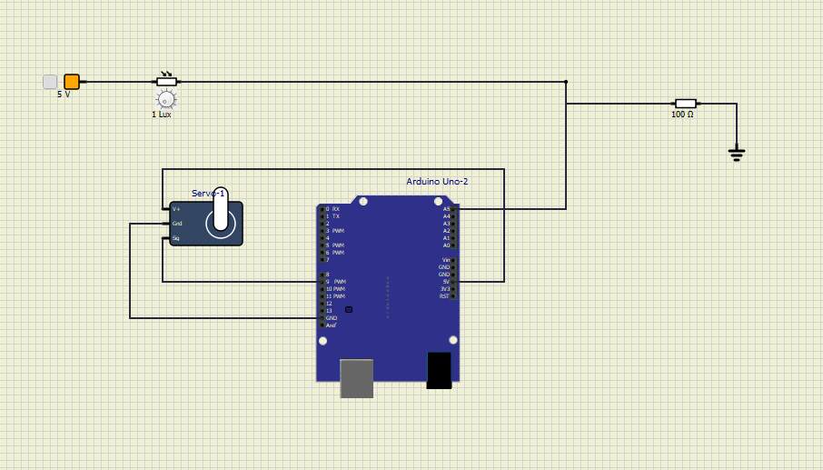

In this subsystem LDR sensor is used to detect the dry waste. When sensor value comes less than 5, then servo motor rotates to 90 degrees, dump the waste in dry bin and come backs to normal position.

* Subsystem 3

Detect a Person and Open the lid

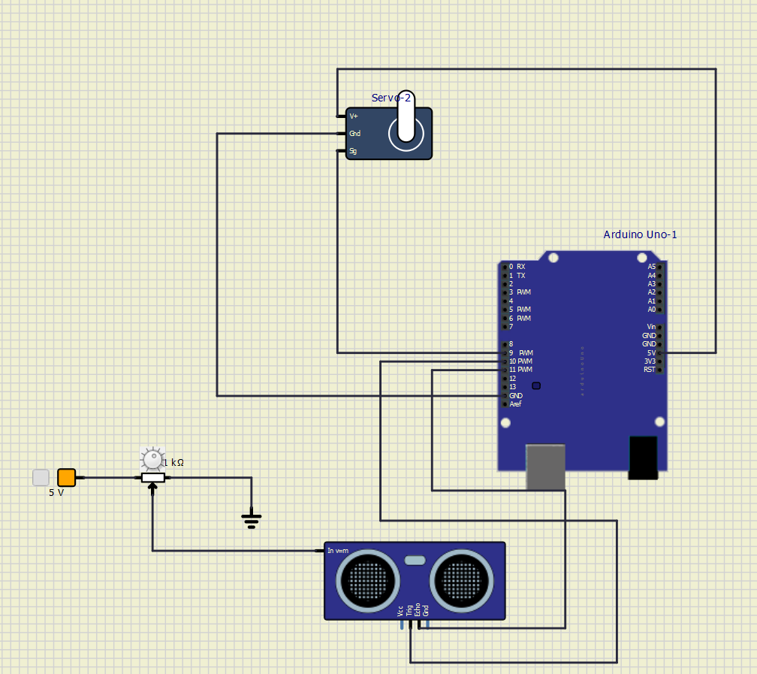

In this subsystem ultrasonic sensor is used to detect, when a person comes near to the system. If the distance is detected as less the 30, then servo motor rotates to 180 degrees, open the lid and close after 2sec and servo motor comes to original position.

* Subsystem 4

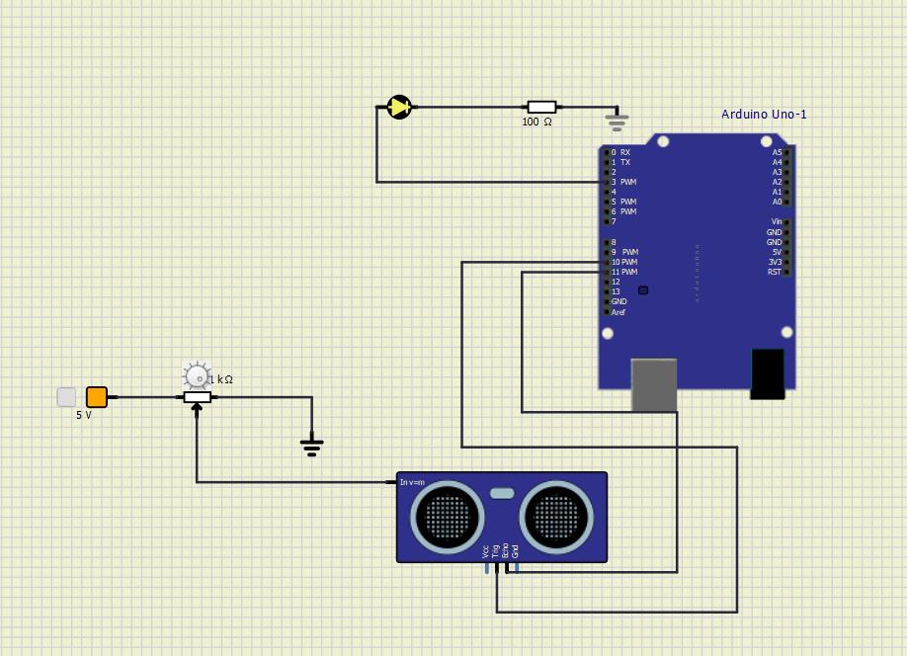 Display message when the bin is full

In this subsystem led is used to indicate when the dust bin is full.

* Complete System

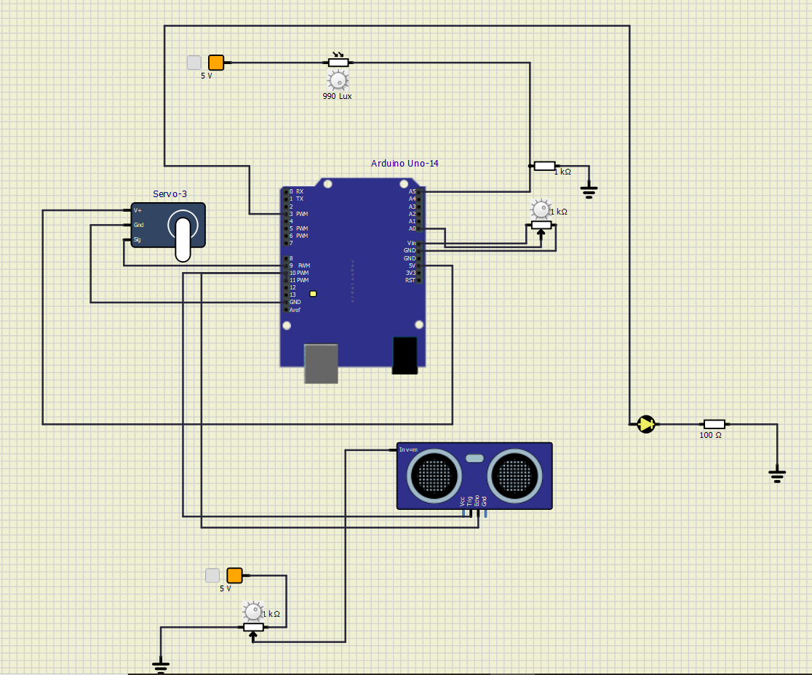

In this the whole system is presented which shows the all the sensors working and indicating the output in the form of motion of servo motor and blinking of led.

8 Conclusion

Automatic Waste Segregator implemented here provides segregation of waste into wet and dry. This type of system can be fabricated in larger dimension for use in various places like educational institutions, offices, hotels, etc. This system is cost effective and reduces the burden of manual separation of the waste. Such an AWS system can reduce health hazards among the workers and the waste can be effectively recycled and reduced. Additional sensors can be included in the proposed system to separate biodegradable and non-biodegradable wastes