A CASE SYUDY ON 8085 “MICRO-PROCESSOR”

FEATURES OF 8085

The Intel 8085 was first produced by Intel in 1977, and it stayed in production until the 1990s. The microprocessor was binary compatible with the Intel 8080 but had less supporting hardware requirements, which allowed the construction of more affordable and less complex microcomputer systems.
With a basic von Neumann design, the Intel 8085 pinned its eight-bit data bus to the 16-bit address bus, which allowed it to limit the number of pins on its surface to 40. Pin 40 and pin 20 on the microprocessor were used for the power supply and electric ground respectively.
At its introduction, the Intel 8085 microprocessor was able to support up to 74 instructions following five general addressing modes. As of 2014, the Intel 8085 is used for instructional purposes at multiple engineering schools as part of their introductory microprocessor courses.
Basic features:-

1.It is 16 bit processor. So that it has 16 bit ALU, 16 bit registers and internal data bus and 16 bit external data bus. It make s faster processing.

2.It has three version based on the frequency of operation:
a)8086 -> 5MHz
b)8086-2 ->8MHz
c)8086-1 ->10 MHz

3.8085 has 20 bit address lines to access memory. Hence it can access
2^20 = 1 MB memory location.

4.8085 has 16-bit address lines to access I/O devices, hence it can access
2^16 = 64K I/O location

5.Pipelining:-8085 uses two stage of pipelining. First is Fetch Stage and the second is Execute Stage.

Fetch stage that prefetch upto 6 bytes of instructions stores them in the queue.
Execute stage that executes these instructions.
Pipelining improves the performance of the processor so that operation is faster.

6.Operates in two modes:-8085 operates in two modes:
a)Minimum Mode: A system with only one microprocessor.
b)Maximum Mode:-A system with multiprocessor.

7.8085 uses memory banks:-The 8085 uses a memory banking system. It means entire data is not stored sequentially in a single memory of 1 MB but memory is divided into two banks of 512KB.

8.Interrupts:-8085 has 256 vectored interrupts.

9.Multiplication And Division:-8085 has a powerful innstrction set. So that it supports Multiply and Divide operation.

Architechture of 8085
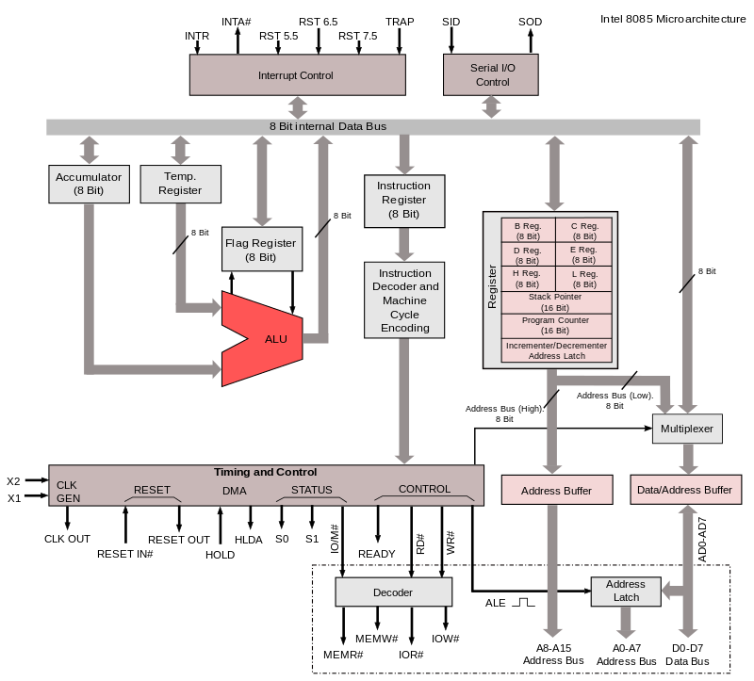
This is the functional block diagram of the 8085 Microprocessor.

Acumulator

It is a 8-bit register which is used to perform airthmetical and logical operation. It stores the output of any operation. It also works as registers for i/o accesses.

Temporary Register

It is a 8-bit register which is used to hold the data on which the acumulator is computing operation. It is also called as operand register because it provides operands to ALU.

Registers

These are general purposes registers. Microprocessor consists 6 general purpose registers of 8-bit each named as B,C,D,E,H and L. Generally theses registers are not used for storing the data permanently. It carries the 8-bits data. These are used only during the execution of the instructions.
These registers can also be used to carry the 16 bits data by making the pair of 2 registers. The valid register pairs available are BC,DE HL. We can not use other pairs except BC,DEand HL. These registers are programmed by user.

ALU

ALU performs the airthmetic operations and logical operation.

Flag Registers

It consists of 5 flip flop which changes its status according to the result stored in an accumulator. It is also known as status registers. It is connected to the ALU.
There are five flip-flops in the flag register are as follows:
- Sign(S)
- zero(z)
- Auxiliary carry(AC)
- Parity(P)
- Carry(C)
1.Sign-
If D7 of the result is 1 then sign flag is set otherwise reset. As we know that a number on the D7 always desides the sign of the number. if D7 is 1: the number is negative. if D7 is 0: the number is positive.
2.Zeros(Z)-
If the result stored in an accumulator is zero then this flip flop is set otherwise it is reset.

3.Auxiliary carry(AC)-
If any carry goes from D3 to D4 in the output then it is set otherwise it is reset.

4.Parity(P)-
If the no of 1's is even in the output stored in the accumulator then it is set otherwise it is reset for the odd.

5.Carry(C)-
If the result stored in an accumulator generates a carry in its final output then it is set otherwise it is reset.

Instruction registers(IR)

It is a 8-bit register. When an instruction is fetched from memory then it is stored in this register.

Instruction Decoder

Instruction decoder identifies the instructions. It takes the informations from instruction register and decodes the instruction to be performed.

Program Counter

It is a 16 bit register used as memory pointer. It stores the memory address of the next instruction to be executed. So we can say that this register is used to sequencing the program. Generally the memory have 16 bit addresses so that it has 16 bit memory. The program counter is set to 0000H.

Stack Pointer

It is also a 16 bit register used as memory pointer. It points to the memory location called stack. Generally stack is a reserved portion of memory where information can be stores or taken back together.

Timing and Control Unit

It provides timing and control signal to the microprocessor to perform the various operation.It has three control signal. It controls all external and internal circuits. It operates with reference to clock signal.It synchronizes all the data transfers.
There are three control signal:
- ALE-Airthmetic Latch Enable, It provides control signal to synchronize the components of microprocessor.
- RD- This is active low used for reading operation.
- WR-This is active low used for writing operation.
There are three status signal used in microprocessor S0, S1 and IO/M. It changes its status according the provided input to these pins.

Serial Input Output Control-

There are two pins in this unit. This unit is used for serial data communication.

Interrupt Unit

There are 6 interrupt pins in this unit. Generally an external hardware is connected to these pins. These pins provide interrupt signal sent by external hardware to microprocessor and microprocessor sends acknowledgement for receiving the interrupt signal. Generally INTA is used for acknowledgement.

Register Section

Many registers has been used in microprocessor. PIPO shift register It consists of PIPO(Parallel Input Parallel Output) register.
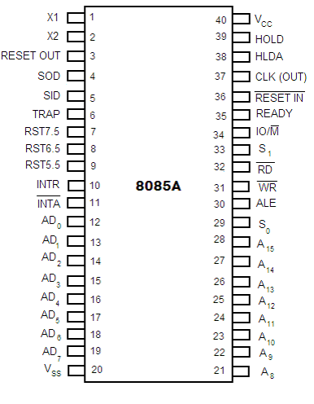
Pin diagram of 8085 :

8085 is a 40 pin IC, The signals from the pins can be grouped as follows

1. Power supply and Clock frequency signals:

Vcc: + 5 volt power supply
Vss: Ground
X1, X2 : Crystal or R/C network or LC network connections to set the frequency of internal clock generator. The frequency is internally divided by two. Since the basic operating timing frequency is 3 MHz, a 6 MHz crystal is connected externally. CLK (output)-Clock Output is used as the system clock for peripheral and devices interfaced with the microprocessor.

2. Address Bus:

It carries the most significant 8 bits of the memory address or the 8 bits of the I/O address.Bus Structure in 8085

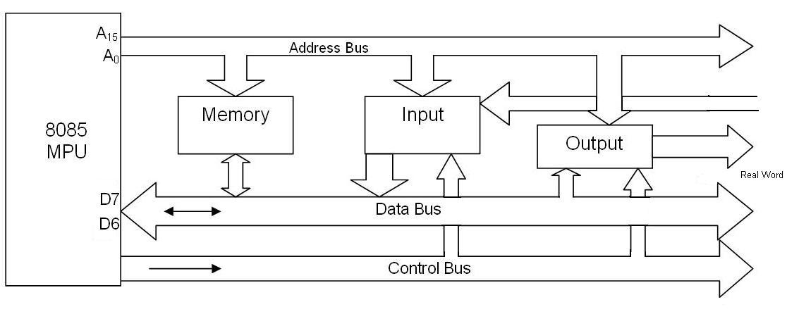
Genearlly, Microprocessor has 16 bit address bus. The bus over which the CPU sends out the address of the memory location is known as Address bus. The address bus carries the address of memory location to be written or to be read from.
The address bus is unidirectional. It means bits flowing occurs only in one direction, only from microprocessor to peripheral devices. We can find that how much memory location it can using the formula 2^N. where N is the number of bits used for address lines.

3. Data bus:

- These multiplexed set of lines used to carry the lower order 8 bit address as well as data bus.
- During the opcode fetch operation, in the first clock cycle, the lines deliver the lower order address A0 - A7.
- In the subsequent IO / memory, read / write clock cycle the lines are used as data bus.
- The CPU may read or write out data through these lines.
- 8085 Microprocessor has 8 bit data bus. So it can be used to carry the 8 bit data starting from 00000000H(00H) to 11111111H(FFH). Here 'H' tells the Hexadecimal Number. It is bidirectional. These lines are used for data flowing in both direction means data can be transferred or can be received through these lines. The data bus also connects the I/O ports and CPU. The largest number that can appear on the data bus is 11111111.
It has 8 parallel lines of data bus. So it can access upto 2^8 = 256 data bus lines.

4. Control and Status signals:

ALE (output) - Address Latch Enable.
- It is an output signal used to give information of AD0-AD7 contents.
- It is a positive going pulse generated when a new operation is started by uP.
- When pulse goes high it indicates that AD0-AD7 are address.
- When it is low it indicates that the contents are data.
RD (output 3-state, active low)
- Read memory or IO device.
- This indicates that the selected memory location or I/O device is to be read and that the data bus is ready for accepting data from the memory or I/O device
WR (output 3-state, active low)
- Write memory or IO device.
- This indicates that the data on the data bus is to be written into the selected memory location or I/O device.
IO/M (output) - Select memory or an IO device.
- This status signal indicates that the read / write operation relates to whether the memory or I/O device.
- It goes high to indicate an I/O operation.
- It goes low for memory operations.

Addressing Modes in 8085

- Immediate Addressing Mode
- Register Addressing Mode
- Direct Addressing Mode
- Indirect Addressing Mode
- Implied/implicit Addressing Mode

Immediate Addressing Mode:
An immediate is transferred directly to the register.
Eg: -
MVI A, 30H (30H is copied into the register A)
MVI B,40H(40H is copied into the register B).

Register Addressing Mode:
Data is copied from one register to another register.
Eg: -
MOV B, A (the content of A is copied into the register B)
MOV A, C (the content of C is copied into the register A).

Direct Addressing Mode:
Data is directly copied from the given address to the register.
Eg: -
LDA 3000H (The content at the location 3000H is copied to the register A).

Indirect Addressing Mode:
The data is transferred from the address pointed by the data in a register to other register.
Eg: -
MOV A, M (data is transferred from the memory location pointed by the regiser to the accumulator).

Implied / Implicit Addressing Mode:
This mode doesn't require any operand. The data is specified by opcode itself.
Eg: -
RAL
CMP

