AKSHAY KHARMALE
14CO29
BE-CO
BATCH-1

A CASE STUDY ON NPL / EXPERT SYSTEM BASED ON PAPERS PUBLISHED IN IEEE / ACM /SPRINGERS / ANY OTHER POPULAR JOURNALS.

THE EXPERT SYSTEM DESIGNED TO IMPROVE CUSTOMER SATISFACTION

1. ABSTRACT

Customer Relationship Management becomes a leading business strategy in highly competitive business environment. It aims to enhance the performance of the businesses by improving the customer satisfaction and loyalty. The objective of this paper is to improve customer satisfaction on product’s colors and design with the help of the expert system developed by using Artificial Neural Networks. The expert system’s role is to capture the knowledge of the experts and the data from the customer requirements, and then, process the collected data and form the appropriate rules for choosing product’s colors and design.
In order to identify the hidden pattern of the customer’s needs, the Artificial Neural Networks technique has been applied to classify the colors and design based upon a list of selected information. Moreover, the expert system has the capability to make decisions in ranking the scores of the colors and design presented in the selection. In addition, the expert system has been validated with a different customer types.

2. INTRODUCTION

The core part of CRM activities is to understand customer requirements and retain profitable customers.To reach it in a highly competitive market, satisfying customer’s needs is the key to business success. Unprecedented growth of competition has raised the importance of retaining current customers. Retaining existing customers is much less expensive and difficult than recruiting new customers in a mature market. So customer retention is a significant stage in Customer Relation Management, which is also the most important growth point of profit.Factors that influence customer satisfaction degree are concerned by all enterprise managers. Marketing literature states that it is more costly to engage a new customer than to retain an existing loyal customer. Churn prediction models are developed by academics and practitioners to effectively manage and control customer churn in order to retain existing customers. So,Customer satisfaction is most important.

However, it is a difficult and a complex task to identify the customer’s needs such as colors and design of the products. The objective of this paper is to design and implement the expert system in order to assess customer satisfaction and reveal appropriate strategies to improve it. As the customer satisfaction on colors and design can have a complex hidden pattern and, therefore, the approach of the paper should have an ability to perform pattern recognition, classification and forecast which make the artificial neural networks an appropriate technique to be applied in the expert system. The conceptual work of the paper is illustrated in Figure 1, in which the assumption of the customer requirements and expert system are based upon the statement that ‘‘in general, the same customer group will like the same colors’’.

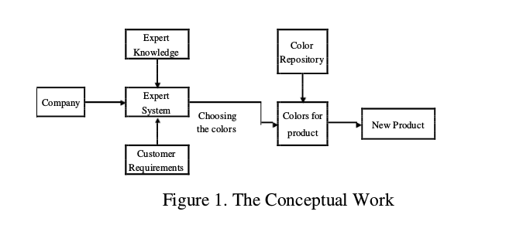

3. Expert System

An Expert System is viewed as a computer simulation of a human expert. Expert Systems are an emerging technology with many areas of potential applications. Expert systems are artificial intelligence (AI) tools that capture the expertise of knowledge workers and provide advice to (usually) non-experts in a given domain. Thus, expert systems constitute a subset of the class of AI systems primarily concerned with transferring knowledge from experts to novices. Knowledge-based expert systems, or simply expert systems, use human knowledge to solve problems that normally would require human intelligence. These expert systems represent the expertise knowledge as data or rules within the computer. These rules and data can be called upon when needed to solve problems. There are three main parts to the expert system: knowledge base, a set of if-then rules; working memory, a database of facts; inference engine, the reasoning logic to create rules and data.

In this paper, the expert system roles have been designed to capture the knowledge of the experts and the data of customer requirements. After that the system is able to process these data and form rules to customize colors in products. Finally, the expert system will deliver the decision ranking of the scores based upon the product samples, which are presented in the selection process.

4. CONCLUSIONS

Across market segments, a vast variety of colors mixing in different products that makes it a difficult and complicated task to identify the customer’s needs. The contribution of this paper is in designing the system that is the combination of the expert system and the ANN.
The customers can interact with the interface of the expert system to ask and get the advices from the system. Another main result, knowledge from data analyzing, guides us in detail about how to utilize customer behaviour on preferred products (colors) in combination with knowledge captured from the expert in prediction of the colors.
This benefits greatly the manufacturer in offering the right colors to the right customer group of its new product in order to achieve customer satisfaction. Correlation Coefficient can be found. According to that, we can identify the customer’s behaviour.

