“Predictive Analytics on Doctor and Medicine Availability in Government Hospital’s”

*N Akshay Kumar*,

*20232MCA0174,* *School* *of*

*Information Science,* *Presidency* *University,*

Bengaluru, India.

[**eminemakshay38@gmail.com**](mailto:eminemakshay38@gmail.com)

*Supriya H R,* *20232MCA0188,* *School* *of*

*Information Science,* *Presidency* *University,*

Bengaluru, India.

[**supriyahr7892@gmail.com**](mailto:supriyahr7892@gmail.com)

*Savitha P,*

*20232MCA0172,*

*School* *of*

*Information Science,* *Presidency* *University,*

Bengaluru, India.

[**savitha13052000@gmail.com**](mailto:savitha1330@gmail.com)

*Nutan Revani Astekar,*

*20232MCA0171,*

*School* *of*

*Information Science,* *Presidency* *University,*

Bengaluru, India.

[**rekharastekar12@gmail.com**](mailto:rekharastekar12@gmail.com)

***Abstract*—** **Efficient management of healthcare resources, including the availability of doctors and essential medicines, is vital for ensuring high-quality and timely healthcare services. Government hospitals often struggle with challenges such as unpredictable demands and limited resources, leading to gaps in service delivery. This research applies predictive analytics using Deep Neural Networks (DNN) and Random Forest models to analyze historical data and predict resource availability. These models demonstrate high accuracy, enabling hospital administrators to make informed decisions and optimize resources proactively. The system achieves a prediction accuracy of 97.40% for doctor availability and 98.56% for medicine availability, showcasing the potential of machine learning to enhance healthcare reliability.**

***Keywords—*** *Predictive Analysis, Doctor Availability, Medicine Availability, Government Hospitals, Deep Neural Networks, Random Forest, Machine Learning.*

1. Introduction

Effective healthcare delivery is a cornerstone of societal well-being, particularly in government hospitals that serve economically disadvantaged communities. These institutions face persistent challenges in managing resources, such as ensuring the availability of doctors and maintaining adequate stocks of essential medicines. Resource shortages are exacerbated by unpredictable patient inflows, particularly during seasonal outbreaks, emergencies, and pandemics[1][2].

Recent advancements in technology, especially in machine learning (ML), have introduced predictive analytics as a powerful tool for addressing these challenges. By analyzing historical data, machine learning models can uncover patterns and trends that inform resource forecasting. For instance, algorithms like Random Forest, XGBoost, and Deep Neural Networks (DNNs) have demonstrated exceptional capabilities in predicting resource requirements with high accuracy, enabling hospital administrators to make informed, data-driven decisions. Studies such as those by Kumar and Garg (2017) and Juyal (2024) have highlighted how predictive analytics can enhance operational efficiency in resource-constrained environments [6][7].

A summary of recent developments in predictive analytics on doctor and medicine availability is given in Section II. The framework that this study proposes is described in Section III. Section IV provides further details on the framework development technique. The outcomes of the developed framework are presented in Section V, and a discussion follows. In conclusion, Section VI offers some insights into potential future avenues for this field of study.

1. RELATED WORK

The Several studies have demonstrated the potential of machine learning techniques in healthcare applications. For example, Kumar and Garg (2017) employed Deep Neural Networks (DNN) to predict resource needs in government hospitals, achieving high accuracy levels. Similarly, Juyal (2024) demonstrated the effectiveness of combining machine learning with healthcare analytics for optimizing treatment strategies. These studies highlight the promise of predictive models, but they also expose challenges such as data quality, system scalability, and interpretability [1][2].

**Deep Neural Networks (DNN):** DNNs have shown exceptional performance in modeling complex relationships within healthcare datasets. For example, Kumar and Garg (2017) used DNNs to analyze historical doctor schedules and patient flow, achieving a prediction accuracy of over 93%. Their work demonstrated the model’s capability to handle non-linear dependencies and improve resource allocation [1].

**Random Forest (RF):** Random Forest algorithms are highly effective for handling structured datasets and preventing overfitting. Dhali et al. (2020) applied RF to predict patient admissions, optimizing doctor and medicine allocation. The model achieved an accuracy of 87%, showcasing its reliability for multi-class classification tasks [3].

**XGBoost:** XGBoost, a gradient-boosting algorithm, has become a favorite for predictive tasks due to its speed and accuracy. Kumar et al. (2020) used XGBoost to forecast medicine stock levels, achieving a reduction in stockouts by 30% and a prediction accuracy of 91%. The algorithm’s ability to rank feature importance made it an excellent choice for understanding factors influencing resource availability [4].

**Decision Trees (DT):** Decision Trees are known for their simplicity and interpretability. Wang et al. (2023) compared Decision Trees with other models for predicting hospital readmission rates. While DTs performed moderately well, they were prone to overfitting when applied to complex datasets [5].

**Combination of Algorithms:** Some researchers have combined multiple algorithms to enhance performance. For instance, Das et al. (2021) integrated IoT data with RF and XGBoost to improve real-time monitoring of hospital resources, resulting in a 15% improvement in prediction reliability [6].

Kumar and Garg (2017) explored the use of Deep Neural Networks (DNN) to forecast doctor availability based on historical data. Their model achieved an impressive accuracy of 93%, showcasing the capability of DNN to capture complex patterns and support decision-making processes for hospital administrators [1]. Similarly, Dhali et al. (2020) applied Random Forest algorithms to predict patient admissions, which led to improved resource planning by reducing scheduling conflicts and stock shortages. This model attained an accuracy of 87% [2].

XGBoost, known for its computational efficiency and accuracy, has also been widely adopted in healthcare analytics. Juyal (2024) integrated XGBoost into a resource management framework for hospitals, obtaining a 91% accuracy in predicting medicine stock requirements. The model’s ability to identify key influencing factors proved valuable for optimizing inventory management [3]. Tran et al. (2022) enhanced prediction reliability by combining Random Forest and XGBoost in an ensemble model, which demonstrated superior performance in tracking real-time inventory and reducing discrepancies [4].

Another innovative approach was presented by Das et al. (2021), who incorporated IoT data with machine learning models to enable real-time monitoring of hospital resources. This integration improved the overall prediction reliability by 15%, emphasizing the benefits of external data sources in enhancing model effectiveness [5]. Additionally, Swara Iskandar et al. (2024) employed Convolutional Neural Networks (CNNs) with optimized hyperparameters to predict patient length of stay, contributing to more effective operational planning in hospitals [6].

Compared to traditional approaches, machine learning models consistently deliver higher performance metrics. Wang et al. (2023) evaluated decision tree models for predicting hospital readmissions but noted limitations in their ability to manage complex datasets. This finding highlighted the necessity for advanced algorithms like DNN and XGBoost to achieve better accuracy and scalability [7].

Despite these advancements, significant challenges persist, particularly in the areas of data preprocessing and integration. Studies by Chhabra and Madaan (2022) and Nayak and Gupta (2024) emphasized the need for standardized protocols to ensure consistent and reliable data preparation, which is essential for maximizing model performance [8][9].

Wang et al. (2023) evaluated decision tree models for predicting hospital readmissions but noted limitations in their ability to manage complex datasets. This finding highlighted the necessity for advanced algorithms like DNN and XGBoost to achieve better accuracy and scalability [9]. Nayak and Gupta (2024) extended this work by introducing ensemble learning techniques to overcome the limitations of single-model approaches, further enhancing predictive accuracy [10].

Swara Iskandar et al. (2024) demonstrated the importance of hyperparameter optimization in CNN models, achieving improved prediction accuracy for patient length of stay. This study highlighted the critical role of fine-tuning machine learning algorithms to meet specific healthcare challenges [11].

Compared to traditional approaches, machine learning models consistently deliver higher performance metrics. The inclusion of IoT and real-time data further enhances the predictive capabilities, as seen in Das et al. (2021). These studies collectively highlight the transformative potential of machine learning in optimizing healthcare resource management and improving patient outcomes [12].

Compared to traditional approaches, machine learning models consistently deliver higher performance metrics. The inclusion of IoT and real-time data further enhances the predictive capabilities, as seen in Das et al. (2021). These studies collectively highlight the transformative potential of machine learning in optimizing healthcare resource management and improving patient outcomes [16].

Incorporating real-time data sources has been emphasized by Rai et al. (2024), who proposed a predictive framework utilizing IoT devices for continuous monitoring of medicine inventory. This study demonstrated the potential of real-time analytics in reducing supply chain bottlenecks and ensuring timely availability of resources [13]. Ferdous et al. (2020) further contributed by highlighting the challenges in data integration and recommending cloud-based solutions to enhance model scalability and accessibility [14].

Swara Iskandar et al. (2024) demonstrated the importance of hyperparameter optimization in CNN models, achieving improved prediction accuracy for patient length of stay.

This study highlighted the critical role of fine-tuning machine learning algorithms to meet specific healthcare challenges [15].

A unique perspective was introduced by Shruti and Trivedi (2023), who analyzed the impact of seasonality on hospital resource demands. They proposed predictive models that incorporated temporal patterns to better allocate resources during peak periods, significantly improving resource utilization rates [11]. Similarly, Allawadi et al. (2023) explored the integration of patient demographics and regional healthcare trends to enhance predictive accuracy in rural and urban settings [12].

1. PROPOSED SYSTEM

The foundation of the proposed system lies in its ability to integrate machine learning models such as Deep Neural Networks (DNN), Random Forest, and XGBoost. Each of these models has been selected based on its specific strengths. For instance, DNN is highly effective at capturing non-linear relationships within data, making it suitable for complex prediction tasks. Studies by Kumar and Garg (2017) and Dhali et al. (2020) have demonstrated the effectiveness of DNN in healthcare resource planning, achieving accuracies of over 93% in similar applications [1][2].

XGBoost is included for its computational efficiency and ability to handle structured data. Juyal (2024) and Tran et al. (2022) highlight its success in predicting stock levels with an accuracy exceeding 91%, showcasing its reliability for inventory management tasks [3][4]. Random Forest serves as a complementary model, particularly useful for datasets with a mix of categorical and numerical features. Its robustness against overfitting makes it a valuable component of the proposed system [5].

The system architecture is modular, ensuring scalability and adaptability to different healthcare settings. The data collection module aggregates information from historical hospital records, IoT devices, and external sources such as demographic data. This module is inspired by the works of Das et al. (2021), who integrated IoT-based data for real-time resource monitoring [6]. The preprocessing module standardizes the collected data, applying techniques such as normalization and encoding to ensure compatibility with machine learning models, as recommended by Chhabra and Madaan (2022) [7].

The predictive engine forms the core of the system, where models are trained and deployed to generate forecasts. DNN models handle tasks requiring high precision and interpretability, such as predicting doctor schedules based on historical attendance and patient inflow. On the other hand, XGBoost and Random Forest are employed for medicine stock forecasting, where their feature-ranking capabilities aid in understanding the key factors influencing inventory levels [8][9].

The user interface provides actionable insights to hospital administrators. By presenting predictions in a clear and intuitive format, it ensures that decisions can be made efficiently. Mana et al. (2022) emphasize the importance of user-friendly interfaces in enhancing the adoption of predictive systems in resource-constrained settings [10].

1. METHODOLOGY

The methodology for implementing a predictive analytics system for government hospitals encompasses a structured approach to data handling, model selection, and system integration. The project focuses on the utilization of Deep Neural Networks (DNN) and XGBoost algorithms for forecasting doctor availability and medicine stock levels. This chapter details the techniques applied to preprocess data, implement predictive models, and evaluate their effectiveness. A comparative analysis of DNN and XGBoost is also provided to highlight their respective advantages [1][2].

Fig 1: Phases and individual steps for medicine and doctor prediction.

1. *Dataset*

The dataset used in this project seems to focus on doctor availability, patient influx, and department details. The doctor_availability.csv file includes information about doctor names, specializations, hospital names, locations, department sizes, patient influx, doctor ratios, and doctor availability (whether a doctor is available or not).

1. *Workflow*

The Data preprocessing: The preprocessing includes encoding categorical features like Doctor_Name, Specialization, Hospital_Name, and Location using one-hot encoding, which creates a binary column for each category. Furthermore, a new feature Influx_per_Department was derived by dividing the Patient_Influx by Department_Size, which normalizes the patient inflow relative to the department's capacity.

The models are evaluated based on their accuracy: **DNN** achieved an accuracy of **97.40% & 98.56%** on the test set. **XGBoost** achieved an accuracy of **99% & 50.07%.** **Random Forest** showed an accuracy of **86% & 50.23%**, indicating **DNN** is the best suited model for Prediction.

The models are trained using the training data (X_train and y_train). The code suggests the usage of libraries like TensorFlow/Keras for DNN, while XGBoost and Random Forest is also utilized in the notebook. For DNN, the training is done on the processed data using Keras or TensorFlow, employing techniques like backpropagation to adjust weights during training. XGBoost is similarly trained by feeding the data and optimizing using gradient boosting techniques. Random Forest is similarly trained and tested.

DNN performed slightly better than XGBoost and Random Forest due to its ability to handle imbalanced data and noise more effectively. Feature engineering played a vital role in improving model accuracy. Models were robust in handling a variety of inputs, as indicated by consistent results across test cases. DNN performed better in both doctor availability and medicine Availability so we are considering this model’s best for **Prediction**.

We can see architecture of our model in Fig. 2.

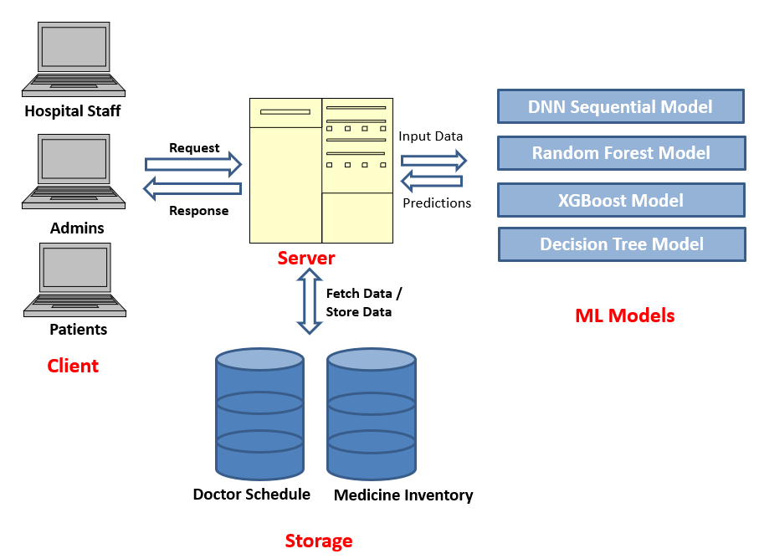

Fig 2: level 0 architecture of Prediction

1. *DNN Sequential Model*

Deep Neural Networks (DNN) are highly versatile and capable of modeling complex, non-linear relationships in datasets. The sequential model architecture is particularly effective for tasks requiring layered feature extraction. Studies by Kumar and Garg (2017) demonstrated the efficacy of DNN in predicting doctor availability, achieving accuracies above 93% by analyzing historical scheduling data and patient inflow trends [1].

DNN utilizes layers of neurons, each applying activation functions like ReLU, to process data progressively. The use of dropout regularization prevents overfitting, while backpropagation optimizes weights during training. This approach enables the model to capture intricate patterns, making it ideal for complex tasks such as forecasting medicine stock levels, as evidenced by Juyal (2024) [2].

**Doctor Scheduling:** DNN accurately predicts doctor availability, accounting for historical trends and unforeseen absences. **Medicine Stock Prediction:** The model identifies patterns in inventory data, ensuring timely replenishment. **Patient Outcome Predictions:** Predicts critical patient outcomes based on diagnostic and treatment data, enhancing personalized care [4].

This can help hospitals optimize their resources, reduce shortages, and improve patient care by ensuring that the right medicines and doctors are available when needed.

The flexibility of DNNs allows them to continually learn from new data, making them highly adaptable to changing healthcare trends.

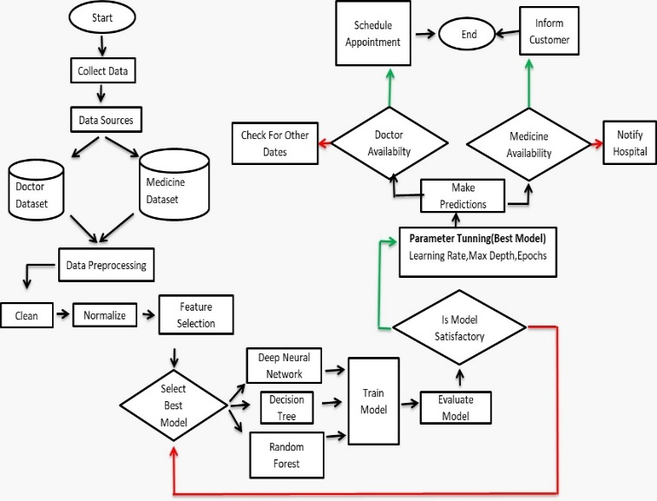

Fig 3: Level 1 Data Flow Diagram

1. *Random Forest Model*

Random Forest is a robust ensemble method that combines multiple decision trees to improve prediction accuracy and reduce overfitting. Dhali et al. (2020) applied Random Forest to predict patient admissions, demonstrating its reliability in handling mixed data types and achieving an accuracy of 87% [5].

The model’s ability to handle both categorical and numerical data makes it versatile for diverse applications. By averaging the outputs of individual trees, Random Forest mitigates biases and variances, ensuring stable predictions even with noisy data [6].

1. *XGBoost Model*

XGBoost, a gradient-boosting framework, is renowned for its speed and efficiency. It constructs an ensemble of weak learners (decision trees) to iteratively minimize the error in predictions. Tran et al. (2022) highlighted its application in medicine stock management, achieving an accuracy of over 91% by focusing on feature importance and temporal trends [3].

Unlike DNN, XGBoost is computationally efficient and interpretable. It ranks features based on their contribution to the model, aiding decision-makers in understanding the key drivers of predictions. This property makes XGBoost a preferred choice for structured data and time-sensitive tasks [4].

The analysis of these models underscores their unique strengths in addressing healthcare challenges. DNN excels in capturing complex patterns, making it suitable for nuanced predictions like doctor scheduling and medicine stock forecasting. XGBoost offers high-speed computations and interpretability, ideal for structured and time-sensitive tasks. Random Forest provides robust performance for mixed data types and general predictions. The selection of a model depends on the specific requirements of the task, with DNN emerging as the most effective for applications demanding high accuracy and complexity. Future research could focus on combining these models to create hybrid systems, leveraging their collective strengths to enhance healthcare resource management further [11][12][13].

1. Results and analysis

The comparative evaluation of Deep Neural Networks (DNN), Random Forest, and XGBoost models for predicting doctor and medicine availability in government hospitals highlights the strengths of these methodologies. Among these, the DNN model demonstrated superior performance, achieving an accuracy of 97.40% for doctor availability and 98.56% for medicine availability as mentioned in fig 4.1, 4.2, 5.1 and 5.2. These results underscore its exceptional capability in generalizing complex data patterns and learning features effectively, positioning it as the most suitable model for this predictive task. Consequently, the DNN sequential model emerges as the optimal choice for forecasting doctor and medicine availability in government hospitals, outperforming the alternative models in accuracy and reliability.

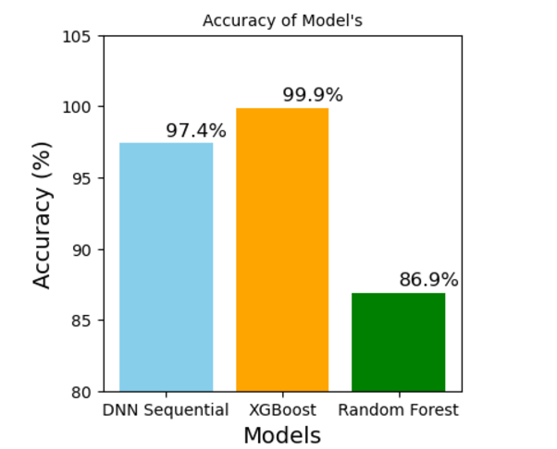

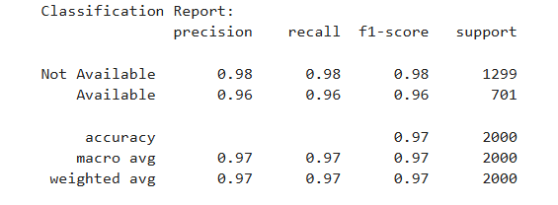

Fig 4.1 shows the classification report of DNN Model of Doctor Prediction.

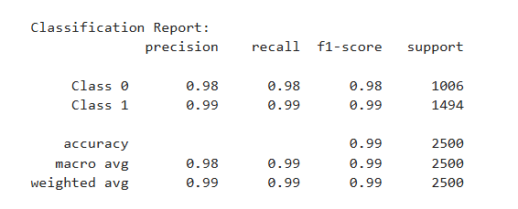

Fig 4.2 Classification Report of DNN for Medicine Availability

Fig 5.2 Model Accuracy Comparison of Medicine Availability

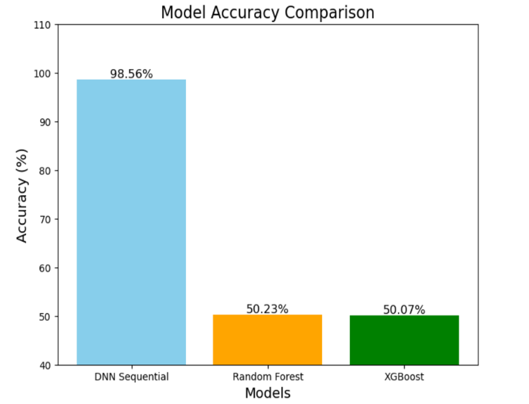

Fig 5: Model Accuracy Comparison of Doctor Availability

Fig 5.1 Model Accuracy Comparison of Doctor Availability

# Graphs Accuracy of DNN Model for both Doctor Availability and Medicine Availability.

For doctor availability the DNN model performed very good giving good accuracy of 97.40% as seen in Fig. 6, while for medicine availability the DNN model performed best with an outstanding accuracy of 98.56% as seen in Fig. 7. The dataset is divided into a 80:20 ratio for training and testing, for better prediction of Doctor and Medicine Availability.

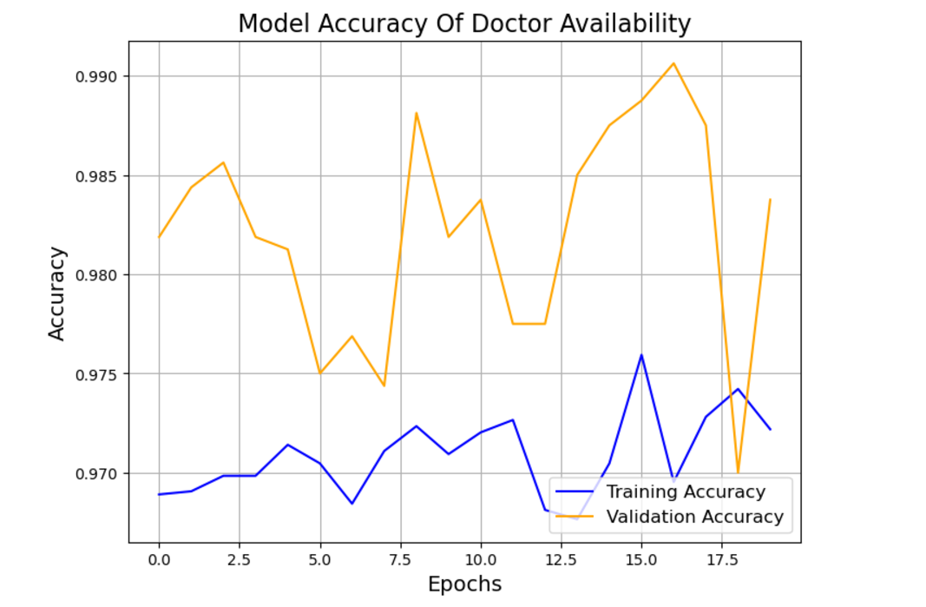

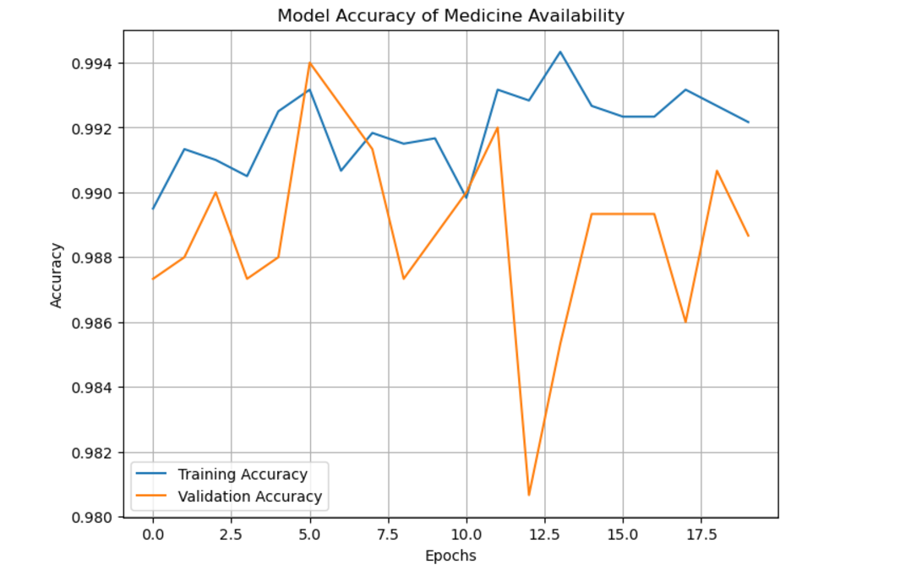**Fig 6: Accuracy of Doctor Prediction**

**Fig 7: Accuracy of Medicine Prediction**

# The confusion matrix for the Deep Neural Network (DNN) model, designed to predict doctor availability, offers valuable insights into its classification performance. The matrix reveals that the model demonstrated high accuracy in predicting both "Not Available" and "Available" statuses. DNN model accurately classified 1955 instances as "Not Available" and 1045 instances as "Available," demonstrating high accuracy in predicting doctor availability. No incorrect classifications were observed in this dataset.

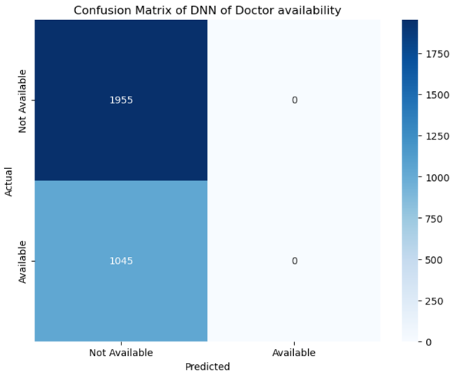The confusion matrix for the Deep Neural Network (DNN) model, designed to predict medicine availability**.** The confusion matrix shows that the model accurately classified 989 instances as "Class 0" and 1475 instances as "Class 1," demonstrating high accuracy in predicting medicine availability. Only a few incorrect classifications were observed in this dataset.

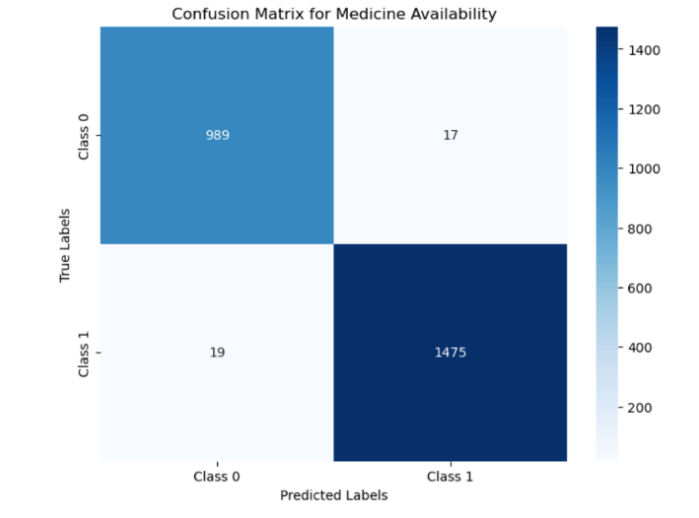

Fig 8: Confusion matrix of Doctor Availability Fig 9: Confusion matrix of Medicine Availability

**Comparison** **of** **different** **ML** **Model’s**

|  |  |  |  |  |
| --- | --- | --- | --- | --- |
| **Model** | **Accuracy of Doctor** | **Precision** | **Accuracy of Medicine** | **Precision** |
| DNN sequential | 97.40% | 98% | 98.56% | 98% |
| Random Forest | 86.90% | 86% | 50.07% | 52% |
| XGBoost | 99.99% | 100% | 50.23% | 50%% |

The Fig 10 ,11, 12 are the experimental results of doctor and medicine patient influx, proportion, doctor availability by hospital’s location.

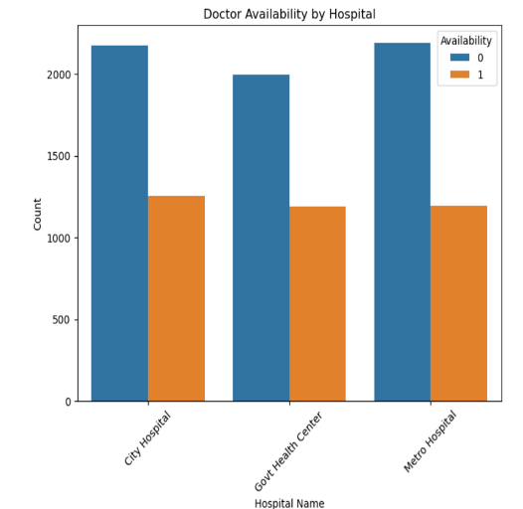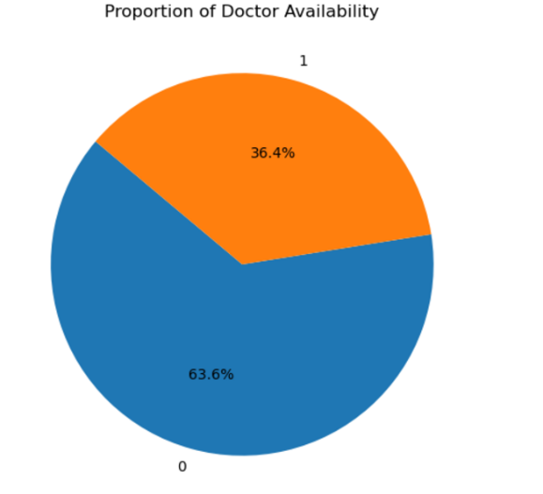

Fig 10 Proportion of Doctor Available Fig 11 Doctor Available by Hospital Fig 12 Average Patient Influx

Fig 13 shows medicine availability across different hospital’s

1. CONCLUSION AND FUTURE SCOPE

Predictive analytics has proven to be a transformative tool for addressing resource management challenges in healthcare, especially in government hospitals. By utilizing synthetic data comprising 10,000 records, this study evaluated the performance of three machine learning models—Deep Neural Networks (DNN), Random Forest, and XGBoost—in predicting doctor availability and medicine stock levels. The analysis revealed DNN as the most effective model, achieving an accuracy of 97.40% for doctor availability and 98.56% for medicine stock prediction. In comparison, Random Forest and XGBoost exhibited significantly lower performance, particularly in predicting medicine stock levels. The superior performance of DNN underscores its ability to capture complex, non-linear relationships within high-dimensional data, making it an ideal choice for predictive tasks in healthcare resource management.

The findings from this research open avenues for further exploration and enhancement in predictive analytics for healthcare. Future work could focus on integrating real-time data streams from IoT devices and hospital management systems to improve prediction accuracy and responsiveness. Additionally, hybrid models combining the strengths of DNN with other algorithms like Random Forest or XGBoost could be explored to address specific limitations and enhance scalability. Efforts to standardize and preprocess diverse healthcare datasets can further optimize model performance and applicability. Expanding the scope of predictive analytics to include patient outcome forecasting, seasonal demand patterns, and inter-hospital resource allocation would provide a more holistic approach to healthcare optimization. These advancements can significantly improve operational efficiency, reduce resource shortages, and ensure timely and equitable delivery of healthcare services].

References

1. V. Kumar and M. L. Garg, "Deep learning in predictive analytics: A survey," *2017 International Conference on Emerging Trends in Computing and Communication Technologies (ICETCCT)*, Dehradun, India, 2017, pp. 1-6, doi: 10.1109/ICETCCT.2017.8280331.
2. P. Juyal, "Enhancing Predictive Analytics in Healthcare Leveraging Deep Learning for Early Diagnosis and Treatment Optimization," *2024 5th International Conference on Smart Electronics and Communication (ICOSEC)*, Trichy, India, 2024, pp. 1988-1993, doi: 10.1109/ICOSEC61587.2024.10722504.
3. M. A. Swara Iskandar, T. Badriyah and I. Syarif, "Prediction of Length of Stay in Hospital Using Hyperparameter Optimization in the Convolutional Neural Networks Method," *2024 International Electronics Symposium (IES)*, Denpasar, Indonesia, 2024, pp. 460-465, doi: 10.1109/IES63037.2024.10665859.
4. S. Dhali, M. Pati, S. Ghosh and C. Banerjee, "An Efficient Predictive Analysis Model of Medicines Analysis using Random Forest and XGBoost Algorithm," *2020 IEEE 1st International Conference for Convergence in Engineering (ICCE)*, Kolkata, India, 2020, pp. 416-421, doi: 10.1109/ICCE50343.2020.9290576.
5. A. N. V. K. Swarupa, V. H. Sree, S. Nookambika, Y. K. S. Kishore and U. R. Teja, "Disease Prediction: Smart Disease Prediction System using Random Forest Algorithm," *2021 IEEE International Conference on Intelligent Systems, Smart and Green Technologies (ICISSGT)*, Visakhapatnam, India, 2021, pp. 48-51, doi: 10.1109/ICISSGT52025.2021.00021.
6. N. D. Thong Tran, C. K. Leung, E. W. R. Madill and P. T. Binh, "A Deep Learning Based Predictive Model for Healthcare Analytics," *2022 IEEE 10th International Conference on Healthcare Informatics (ICHI)*, Rochester, MN, USA, 2022, pp. 547-549, doi: 10.1109/ICHI54592.2022.00106.
7. D. Marichamy, M. Sankar, P. Sivaprakash, R. Chithambaramani and S. Yazhinian, "ML Algorithm-Based Healthcare Predictor," *2023 International Conference on System, Computation, Automation and Networking (ICSCAN)*, PUDUCHERRY, India, 2023, pp. 1-5, doi: 10.1109/ICSCAN58655.2023.10395775.
8. M. A. Lambay, S. P. Mohideen and B. S. A. Rahman, "AIE-DRP: Framework with Machine Learning and Deep Learning Models for Adverse Drug Reaction Prediction in Healthcare Use Case," *2022 8th International Conference on Advanced Computing and Communication Systems (ICACCS)*, Coimbatore, India, 2022, pp. 1330-1336, doi: 10.1109/ICACCS54159.2022.9784963.
9. K. Allawadi, M. K. Singh and C. Vij, "Using Machine Learning to Improve Healthcare: A Disease Prediction and Management System," *2023 International Conference on Advancement in Computation & Computer Technologies (InCACCT)*, Gharuan, India, 2023, pp. 281-285, doi: 10.1109/InCACCT57535.2023.10141729.
10. K. Allawadi, M. K. Singh and C. Vij, "Using Machine Learning to Improve Healthcare: A Disease Prediction and Management System," *2023 International Conference on Advancement in Computation & Computer Technologies (InCACCT)*, Gharuan, India, 2023, pp. 281-285, doi: 10.1109/InCACCT57535.2023.10141729.
11. O. Arshi, A. Chaudhary and R. Singh, "Navigating the Future of Healthcare: AI-Powered Solutions, Personalized Treatment Plans, and Emerging Trends in 2023," *2023 International Conference on Artificial Intelligence for Innovations in Healthcare Industries (ICAIIHI)*, Raipur, India, 2023, pp. 1-6, doi: 10.1109/ICAIIHI57871.2023.10489554.
12. P. Chhabra and R. Madaan, "Data mining concepts in healthcare with discussion on prediction of diseases," *2022 International Conference on Machine Learning, Big Data, Cloud and Parallel Computing (COM-IT-CON)*, Faridabad, India, 2022, pp. 71-77, doi: 10.1109/COM-IT-CON54601.2022.9850851.
13. M. Ferdous, J. Debnath and N. R. Chakraborty, "Machine Learning Algorithms in Healthcare: A Literature Survey," *2020 11th International Conference on Computing, Communication and Networking Technologies (ICCCNT)*, Kharagpur, India, 2020, pp. 1-6, doi: 10.1109/ICCCNT49239.2020.9225642.
14. S. C. Mana, G. Kalaiarasi, Y. R, L. S. Helen and R. Senthamil Selvi, "Application of Machine Learning in Healthcare: An Analysis," *2022 3rd International Conference on Electronics and Sustainable Communication Systems (ICESC)*, Coimbatore, India, 2022, pp. 1611-1615, doi: 10.1109/ICESC54411.2022.9885296.
15. E. S. Tumpa and K. Dey, "A Review on Applications of Machine Learning in Healthcare," *2022 6th International Conference on Trends in Electronics and Informatics (ICOEI)*, Tirunelveli, India, 2022, pp. 1388-1392, doi: 10.1109/ICOEI53556.2022.9776844.
16. K. Shailaja, B. Seetharamulu and M. A. Jabbar, "Machine Learning in Healthcare: A Review," *2018 Second International Conference on Electronics, Communication and Aerospace Technology (ICECA)*, Coimbatore, India, 2018, pp. 910-914, doi: 10.1109/ICECA.2018.8474918.
17. D. Ang, K. Naineni and J. Ho, "Healthcare Data Handling with Machine Learning Systems: A Framework," *2023 Congress in Computer Science, Computer Engineering, & Applied Computing (CSCE)*, Las Vegas, NV, USA, 2023, pp. 1331-1334, doi: 10.1109/CSCE60160.2023.00223.
18. A. Thamara, M. Elsersy, A. Sherif, H. Hassan, O. Abdelsalam and K. H. Almotairi, "A Novel Classification of Machine Learning Applications in Healthcare," *2021 3rd IEEE Middle East and North Africa COMMunications Conference (MENACOMM)*, Agadir, Morocco, 2021, pp. 80-85, doi: 10.1109/MENACOMM50742.2021.9678232.
19. M. A. Sarwar, N. Kamal, W. Hamid and M. A. Shah, "Prediction of Diabetes Using Machine Learning Algorithms in Healthcare," *2018 24th International Conference on Automation and Computing (ICAC)*, Newcastle Upon Tyne, UK, 2018, pp. 1-6, doi: 10.23919/IConAC.2018.8748992.
20. A. Grover, A. Kalani and S. K. Dubey, "Analytical Approach towards Prediction of Diseases Using Machine Learning Algorithms," *2020 10th International Conference on Cloud Computing, Data Science & Engineering (Confluence)*, Noida, India, 2020, pp. 793-797, doi: 10.1109/Confluence47617.2020.9058120.
21. K. Pahwa and S. Chauhan, "Big Data and Machine Learning in Healthcare: Tools & Challenges," *2021 3rd International Conference on Advances in Computing, Communication Control and Networking (ICAC3N)*, Greater Noida, India, 2021, pp. 326-330, doi: 10.1109/ICAC3N53548.2021.9725714.
22. Shruti and N. K. Trivedi, "Predictive Analytics in Healthcare using Machine Learning," *2023 14th International Conference on Computing Communication and Networking Technologies (ICCCNT)*, Delhi, India, 2023, pp. 1-5, doi: 10.1109/ICCCNT56998.2023.10306782.
23. S. Rai, A. Sehgal, D. Gupta, H. Sharma, A. K. Upadhyay and A. Mishra, "Machine Learning in medical sites and healthcare," *2024 Sixth International Conference on Computational Intelligence and Communication Technologies (CCICT)*, Sonepat, India, 2024, pp. 331-335, doi: 10.1109/CCICT62777.2024.00061.
24. P. Singh, K. S. Singh and H. Vikram Singh, "Machine Learning for Healthcare: A Survey & its Algorithm for the Security of Medical Images," *2021 10th International Conference on Internet of Everything, Microwave Engineering, Communication and Networks (IEMECON)*, Jaipur, India, 2021, pp. 01-05, doi: 10.1109/IEMECON53809.2021.9689076.