Machine Learning with Big Data
Assignment 3

Efficient Similarity Detection using k-Grams,
MinHash and LSH



Submitted by - Akshay Kumar (M25DE1028)
GitHub Link – Assignment 2

The MovieLens dataset is a widely used benchmark dataset for recommender system research. It contains user ratings for movies along with movie metadata such as title and genres.
For this assignment, the MovieLens Latest Small dataset was used. The dataset contains approximately 100,000 ratings from around 600 users on nearly 9,000 movies.
The following files were used:
movies.csv – contains movieId, movie title, and genres
ratings.csv – contains userId, movieId, rating, and timestamp
Genres were treated as textual descriptions of movies and used as input features for building content-based recommendation models.

Step 1: Creating the folder structure
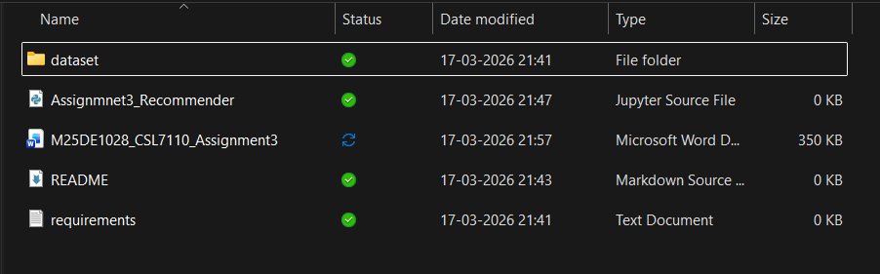

Step 2: Initialize git and first commit
