**Blinkit** (grocery)

The website where we can buy the Daily essentials and household items and get delivered in minutes.

Navigation Bar

* Company name
* Search bar
* Profile
* My cart

Advertisements and Discount **Section** 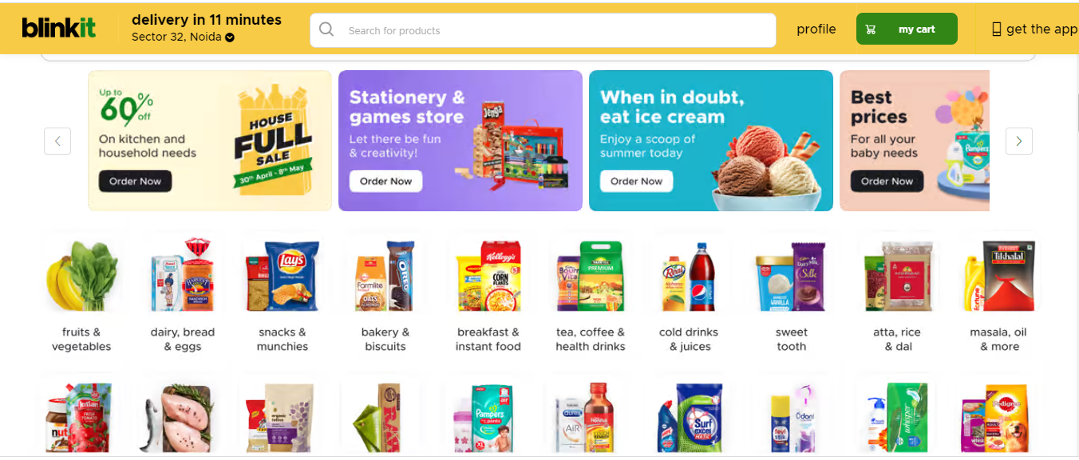

**Menu bar**

* A hotizontal division below navigation bar where different categories of items are displayed.

**Bank and Wallet Offers**

* Different Bank offers are displayed.

**Sort by**

* Price
* Discount
* Name(a->z)

**Item’s list**

* Each item in its respective group
* Image of item and its name and price
* Option to buy and add to cart
* Discount offers

**Placing order**

* Proceed to cart
* Add delivery address
* payment
* upi
* card
* Net banking