NIKE(Premium brand)

A premium fashion brand where you can buy a wide range of premium shoes, tshirts, sportswear etc. for men,women,kids.

**Navigation bar:**

>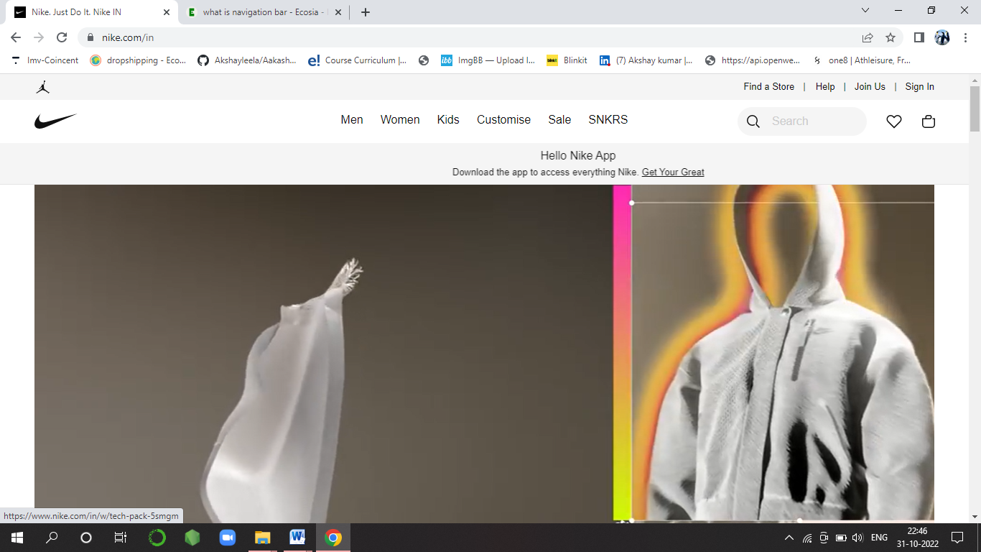

> **Popular products Section**

> Products Gallery

> Trending Section

A section where you see products that are selling more

> Gender-wise products

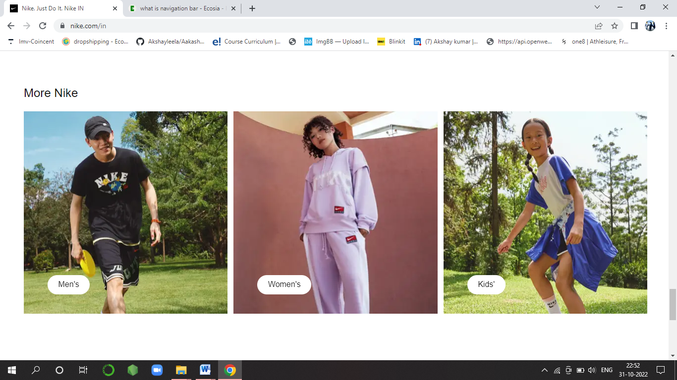

>Footer section:

It has social media account links to follow, ‘More about Nike’ section

**> Listing Page :**

Filters according to Gender, Price etc.