TESLA-SJCE

TESLA-SJCE is the Electrical & Electronics Engineering (EEE) departmental club of SJCE, where technology meets creativity. As a techno-cultural hub, the club blends technical expertise with interactive learning and fun-filled activities. From hands-on workshops to thrilling events, TESLA-SJCE fosters innovation, teamwork, and a dynamic learning experience

Achievements (April 2024 – March 2025)

1. Electrovaganza (May 2024): A spectacular three-day annual fest featuring electrifying cultural performances, engaging technical sessions, and fun activities, making it a much-awaited event on campus.
2. Thrive and Drive (October 2024): An exciting initiation for freshers with games, music, and dance performances, while giving them a glimpse into the vibrant TESLA community.
3. Treasure Hunt (November 2024): A high-energy crime-mystery-themed hunt that kept participants on their toes, solving puzzles and unravelling clues across campus.
4. Outreach Program (December 2024): A heartwarming initiative where members visited a government school to educate young minds on electrical safety through interactive demonstrations and engaging activities.
5. Sensor Workshop (December 2024): A hands-on experience where participants built circuits, worked with sensors, and explored coding, igniting their passion for electronics.
6. Career Carnival (January 2025): A power-packed placement preparatory event in collaboration with the Placement Cell, featuring mock interviews, expert talks, and industry insights to guide students toward career success.
7. Monthly Online Quiz: A thrilling knowledge battle covering trending topics, keeping participants updated and engaged.

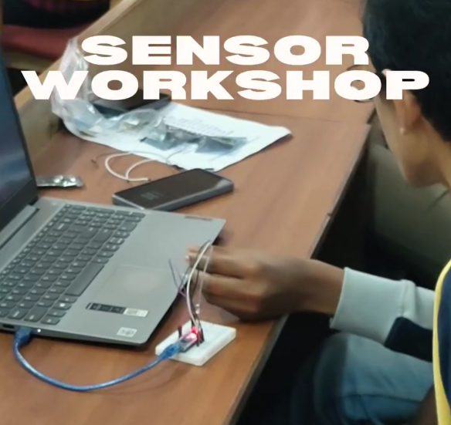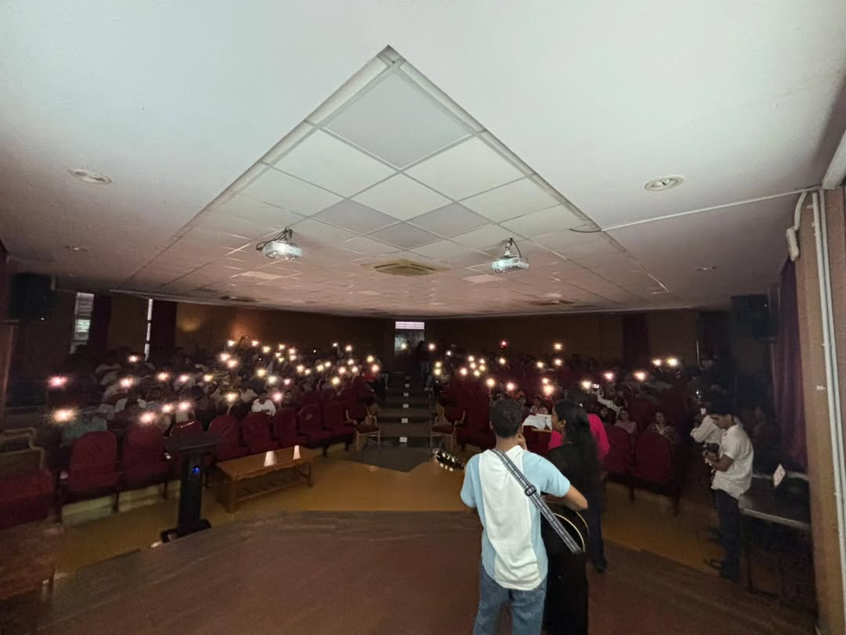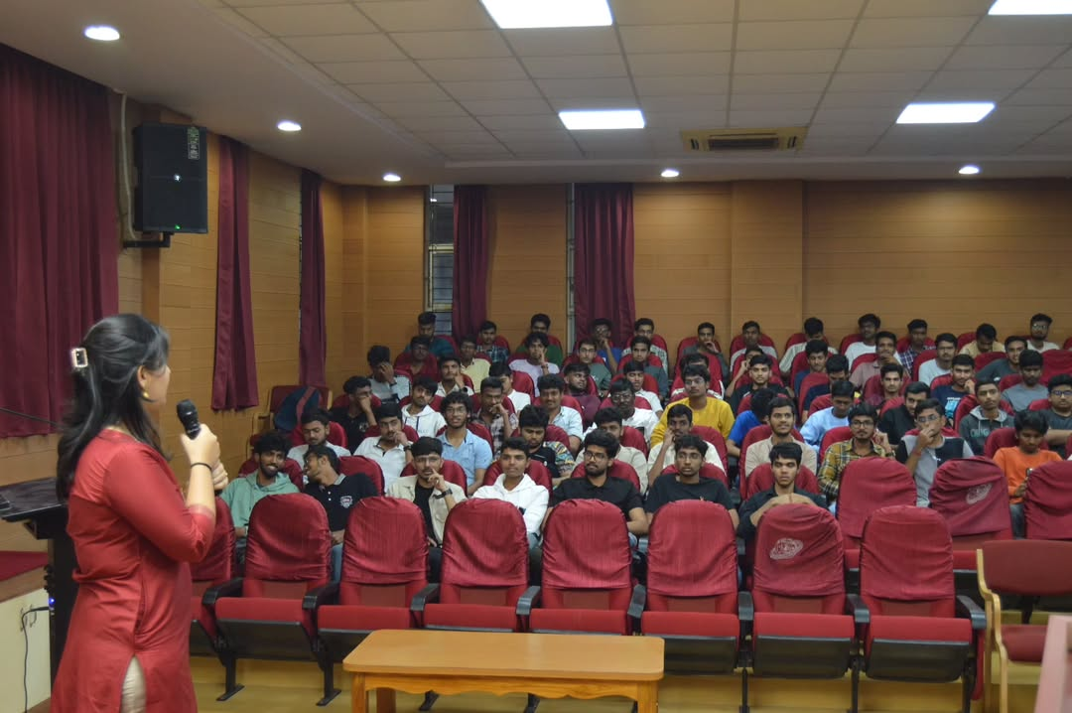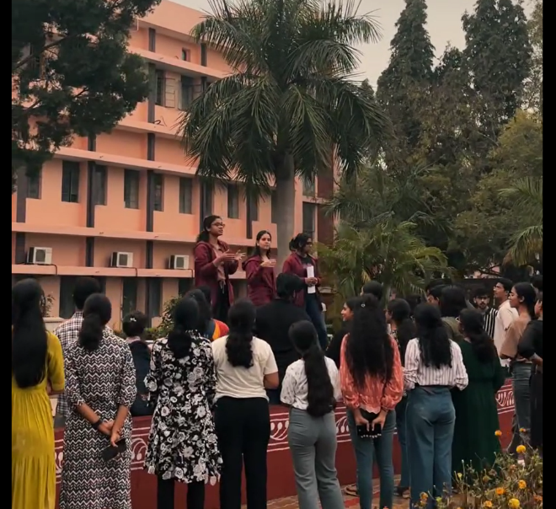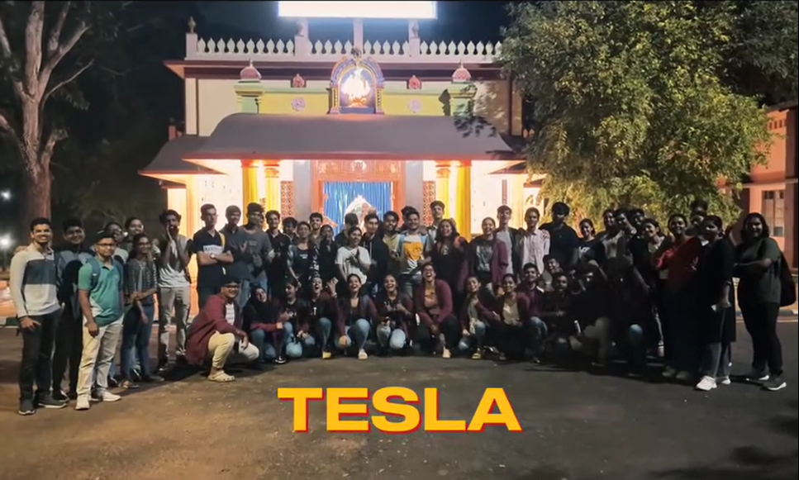THRIVE AND DRIVE

TREASURE HUNT

SENSOR WORKSHOP

THRIVE AND DRIVE

ELECTROVAGANZA

(ANNUAL EVENT)

