**BIOSTATS 203 FINAL PROJECT**

**Submitted by:**

**Akshay Shetty**

**UID: 905028886**

**Email: akshashe@ucla.edu**

# Summary of the results

1. From the dataset provided to us, it is quite evident that the number of children dropped at subsequent assessment period. The study started with 203 subjects at baseline, 165 at exit, 135 at Followup 1 and 104 at Followup 2. This is quite common occurrence in a scientific study or experiment done over a long period of time. People lose interest or parents do not find time to go to the study.
2. Though many leave the study after the baseline, quite a lot of children completed the all the four visits (87) accounting up to 43% which is quite impressive if you consider the fact that they are children (they often lose interest in long questionnaire). There is a sizable population (23) accounting up to 11% that just showed up only in the baseline period. We are still not clear on the reason for absence
3. If you consider the combination of visits done by students, most children attended all the assessment levels like I mentioned above. However, we are interested to know the effects on attending after the intervention mainly the Exit and Followup2. The exit level is immediately after the intervention. We see that 38 children attended the baseline and exit assessments and then left (nearly 18.72%). 10 people opted to skip Exit phase and attend the two follow ups. One person attended the Follow up 2 skipping other levels. This is outlier case. We are not sure if the intervention helped in this case.
4. In case of Pro social behavior, the mean of scores improved upon successive visits (significant when compared to baseline). This could mean the intervention helped the children gain healthy social behavior. The standard deviation slightly increased which could mean, the intervention might not have helpful to some.
5. Overall women had better pro social behavior at baseline and at followup2 compared to men. The slightly lesser Standard deviation meant that the intervention was much more effective on overall women population. Males saw growth in pro social behavior subscale, but the number of subjects were less than women at every stage and decreasing.
6. The Peer problem mean kept improving (became lesser) at exit and follow up 1 but what is troublesome is the fact it became almost the same value as that at baseline. The problem is much more evident in the case of males although females too didn’t benefit from the intervention. The standard deviations among the scores were quite high and it could be said that intervention didn’t help the children to mitigate peer problem.
7. Inattention and hyperactivity score came down significantly among both males and females and thus a clear indication that the intervention helped in this case. However, the high standard deviation means that not all subjects were benefitted.
8. The conduct problem subscale remains (maybe increased a bit) from the baseline period to followup2 period. While this may look like the intervention didn’t work, the t-test provided us the result that that there is some improvement in the conduct problem issues while slightly small.
9. The emotional symptoms subscale came down significantly for both males and females. Emotional symptoms is a good factor to see if the intervention is working as children are usually volatile in the age group 4-17. Its good to see that the intervention has helped in this case.

(10) The point (6) clears provides that Peer Problem was not solved. This is confirmed by the T-test which essentially accepted the hypothesis that the two means (baseline and the last assessment levels) are same and thereby there is no improvement.

(12) The t-tests always provided us the fact that the variances differed in every assessment level for every subscale except Peer to Peer.

(13) From R, we were able to simulate a dataset that corresponds almost to the original dataset provided to us.

(14) The increase in sample size showed that there is improvement in the significant treatment as the means moved away from the existing means and we could basically see that the CPS (Conduct Problem) subscale started to differ more and more from the baseline to the later assessment levels. This could allow us to have a dataset that corresponds to the original one in which the conduct problem subscale has different means in the baseline and later levels. So, increasing the sample size could have better dataset to compare to the real world.

(15) Plot 2 shows significant treatment going down with increase in missing dataset probability. The reason could be that we have lesser visit values for exit, followup1 and followup2 with increasing miss percentages thereby reducing the number of samples we can effectively compare the conduct problem subscale improvement measures. If we increase continuously, there is so much noise in the dataset that it is ineffective to make any predictions on improvements.

(16) The above problem is amplified the by the second missing argument which increase the NA values in the dataset and could again lead to ineffective dataset.

# SAS Outputs and Results:

(1)

|  |  |  |
| --- | --- | --- |
| Count and Percentage of Children for each assessment level | | |
| Assessment Level | **Count** | **Percentage (%)** |
| Baseline | 203 | 100 |
| Exit | 165 | 81.28 |
| Followup 1 | 135 | 66.50 |
| Followup 2 | 104 | 51.23 |
| Total of children | 203 | 100 |

(2)

|  |  |  |
| --- | --- | --- |
| Count and Percentage of children for the number of completed assessements | | |
| No of Assessments completed | **Count** | **Percentage** |
| 1 | 23 | 11.33 |
| 2 | 43 | 21.18 |
| 3 | 50 | 24.63 |
| 4 | 87 | 42.86 |
| Total | 203 | 100 |

Here the No of Assessments = 4 implies the children who have completed all four assessments level [ Baseline, Exit, Followup1, Followup2]

1. Here we have the following nomenclature in the order of visits

B – Baseline visit only

BE – Baseline and Exit

BF1 – Baseline and Followup 1

BF2- Baseline and Followup 2

BEF1 – Baseline, Exit and Followup 2

BEF2 – Baseline, Exit and Followup 2

BF1F2 – Baseline, Followup 1 and Followup 2

BEF1F2 – Baseline, Exit, Followup1 and Followup 2 [All assessments levels completed]

|  |  |  |
| --- | --- | --- |
| Count and Percentages of for combination of completed assessments | | |
| Combination | **Count** | **Percentage** |
| B | 23 | 11.33 |
| BE | 38 | 18.72 |
| BF1 | 4 | 1.97 |
| BF2 | 1 | 0.49 |
| BEF1 | 34 | 16.75 |
| BEF2 | 6 | 2.96 |
| BF1F2 | 10 | 4.93 |
| BEF1F2 | 87 | 42.86 |
| Total | 203 | 100 |

1. Here we will present each sdq stats overall results and then divide results per gender

4.1 SDQ_PSB: Prosocial Behavior Subscale score (range: 0-10)

|  |  |  |  |
| --- | --- | --- | --- |
| SDQ_PSB: Prosocial Behavior Subscale score [Overall picture] | | | |
| Visit | **Mean** | **Standard Deviation** | **Count** |
| Baseline | 6.84 | 1.96 | 203 |
| Exit | 8.33 | 2.03 | 165 |
| Followup1 | 8.76 | 2.03 | 135 |
| Followup2 | 8.22 | 2.39 | 104 |

|  |  |  |  |  |  |  |
| --- | --- | --- | --- | --- | --- | --- |
| SDQ_PSB: Prosocial Behavior Subscale vs Gender | | | | | | |
|  | **Male** | | | **Female** | | |
| Visit | Mean | SD | Count | Mean | SD | Count |
| Baseline | 6.45 | 2.09 | 101 | 7.23 | 1.76 | 102 |
| Exit | 7.99 | 2.29 | 77 | 8.63 | 1.73 | 88 |
| Followup1 | 8.41 | 2.30 | 66 | 9.10 | 1.67 | 69 |
| Followup2 | 7.76 | 2.47 | 55 | 8.73 | 2.20 | 49 |

4.2 SDQ_PPS: Peer Problems Subscale score (range: 0 – 10)

|  |  |  |  |
| --- | --- | --- | --- |
| SDQ_PPS: Peer Problems Subscale score [Overall picture] | | | |
| Visit | **Mean** | **Standard Deviation** | **Count** |
| Baseline | 2.17 | 1.88 | 203 |
| Exit | 1.68 | 1.80 | 165 |
| Followup1 | 1.73 | 1.95 | 135 |
| Followup2 | 2.13 | 2.47 | 104 |

|  |  |  |  |  |  |  |
| --- | --- | --- | --- | --- | --- | --- |
| SDQ_PPS: Peer Problems Subscale score vs Gender | | | | | | |
|  | **Male** | | | **Female** | | |
| Visit | Mean | SD | Count | Mean | SD | Count |
| Baseline | 2.27 | 1.89 | 101 | 2.07 | 1.87 | 102 |
| Exit | 1.97 | 1.84 | 77 | 1.42 | 1.73 | 88 |
| Followup1 | 1.82 | 1.83 | 66 | 1.64 | 2.06 | 69 |
| Followup2 | 2.29 | 2.45 | 55 | 1.94 | 2.50 | 49 |

4.3 SDQ_IHA: Inattention-Hyperactivity Subscale score (range: 0-10)

|  |  |  |  |
| --- | --- | --- | --- |
| SDQ_IHA: Inattention-Hyperactivity Subscale score [Overall picture] | | | |
| Visit | **Mean** | **Standard Deviation** | **Count** |
| Baseline | 4.53 | 2.63 | 203 |
| Exit | 3.33 | 2.51 | 165 |
| Followup1 | 3.40 | 3 | 135 |
| Followup2 | 3.60 | 3.34 | 104 |

|  |  |  |  |  |  |  |
| --- | --- | --- | --- | --- | --- | --- |
| SDQ_IHA: Inattention-Hyperactivity Subscale score vs Gender | | | | | | |
|  | **Male** | | | **Female** | | |
| Visit | Mean | SD | Count | Mean | SD | Count |
| Baseline | 5.02 | 2.54 | 101 | 4.05 | 2.64 | 102 |
| Exit | 3.40 | 2.59 | 77 | 3.26 | 2.45 | 88 |
| Followup1 | 3.30 | 2.93 | 66 | 3.49 | 3.09 | 69 |
| Followup2 | 3.47 | 3.28 | 55 | 3.73 | 3.44 | 49 |

4.4 SDQ_CPS: Conduct Problems Subscale score (range: 0-10)

|  |  |  |  |
| --- | --- | --- | --- |
| SDQ_CPS: Conduct Problems Subscale score [Overall picture] | | | |
| Visit | **Mean** | **Standard Deviation** | **Count** |
| Baseline | 2.57 | 2.01 | 203 |
| Exit | 1.73 | 1.81 | 165 |
| Followup1 | 1.86 | 2.18 | 135 |
| Followup2 | 2.39 | 2.76 | 104 |

|  |  |  |  |  |  |  |
| --- | --- | --- | --- | --- | --- | --- |
| SDQ_CPS: Conduct Problems Subscale score vs Gender | | | | | | |
|  | **Male** | | | **Female** | | |
| Visit | Mean | SD | Count | Mean | SD | Count |
| Baseline | 2.72 | 2.13 | 101 | 2.42 | 1.90 | 102 |
| Exit | 1.65 | 1.68 | 77 | 1.81 | 1.92 | 88 |
| Followup1 | 1.82 | 2.10 | 66 | 1.90 | 2.26 | 69 |
| Followup2 | 2.27 | 2.75 | 55 | 2.53 | 2.80 | 49 |

4.5 SDQ_ESS: Emotional Symptoms Subscale score (range: 0-10)

|  |  |  |  |
| --- | --- | --- | --- |
| SDQ_ESS: Emotional Symptoms Subscale score [Overall picture] | | | |
| Visit | **Mean** | **Standard Deviation** | **Count** |
| Baseline | 3.51 | 2.28 | 203 |
| Exit | 2.81 | 2.65 | 165 |
| Followup1 | 2.59 | 2.60 | 135 |
| Followup2 | 2.74 | 2.78 | 104 |

|  |  |  |  |  |  |  |
| --- | --- | --- | --- | --- | --- | --- |
| SDQ_ESS: Emotional Symptoms Subscale score vs Gender | | | | | | |
|  | **Male** | | | **Female** | | |
| Visit | Mean | SD | Count | Mean | SD | Count |
| Baseline | 3.33 | 2.23 | 101 | 3.69 | 2.32 | 102 |
| Exit | 2.62 | 2.55 | 77 | 2.97 | 2.75 | 88 |
| Followup1 | 2.20 | 2.41 | 66 | 2.96 | 2.74 | 69 |
| Followup2 | 2.33 | 2.90 | 55 | 3.20 | 2.60 | 49 |

1. T-test

In t-test,

We have

NULL Hypothesis: The means are equal [ Improvement was not observed from the baseline to last assessment level, that is the condition is almost same]

Alternate Hypothesis: The means are different [ That is changes are observed from baseline to last assessment level, the condition is improved if mean decreases in some SDQs like ESS, PPS, CPS and IHA and if mean increase in PSB.

P< 0.05 – We reject null hypothesis

|  |  |  |  |  |  |  |
| --- | --- | --- | --- | --- | --- | --- |
| T-Test results for each of the subscales | | | | | |  |
| Subscale | **Equality of variance**  **(Pr < 0.05)** | **Method** | **Equality of means**  **(Pr <0.05)** | **Means (Baseline)** | **Means ( Last Assessment level)** | **Conclusion** |
| SDQ_ESS | 0.0280(Reject) | Satterthwaite | 0.0081(Reject) | 3.528 | 2.8111 | Means are not equal. Looking at means, there is improvement |
| SDQ_CPS | 0.0299(Reject) | Satterthwaite | 0.0464 (Reject) | 2.572 | 2.094 | Means are not equal. Looking at means, there is improvement |
| SDQ_IHA | 0.0267(Reject) | Satterthwaite | 0.0001(Reject) | 4.611 | 3.44 | Means are not equal. Looking at the means, there is improvement. |
| SDQ_PPS | 0.0097(Reject) | Satterthwaite | 0.2640(Accept) | 2.0333 | 1.7944 | Means are equal. There is no improvement from baseline |
| SDQ_PBS | 0.0128(Reject) | Satterthwaite | 0.0001(Reject) | 6.861 | 8.422 | Means are not equal. There is improvement from base as mean gradually increases in pbs |

# R Outputs and Results

1. The Sample size effect on significant treatment is plotted as below

I have considered sdq_cps [ Conduct Problem Subscale for the plot]

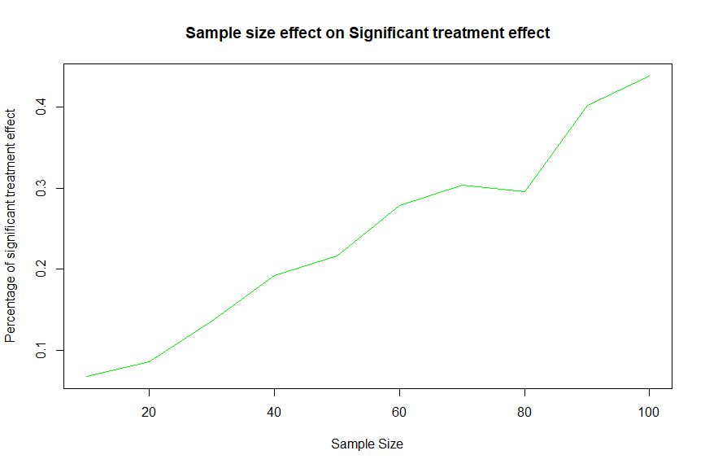

1. Missing first data percentage effect on significant treatment 