**Before reading further, make sure you’ve tested the digitalcerti software by sending a certi to yourself.**

Q) What is this script for?

🡪 It is for reading each entry(row) from a .CSV file and feeding each column from that row as an input to the form at localhost/digitalcerti. In short, it automatically opens up the browser, goes to localhost/digitalcerti, fills up the form, issues the certi and closes the browser window when its done.

Q) How do I run it on my PC?

🡪Before running it, you need to install some requirements for the script.

Follow these steps:

1: Install Python 3.6(If you haven’t already, see any youtube video regarding the setting of environment variables.)

2: Check if python has installed properly by typing ‘python’ on the cmd. (See the img below.)

Type🡪 exit()

To exit the python shell.

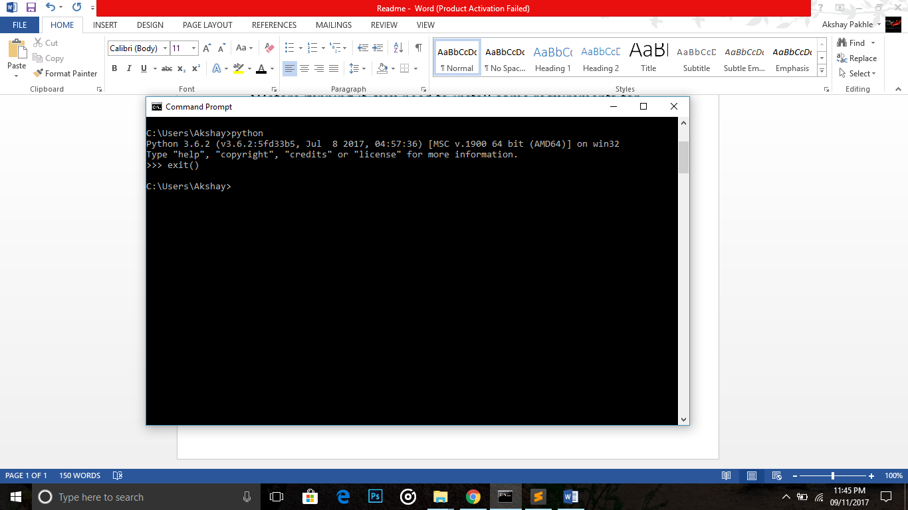

3. After this, you need to install some modules.

Type🡪pip install selenium

And after selenium is installed,

Type🡪pip install ipython

(Since I’ve installed them already , its showing me that the requirements are satisfied, it’ll be something like selenium has been installed in your case)

Refer this video if you have any trouble:

https://www.youtube.com/watch?v=8iAqUVvytJk

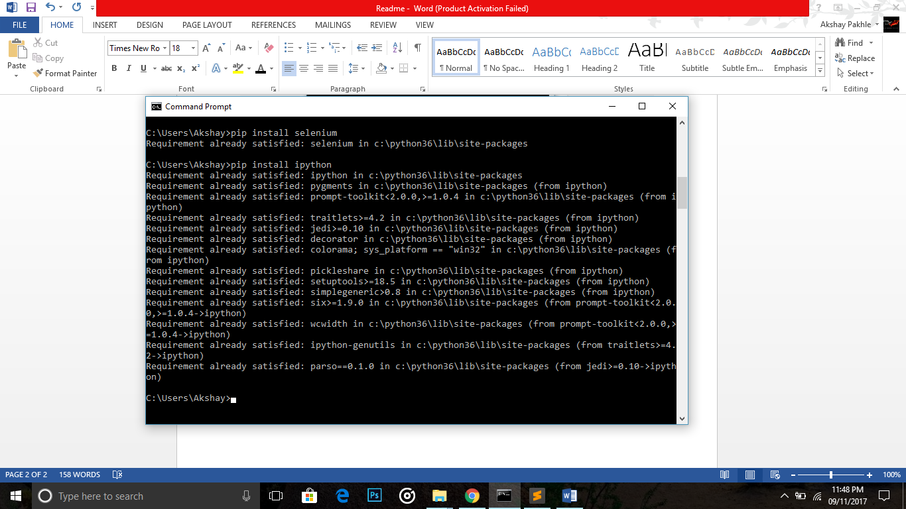

4: Now, you have the required modules. Next thing to ensure is that you have chromedriver,filename.csv(In my case it is Test.csv),auto_send.py in the same folder.

Like This:

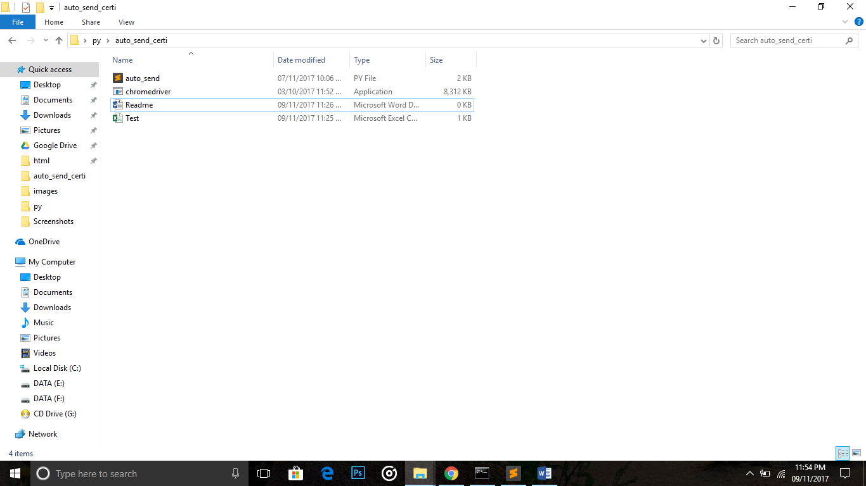

5: Now, open the auto_send.py file in any text editor and change ‘test.csv’ to ‘your_file_name.csv’(here your_file_name means the csv file that you want to read from, it may be Gwigle.csv or NTPP.csv or whatever) and save the script.

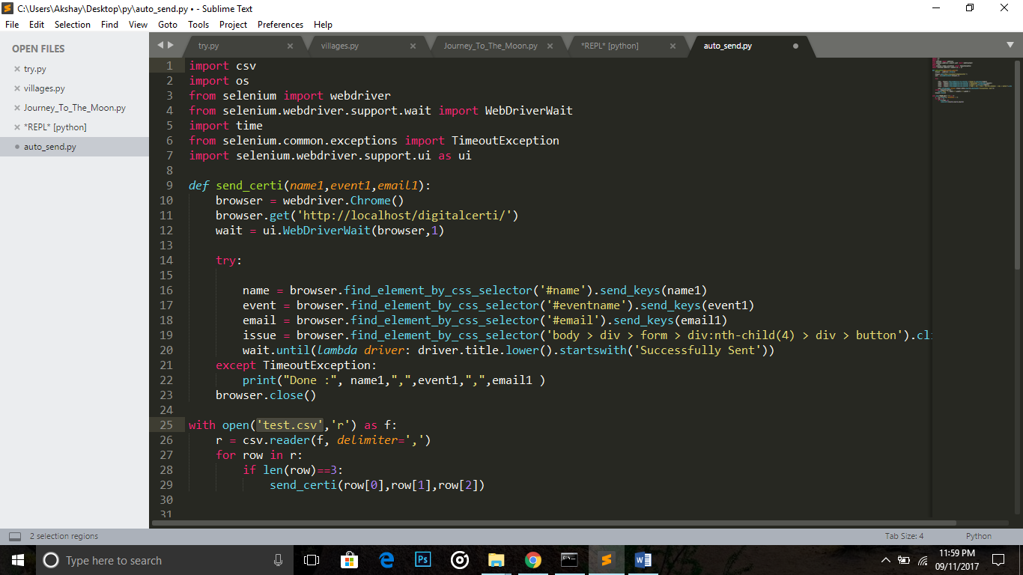

6: Now, if you’ve done everything correctly, you should be able to run the script.

Go to the cmd and navigate to the folder you’re script is in and type🡪python auto_send.py

Now, just wait as you see a browser window opening up automatically and doing all the work for you.

The script will run until the entire .csv file has been looped through.(It may take a couple of hours)

Don’t exit while the script is executing, wait for it to finish.(Ideal case)

This is my test.csv file:

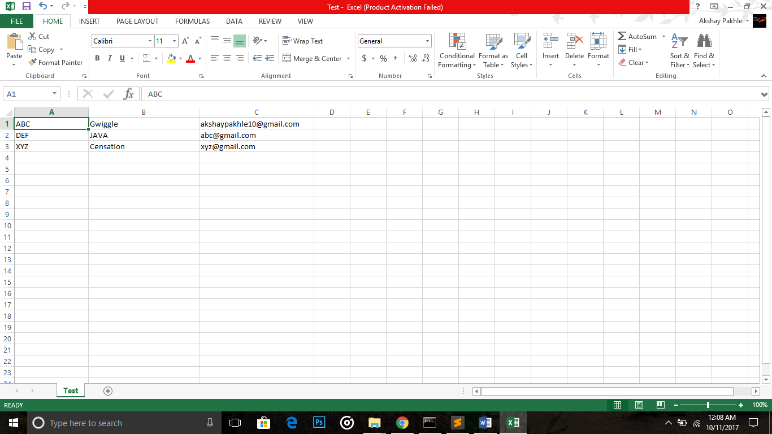

And after running my auto_send.py script:

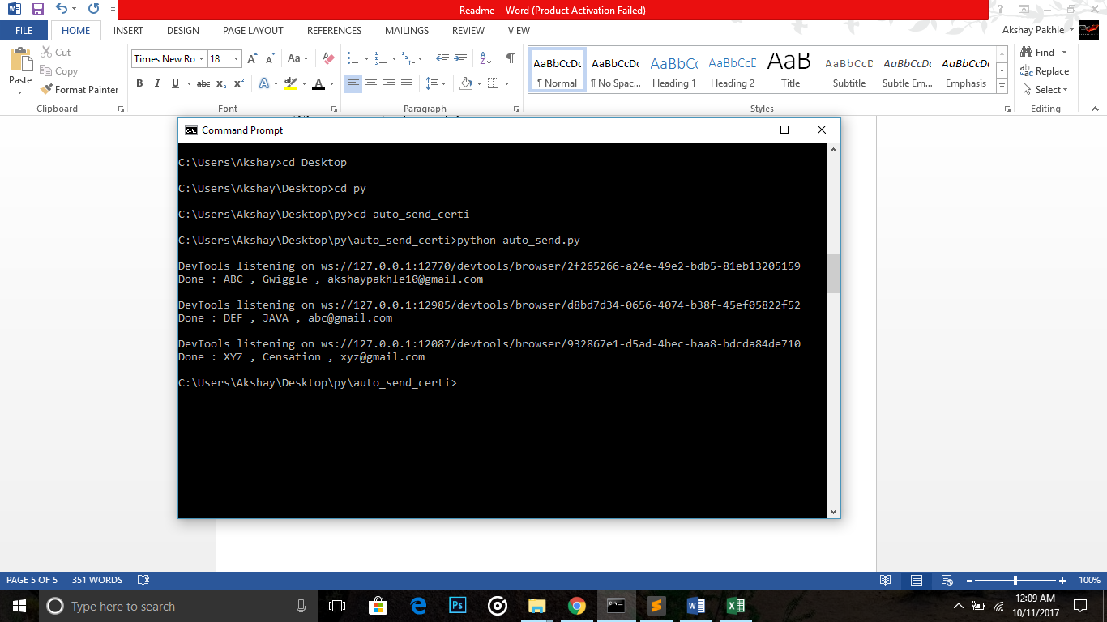

As you can see,

**Done: ABC , Gwiggle ,** [**akshaypakhle10@gmail.com**](mailto:akshaypakhle10@gmail.com) prompt indicates that the script has read the first row from my csv file and sent a certi to that email address, then it moved on to the next row and did the same until my csv file was done completely(In my case there were only 3 entries in the csv file.)

FAQ:

Q)What if I had to stop the script in the middle of its execution due to some reason?

🡪Well, in that case, you’d have to see upto which row the script looped through, for eg: you’ll see something like

Done: blah blah blah.

So now, got to the csv file and delete the rows upto which the script has looped through(i.e go to row blah blah blah and delete it & all the rows above it and ) and save it.

Now, you can run it again and the script will send the certi to the remaining people.