JUNIOR FLUTTER DEVELOPER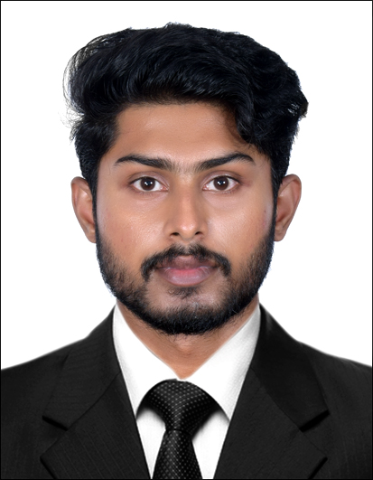
AKSHAY CHANDRAN
Email : akshay.payya@gmail.com
Mobile : 7736976618
Address : Akshay nivas, Manantheri Sathram P.O Manantheri,
Kannur,670643

OBJECTIVES
OBJECTIVES

Seeking an opportunity in a dynamic, innovative and creative environment where I can explore my ideas and to utilize my technical skills for achieving the target and developing the best performance in the organization.

Qualification | Institution/University | Year of Passing | Mark in Percentage
B.Tech Computer science | Malabar Institute of Technology, Kannur | 2019 | 74.69
PLUS TWO | SN Trust higher secondary school Thottada, Kannur | 2015 | 66.25
SSLC | MHSS-Mambaram Higher Secondary School, Kannur | 2013 | 75%

- 3 month training on Flutter at Spectrum Softtech Solutions, Mahakavi G Rd, Ernakulam South, Kochi, Kerala 682011.
- Food Donation in Flutter
- College Main Project : Unpaired image-to-image translation
- Mini Project : Blind Assistance using AI – BLISS

- Programming Languages known: C, Dart
- Frameworks Known: Bootstrap, Flutter
- Scripting Languages known : HTML, CSS, JavaScript, jQuery
- Database: MySql, sqlfilte, Firebase
- Operating Systems : Windows, Andriod, Linux
- Computer Proficiency : Coding, Ms Office, LibreOffice, Assembling Pc Components and Diagnosing technical issues, Google Colab, Google Cloud Console, Magento(Google Re-captcha, Social Login, Payment Gateway, Custom Module & Authentication, Flashing Android Firmware
- Softwares Known : Andriod Studio, Latex

- English (Read, Write and speak),
- Malayalam (Read, Write and speak),
- Hindi(Speak),
- Tamil(speak)

- Self Motivate,
- Positive Thinker,
- Dedicated,
- Smart Working

I, Akshay chandran, hereby declare that all the information given above are true and correct to the
best of my knowledge and belief.

Date :
Place : Akshay Chandran
ACADEMIC PROJECT ,SEMINAR,INDUSTRIAL VISIT AND TRAINING
ADDITIONAL SKILLS
LANGUAGES KNOWN
SKILLS
DECLARATION

