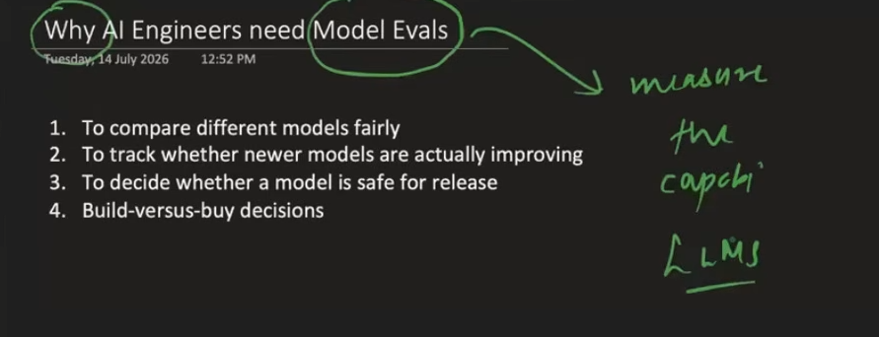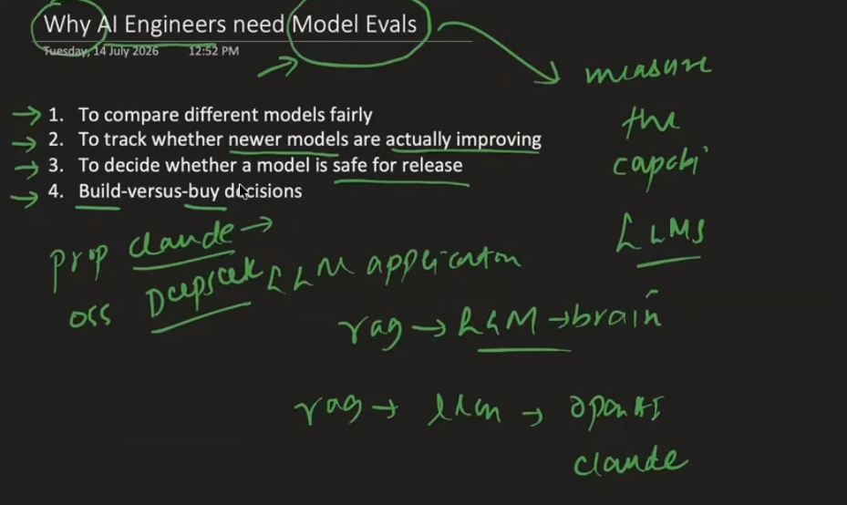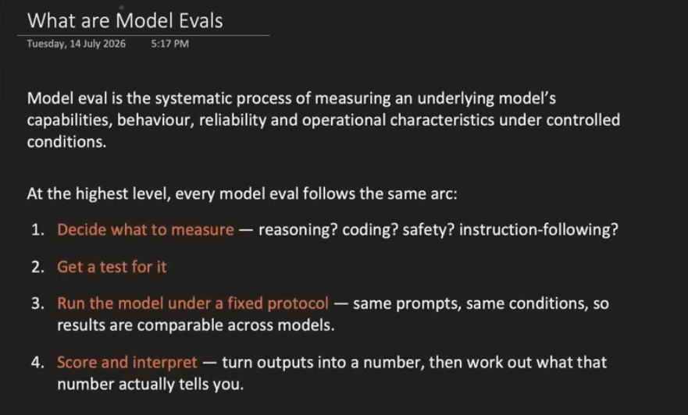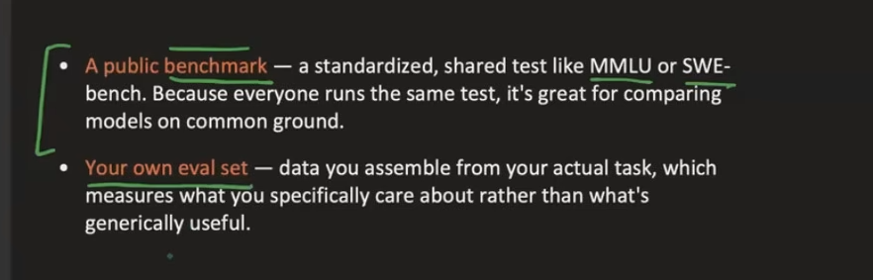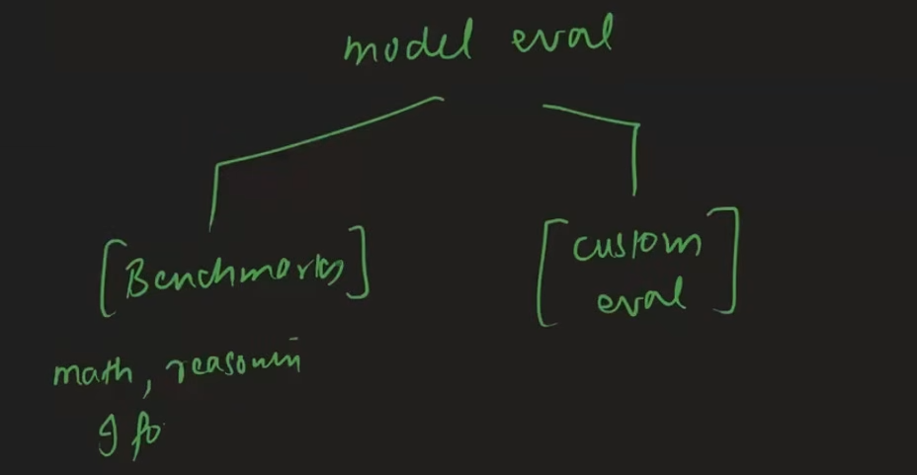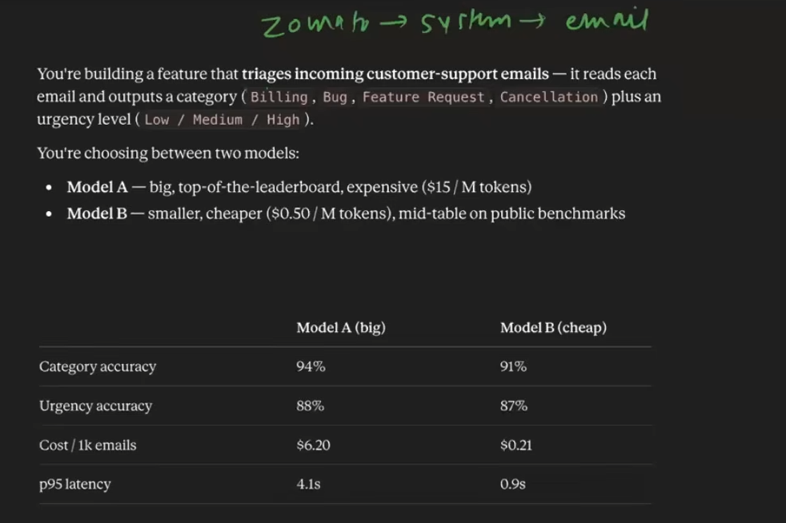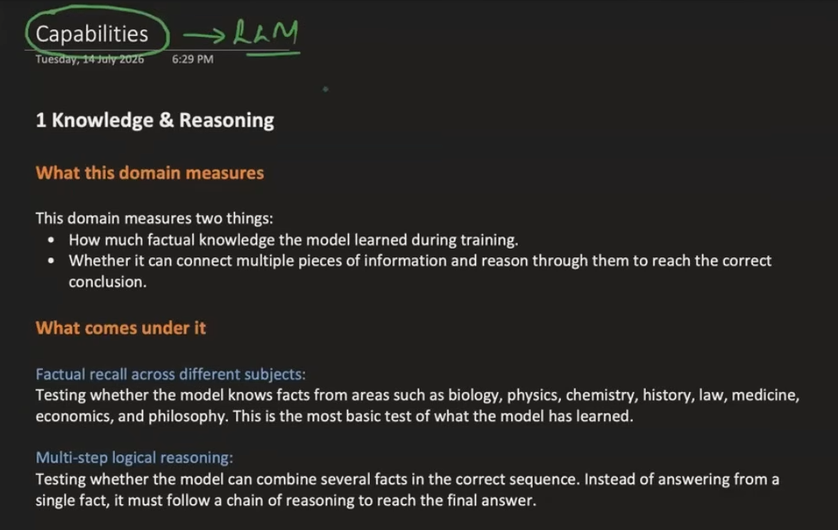
Capabilities

1 Knowledge & Reasoning

What this domain measures

This domain measures two things:
- How much factual knowledge the model learned during training.
- Whether it can connect multiple pieces of information and reason through them to reach the correct conclusion.

What comes under it

Factual recall across different subjects:
Testing whether the model knows facts from areas such as biology, physics, chemistry, history, law, medicine, economics, and philosophy. This is the most basic test of what the model has learned.

Multi-step logical reasoning:
Testing whether the model can combine several facts in the correct sequence. Instead of answering from a single fact, it must follow a chain of reasoning to reach the final answer.

Why frontier labs evaluate this separately

This domain is commonly used as a proxy for answering the question:
How intelligent is this model?

It is also the capability most often discussed by the media and the general public. Frontier labs therefore need to show that their models can match or outperform competitors on widely recognized knowledge and reasoning benchmarks.

Real-world relevance

This capability matters when models are used for:
- Analyzing research papers.
- Answering complex customer questions.
- Writing technically accurate documents.
- Assisting professionals in fields such as law, medicine, science, and finance.

2 Coding & Software Engineering

What this domain measures

This domain measures whether a model can write code that actually works.

It also tests whether the model can work inside real software engineering environments involving large codebases, multiple files, development tools, repositories, and complex workflows.

What comes under it

Function-level code generation:
Writing individual functions from natural-language instructions. The model must handle edge cases, validate inputs, and follow the required function interface.

Real-world bug fixing in existing codebases:
Giving the model a real GitHub issue and an existing repository, then asking it to identify the root cause and create a correct patch without breaking other parts of the software.

Multi-file, long-horizon engineering tasks:
Making changes across several files, understanding how different parts of the system depend on each other, and performing tasks such as refactoring or adding new features.

Command-line and system administration:
Completing multi-step tasks through a terminal, such as installing packages, configuring servers, running diagnostic commands, and combining different tools.

API and function calling:
Making correct API calls with the right parameters, handling errors, and correctly processing the returned results.

Why frontier labs evaluate this separately

Better coding performance can directly improve developer productivity and create significant business value.

Frontier labs also compete heavily on coding benchmarks because developers are an important customer group and a major source of revenue.

Real-world relevance

This domain matters for:
- Code generation.
- Debugging.
- Code review.
- CI/CD automation.
- Software maintenance.
- General software engineering work.

Coding evaluations often reveal some of the largest performance differences between leading models and weaker ones.

3 Mathematics

What this domain measures

This domain measures whether a model can perform accurate symbolic and numerical reasoning.

Mathematics is especially useful for evaluation because the final answer is usually either correct or incorrect. A response cannot succeed simply by sounding convincing.

What comes under it

Grade-school mathematics and basic arithmetic reasoning:
Solving multi-step word problems by converting natural language into mathematical expressions and carrying out the correct sequence of calculations.

Competition-level problem solving:
Solving problems from competitions such as AIME. These problems may require creative reasoning, combinatorics, geometry, number theory, and pattern recognition.

Undergraduate and graduate-level mathematics:
Solving advanced problems from areas such as real analysis, abstract algebra, topology, probability theory, and differential equations. These may require long reasoning chains.

Research-level mathematical reasoning:
Solving problems close to the frontier of mathematical research, where even expert mathematicians may need several days to arrive at a solution.

Why frontier labs evaluate this separately

Mathematics provides one of the cleanest tests of genuine reasoning.

There is little room for a plausible-sounding but incorrect answer. This makes mathematical evaluation useful for checking whether a model can perform formal and verifiable reasoning instead of relying only on pattern matching.

Real-world relevance

This capability is important for:
- Scientific computing.
- Financial modelling.
- Engineering simulations.
- Data analysis.
- Any application requiring precise numerical results.

4 Long Context

What this domain measures

This domain measures whether a model can effectively use information from very long inputs, sometimes containing hundreds of thousands of tokens.

What comes under it

Single-fact retrieval from long contexts:
Finding one specific piece of information hidden somewhere inside a very long document.

Multi-fact co-reference across long texts:
Tracking the same person, entity, concept, or constraint across multiple mentions that appear far apart in a document or conversation.

Aggregation over long content:
Summarizing, counting, comparing, or identifying patterns using information spread across a large amount of text.

Code repository understanding:
Navigating a large codebase, understanding relationships between files, and reasoning about cross-file dependencies.

Why frontier labs evaluate this separately

Context-window size has become an important marketing number:
128K → 200K → 1M tokens

However, a large advertised context window does not guarantee that the model can use all of that information effectively.

Labs therefore need to demonstrate that their models can genuinely use the context capacity they claim to support.

Real-world relevance

Long-context capability matters for:
- Reviewing legal contracts.
- Analyzing academic papers.
- Maintaining large codebases.
- Handling long customer-support conversations.
- Working with large collections of documents.

5 Vision & Multimodal

What this domain measures

This domain measures whether a model can understand and reason about visual information along with text.

What comes under it

Scientific chart and graph understanding:
Reading axes, legends, data points, and trends. The model may need to extract exact values as well as explain the broader meaning of the chart.

Document and form understanding:
Processing scanned documents, invoices, tables, and forms. The model must understand not only the words but also how the information is arranged on the page.

GUI and screen understanding:
Understanding computer or mobile-device screens. This includes identifying buttons, menus, dialog boxes, input fields, and the current state of an application.

Why frontier labs evaluate this separately

Vision allows models to handle tasks that text-only systems cannot perform.

It enables new use cases and has become an important area where frontier models can differentiate themselves after many text benchmarks have started becoming saturated.

Real-world relevance

This capability matters for:
- Processing invoices.
- Analyzing charts and research figures.
- Navigating software interfaces.
- Reading medical images.
- Understanding engineering diagrams.
- Working with visually complex documents.

6 Agentic & Tool Use

What this domain measures

This domain measures whether a model can take actions instead of only generating text.

An agentic model may browse the internet, call APIs, manipulate files, execute code, operate software, and complete complex multi-step tasks.

To succeed, the model must plan its actions, choose the right tools, track progress, and recover when something goes wrong.

This is widely considered one of the next major frontiers of AI evaluation.

What comes under it

Web browsing and persistent research:
Navigating multiple websites, following links, searching for information, and combining findings from many online sources. Some tasks may require visiting dozens or even hundreds of pages.

Structured tool calling and API interaction:
Using external tools and APIs correctly by selecting the right function, passing valid parameters, handling responses, chaining calls, and recovering from errors.

Desktop and computer use:
Operating real applications through visual interaction, including clicking, typing, and navigating across word processors, spreadsheets, email clients, and file managers.

Multi-turn task execution with planning:
Breaking a large goal into smaller steps, completing them in the correct order, checking intermediate results, and adjusting the plan when something fails.

Why frontier labs evaluate this separately

A model may possess a large amount of knowledge but still be unable to use that knowledge to complete a practical task.

Agentic evaluation measures the difference between:
What the model knows
and
What the model can actually do

This gap remains large even among frontier models.

Real-world relevance

Agentic capability is important for:
- Coding agents.
- Research assistants.
- Customer-service bots.
- Data-entry automation.
- Personal assistants.
- Any workflow where the AI must perform actions rather than simply provide an answer.

7 Safety & Alignment

What this domain measures

This domain measures whether a model can be trusted to behave responsibly.

It checks whether the model refuses harmful requests, avoids deception and sycophancy, resists adversarial attacks, and continues following safety principles even when a user pressures it to behave differently.

What comes under it

Refusal of harmful content generation:
Checking whether the model appropriately refuses requests involving cybercrime, violence, harassment, misinformation, and illegal activities.
At the same time, the model should not become so cautious that it refuses harmless or legitimate requests.

Resistance to adversarial attacks and jailbreaks:
Testing whether the model maintains its safety rules when users attempt to bypass them through prompt injection, role-playing, encoded instructions, or other adversarial methods.

Truthfulness versus sycophancy:
Checking whether the model gives the correct answer even when it disagrees with the user's beliefs or expectations.
A safe and reliable model should not simply tell users what they want to hear.

Cybersecurity capabilities:
Evaluating whether the model can perform advanced cybersecurity tasks such as cryptography, reverse engineering, digital forensics, and exploitation.
This is especially important for understanding potentially dangerous autonomous capabilities.

Why frontier labs evaluate this separately

Safety is both a regulatory requirement and a major reputational concern.

Real-world relevance

Any organization deploying an AI model to the public must test whether its safety controls work properly.

This domain directly affects:
- Legal liability.
- Regulatory compliance.
- Brand reputation.
- User trust.
- Responsible deployment.

8 Instruction Following

What this domain measures

This domain measures whether a model does exactly what the user asked it to do — no more and no less.

The instructions may include requirements related to format, length, tone, style, structure, or content.

A model may have excellent knowledge but still be frustrating to use if it repeatedly ignores simple instructions.

What comes under it

Verifiable constraint satisfaction:
Following instructions that can be checked automatically, such as:
- Staying within a word limit.
- Using bullet points.
- Producing valid JSON.
- Following a markdown structure.
- Using specific section headings.

Handling ambiguous or incomplete instructions:
Understanding what the user probably wants when the request is underspecified, asking a clarifying question when necessary, and choosing reasonable defaults when appropriate.

Why frontier labs evaluate this separately

Instruction following strongly affects whether a model feels helpful or frustrating in everyday use.

It is one of the capabilities most directly connected to user satisfaction in real production environments.

Real-world relevance

Almost every practical use of a language model depends on instruction following.

Examples include:
- Generating reports in a required format.
- Writing code according to specific style rules.
- Producing structured JSON outputs.
- Following brand-tone requirements.
- Maintaining coherent multi-turn conversations.

