A benchmark is a standardised test used to measure a particular model capability.

Every benchmark is built from four parts.

Part 1 — The dataset

The dataset is the questions plus the answer key. For example GSM8K: a few thousand word problems, each paired with its correct number.

"Natalia sold clips to 48 friends in April, and then she sold half as many clips in May. How many clips did she sell altogether?"
Answer: 72

Part 2 — The run configuration

The run configuration is list of all settings under which the model was run during the evaluation. It has three layers:

a) Prompt construction — how the question is worded and framed

- Zero-shot vs. few-shot: do you show worked examples first? GSM8K is classically reported 8-shot. Few-shot examples reliably lift scores — they teach the model the expected format.

- Chain-of-thought vs. direct: ask bluntly and models blurt a wrong number; add "think step by step" and the model works through it — 48 in April, half is 24 in May, 48+24=72 — and accuracy jumps a lot.

(b) Decoding / sampling configuration

- Temperature - At temperature=0 (greedy), the model picks the most likely token every time — deterministic and reproducible. Above 0, it samples, so the same prompt gives different answers on different runs. Most benchmarks use greedy for reproducibility.

- max_tokens - chain-of-thought needs room. Cap max_tokens too low and the model gets cut off mid-reasoning, never emits its final answer, and scores zero on a question it was solving correctly. That's not a capability failure — it's a config failure that looks identical in the score.

(c) Scoring strategy & Environment

- Single vs. multiple. pass@1 = one attempt. pass@k = k attempts, count it right if any succeed. maj@k (self-consistency) = sample k times, take the majority answer. These are dramatically different numbers on the same model. A model at 92% maj@8 might be 85% pass@1. If a report doesn't say which, the number is uninterpretable.

- Tools on or off. A model with a Python interpreter scores very differently on math than one without. Same model, same questions, tools toggled: large score gap. GSM8K with code execution is barely the same test as GSM8K without.

Part 3 — The scoring method

Scoring is how an output becomes a number.

(a) Extraction — finding the answer in the output. The model doesn't emit 72. It emits "Natalia sold 48 clips in April. Half of 48 is 24. So 48 + 24 = 72 clips altogether." Something must pull 72 out of that.

Usually a regex ("take the last number," or parse after ####).

This is fragile and rarely discussed. If the model answers 72 clips or $72 or seventy-two, does your parser catch it? A brittle extractor scores a correct model as wrong.

(b) Comparison — deciding if the extracted answer is right. For GSM8K: does 72 equal the key's 72? Trivial. This is what closed-ended means: one right answer, automatic grading, nothing to argue about.
Contrast open-ended — "write a good summary." No answer key. You need a human or an LLM judge, and now the grader itself is a source of error and bias. Most benchmark controversy lives here.

Part 4 — The aggregation

You've graded thousands of items, each right or wrong. Aggregation collapses them into a summary: 920 of 1,000 → "92% on GSM8K."

Aggregation has its own choices: unweighted mean vs. weighted by subject (MMLU has 57 subjects of unequal size)

Model Eval using Benchmarks
An evaluation is a loop over the dataset. Per item:

- Load the item — question + answer.

- Build the prompt — inject few-shot examples, apply the chat template, add instructions. Now you have the exact string (or message list) the model sees.

- Call the model — with the pinned decoding config (temperature, max_tokens etc.). For an API model this is an HTTP call; for a local model, a forward pass.

- Capture the raw output — and log it verbatim. This matters: when a score looks wrong, the raw outputs are the only way to tell whether the model failed or your parser did.

- Extract the answer — regex or parser pulls 72 out of the prose.

- Grade — compare against the key → 1 or 0.

- Store — per-item result, plus the prompt and output that produced it.

After the loop: aggregate the per-item scores → the headline number.
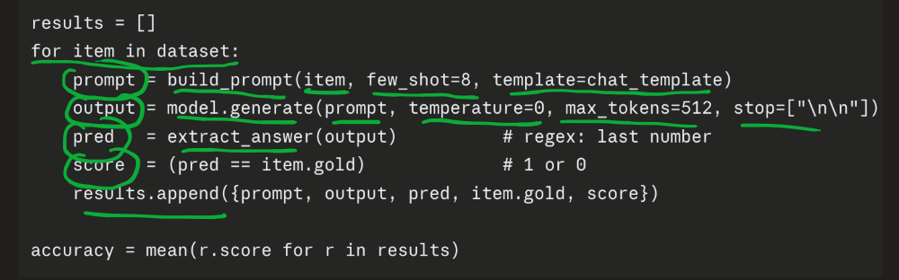
results = []

for item in dataset:
prompt = build_prompt(item, few_shot=8, template=chat_template)
output = model.generate(prompt, temperature=0, max_tokens=512, stop=["\n\n"])
pred = extract_answer(output) # regex: last number
score = (pred == item.gold) # 1 or 0
results.append({prompt, output, pred, item.gold, score})

accuracy = mean(r.score for r in results)
Need for an Eval Harness
At first, evaluation seems simple:

Take a question
Send it to the model
Check the answer
Repeat for all questions

But, you also need to handle things like:

- Extracting the final answer correctly when the model writes The answer is C, C., or Option C
- Scoring answers using the benchmark’s exact method
- Sending thousands of questions efficiently in batches
- Retrying failed API requests
- Handling rate limits

An evaluation harness is a ready-made system that already handles these details.

The harness already knows:
- Where to get the benchmark(GSM8K, MMLU etc.) questions
- How to format each question
- How to send it to the model
- How to extract the model’s answer
- How to judge whether it is correct
- How to calculate the final benchmark score

A benchmark is the exam paper.
An evaluation harness is the complete exam administration system: instructions, answer-sheet format, checking rules, and score calculation.

Tools such as lm-evaluation-harness, Inspect, and HELM act as an eval harness.

Who runs model evals?
1. Frontier labs (the model builders)

Who: OpenAI, Anthropic, Google DeepMind, Meta, Mistral, DeepSeek, Qwen — anyone shipping a model.

Why they evaluate:

- Internally, during development - This is the invisible majority of eval work. Evals guide pretraining decisions, post-training, which checkpoint to ship. Without them, model development is blind — you can't improve what you can't measure.

- Release gating - Deciding whether a model is good enough — and safe enough — to ship.

- Marketing - The benchmark table in a launch post. This is the part you see.

How to read their numbers: lab numbers are a ceiling, measured under favorable conditions. Biased in selection and configuration

2. Third-party evaluators

Who: Independent orgs whose product is the evaluation — LMArena (Chatbot Arena), Artificial Analysis, Epoch AI, Vals AI, and similar.

Why they evaluate: it's their reason for existing. They run models independently and publish comparisons. Their business model depends on being seen as neutral.

How to read their numbers:
This group is the most useful to you as an engineer, for one reason: they run every model themselves, under the same conditions.

They also measure what labs omit: cost and latency.

3. Companies and AI Engineering Teams

Labs measure general capability and third parties measure cross-model comparability. Nobody is measuring whether the model classifies your support emails correctly at a price you can afford.

Why Benchmarks can be misleading?
- Benchmark contamination
- Benchmark saturation
- Configuration gaming
- Aggregation
