Customer Churn Prediction Model
  - Sprint Report: Velocity, Burndown and Retrospectives

Detail | Value
Course | Software Engineering Mini Project, PES University
Team | Hackforge
Team members (SRN) | Akshaya B (PES1UG24AM026); Ashwin C H (PES1UG24AM900); Amar Patil (PES1UG24AM031)
Sprints covered | Sprint 1, Sprint 2, Sprint 3
Date | 30 October 2026

1. Introduction

1.1 Purpose
This report records how the team planned and delivered the project in sprints. For each sprint it gives the sprint goal, the backlog with story points, the velocity, a burndown chart, the outcome and the retrospective. A project-level velocity chart and burn-up chart summarise all sprints.

1.2 Data sources and method
Story points are taken from the GitHub issues. A story is counted as planned when its issue was created and as done when its issue was closed on GitHub (Sprints 1 and 2) or when its work was committed (Sprint 3, whose issues close when the pull requests are merged). All times are IST.
Story points use the scale 1, 2, 3, 5 and 8. Velocity is the number of story points completed in a sprint. The burndown charts plot the points still remaining after each recorded event; the dashed line shows the sprint scope (including stories added during the sprint) and the dotted line shows an ideal, even burndown of the initial scope. The data behind every chart is kept in docs/sprint-report/sprint_data.json (IST (UTC+05:30)).

2. Summary of Sprints
Sprint | Window | Stories | Planned at start | Added | Completed | Completion
Sprint 1 | 19 to 23 October 2026 | 5 | 13 | 10 | 23 | 100%
Sprint 2 | 26 to 30 October 2026 | 6 | 13 | 13 | 26 | 100%
Sprint 3 | 2 to 6 November 2026 (optional sprint, Deliverable Part 3) | 10 | 26 | 18 | 44 | 100%

2.1 Velocity
The team completed every committed story in every sprint. Velocity rose from 23 points in Sprint 1 to 26 points in Sprint 2 and 44 points in Sprint 3, an average of 31 points per sprint. The growth reflects the shared modules, automated tests and CI built in the earlier sprints, which made later stories faster to deliver safely.
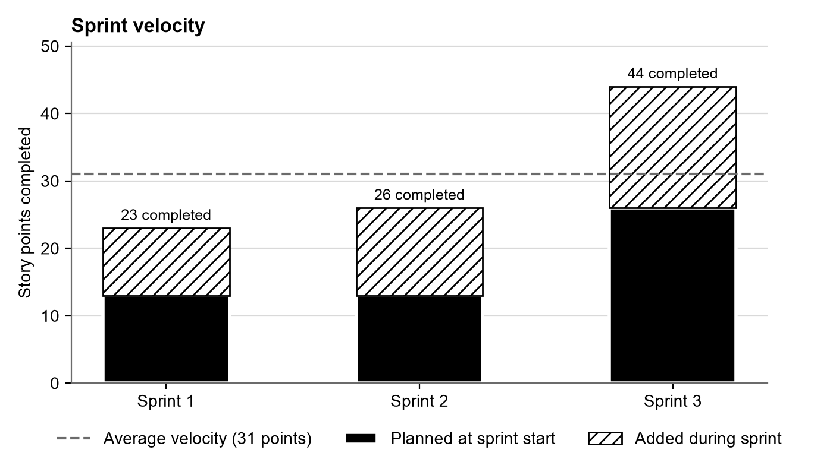
Figure 1. Story points completed per sprint

2.2 Project burn-up
The burn-up chart shows the total scope of the project growing as each sprint's stories were planned, and the completed points following it. All 93 planned points are complete.
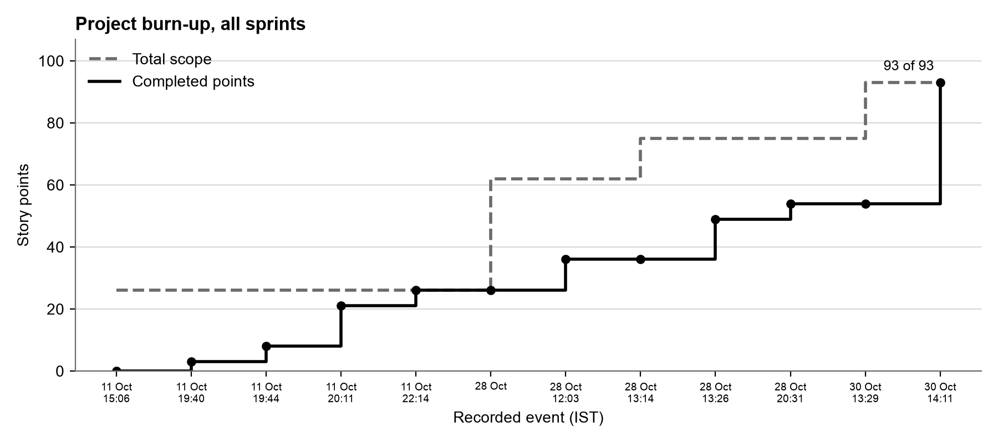
Figure 2. Project burn-up across all sprints

3. Sprint 1
Sprint window: 19 to 23 October 2026

3.1 Sprint goal
Deliver the functional core: a customer input form with sample customers, real-time XGBoost prediction with a probability visualiser, input validation, and a clear, light user interface with a risk gauge and churn drivers.

3.2 Sprint backlog
ID | Story | Points | Assignee | Planned | Done
#1 | Interactive Customer Profile Input Form with Presets | 5 | ash29032006 | 11 Oct 15:06 | 11 Oct 20:11
#2 | Real-time XGBoost Prediction Engine and Probability Visualizer | 5 | Akshayshetty742 | 11 Oct 15:09 | 11 Oct 19:44
#3 | Robust Input Validation and Boundary Guards | 3 | ash29032006 | 11 Oct 15:09 | 11 Oct 20:11
#13 | Bright Theme Redesign and One-Click Persona Preset Cards | 5 | Akshayshetty742, amarpatil2004 | 28 Oct 11:50 | 28 Oct 12:03
#14 | Real-Time Risk Gauge, Key Driver Breakdown and Boundary Feedback | 5 | Akshayshetty742, amarpatil2004 | 28 Oct 11:50 | 28 Oct 12:03
 | Total | 23

3.3 Velocity
Planned at start | Added during sprint | Total scope | Completed (velocity) | Completion
13 | 10 | 23 | 23 | 100%

3.4 Burndown
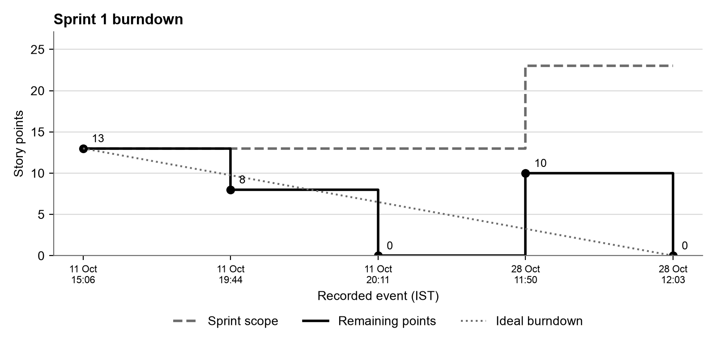
Figure 3. Sprint 1 burndown
Time (IST) | Event | Scope | Remaining
11 Oct 15:06 | Planned #1, #2, #3 (13 points) | 13 | 13
11 Oct 19:44 | Completed #2 (5 points) | 13 | 8
11 Oct 20:11 | Completed #1, #3 (8 points) | 13 | 0
28 Oct 11:50 | Planned #13, #14 (10 points) | 23 | 10
28 Oct 12:03 | Completed #13, #14 (10 points) | 23 | 0

The sprint finished with 0 of 23 points remaining. 10 points of scope were added during the sprint and completed in the same sprint.

3.5 Outcome
All five stories were completed (23 of 23 points). The product could take a customer profile, validate it, and show a churn probability, risk tier and risk drivers in real time. Pull requests #8 and #9 delivered the core stories, the interface stories were delivered in PR #18, and the 1-minute demonstration video was recorded.
Demonstration video: docs/evidence/videos/sprint1.mp4

3.6 Retrospective

What went well
- A working end-to-end product existed from the first stories, so every later story added value to something users could already try.
- The validation rules caught impossible customer profiles (for example internet add-ons without internet service) before they reached the model.
- The four sample customers made demonstrations and manual checks fast and repeatable.
- Feature branches and pull requests kept main stable, and the GitHub Projects board recorded the story points and sprint of the backlog items.

What we will do better
- Close each issue on the board as soon as its work is merged, so the burndown reflects progress day by day.
- Add a teammate review to every pull request before merging.
- Keep stories at 5 points or fewer so progress is visible in smaller steps.

Action items
- Link pull requests to the issues they close (adopted in Sprint 2, PR #18).
- Grow the automated test suite with each new feature (adopted in Sprint 2).
- Run the CI workflow on every pull request (adopted from PR #9 onwards).

4. Sprint 2
Sprint window: 26 to 30 October 2026

4.1 Sprint goal
Complete the product: model evaluation and benchmarking, an automated test suite with continuous integration, a what-if retention simulator, decision threshold tuning, and batch CSV scoring, then freeze the documentation.

4.2 Sprint backlog
ID | Story | Points | Assignee | Planned | Done
#4 | Model Performance Benchmarking and Evaluation | 5 | ash29032006 | 11 Oct 15:11 | 11 Oct 20:11
#5 | Automated Tests for Validation and Prediction Pipeline | 5 | ash29032006, Akshayshetty742 | 11 Oct 15:11 | 11 Oct 22:14
#6 | GitHub Actions CI Workflow for Automated Verification | 3 | Akshayshetty742 | 11 Oct 15:12 | 11 Oct 19:40
#15 | Interactive What-If Retention Strategy Simulator | 5 | Akshayshetty742, amarpatil2004 | 28 Oct 13:14 | 28 Oct 13:26
#16 | Decision Threshold Tuning, Confusion Matrix and Batch CSV Scoring | 5 | Akshayshetty742, amarpatil2004 | 28 Oct 13:14 | 28 Oct 13:26
#17 | Final Verification, Documentation Freeze and Release | 3 | Akshayshetty742, amarpatil2004 | 28 Oct 13:14 | 28 Oct 13:26
 | Total | 26

4.3 Velocity
Planned at start | Added during sprint | Total scope | Completed (velocity) | Completion
13 | 13 | 26 | 26 | 100%

4.4 Burndown
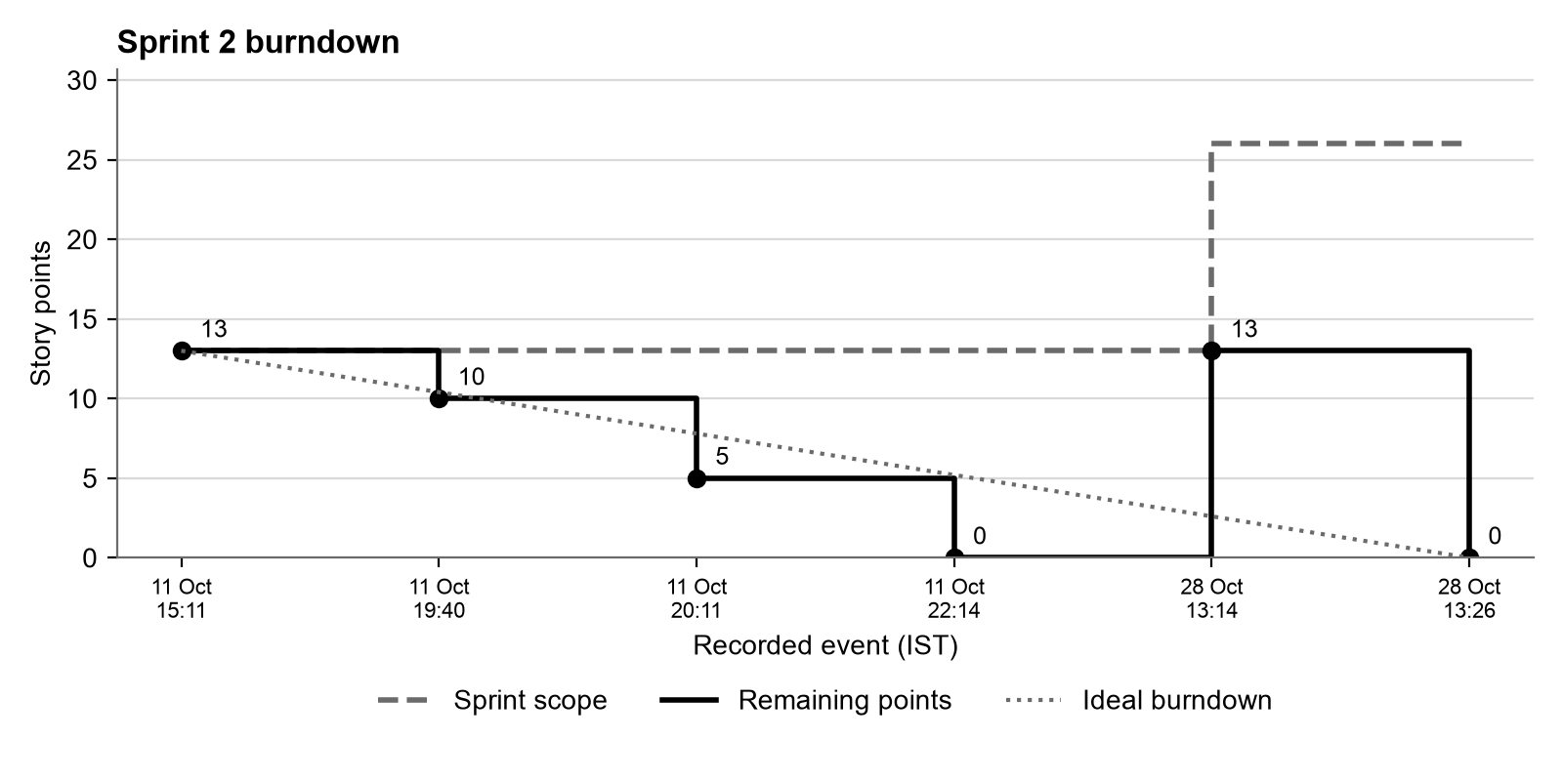
Figure 4. Sprint 2 burndown
Time (IST) | Event | Scope | Remaining
11 Oct 15:11 | Planned #4, #5, #6 (13 points) | 13 | 13
11 Oct 19:40 | Completed #6 (3 points) | 13 | 10
11 Oct 20:11 | Completed #4 (5 points) | 13 | 5
11 Oct 22:14 | Completed #5 (5 points) | 13 | 0
28 Oct 13:14 | Planned #15, #16, #17 (13 points) | 26 | 13
28 Oct 13:26 | Completed #15, #16, #17 (13 points) | 26 | 0

The sprint finished with 0 of 26 points remaining. 13 points of scope were added during the sprint and completed in the same sprint.

4.5 Outcome
All six stories were completed (26 of 26 points). The product gained live evaluation with threshold tuning, batch scoring with a downloadable outreach list, and the what-if simulator. The suite reached 98 automated tests, every CI run passed, and the 2-minute demonstration video was recorded. PR #18 closed issues #15, #16 and #17.
Demonstration video: docs/evidence/videos/sprint2.mp4

4.6 Retrospective

What went well
- The what-if simulator and batch scoring turned the model into a practical retention tool.
- All 98 automated tests passed and every CI run on GitHub was green.
- Pull request #18 was linked to the three issues it delivered, so the board closed them automatically.
- The demonstration video showed the complete product working end to end.

What we will do better
- Measure test coverage, not only the number of tests.
- The application file grew large; move shared logic into modules.
- Record the date each story is finished as it happens.

Action items
- Add statement and branch coverage reports with a minimum threshold in CI (done in Sprint 3).
- Move training logic into shared modules and add a pylint quality gate (done in Sprint 3).
- Link every automated test to a Test Plan test case (done in Sprint 3).

5. Sprint 3
Sprint window: 2 to 6 November 2026 (optional sprint, Deliverable Part 3)

5.1 Sprint goal
Compare classical, deep and quantum machine learning on the churn problem and show all three predictions in the application; make experiments reproducible with DVC and MLflow; update and automate every test case and produce the Part 3 test reports.

5.2 Sprint backlog
ID | Story | Points | Assignee | Planned | Done
S3-1 | DVC pipeline and MLflow experiment tracking | 5 | ash29032006 | 28 Oct | 28 Oct 20:31
S3-2 | Code quality refactor and pylint configuration | 3 | ash29032006 | 28 Oct | 30 Oct 14:11
S3-3 | Deep learning (DML) churn model | 5 | ash29032006 | 28 Oct | 30 Oct 14:11
S3-4 | Quantum machine learning (QML) churn model | 8 | ash29032006 | 28 Oct | 30 Oct 14:11
S3-5 | ML vs DML vs QML benchmark and side-by-side predictions | 5 | ash29032006 | 28 Oct | 30 Oct 14:11
S3-6 | Updated test cases and automation of TC-01 to TC-26 | 5 | ash29032006 | 30 Oct 13:29 | 30 Oct 14:11
S3-7 | Unit, system validation, code coverage and branch coverage reports | 3 | ash29032006 | 30 Oct 13:29 | 30 Oct 14:11
S3-8 | CI upgrade: lint, coverage gate and report artifacts | 3 | ash29032006 | 30 Oct 13:29 | 30 Oct 14:11
S3-9 | SRS, SAD and Test Plan v1.1, traceability and deviations | 5 | ash29032006 | 30 Oct 13:29 | 30 Oct 14:11
S3-10 | README, project report and repository tidy-up | 2 | ash29032006 | 30 Oct 13:29 | 30 Oct 14:11
 | Total | 44

5.3 Velocity
Planned at start | Added during sprint | Total scope | Completed (velocity) | Completion
26 | 18 | 44 | 44 | 100%

5.4 Burndown
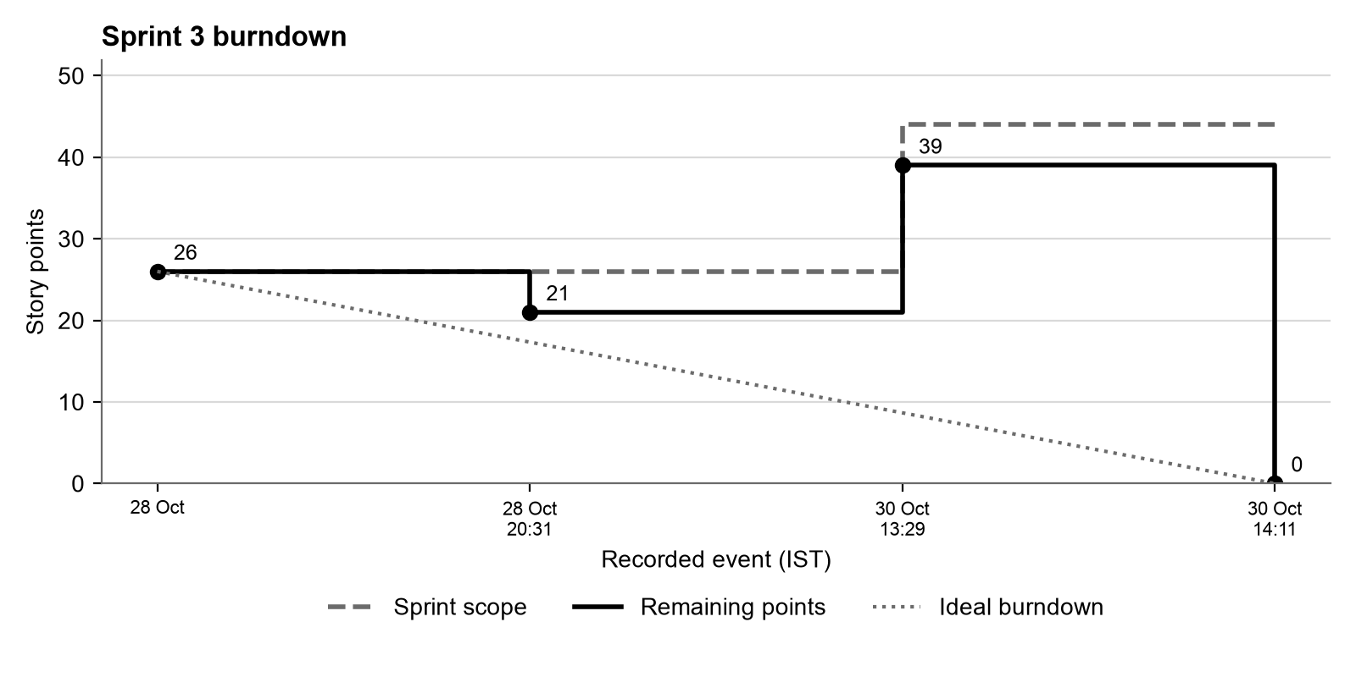
Figure 5. Sprint 3 burndown
Time (IST) | Event | Scope | Remaining
28 Oct | Planned S3-1, S3-2, S3-3, S3-4, S3-5 (26 points) | 26 | 26
28 Oct 20:31 | Completed S3-1 (5 points) | 26 | 21
30 Oct 13:29 | Planned S3-6, S3-7, S3-8, S3-9, S3-10 (18 points) | 44 | 39
30 Oct 14:11 | Completed S3-2, S3-3, S3-4, S3-5, S3-6, S3-7, S3-8, S3-9, S3-10 (39 points) | 44 | 0

The sprint finished with 0 of 44 points remaining. 18 points of scope were added during the sprint and completed in the same sprint.

5.5 Outcome
All ten stories were completed in code (44 of 44 points) ahead of the sprint window. The three paradigms reach ROC-AUC between 0.829 and 0.846 on the same test set, and the application shows all three predictions for every customer. The test suite grew to 152 tests covering all 26 test cases, with 89.1% statement coverage, 79.4% branch coverage and a pylint score of 9.82/10.

5.6 Retrospective

What went well
- Training every paradigm on the identical split made the comparison fair and easy to explain.
- Writing the deep and quantum models with the scikit-learn interface let one evaluation and logging path serve all three paradigms.
- Running the full training pipeline inside the tests, in a temporary folder, verified it end to end without risking the production model.
- The test reports are generated by one command from a real run, so they always match the code.

What we will do better
- Open review requests early so the repository owner has time to review each pull request.
- Split the application into page modules as it keeps growing.
- Add a shared DVC remote so every teammate can pull the same data and models.

Action items
- Review and merge the three Sprint 3 pull requests in order (models, testing, documentation).
- Use the test reports as the regression baseline during the 2 to 6 November testing week.
- Carry the application refactor into future work.

6. Retrospective Follow-through
Each retrospective produced action items. The table shows how they were carried forward.
Raised in | Action | Status
Sprint 1 | Link pull requests to the issues they close. | Adopted in Sprint 2, PR #18
Sprint 1 | Grow the automated test suite with each new feature. | Adopted in Sprint 2
Sprint 1 | Run the CI workflow on every pull request. | Adopted from PR #9 onwards
Sprint 2 | Add statement and branch coverage reports with a minimum threshold in CI. | Done in Sprint 3
Sprint 2 | Move training logic into shared modules and add a pylint quality gate. | Done in Sprint 3
Sprint 2 | Link every automated test to a Test Plan test case. | Done in Sprint 3
Sprint 3 | Review and merge the three Sprint 3 pull requests in order (models, testing, documentation). | Planned for the next sprint
Sprint 3 | Use the test reports as the regression baseline during the 2 to 6 November testing week. | Planned for the next sprint
Sprint 3 | Carry the application refactor into future work. | Planned for the next sprint

7. Conclusion
Across 3 sprints the team completed 21 stories and 93 story points, with every sprint reaching 100% of its scope. Velocity increased in each sprint, and the action items from the Sprint 1 and Sprint 2 retrospectives were carried out in the sprint that followed. The result is a tested, documented churn prediction system that compares classical, deep and quantum machine learning side by side.

