**13.20 How do you locate lines beginning and ending with a dot using:**

**a) grep, b) sed**

Solution: Let us Consider a file with the below content:

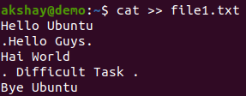

File1.txt contains this much of data as mentioned below:

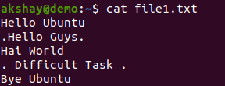

1. Grep

Grep will use the regular expression ^\..*\.$ , which matches the start of line ^ followed by a dot \. Zero or more characters .* followed by a dot before the end of the line $

Output:



1. Sed

Sed also uses the regular expression but, in sed you need to put them between the slashes in //p using -n option

For the above same data but applying/using the concept of sed

output:

