**Assignment-2**

**Akshay Kumar Reddy G.**

**Class Id: 11 (16231179).**

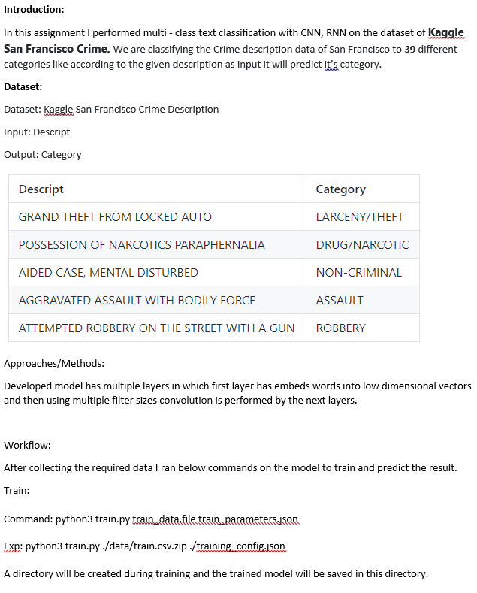

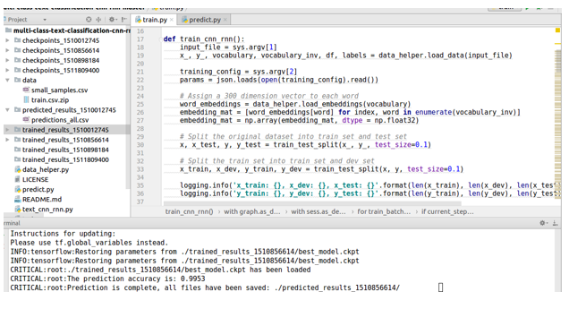Predict: To predict the results provide the model directory which generated while running train.py and new data to predict.

Command: python3 predict.py ./trained_results_directory/ new_data.file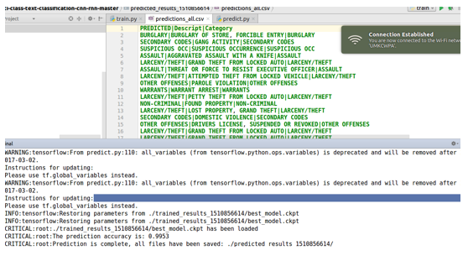

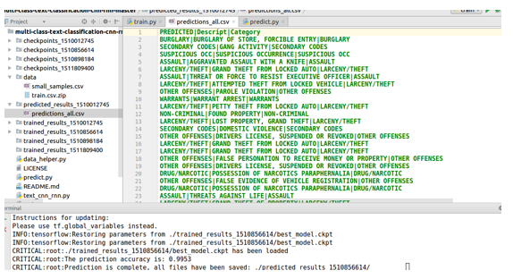

Here based on the description i.e. type of crime committed it is classified into different categories.

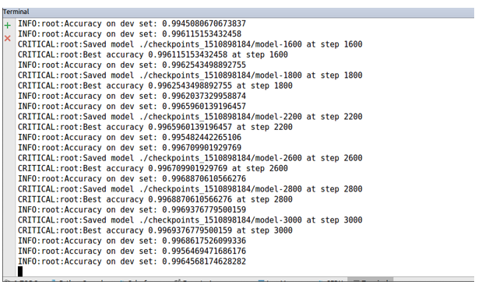

Source: **https://github.com/jiegzhan/multi-class-text-classification-cnn-rnn**