**Word frequency code:**

**with** open(**'test'**) **as** t: *#opening a file named test which has data* data = t.read()  
t.closed  
print(data)  
data_string= data.replace(**'('**,**''**).replace(**')'**,**''**).replace(**'.'**,**''**).replace(**'"'**,**''**).replace(**','**,**''**).replace(**"'"**,**''**)  
*#from above step all the mentioned special characters will be replaced with space*f=data_string.lower().split()  
*#here data(string) will be converted to lowercase and splitted into words*print(f)  
wordcount={}  
**for** w **in** f:  
 **if** w **not in** wordcount:  
 wordcount[w] = 1  
 **else**:  
 wordcount[w] += 1  
*#words which occur for first time will be counted as 1 and if they repeat their count is increased by 1.*print(wordcount)

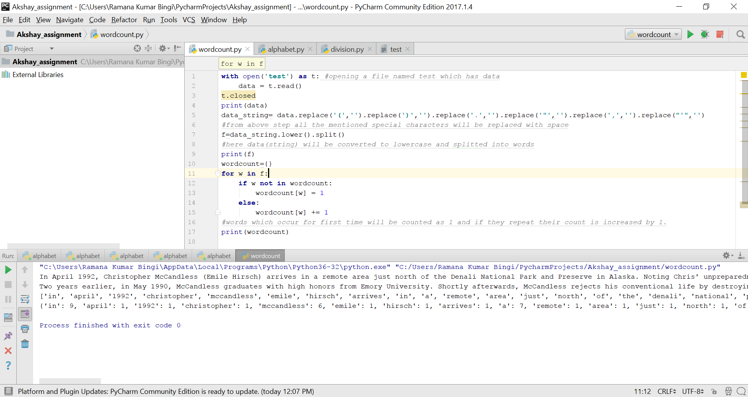

**Check for letters of alphabet:**

**import** string  
input_string=input(**'Enter the string'**)  
f= set(input_string.lower()) *#input string is converted to set of individual lowercase characters*print(f)  
alphabet=set(string.ascii_lowercase) *#letters of alphabets are stored in set***if** f >= alphabet: *#input string is compared with the set of letters of alphabets* print(**'given string has all letters of alphabet'**)  
**else**:  
 print(**"string doesn't contains all letters of alphabet"**)

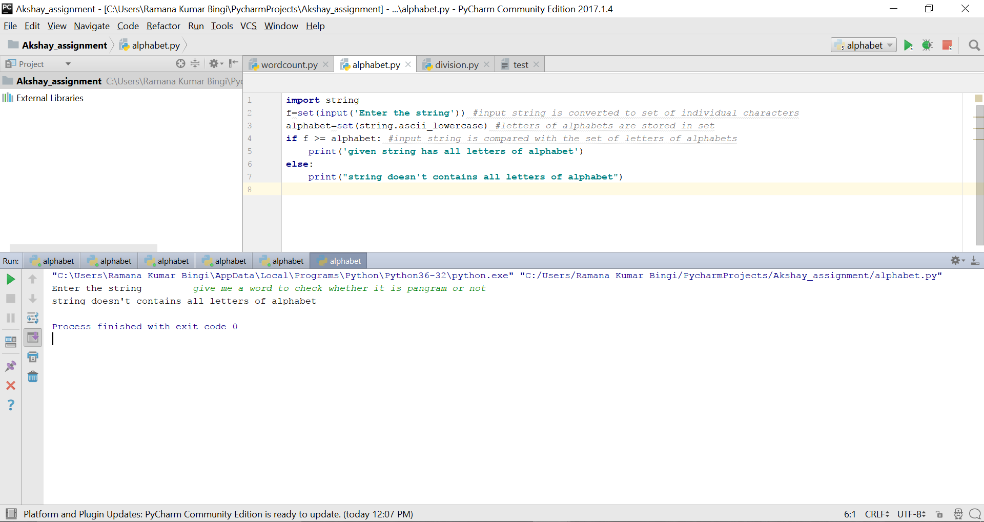

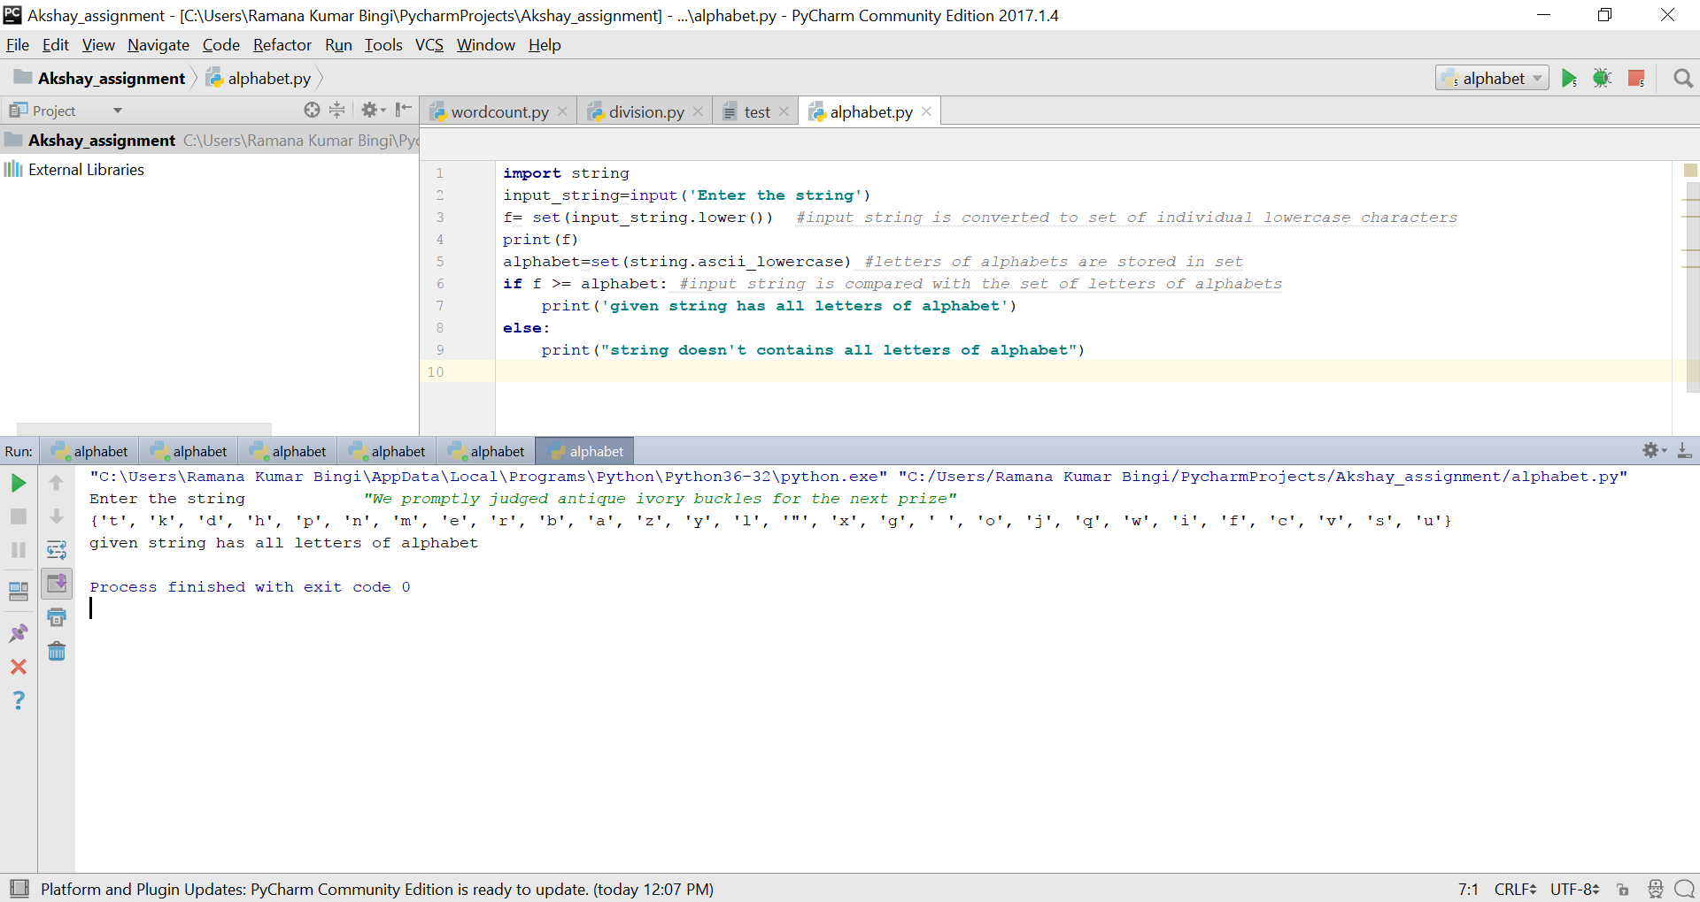

**Numbers divisible by 5,2 b/w 700 to 1700**

x = 700  
*#numbers which are divisile by 5 and which are multiples of 2 will be the multiples of 10.***while** x <= 1700:  
 **if** (x % 5 == 0 **and** x % 2 == 0):  
 print(x)  
 x += 1

