Activity_main =>
<?xml version="1.0" encoding="utf-8"?>
<androidx.constraintlayout.widget.ConstraintLayout
xmlns:android="http://schemas.android.com/apk/res/android"
xmlns:app="http://schemas.android.com/apk/res-auto"
android:layout_width="match_parent"
android:layout_height="match_parent"
android:padding="20dp">
<EditText
android:id="@+id/etRoll"
android:layout_width="0dp"
android:layout_height="wrap_content"
android:hint="Enter Roll Number"
android:inputType="number"
app:layout_constraintTop_toTopOf="parent"
app:layout_constraintStart_toStartOf="parent"
app:layout_constraintEnd_toEndOf="parent"/>
<EditText
android:id="@+id/etName"
android:layout_width="0dp"
android:layout_height="wrap_content"
android:hint="Enter Student Name"
app:layout_constraintTop_toBottomOf="@id/etRoll"
app:layout_constraintStart_toStartOf="parent"
app:layout_constraintEnd_toEndOf="parent"
android:layout_marginTop="16dp"/>
<EditText
android:id="@+id/etMarks"
android:layout_width="0dp"
android:layout_height="wrap_content"
android:hint="Enter Marks"
android:inputType="number"
app:layout_constraintTop_toBottomOf="@id/etName"
app:layout_constraintStart_toStartOf="parent"
app:layout_constraintEnd_toEndOf="parent"
android:layout_marginTop="16dp"/>
<com.google.android.material.floatingactionbutton.FloatingActionButton
android:id="@+id/fabAdd"
android:layout_width="wrap_content"
android:layout_height="wrap_content"
android:layout_margin="16dp"
android:layout_marginStart="32dp"
android:layout_marginBottom="16dp"
android:contentDescription="Add"
android:src="@android:drawable/ic_input_add"
app:layout_constraintBottom_toBottomOf="parent"
app:layout_constraintStart_toStartOf="parent" />
<com.google.android.material.floatingactionbutton.FloatingActionButton
android:id="@+id/fabRead"
android:layout_width="wrap_content"
android:layout_height="wrap_content"
android:contentDescription="Read"
android:src="@android:drawable/ic_menu_search"
app:layout_constraintBottom_toBottomOf="parent"
app:layout_constraintStart_toEndOf="@id/fabAdd"
android:layout_margin="16dp"/>
<com.google.android.material.floatingactionbutton.FloatingActionButton
android:id="@+id/fabEdit"
android:layout_width="wrap_content"
android:layout_height="wrap_content"
android:contentDescription="Update"
android:src="@android:drawable/ic_menu_edit"
app:layout_constraintBottom_toBottomOf="parent"
app:layout_constraintStart_toEndOf="@id/fabRead"
android:layout_margin="16dp"/>
<com.google.android.material.floatingactionbutton.FloatingActionButton
android:id="@+id/fabDelete"
android:layout_width="wrap_content"
android:layout_height="wrap_content"
android:layout_margin="16dp"
android:layout_marginStart="112dp"
android:layout_marginBottom="24dp"
android:contentDescription="Delete"
android:src="@android:drawable/ic_menu_delete"
app:layout_constraintBottom_toBottomOf="parent"
app:layout_constraintStart_toEndOf="@id/fabEdit" />
</androidx.constraintlayout.widget.ConstraintLayout>

Student.kt =>
package com.example.ca1
data class Student(
var roll: Int? = null,
var name: String? = null,
var marks: String? = null
)

MainActivity.kt =>
package com.example.ca1
import android.os.Bundle
import android.widget.EditText
import android.widget.Toast
import androidx.activity.enableEdgeToEdge
import androidx.appcompat.app.AppCompatActivity
import com.google.android.material.floatingactionbutton.FloatingActionButton
import com.google.firebase.database.DatabaseReference
import com.google.firebase.database.FirebaseDatabase
class MainActivity : AppCompatActivity() {
private lateinit var etRoll: EditText
private lateinit var etName: EditText
private lateinit var etMarks: EditText
private lateinit var btnRead: FloatingActionButton
private lateinit var btnAdd: FloatingActionButton
private lateinit var btnEdit: FloatingActionButton
private lateinit var btnDelete: FloatingActionButton
private lateinit var database: DatabaseReference
override fun onCreate(savedInstanceState: Bundle?) {
super.onCreate(savedInstanceState)
enableEdgeToEdge()
setContentView(R.layout.activity_main)
etRoll = findViewById(R.id.etRoll)
etName = findViewById(R.id.etName)
etMarks = findViewById(R.id.etMarks)
btnAdd = findViewById(R.id.fabAdd)
btnRead = findViewById(R.id.fabRead)
btnEdit = findViewById(R.id.fabEdit)
btnDelete = findViewById(R.id.fabDelete)
database = FirebaseDatabase.getInstance().getReference("Students")
btnAdd.setOnClickListener {
val roll = etRoll.text.toString().toIntOrNull()
val name = etName.text.toString()
val marks = etMarks.text.toString()
if (roll != null && name.isNotEmpty() && marks.isNotEmpty()) {
val student = Student(roll, name, marks)
database.child(roll.toString()).setValue(student)
.addOnSuccessListener {
Toast.makeText(this, "Student Added", Toast.LENGTH_SHORT).show()
}
.addOnFailureListener {
Toast.makeText(this, "Error: ${it.message}", Toast.LENGTH_SHORT).show()
}
} else {
Toast.makeText(this, "Fill all fields", Toast.LENGTH_SHORT).show()
}
}
btnRead.setOnClickListener {
val roll = etRoll.text.toString()
if (roll.isNotEmpty()) {
database.child(roll).get()
.addOnSuccessListener {
if (it.exists()) {
val name = it.child("name").value
val marks = it.child("marks").value
etName.setText(name.toString())
etMarks.setText(marks.toString())
Toast.makeText(this, "Student Found", Toast.LENGTH_SHORT).show()
} else {
Toast.makeText(this, "Student Not Found", Toast.LENGTH_SHORT).show()
}
}
} else {
Toast.makeText(this, "Enter Roll No", Toast.LENGTH_SHORT).show()
}
}
btnEdit.setOnClickListener {
val roll = etRoll.text.toString()
val name = etName.text.toString()
val marks = etMarks.text.toString()
if (roll.isNotEmpty() && name.isNotEmpty() && marks.isNotEmpty()) {
val student = Student(roll.toInt(), name, marks)
database.child(roll).setValue(student)
.addOnSuccessListener {
Toast.makeText(this, "Student Updated", Toast.LENGTH_SHORT).show()
}
.addOnFailureListener {
Toast.makeText(this, "Error: ${it.message}", Toast.LENGTH_SHORT).show()
}
} else {
Toast.makeText(this, "Fill all fields", Toast.LENGTH_SHORT).show()
}
}
btnDelete.setOnClickListener {
val roll = etRoll.text.toString()
if (roll.isNotEmpty()) {
database.child(roll).removeValue()
.addOnSuccessListener {
Toast.makeText(this, "Student Deleted", Toast.LENGTH_SHORT).show()
etRoll.text.clear()
etName.text.clear()
etMarks.text.clear()
}
.addOnFailureListener {
Toast.makeText(this, "Error: ${it.message}", Toast.LENGTH_SHORT).show()
}
} else {
Toast.makeText(this, "Enter Roll No", Toast.LENGTH_SHORT).show()
}
}
}
}

Firebase =>
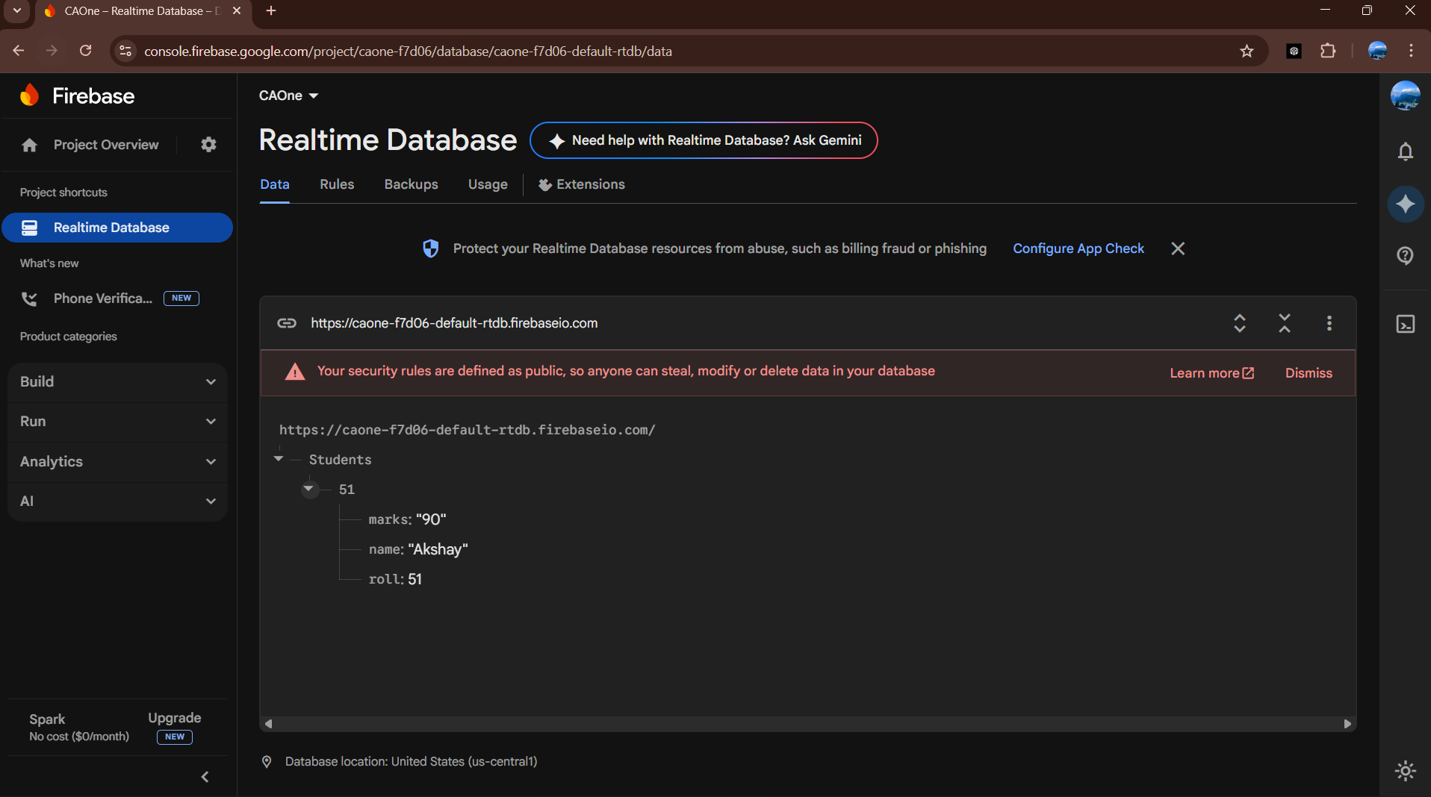

Output =>
