Motorised Door Latch and Catch: Parts List and Description
  - RFID-controlled glass door lock, parts, measurements and function

1. Overview
This document lists every part in the Blender file Door_latch_assembled.blend, with its size and position. The lock is mounted on the inside face of a glass door. The servo drives a gear, which turns an eccentric cam on the spindle. The cam pushes a bolt out of a latch housing and into a catch on the opposite pane. A return spring pulls the bolt back. Nothing is drilled into the glass.
All measurements are in millimetres. Positions are the minimum corner of each part's bounding box (X, Y, Z), where X is across the door, Y is out from the glass, and Z is vertical. The glass face is at Y = -5 mm. The sizes are model estimates taken from the Blender file, and they should be checked against the real parts before printing.

2. Parts list
Part | Size (X x Y x Z) mm | Position (min X, Y, Z) mm
Latch Body | 60.0 x 14.5 x 43.6 | 4.1, -19.5, -76.4
Latch Cover | 60.0 x 15.0 x 43.6 | 4.1, -34.5, -76.4
Mechanism 1 | 32.5 x 10.6 x 57.3 | -3.1, -45.1, -83.2
Catch body | 60.0 x 13.1 x 17.9 | -64.1, -18.1, -63.5
Catch cover | 60.0 x 15.1 x 18.0 | -64.1, -33.1, -63.6
BOLT | 25.0 x 8.0 x 16.0 | -6.0, -16.3, -62.5
CAM (eccentric) | 18.0 x 8.0 x 18.0 | 19.0, -17.0, -69.5
DRIVE_SPINDLE | 8.0 x 62.0 x 8.0 | 30.0, -68.0, -64.5
SPINDLE_GEAR | 42.0 x 4.0 x 42.0 | 13.0, -52.0, -81.5
SERVO_GEAR | 82.0 x 4.0 x 82.0 | 53.0, -52.0, -101.5
SERVO_BODY | 40.0 x 43.0 x 20.0 | 74.0, -48.0, -70.5
Glass Left (reference) | 197.0 x 10.0 x 300.0 | -200.0, -5.0, -150.0
Glass Right (reference) | 197.0 x 10.0 x 300.0 | 3.0, -5.0, -150.0

3. Description of each part

Latch Body
The main housing of the latch. It is mounted flat against the inside glass face. It contains the channel for the bolt and the pocket for the cam. The bolt slides out of this housing toward the catch.

Latch Cover
The cover on the outer face of the latch housing, sitting against the latch body. Its exact fixing method is not defined in the model.

Mechanism 1
A part from the original 3MF design, placed behind the latch cover. Its exact role in the mechanism is not defined in the model and should be confirmed against the original design.

Catch body
The receiving part on the opposite glass pane. It has a pocket that the bolt tip enters when the door is locked. The catch is 18 mm tall, so the bolt can sit fully inside it.

Catch cover
The outer cover of the catch. It closes the catch pocket on the outer face.

BOLT
The sliding bolt. It is 25 mm long and 8 x 16 mm in section. When locked, its tip sits about 6 mm past the latch face into the catch pocket. The cam pushes its right-hand end to move it. A return spring pulls it back.

CAM (eccentric)
A disc of 9 mm radius on the spindle, with its centre 6 mm off the spindle axis. As the spindle turns 180 degrees, the cam pushes the bolt through a 12 mm stroke, which clears the catch when unlocked.

DRIVE_SPINDLE
The 8 mm shaft that runs from the spindle gear through the latch housing. It carries the cam and the spindle gear, and it turns about an axis perpendicular to the door.

SPINDLE_GEAR
A 20-tooth gear, 42 mm across, fixed to the spindle. It meshes with the servo gear. The 2:1 ratio means the spindle turns 180 degrees for each 90 degrees of servo movement.

SERVO_GEAR
A 40-tooth gear, 82 mm across, fixed to the servo horn. The servo turns this gear, and it drives the spindle gear. It sits outboard of the servo body in the same plane as the spindle gear.

SERVO_BODY
The servo motor, sized like an MG995 (40 x 43 x 20 mm). It rests against the inside glass face and is held by a clamp or adhesive pad, so no holes are drilled in the glass.

Glass Left and Right (reference)
These are not part of the lock. They are reference panes showing the glass doors, so the lock can be placed correctly against them.

4. Mechanism operation
1. The ESP32 signals the servo to turn 90 degrees.
2. The servo gear turns the spindle gear through 180 degrees (2:1 ratio).
3. The eccentric cam on the spindle moves the bolt 12 mm out of the catch, so the door can open.
4. When the servo returns to 0 degrees, the return spring pulls the bolt back into the catch, and the door locks.
The control electronics are fitted separately and are not described in this document.

5. Pictures from the Blender file
Wide view of the lock on the glass, with the catch on the left and the latch housing and gears on the right:
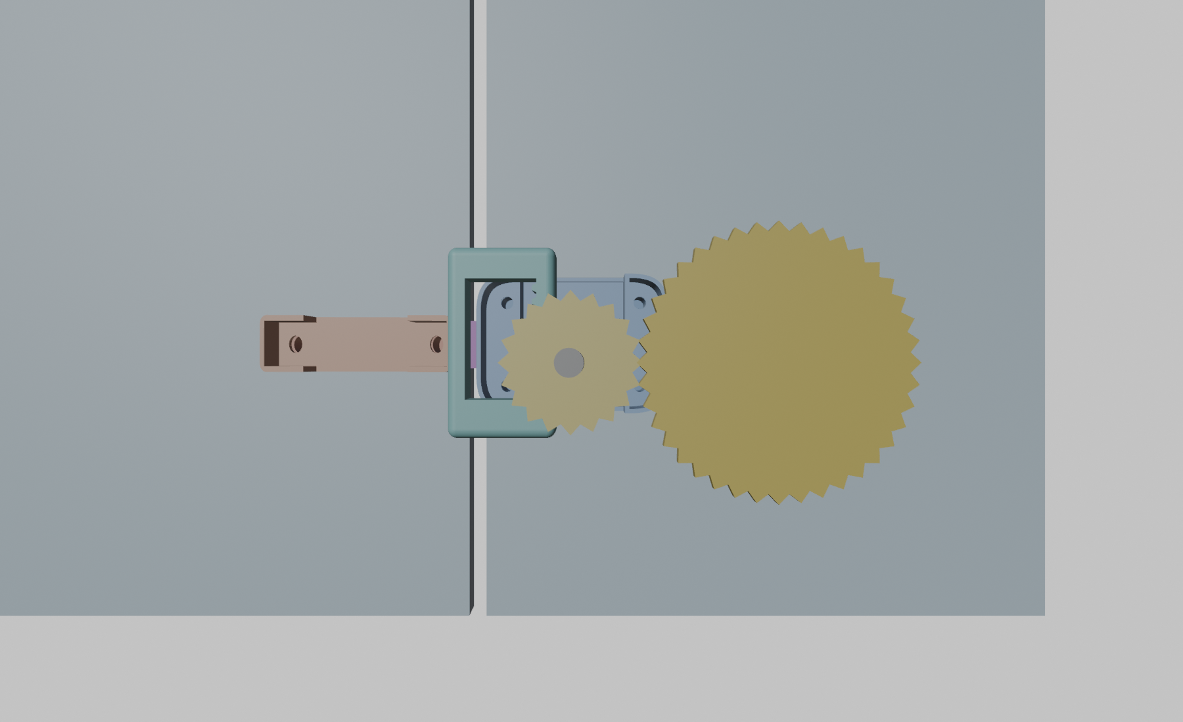

Close view of the gears and latch housing:
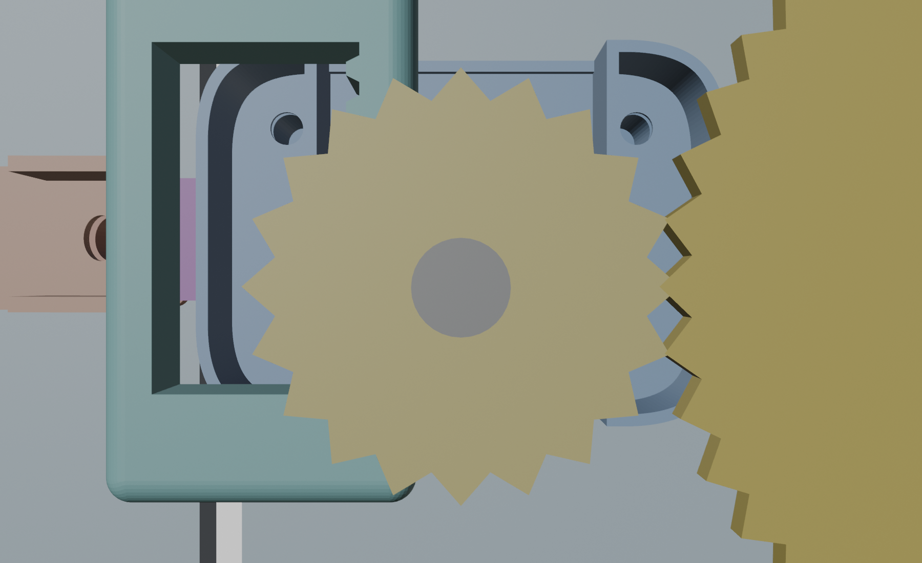

6. Verification status
A two-dimensional rigid-body simulation of the cam mechanism passed in all seven test cases. The cases varied friction (0.1 to 0.4), return spring stiffness (150 to 600 N/m), servo speed and servo torque (down to 0.6 N·m). In each case the bolt retracted at least 4 mm past the catch face and returned to within 1 mm of its locked position.
The simulation is not a full three-dimensional test. Gear backlash, printing tolerances, the real return spring, and the glass mounting have not been tested. The first hardware test should use slow, ramped servo moves.

