Game Design Document
Fill up the following document

- Write the title of your project.
Journey to Castle

- What is the goal of the game?
Goal of the game is to reach the castle and free the princess.

- Write a brief story of your game.
A prince and princess happily lived in their kingdom.
And one faithful day kingdom was attacked by a dragon .
The dragon took away the princess to a distant old castle and locked
her inside it. Now its upto the prince to find the princess and defeat
several monsters in his way.

- Which are the playing characters of this game?
- Playing characters are the ones who respond to the user based on the input from the user.
- Cars, monkeys, dinos, wizards, etc., are the playing characters in the game.

Number | Character Name | What can this character do?
1 | Prince | Move,jump
2 | bullets | Move right
3
4
5
6
7
8

5. Which are the Non-Playing Characters of this game?
- Non-Playing characters are the ones that don't have an action or behavior when the user interacts with the game.
- Hurdles, stones, bananas, coins, etc., are non-playing characters in the game.

Number | Character Name | What can this character do?
1 | monster | Move left
2 | Axe king | Throw axes at player
3 | dragon | Shoot fireballs
4 | princess | goal
5
6
7
8

Draw your imagination of this game. What does this game look like?
- Draw the game either on your computer or on paper.
- Add images of the game scenes to show each of the playing and non-playing characters at least once.

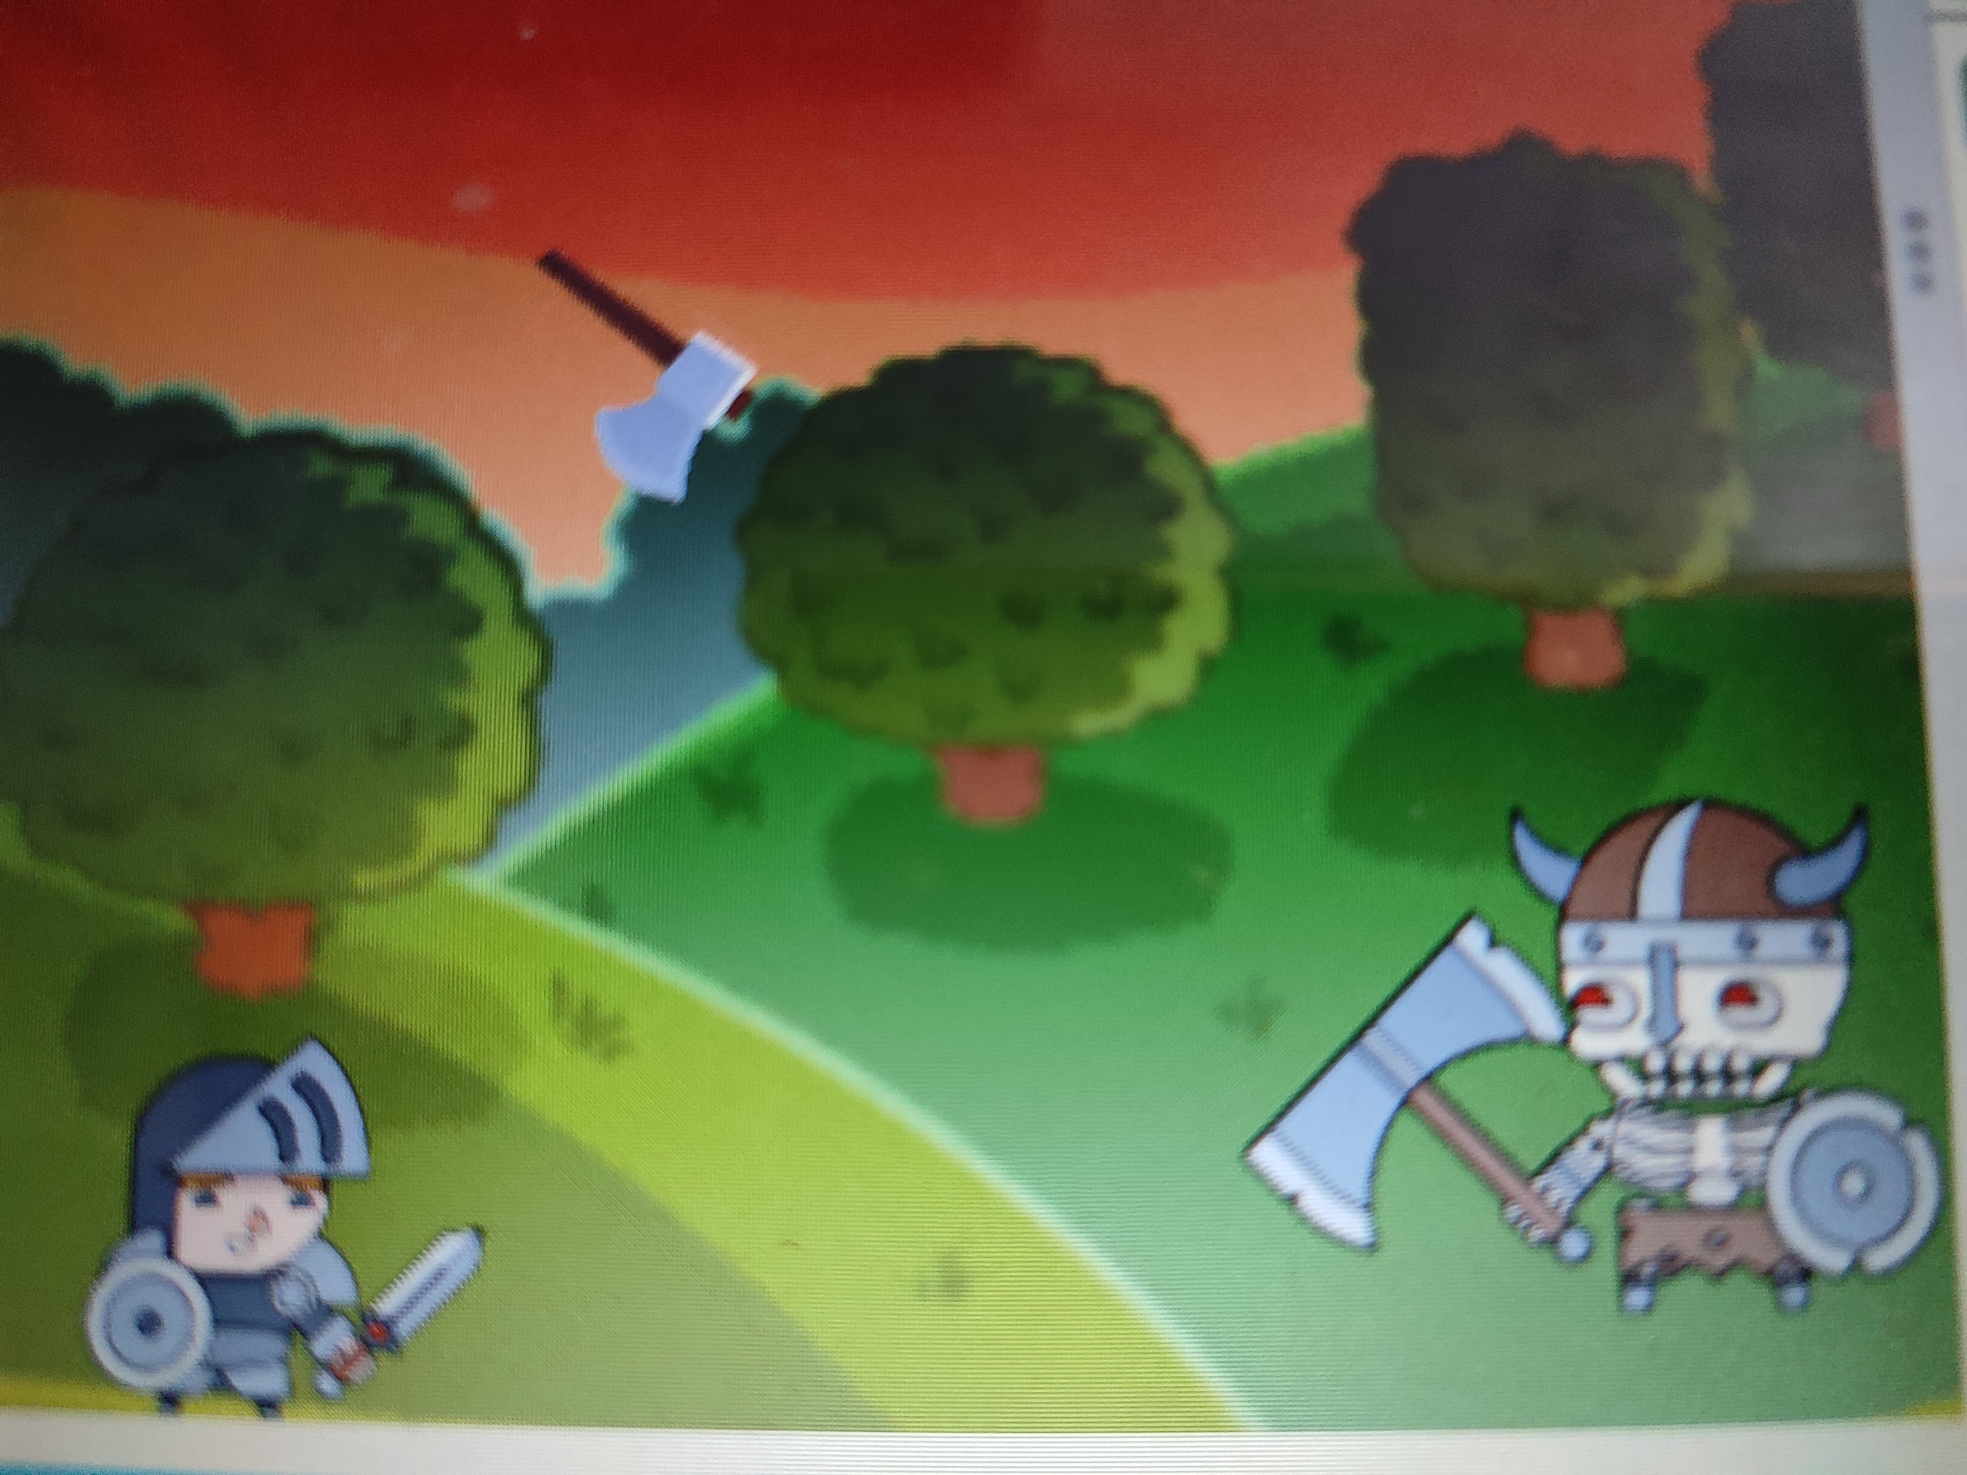

How do you plan to make your game engaging?
As the player will defeat monsters, the speed and power of monsters will increase.

