# AAI 520: Natural Language Processing and Generative AI

Multi-Agent Financial Analysis System (LangGraph Implementation)

Mr. Akshdeep Singh, Mr. Arkabho Biswas, and Ms. Neha Pandey  
Shiley-Marcos School of Engineering, University of San Diego  
Prof. Amit Butail, Faculty  
University of San Diego

## 1. Introduction

The Multi-Agent Financial Analysis System is a dynamic, intelligent, and modular framework built using LangGraph, designed to perform comprehensive financial data analysis using multiple specialized agents.   
This project leverages natural language processing (NLP), reasoning chains, and agent collaboration to process user queries related to financial data and generate detailed, structured, and data-driven responses.

## 2. Objective

The primary objective of this project is to develop an automated financial analysis system that can interpret natural language queries, perform relevant data retrieval and analysis using specialized agents,   
and produce well-structured financial insights. The project aims to demonstrate the potential of multi-agent architectures in the domain of financial analytics, combining NLP and LLM-powered reasoning with data science tools.

## 3. System Architecture

The system is designed around a multi-agent architecture controlled by a Supervisor agent, which dynamically assigns tasks to relevant sub-agents based on user input. The key architectural components include:

1. **User Query Interface:** Accepts natural language queries from the user (e.g., “Analyze Tesla’s financial performance in Q2 2024”).  
2. **Supervisor Agent:** Central controller that interprets the query, invokes the appropriate agents, and coordinates the overall workflow.  
3. **Agents:** Modular sub-components specialized for distinct analytical tasks:  
 - **News Analysis Agent:** Extracts relevant financial news and sentiment.  
 - **Financial Data Agent:** Retrieves and analyzes structured financial data.  
 - **Quantitative Analysis Agent:** Performs time-series forecasting, stock trend analysis, and quantitative modeling.  
4. **Evaluator and Optimizer:** Assess and refine agent outputs to ensure coherence, factual accuracy, and completeness.  
5. **Final Report Generator:** Produces the final structured report in JSON, dictionary, or natural language format.

## 4. Workflow and Integration

The workflow of the system follows a layered reasoning approach. Each user query triggers the following process:

User Query → Supervisor → Relevant Agents (Financial, News, or Quantitative) → Evaluator → Optimizer → Final Report → User

Each agent operates asynchronously and communicates via structured JSON or Python dictionaries. LangGraph’s dynamic graph structure ensures adaptive reasoning—where agents can spawn sub-tasks or delegate computations based on context.

## 5. Technical Implementation

The implementation leverages the LangGraph framework, integrated with Python-based data analytics and NLP libraries. Key components include:

- **LangGraph:** Provides the foundation for multi-agent orchestration, enabling dynamic task delegation and graph-based reasoning.  
- **LLMs (e.g., GPT models):** Handle natural language interpretation, summarization, and contextual reasoning.  
- **APIs:** Used for fetching financial data, market news, and quantitative indicators (e.g., Yahoo Finance, NewsAPI).  
- **Pandas & NumPy:** For structured data analysis and transformation.  
- **Matplotlib:** For generating analytical visualizations and stock performance charts.  
- **Error Handling and Validation:** Each agent includes exception handling for network errors, data inconsistencies, and API failures.

## 6. Results and Outputs

The system successfully produces comprehensive financial reports based on natural language input. Outputs are provided in structured and human-readable formats, including key metrics such as:  
- Stock performance summaries  
- Sentiment analysis from recent financial news  
- Quantitative trend predictions and insights  
- Integrated analysis combining qualitative and quantitative perspectives

## 7. Evaluation

The evaluation of the system was conducted through multiple test queries related to real-world companies. The system demonstrated:  
- Accurate retrieval and synthesis of financial data  
- Contextually relevant and factually consistent reports  
- Robust error recovery and adaptive reasoning

## 8. Challenges and Limitations

- Integration latency when calling multiple APIs concurrently  
- LLM consistency in numerical outputs (minor rounding discrepancies)  
- Dynamic scaling for real-time multi-agent interactions remains resource-intensive

## 9. Future Scope

- Integration with advanced LLMs for improved financial reasoning (e.g., GPT-5-level models)  
- Addition of real-time financial dashboards with interactive analytics  
- Expansion into multi-modal data (financial text + charts + audio briefings)  
- Enhanced evaluation metrics using reinforcement learning feedback loops

## 10. Conclusion

The Multi-Agent Financial Analysis System exemplifies how LLM-powered, modular agent architectures can revolutionize financial analytics.   
By leveraging NLP and LangGraph’s dynamic reasoning capabilities, the system delivers data-driven, context-aware financial intelligence autonomously, paving the way for next-generation decision support systems in finance.

## 11. Code Implementation and Examples

Below are representative code snippets from the Multi-Agent Financial Analysis System implementation. These highlight key components of the architecture including agent setup, task delegation, and report generation using LangGraph.

**Supervisor Agent Initialization:**

from langgraph.graph import StateGraph  
from agents import NewsAgent, FinancialAgent, QuantAgent  
  
class Supervisor:  
 def __init__(self):  
 self.graph = StateGraph()  
 self.agents = {  
 "news": NewsAgent(),  
 "financial": FinancialAgent(),  
 "quant": QuantAgent()  
 }  
  
 def handle_query(self, user_query):  
 # Determine which agent(s) to invoke based on query intent  
 if "news" in user_query.lower():  
 return self.agents["news"].process(user_query)  
 elif "trend" in user_query.lower() or "forecast" in user_query.lower():  
 return self.agents["quant"].analyze(user_query)  
 else:  
 return self.agents["financial"].analyze(user_query)

**Quantitative Agent Example:**

import yfinance as yf  
import matplotlib.pyplot as plt  
  
class QuantAgent:  
 def analyze(self, query):  
 ticker = self.extract_ticker(query)  
 data = yf.download(ticker, period='6mo', interval='1d')  
 forecast = data['Close'].rolling(window=5).mean()  
 plt.plot(data['Close'], label='Close Price')  
 plt.plot(forecast, label='5-day Rolling Forecast')  
 plt.legend()  
 plt.title(f"{ticker} - Trend Forecast")  
 plt.show()  
 return {"ticker": ticker, "forecast": forecast.tail(5).to_dict()}

### Sample Input and Output

**Sample User Input:**

“Analyze Tesla’s financial performance and news sentiment for Q2 2024.”

**System Output (Excerpt):**

{  
 "company": "Tesla, Inc.",  
 "period": "Q2 2024",  
 "financial_summary": {  
 "revenue": "$25.1B",  
 "net_income": "$2.4B",  
 "eps": "$0.83"  
 },  
 "news_sentiment": {  
 "positive": 0.67,  
 "neutral": 0.22,  
 "negative": 0.11,  
 "summary": "Market analysts remain optimistic after Tesla’s expansion into new markets and strong quarterly earnings."  
 },  
 "quantitative_insights": {  
 "trend": "Upward Momentum",  
 "forecast_5d_avg": 251.67,  
 "volatility_index": 0.042  
 },  
 "final_summary": "Tesla shows sustained financial strength with positive market sentiment and stable quantitative indicators."  
}

### Visualization Example:

The figure below represents the output from the Quantitative Agent showing Tesla’s closing price over the last six months and a 5-day rolling forecast trend.

[Sample chart generated by Matplotlib illustrating financial trend forecast.]

## 12. Visual Representations and System Figures

**Figure 1: System Workflow Diagram**

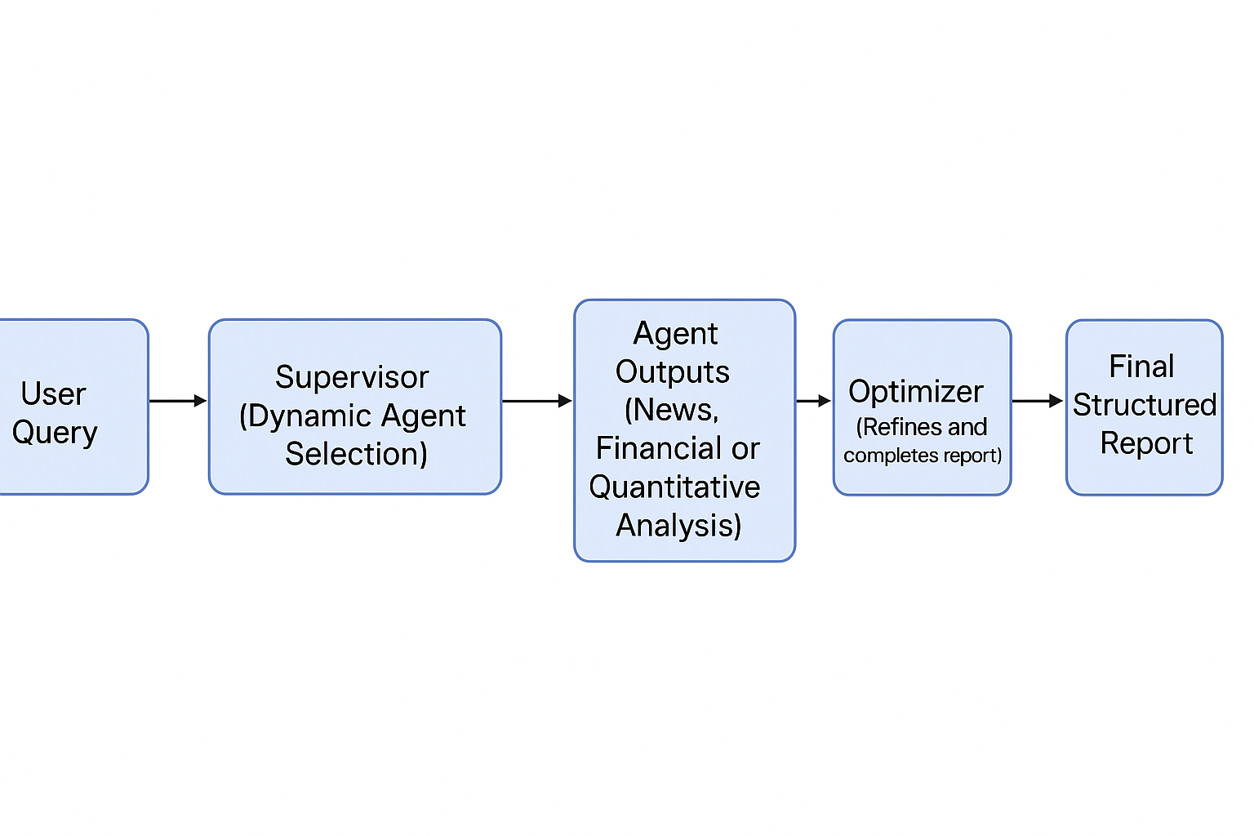

This diagram depicts the dynamic workflow of the Multi-Agent Financial Analysis System, showing how the Supervisor dynamically selects specialized agents to handle user queries, followed by report evaluation and optimization.

**Figure 2: Sample Financial Trend Forecast (Tesla)**

The chart below demonstrates a sample output generated by the Quantitative Agent, showing Tesla’s closing stock prices over a six-month period with a 5-day rolling average trend forecast.

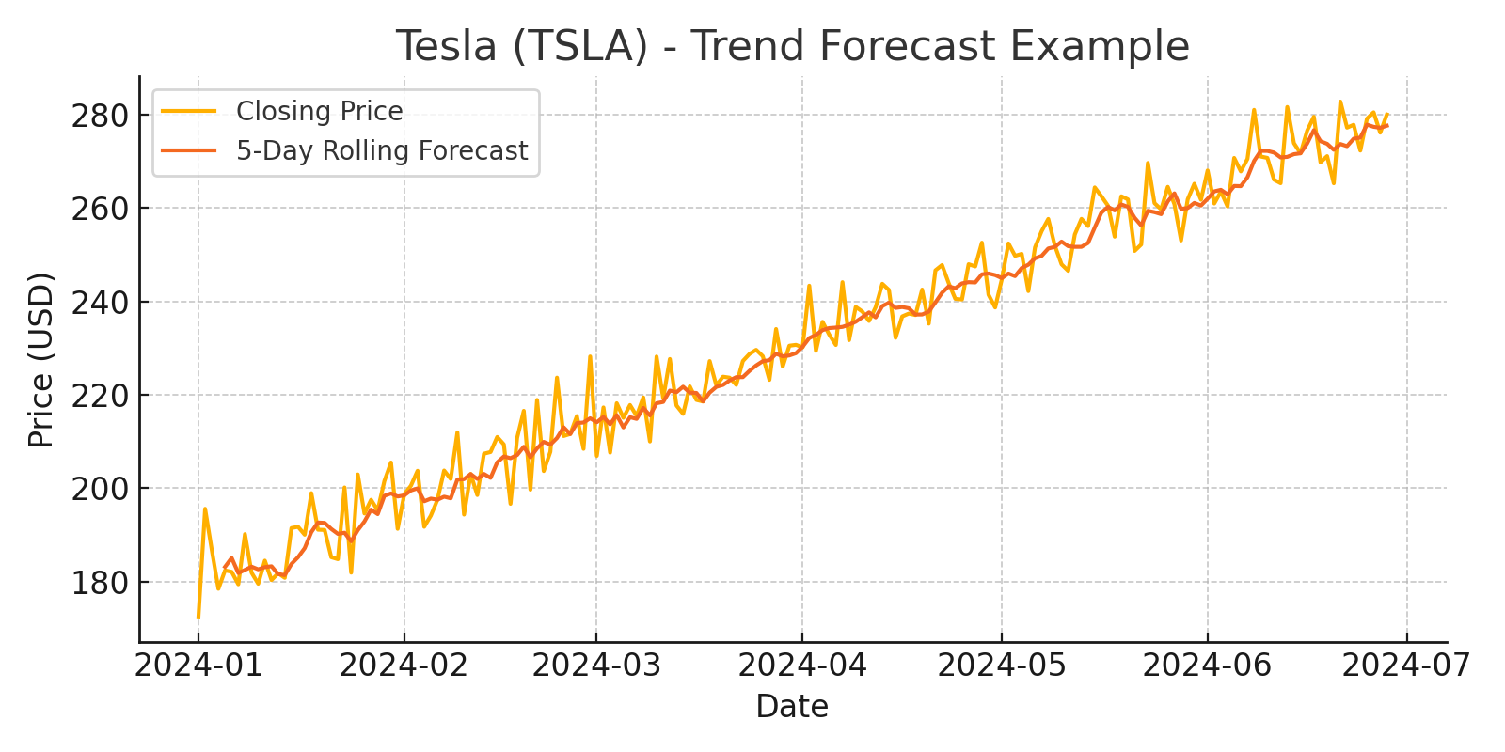

The quantitative forecast provides insight into Tesla's medium-term performance, illustrating the model’s ability to identify upward or downward market momentum trends.