

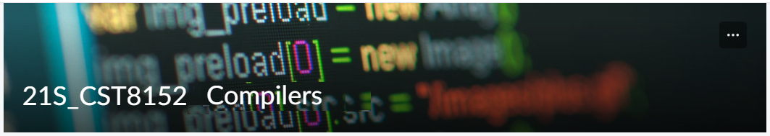

MODEL TASK FOR ASSIGNMENT 2.1 – Viper

Team: Akshit Sabharwal - Id: 041025056
/ Youssef Hamzo- Id: 041024593

- Note: This task is part of the Assignment 2 from Compilers Course. Any problem, contact your lab professor.

PART 1: RE – Regular Expression (1.5 mark)

Lexeme Classes: Define the classes to be used in your regular expression:

Answer:
VIPER:
- L = [a-z, A-z] (letters)
- D = [0, 9] (digits)
- U = [ _ ](underscore)
- P = [ . ] (period)
- M = [ ( ] (MI delimitator)
- N = [ \n ] (Comment ending new line)
- Q = [“] //(SL delimitator)
- C = [#] //comments
- O = [^LDUPMNQC] (other class)
#
NOTE:
~ = except
MI = method identifier
SL = string lateral

Define the RE to be used for: variables, literals and keywords:

Answer:
Variables: L(L|D|U)*
Integer: D(D)*
Float Number: D+(P)D+

Literals:
Comment: C[^N]*N
SL: Q[^Q]*Q

ML = U|L(L|D|U)*M
K = {def, for, if, elif, else, while, do, true, false, return, print } //keywords

PART 2: TD – Transition Diagram (1.5 marks)

Activity: Starting from the previous lexeme classes and obeying the RE, it is possible to define the automata for your language:

Answer (draw / copy image of the automata):
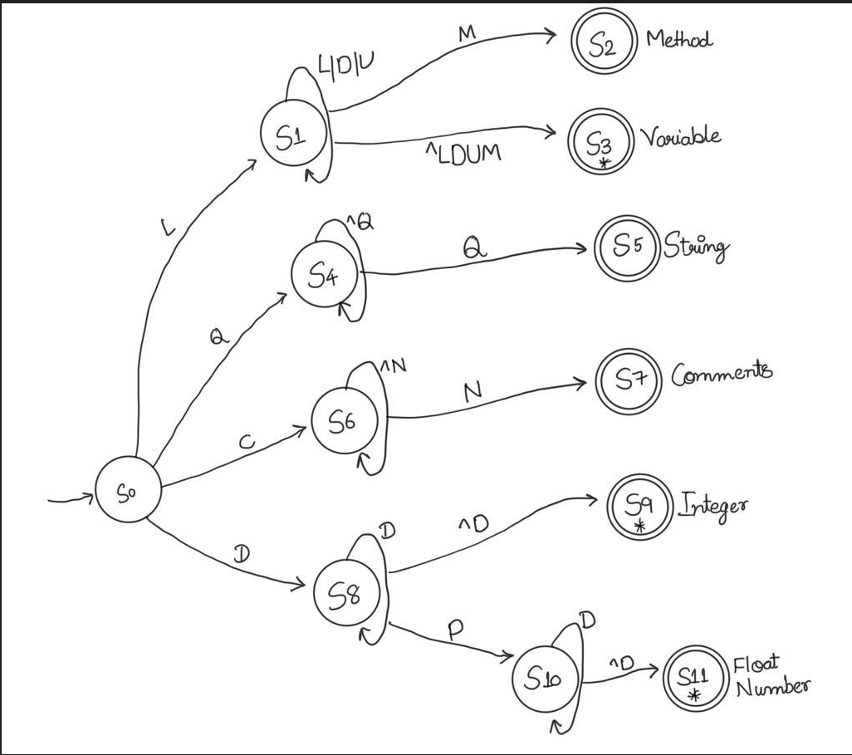

PART 3: TT – Transition Table (2 marks)

Activity: Now, it is possible to define the TT for these lexemes:

Answer (Transition Table):

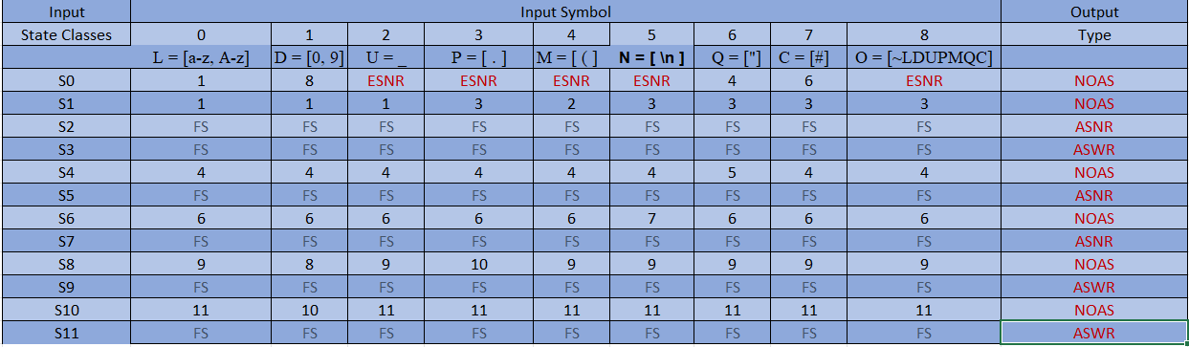

Update: Oct 2nd 2022.

Adapted from resources developed by Prof. Svillen Ranev (Algonquin College, 2019)

