Deployment Issue Report – WSL Server Firewall Configuration
Summary
During deployment testing, the application could not be successfully deployed on the target WSL server. Based on the investigation, the primary issue appears to be that the WSL server's firewall/network configuration is preventing the required communication for deployment and application access.

Observations
- NGINX configuration syntax validated successfully.
- Application and WebSocket configuration were reviewed.
- Network interface was reachable within WSL.
- Despite valid service configuration, deployment/access remained blocked, indicating a network or firewall restriction rather than an application configuration issue.

Conclusion
The evidence collected indicates that the deployment issue is most likely caused by the WSL server firewall or host networking configuration. Required inbound/outbound traffic or port forwarding is not allowing the application to be accessed correctly. Application configuration and NGINX syntax appear to be valid.

Recommended Actions
- Review Windows Defender Firewall rules affecting WSL.
- Verify WSL networking mode and port forwarding configuration.
- Ensure required ports (such as HTTP/HTTPS and application ports) are allowed.
- Confirm no security policy or VPN is blocking traffic between Windows and WSL.
- After firewall/network changes, restart networking/NGINX and repeat deployment.

Supporting Screenshots
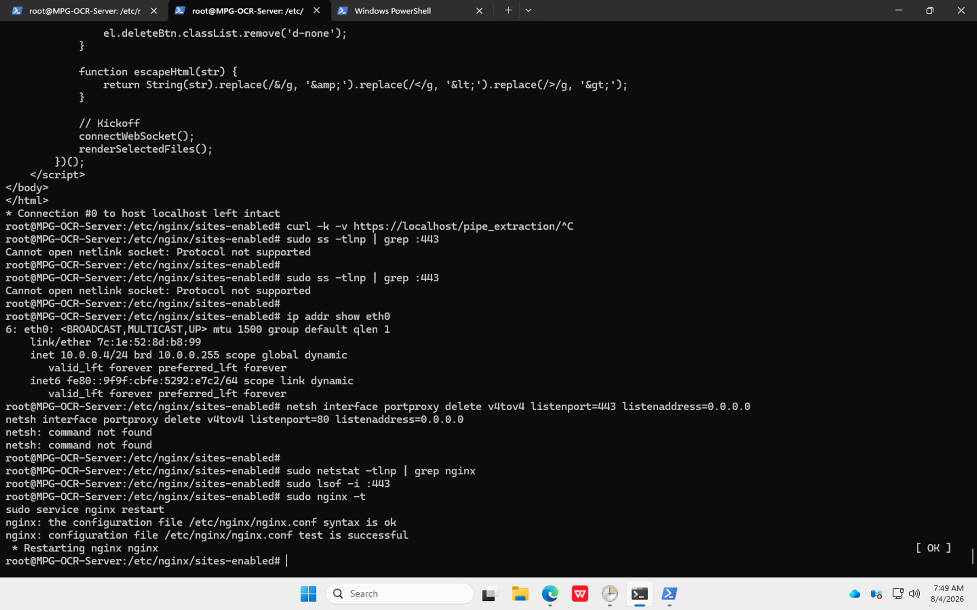
Screenshot 2026-08-04 at 6.19.48 PM.png
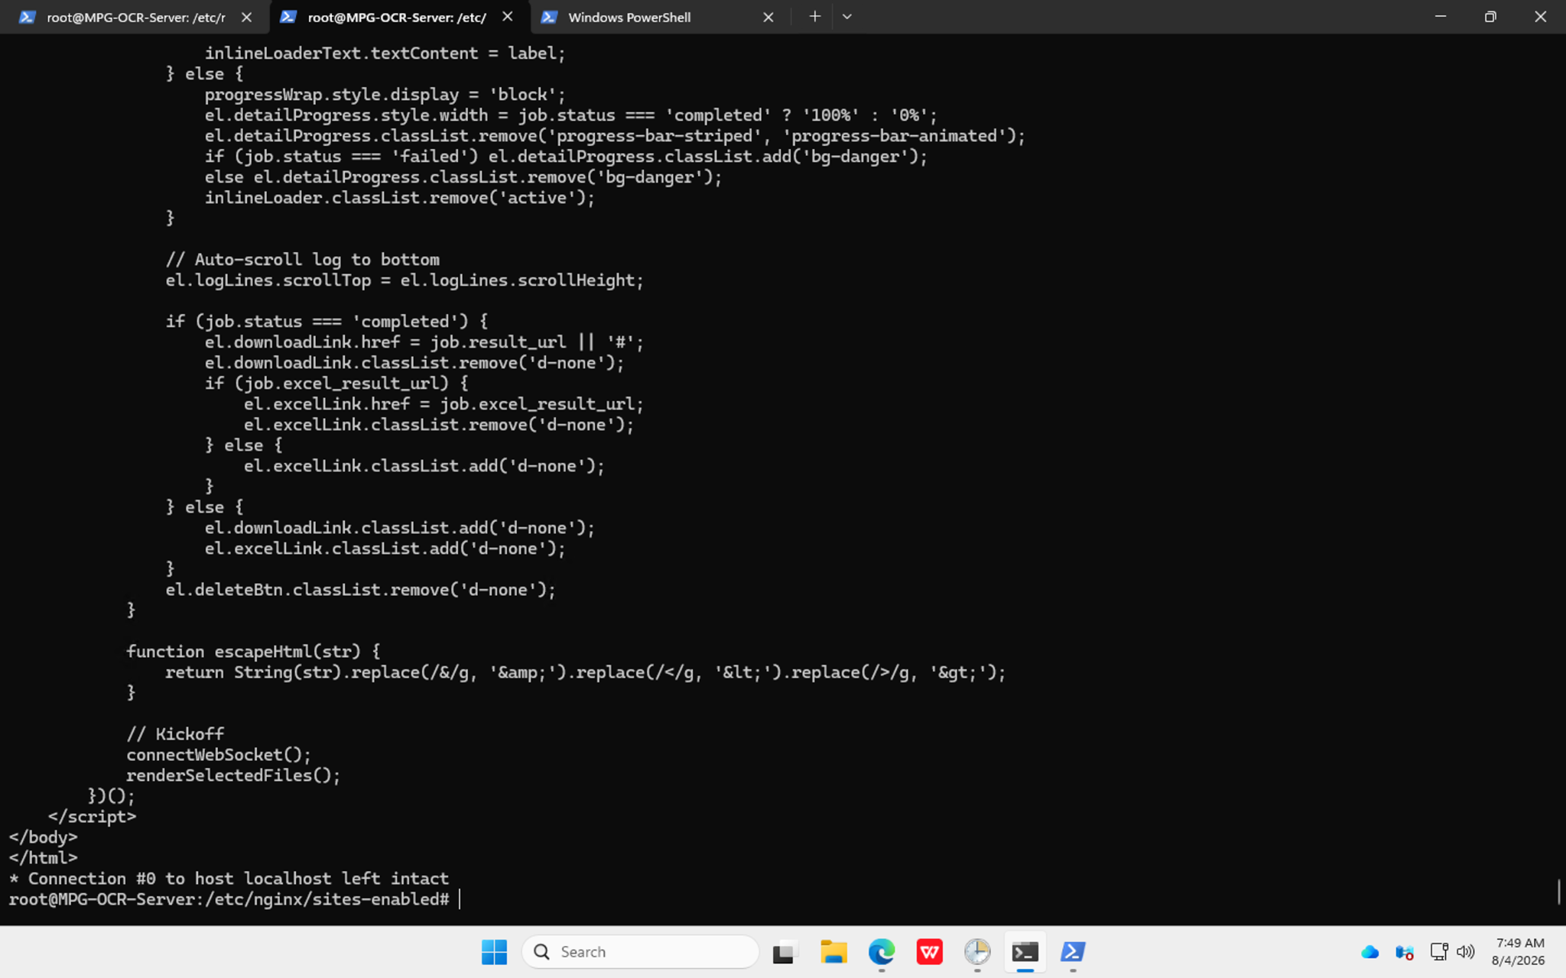
Screenshot 2026-08-04 at 6.19.56 PM.png
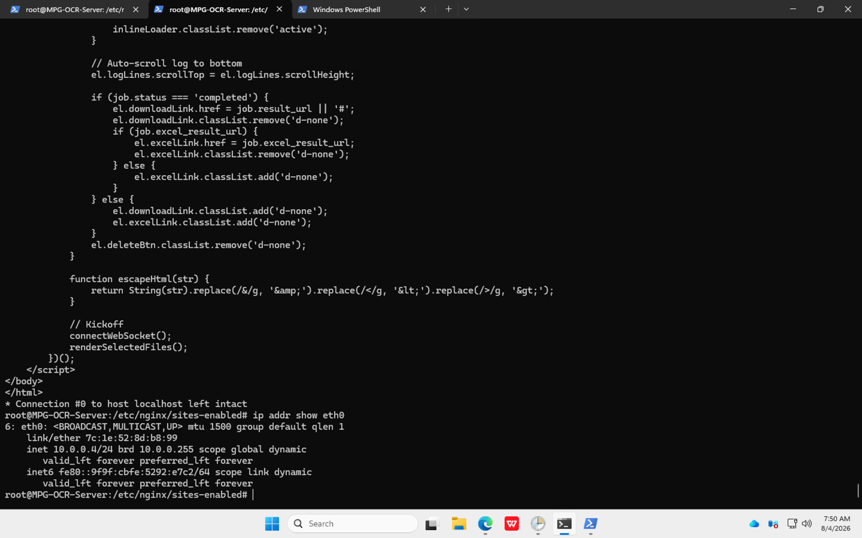
Screenshot 2026-08-04 at 6.20.49 PM.png
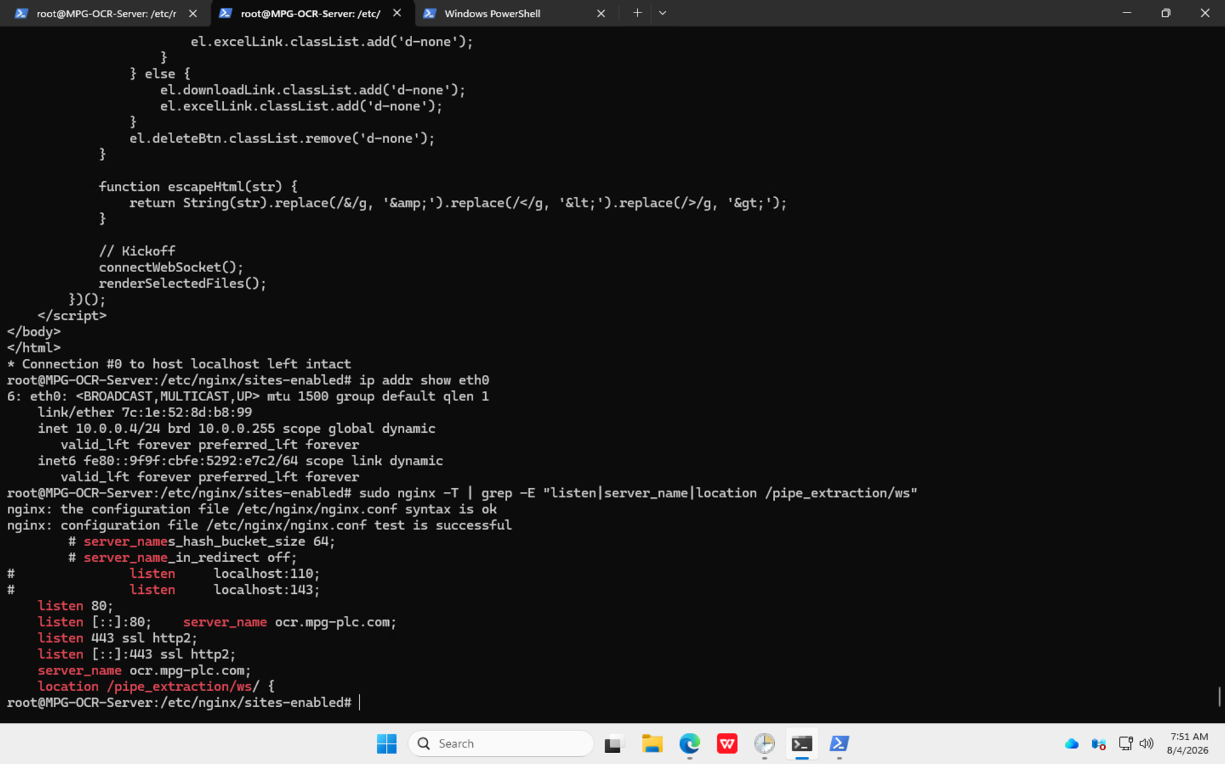
Screenshot 2026-08-04 at 6.21.13 PM(1).png

