University of Petroleum and Energy Studies

School of Computer Science

Department of Cybernetics



**Graphics and Animation Tools (Lab File)**

Course: B.Tech Branch: CSE (OSOS) Batch: 2017-2021 Semester: 7th

**Submitted By:**

**Akshit Chauhan**

**Roll No.: R100217004 Sap ID: 500062444**

**(Batch 1)**

**INDEX**

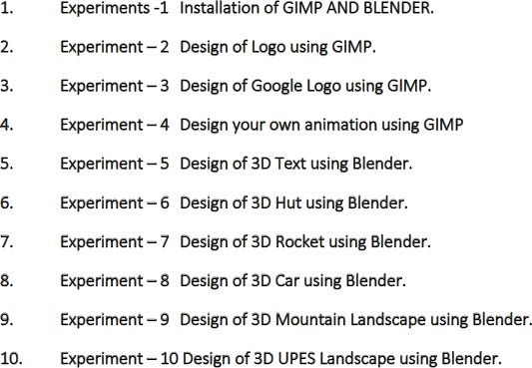

**EXPERIMENT 7: Designing 3D Rocket Using Blender**

**Aim:** Creating a 3D Rocket using Blender.

Steps taken to create the 3D Rocket animation:

1. Click on Add>Mesh and add a cylinder.
2. Click on object and then Shade Smooth to make the cylinder smooth.
3. In the Edit Mode give the cylinder a rocket shape.
4. Add more cylinders that look like thrusts around the central cylinder.

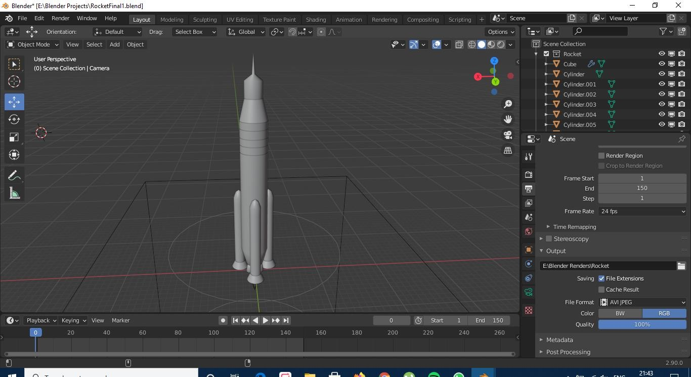

1. Add text ISRO at the front of rocket.

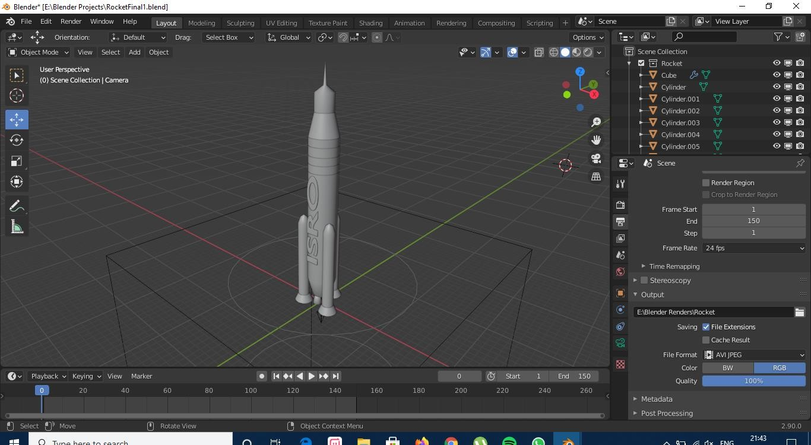

1. Give different shades in the shading tab to the rocket.

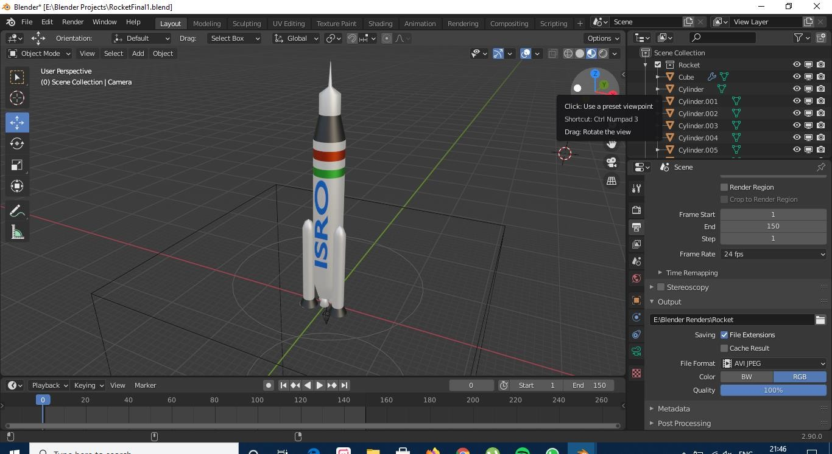

1. Finally add smoke and fire animation after adding a FIRE and SMOKE Domain at the bottom of rocket with the help of an ICOSPHERE Emitter.

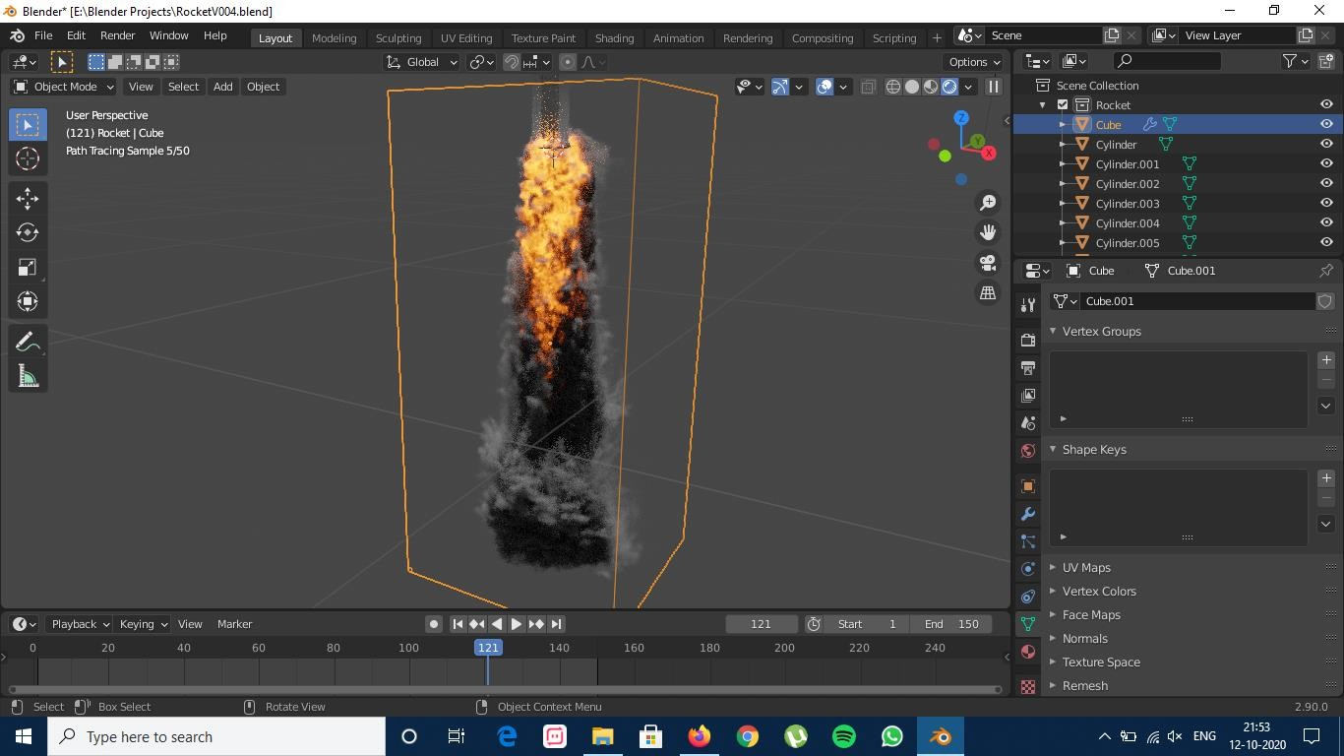

# Following is the Google Drive link for Rendered Final Animation and Blender Files:

[**https://drive.google.com/drive/folders/1patOzTUP020qNHzWUEuZWHpRmvt_**](https://drive.google.com/drive/folders/1patOzTUP020qNHzWUEuZWHpRmvt_bZX3?usp=sharing)[**bZX3?usp=sharing**](https://drive.google.com/drive/folders/1patOzTUP020qNHzWUEuZWHpRmvt_bZX3?usp=sharing)