**Front End Engineering-II**

Project Report Semester-IV (Batch-2022)

Food Delivery Website



# Supervised By: Submitted By:

Mr.Rishab Akshit, 2210991236(G-16)

Akshat Wahi,2210991230(G-26)

**Department of Computer Science and Engineering** **Chitkara University Institute of Engineering & Technology,**

**Chitkara University, Punjab**

|  |  |  |
| --- | --- | --- |
| **Index** | **Content** | **Page No.** |
| 1. | Introduction | 3-5 |
| 2. | Problem Definition and Requirements | 6-7 |
| 3. | Proposed Design / Methodology | 8-11 |
| 4. | Results | 12-25 |
| 5. | References | 26 |

1. **Introduction**

* **Website:** Name: Laziz.
* **Tagline:** "Eat Best At Laziz."
* **Purpose:** The Laziz website aims to provide users with a convenient platform to explore and order delicious food items.
* **Design Theme:** The website boasts a modern and visually appealing design with a focus on food imagery and user-friendly navigation.
* **Key Features:** It offers a variety of features including browsing food items, adding them to the cart, reading blogs, viewing a food gallery, and accessing account functionalities.
  1. **Background**
     + **Inspiration:** The inspiration behind Laziz originates from the desire to create a seamless and enjoyable experience for food enthusiasts to discover and order their favorite dishes online.
     + **Cuisine Focus:** Laziz emphasizes on a diverse range of cuisines, catering to various tastes and preferences of its users.
     + **Quality Assurance:** The website prioritizes quality by partnering with reputed vendors and ensuring fresh ingredients in all dishes.
     + **User Convenience:** Laziz is designed to prioritize user convenience, offering features like easy navigation, secure payment options, and responsive customer support.
     + **Community Engagement:** Beyond food delivery, Laziz fosters community engagement through its blog section, offering culinary tips, recipes, and food-related articles to enrich the user experience.
  2. **Objectives**
     + **Increase User Engagement:** Implement features such as food blogs, recipe sharing, and interactive elements to encourage users to spend more time on the website.
     + **Expand Customer Base:** Develop targeted marketing campaigns to reach new demographics and increase the number of registered users on the platform.
     + **Enhance User Experience:** Continuously optimize the website's design and functionality to ensure easy navigation, fast loading times, and seamless ordering processes.
     + **Improve Retention Rate:** Implement loyalty programs, discounts, and personalized recommendations to incentivize repeat purchases and foster customer loyalty.
     + **Strengthen Vendor Partnerships:** Forge stronger relationships with food vendors to ensure a consistent supply of high-quality ingredients and improve the variety and availability of food options on the platform.

1. **Problem Definition and Requirements**
   1. **Problem Statement**

The current Laziz website suffers from low user engagement, limited customer base, and inefficient operations due to outdated technology. To address these challenges, a comprehensive overhaul is needed, focusing on enhancing user experience, expanding the customer base, and optimizing operational efficiency through modernization and innovation.

* 1. **Software Requirements**
* **Content Management System (CMS):** Implement a robust CMS to manage website content, including food listings, blog posts, user accounts, and orders.
* **E-commerce Platform:** Integrate an e-commerce platform to facilitate online ordering, secure payment processing, order tracking, and delivery management.
* **Customer Relationship Management (CRM) System:** Deploy a CRM system to track customer interactions, manage feedback, and personalize marketing campaigns to improve customer retention.
* **User Engagement Features:** Develop interactive features such as food blogs, recipe sharing, user reviews, and social media integration to enhance user engagement and encourage community participation.
* **Analytics and Reporting Tools:** Utilize analytics tools to track website traffic, user behavior, order trends, and performance metrics to make data-driven decisions and optimize business operations**.**
  1. **Hardware Requirements**
     + **Web Servers:** Deploy high-performance web servers capable of handling concurrent user requests, ensuring fast loading times and minimal downtime.
     + **Database Servers:** Utilize scalable database servers to store and manage large volumes of data, including food listings, user accounts, orders, and transaction records.
     + **Networking Infrastructure:** Ensure reliable internet connectivity and sufficient network bandwidth to support real-time order processing, communication with delivery partners, and data transfer between servers and client devices.
     + **Backup and Recovery Systems:** Implement backup and recovery systems to prevent data loss and minimize downtime in the event of hardware failures, software errors, or security breaches.
     + **Workstations:** Provide employees with modern workstations equipped with sufficient processing power, memory, and storage capacity to perform their duties efficiently, including order processing, customer support, and website maintenanc

1. **Proposed Design/Methodology**

The proposed design for the Laziz website involves several key aspects, including the frontend user interface, backend functionality, database management, and integration of modern technologies**.** Here's an outline of the proposed methodology:

* 1. **Frontend Development :**
     + Implement a clean and visually appealing design with attention to user experience principles.
     + Incorporate features such as dynamic content loading, smooth transitions, and interactive elements to enhance engagement.
  2. **Backend Development**
     + Use Node.js or Django for the backend to ensure scalability, flexibility, and performance.
     + Develop RESTful APIs to facilitate communication between the frontend and backend, enabling seamless data exchange.
     + Implement user authentication and authorization mechanisms to ensure secure access to the website's features and resources.
  3. **Database Management**
     + Employ a relational database management system (e.g., PostgreSQL or MySQL) to store user data, product information, and transaction records.
     + Design an efficient database schema with appropriate normalization to minimize data redundancy and optimize query performance.
     + Implement data validation and error handling mechanisms to maintain data integrity and consistency.
  4. **Integration of Modern Technologies:**
     + Utilize cloud services (e.g., AWS or Azure) for hosting the website, ensuring scalability, reliability, and availability.
     + Integrate payment gateways (e.g., Stripe or PayPal) to facilitate secure and convenient online transactions.
     + Incorporate analytics tools (e.g., Google Analytics) to track user behavior, gather insights, and optimize marketing strategies.

**3.5 File Structure:**

* + - Organize the project files into separate directories for frontend and backend code.
    - Follow a modular structure with components, routes, models, and controllers for better code organization and maintainability.
    - Include configuration files, static assets, and documentation within their respective directories for clarity and ease of access.

**3.6 Algorithms Used:**

* + - Implement algorithms for various functionalities such as product recommendation, search optimization, and order processing.
    - Use algorithms like collaborative filtering or content-based filtering for personalized product recommendations.
    - Employ search algorithms like binary search or trie for efficient product search and retrieval.
    - Implement sorting algorithms (e.g., quicksort or mergesort) for sorting product listings based on various criteria.

1. **Results**
   1. **Code** 
      * HTML Code for index page

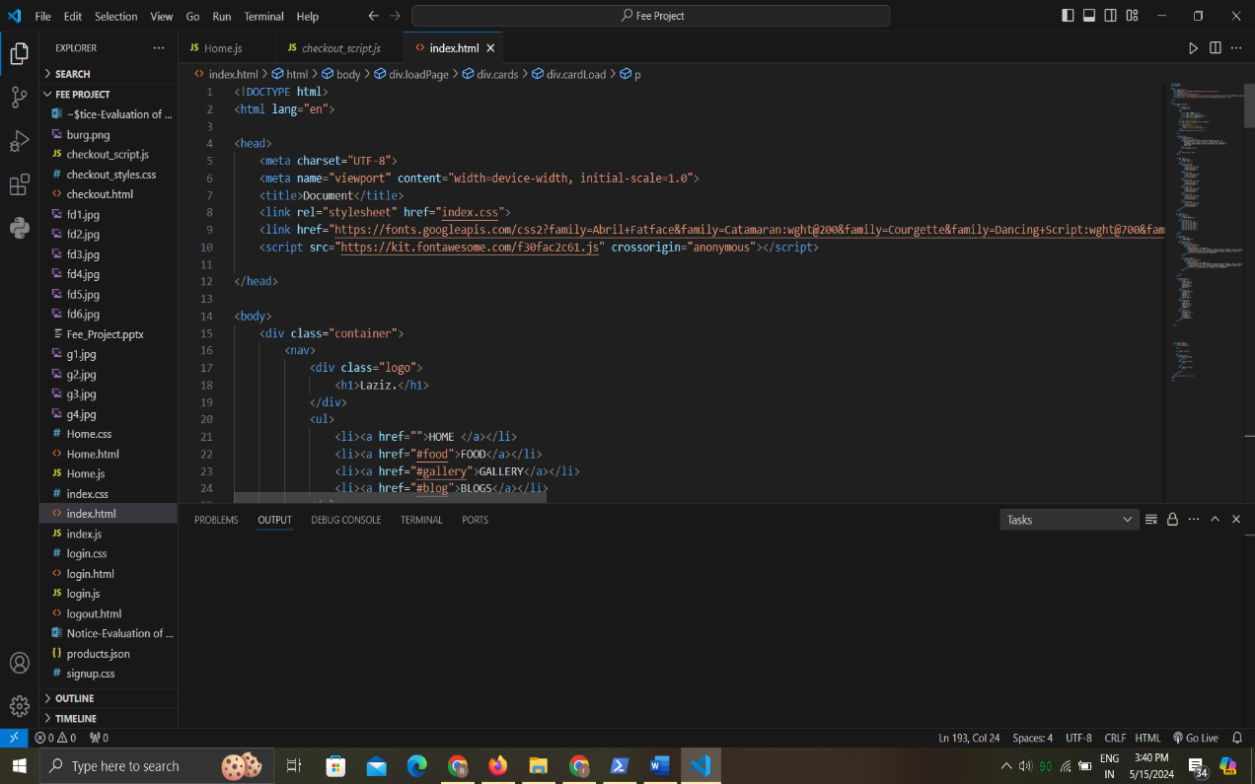

* CSS code for index page

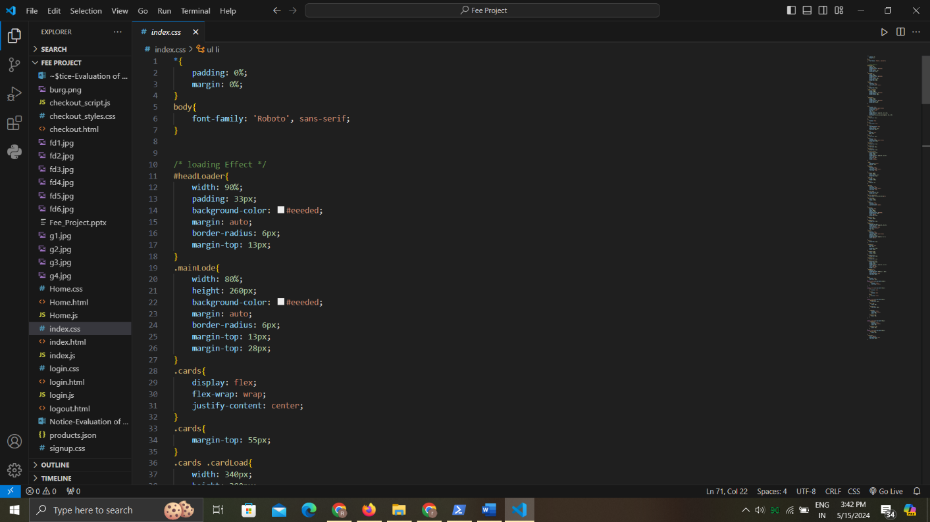

* + - JS code for index page

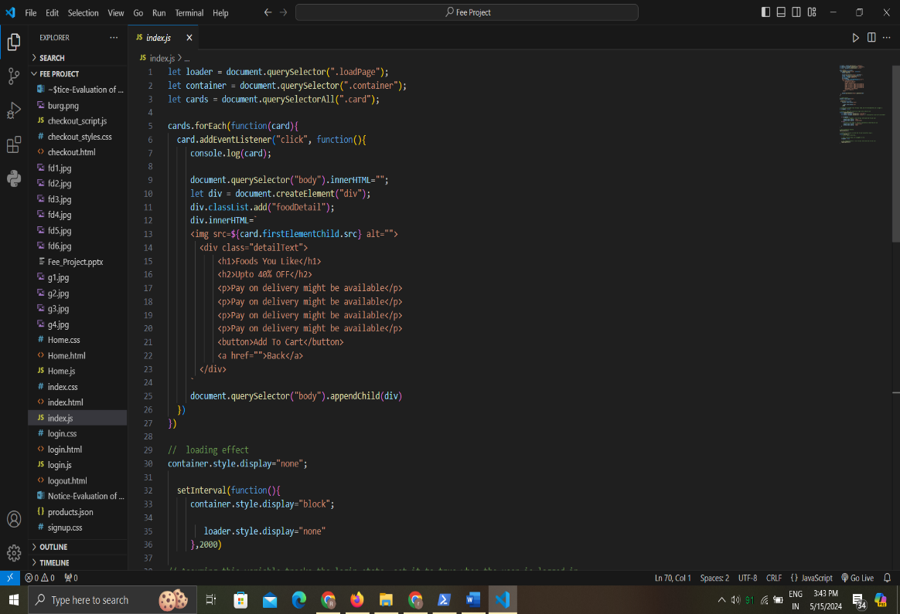

* + - HTML code for Login Page

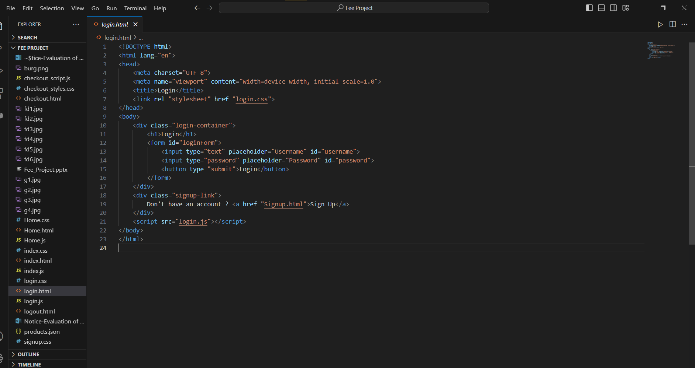

* + - CSS code for Login Page

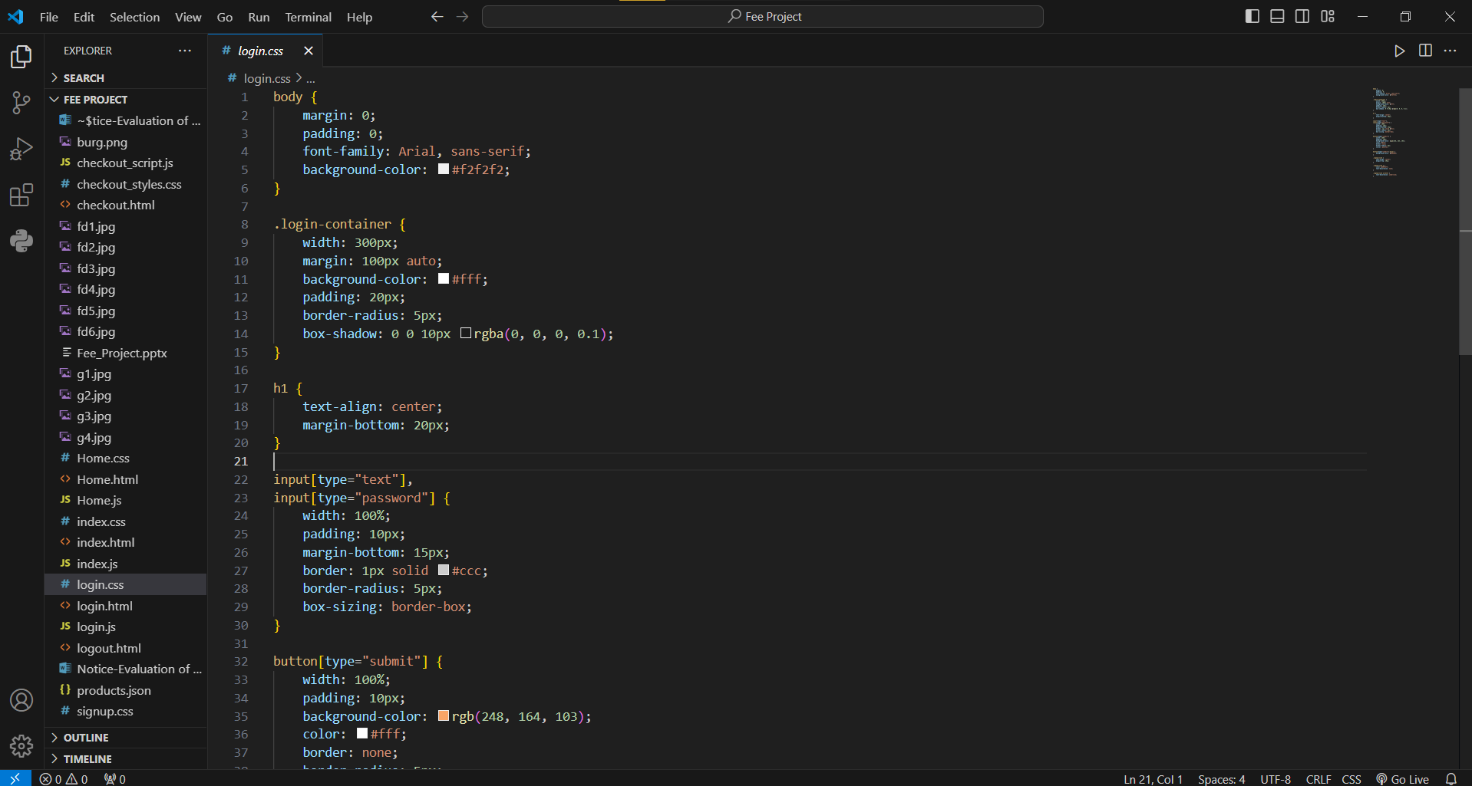

* + - JS Code for Login Page

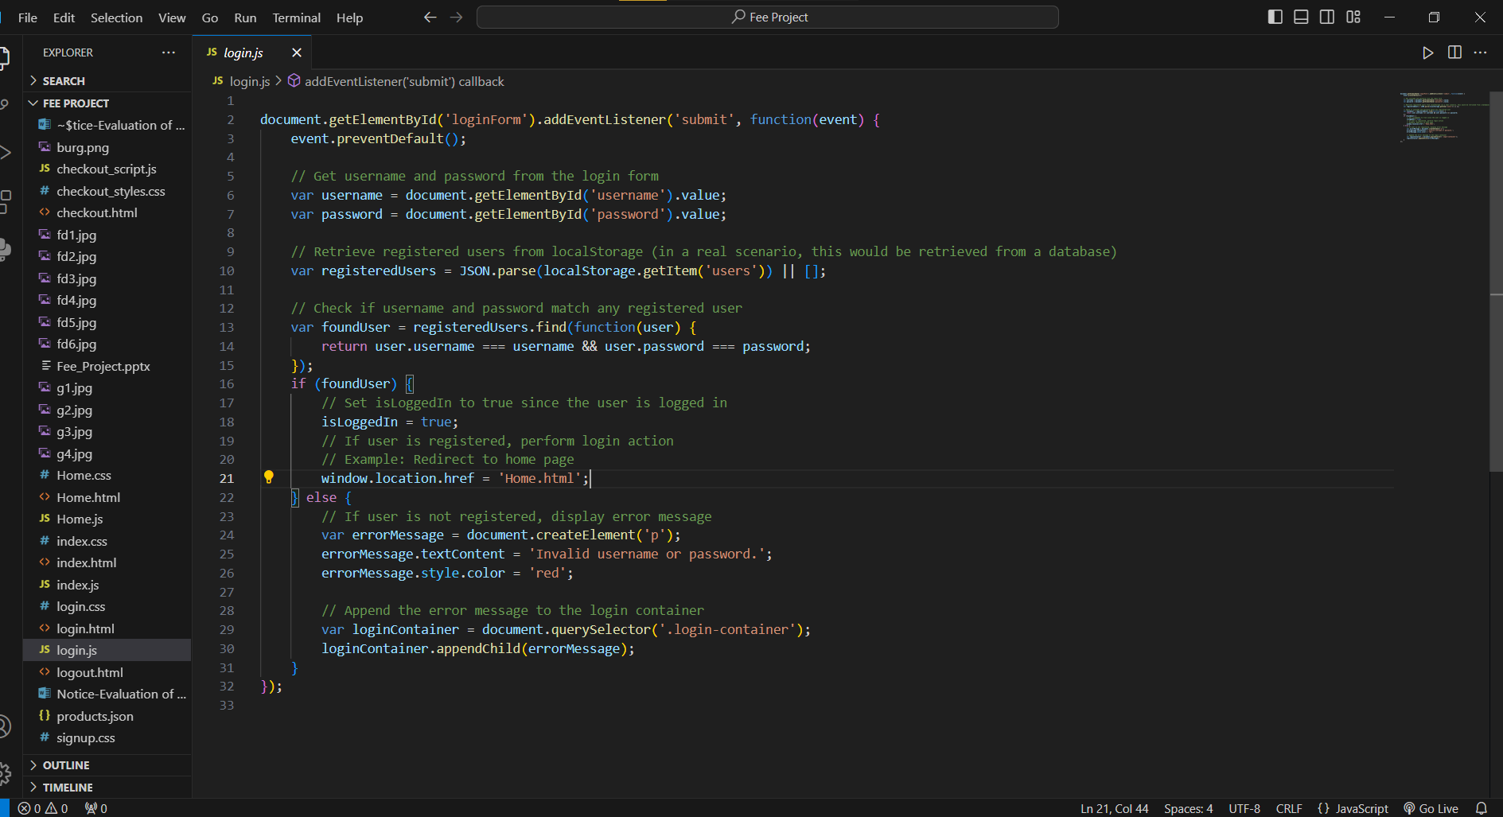

* + - HTML code for Home Page

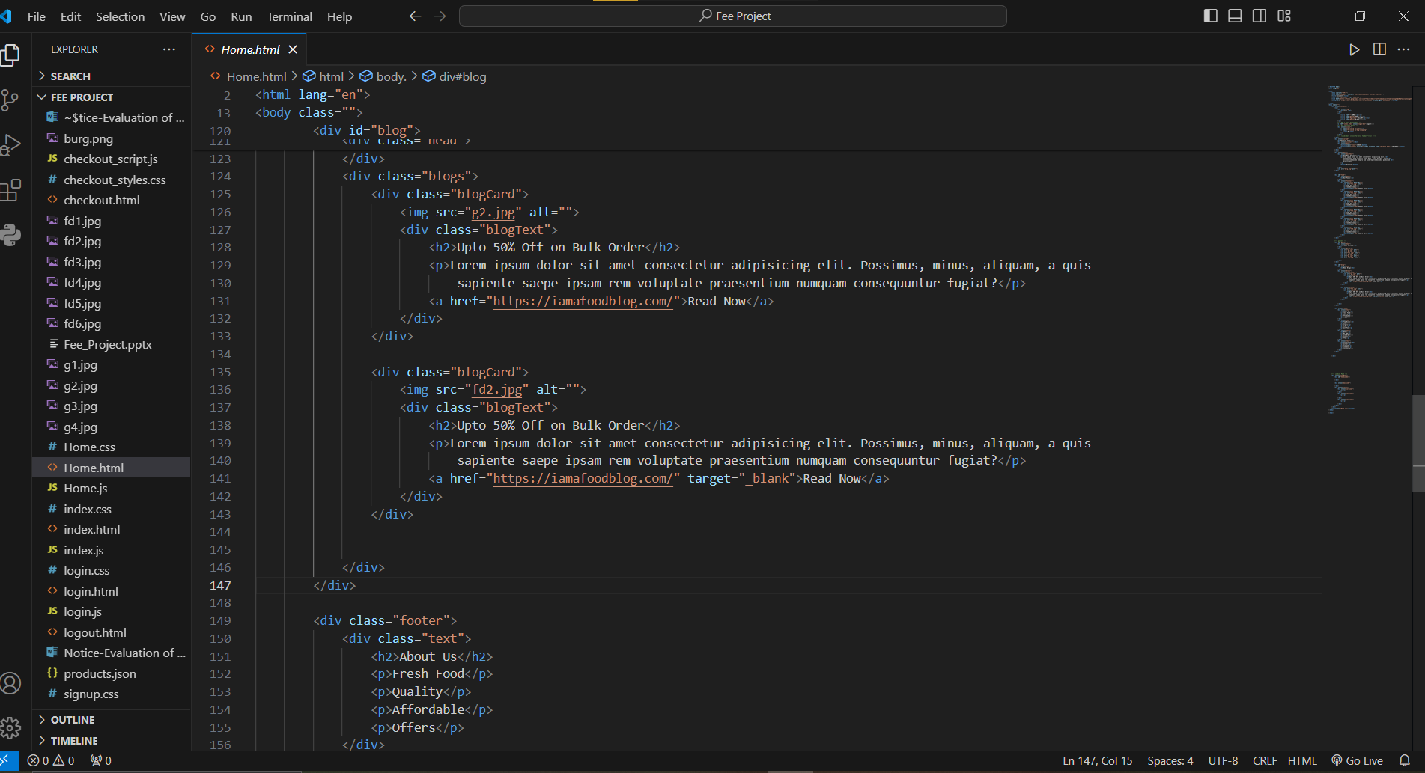

* + - CSS Code for Home Page

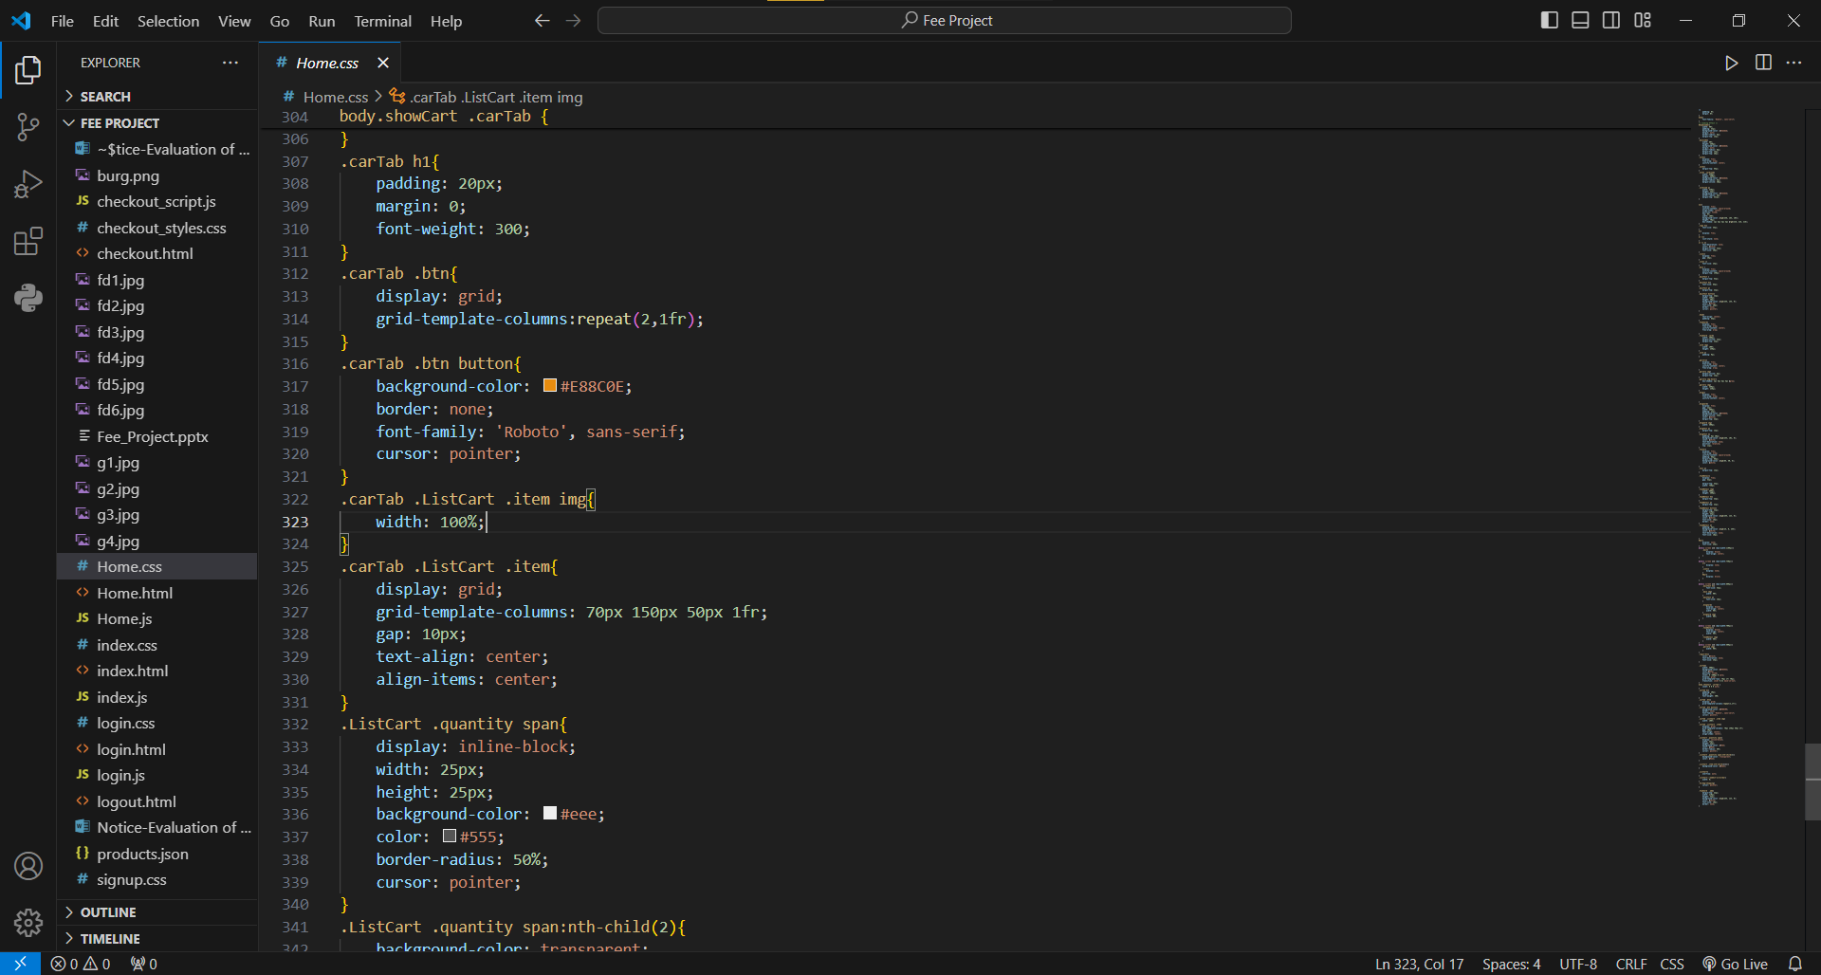

* + - JS Code for Home Page

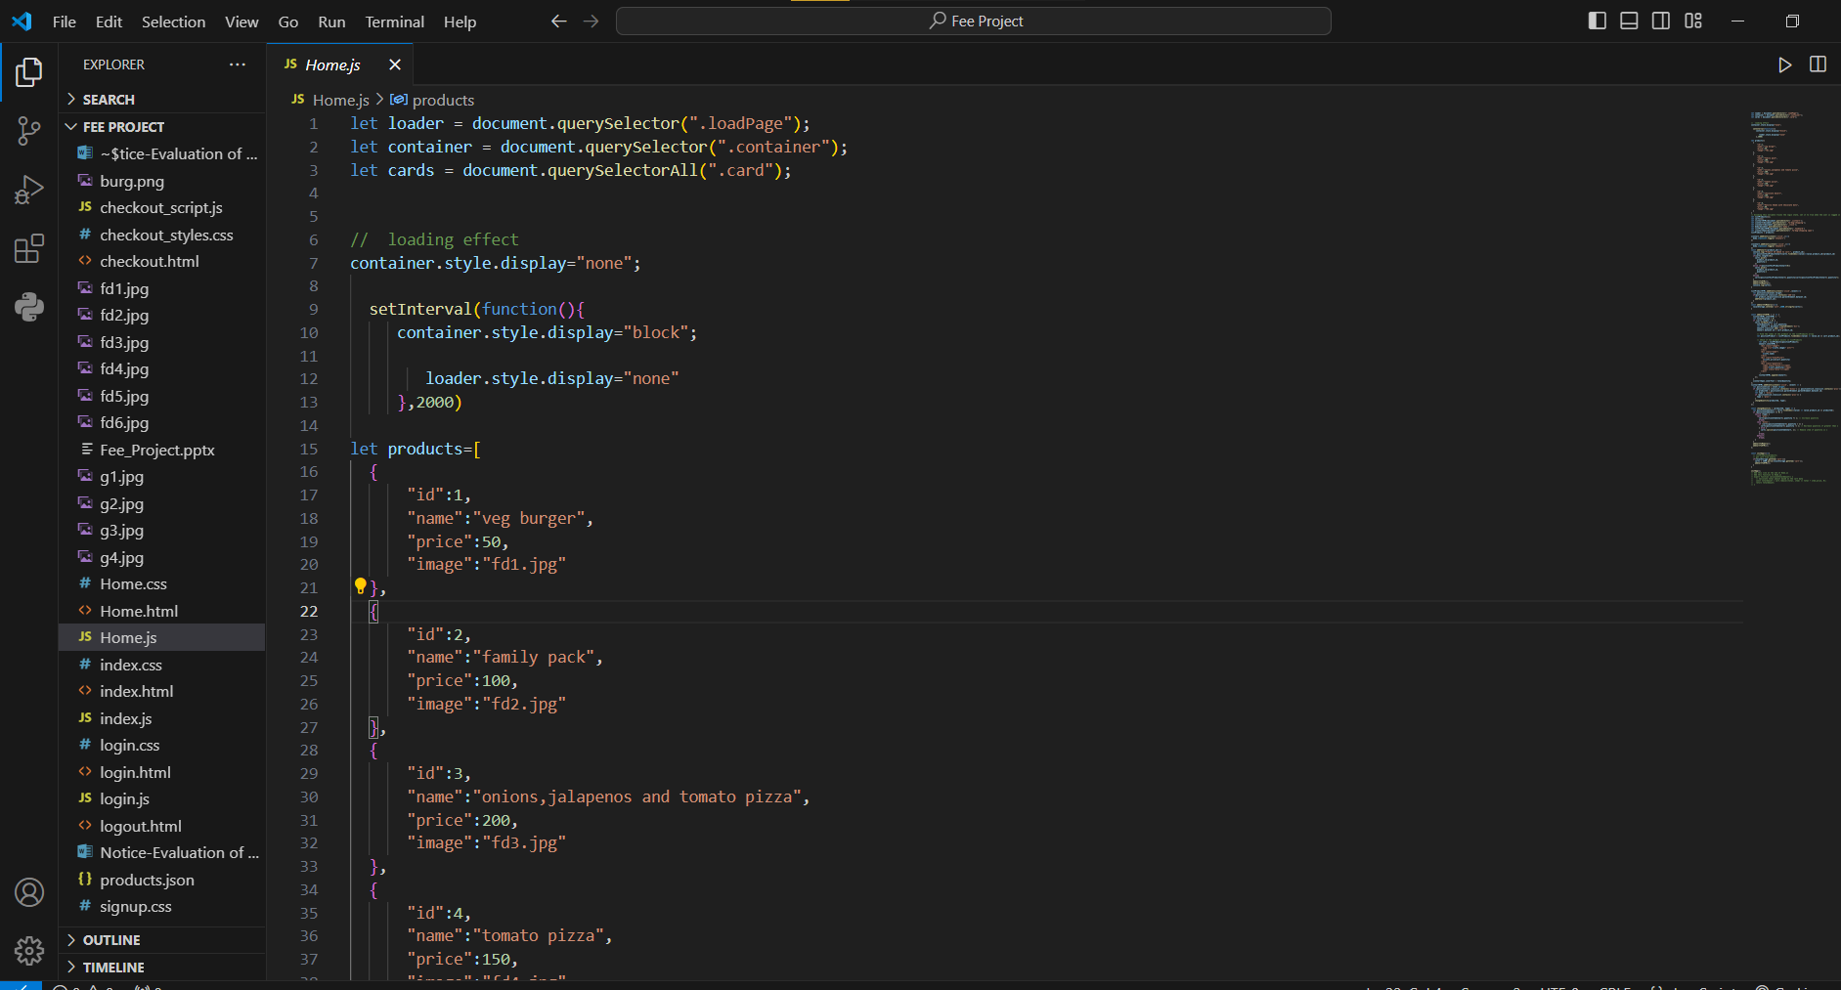

* + - HTML Code for Checkout Page

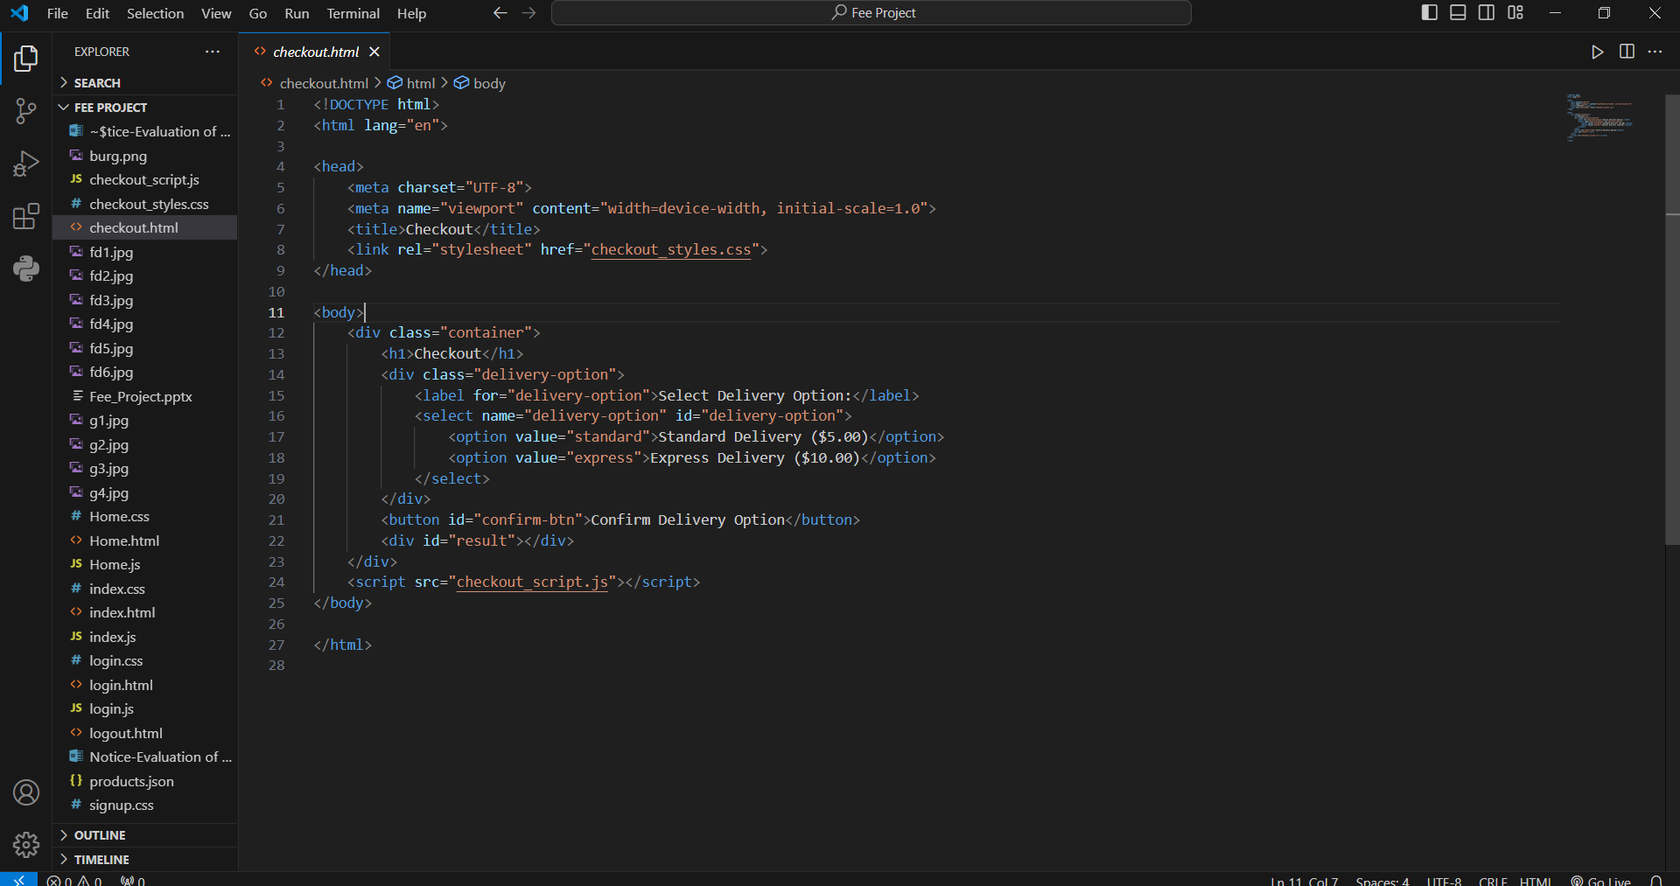

* + - CSS code for Checkout Page

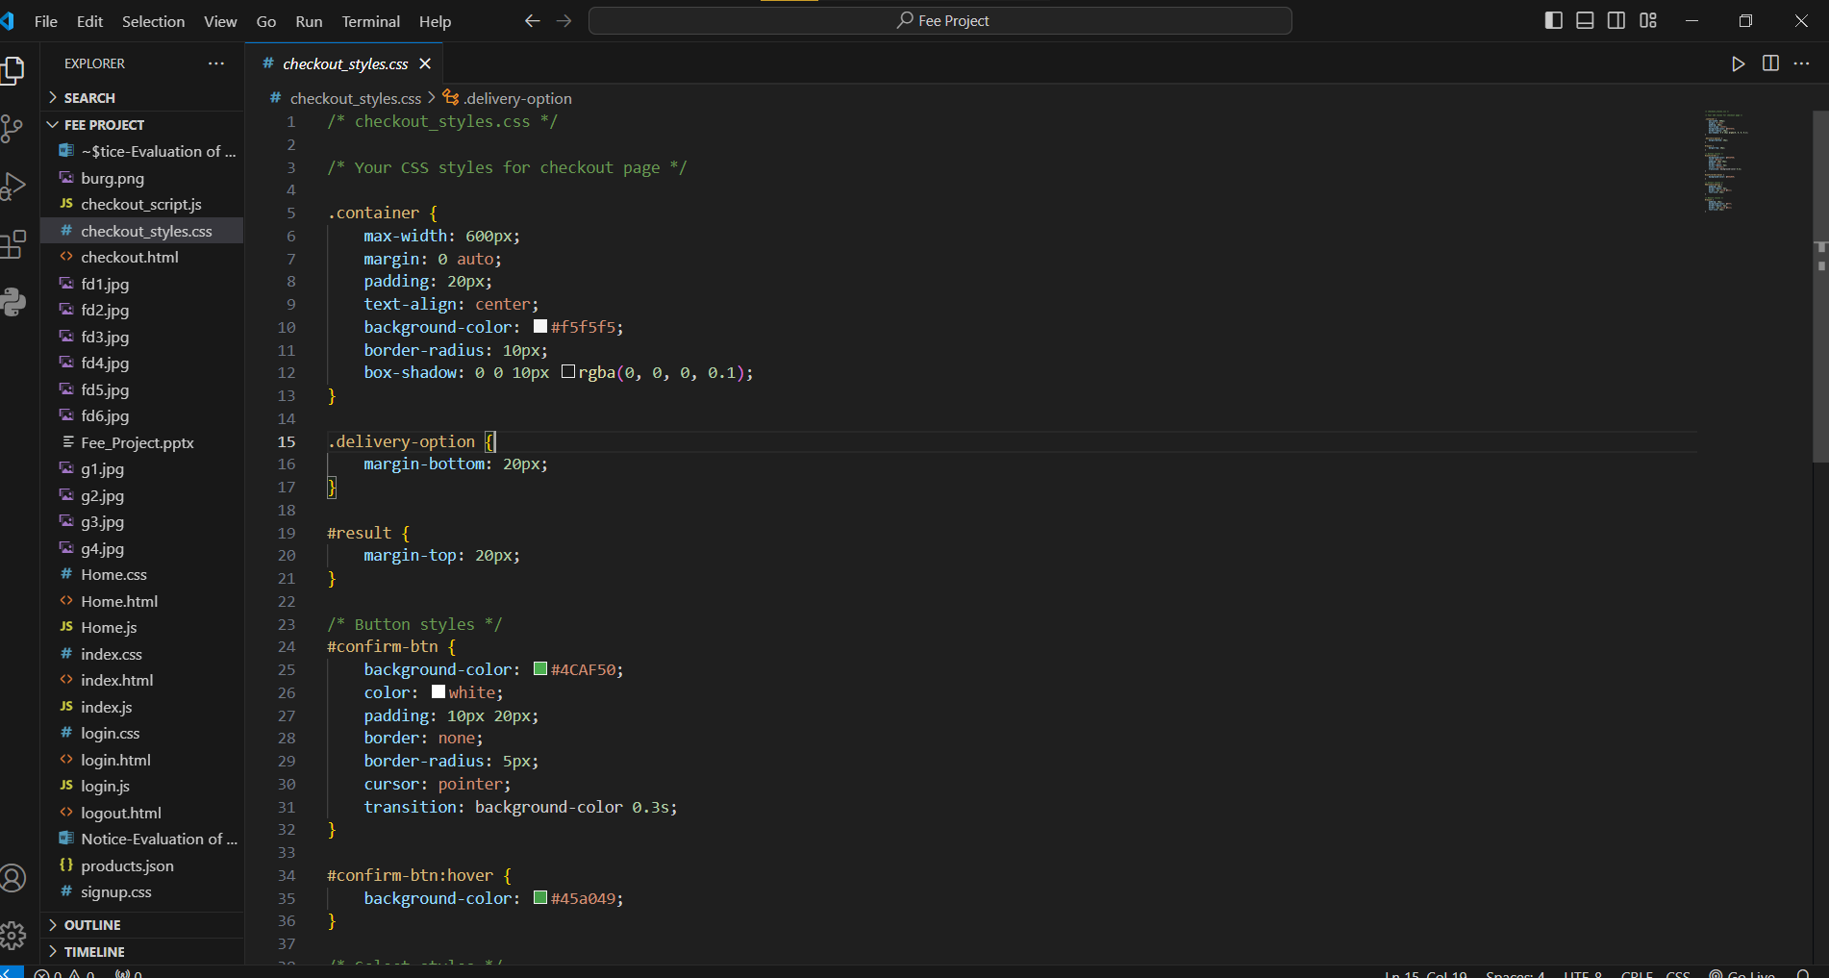

* JS Code for Checkout Page

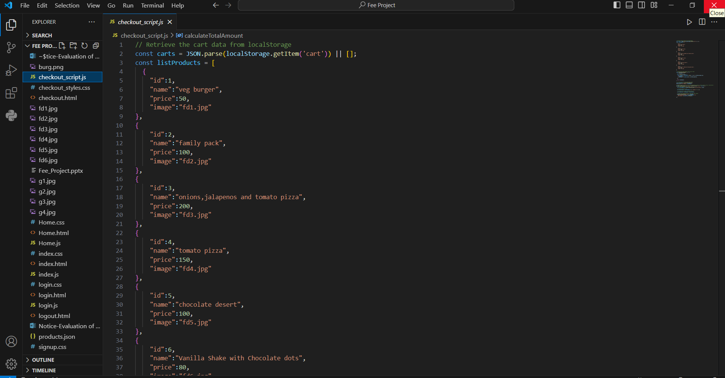

* 1. **Website**
* Index Page

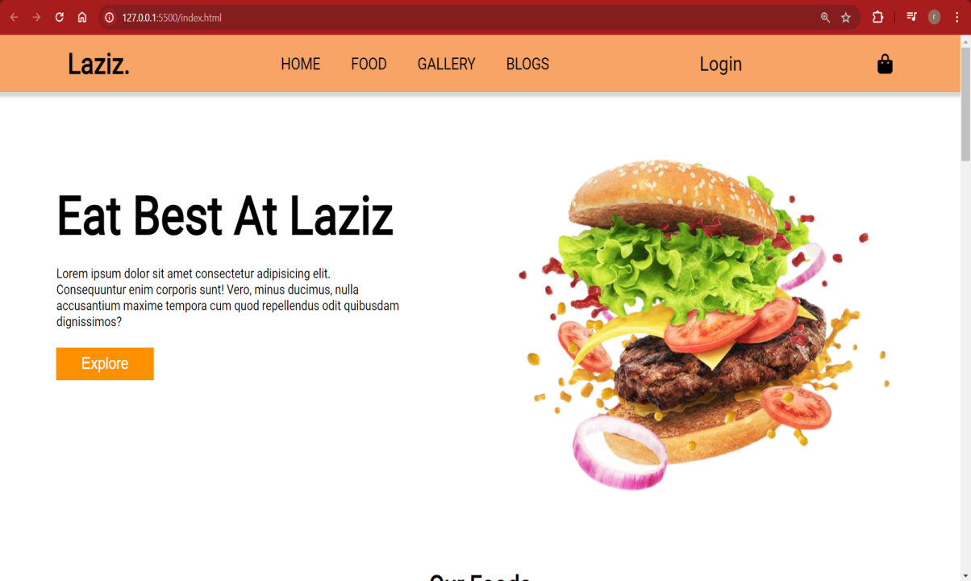

* Login Page

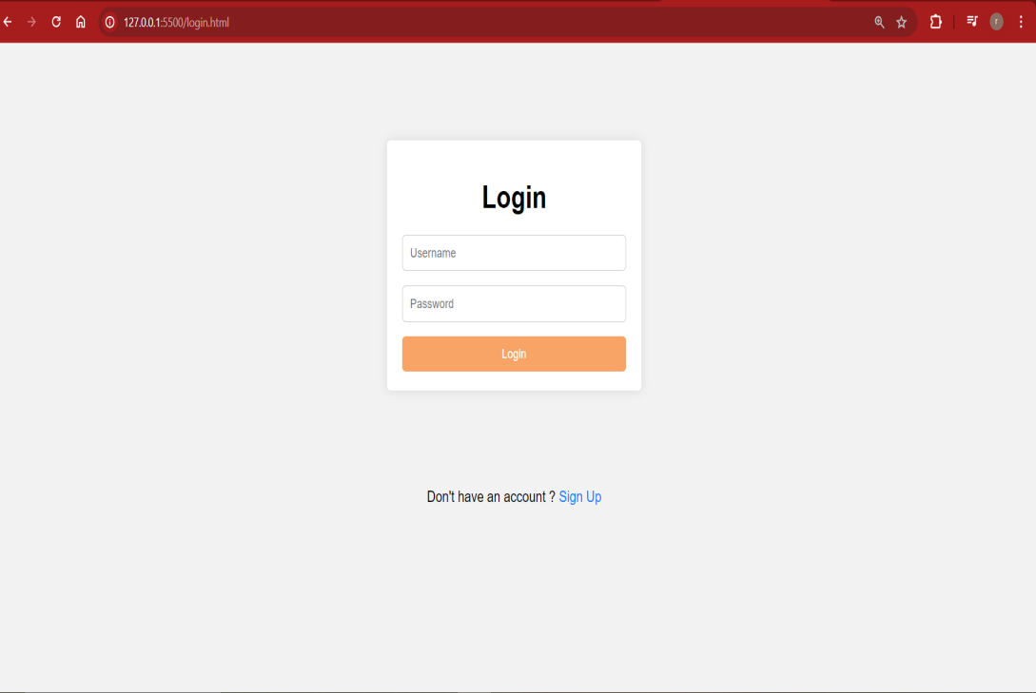

* Sign Up Page

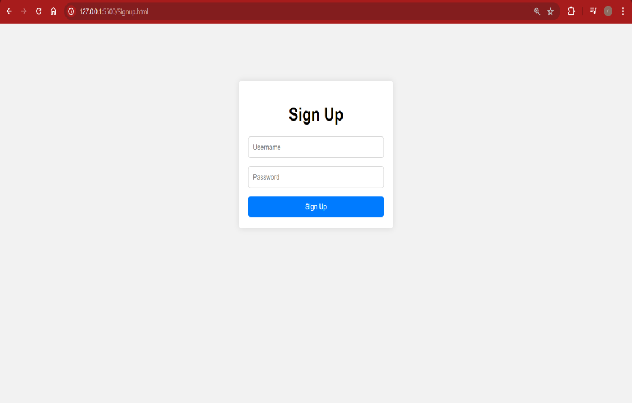

* Home Page

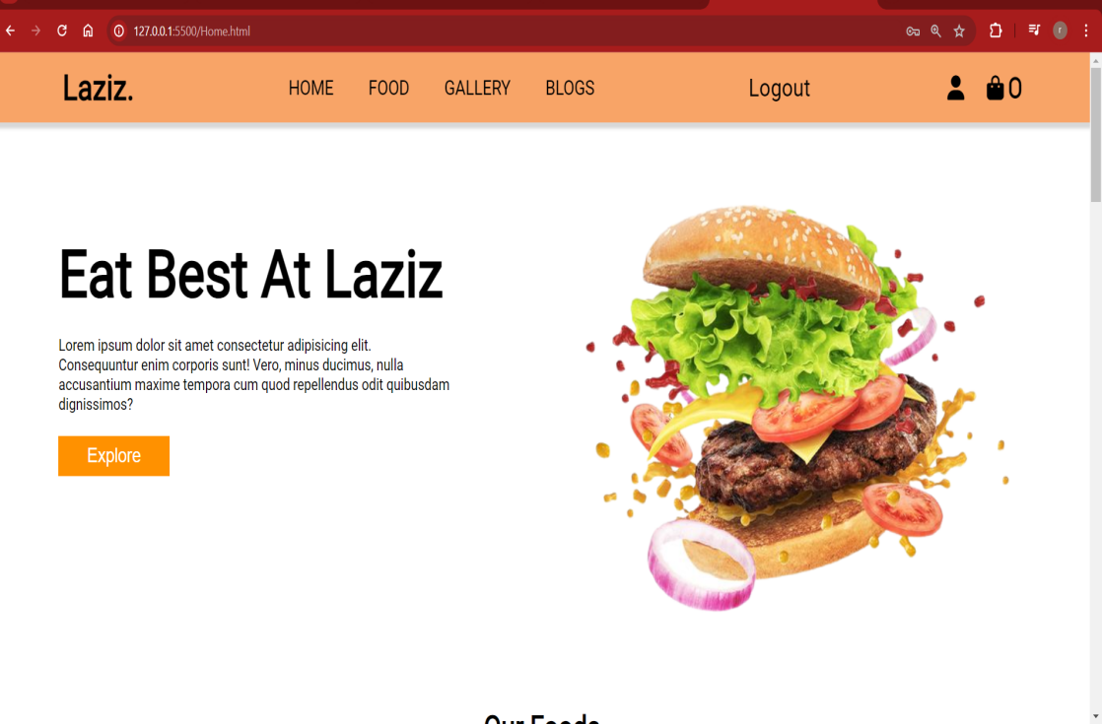

* Add To Cart Option

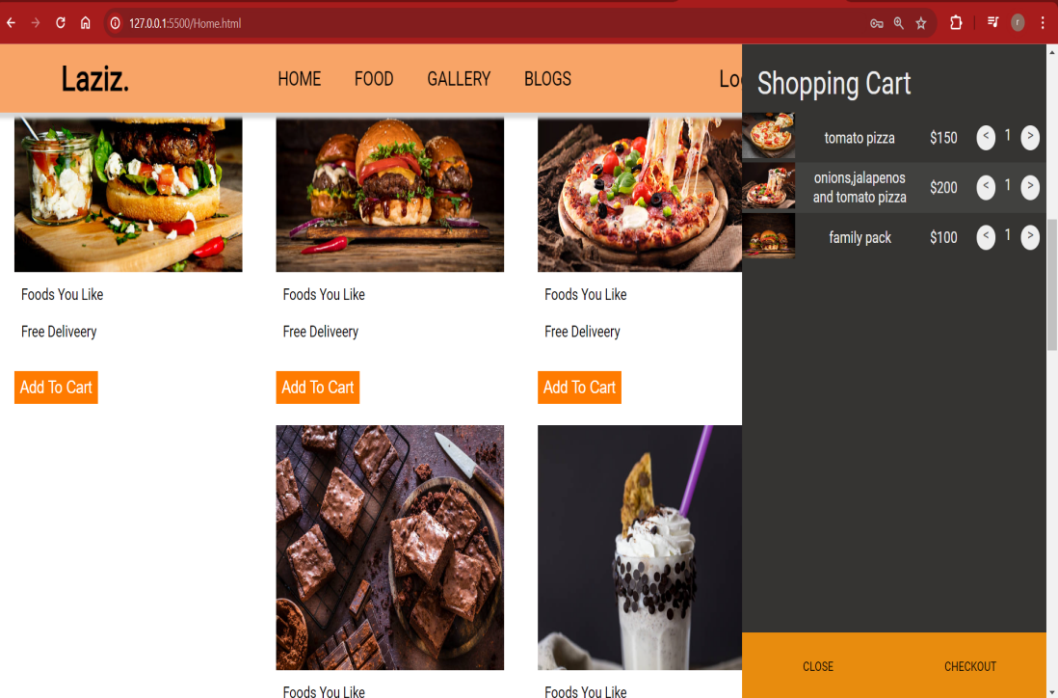

* Checkout Page for Delivery Option

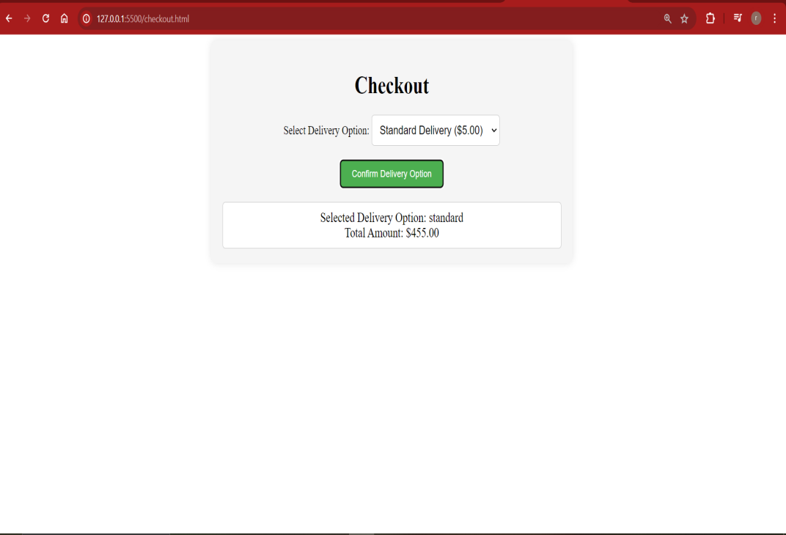

1. **References**
   1. Youtube: https://www.youtube.com
   2. Google https://www.google.com
   3. AI Tools(like Chatgpt , Gemini etc)