Project Report
Student Details
- Name: Akshit Mittal
- Roll Number: 23f2004636
- Course: Modern Application Development
- Branch: BS in Data Science and Applications
- College: IIT Madras

Project Title
Household Services Application V2: Rise Home Services
Problem Statement
In today’s fast-paced world, households increasingly rely on professional services for maintenance and repairs. However, managing service requests, connecting with professionals, and ensuring quality service delivery is challenging. This project aims to create a comprehensive, multi-user platform for household services that connects service professionals with customers under an admin-monitored system. The application will support role-based access, service management, and activity tracking while ensuring seamless communication between all stakeholders.
Approach
- The project is built as a web-based platform with the following key functionalities:
- Role-based Access: Admin, Service Professional, and Customer roles with specific access controls implemented using Flask Security.
- Service Management: Admin can create, update, and delete services while monitoring all users and managing approvals or bans.
- Service Requests: Customers can create and manage service requests, and professionals can accept, reject, or close these requests.
- Batch Jobs and Reporting: Daily reminders for pending tasks, monthly activity reports, and CSV export functionality handled using Celery and Redis.
- Performance Optimization: Caching was implemented using Redis for frequently accessed data, with cache expiry for optimized performance.
- The UI was developed using VueJS for interactivity.

Frameworks and Libraries Used
- Database:
  - SQLite for data storage
- Backend:
  - Flask for building the API.
  - Flask-SQLAlchemy for ORM and database management.
  - Flask-Security-too for handling security, including user authentication and authorization.
- Frontend/UI:
  - Vue.js (version 2) for building the user interface.
  - Vue2
  - CDN to include Vue.js
  - Bootstrap for HTML generation and styling
- Batch Jobs:
  - Redis and Celery for managing background and batch jobs.
- Security:
  - Flask-Security-too for handling authentication and authorization
ER Diagram
The ER diagram outlines the relationships between the following tables:
- Users (Admin, Customers, Professionals)
- User_Roles
- Customers
- Professionals
- Roles
- Services (Types of services provided)
- Service Requests (Details of requested services)
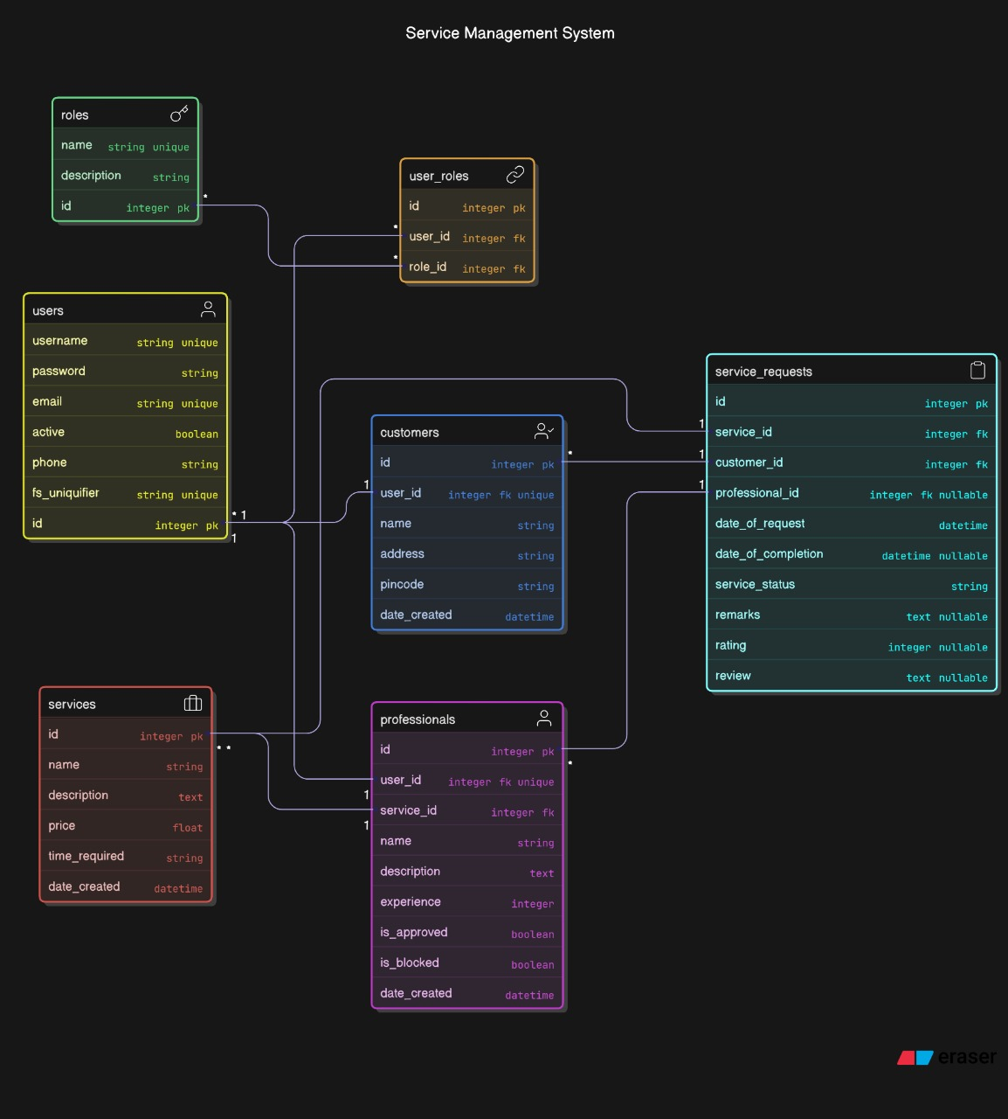
The detailed ER diagram is available:
API Resource Endpoints
1. Authentication APIs
/api/login - Authenticate users (admin, professional, customer)
/api/register/customer - Register new customer
/api/register/professional - Register new service professional
/api/logout - Log out current user
2. Admin APIs
/api/admin/dashboard - Get admin dashboard data (users count, services count, etc.)
/api/admin/users - Get all users (customers and professionals)
/api/admin/users/<user_id>/block - Block a user
/api/admin/users/<user_id>/unblock - Unblock a user
/api/admin/professionals - Get all service professionals
/api/admin/professionals/<pro_id>/approve - Approve a service professional
/api/admin/professionals/<pro_id>/reject - Reject a service professional
/api/admin/reports/export-csv - Export service requests data as CSV (async job)
/api/admin/reports/monthly - Generate monthly activity report
3. Service Management APIs
/api/services - Get all services (GET) or create new service (POST)
/api/services/<service_id> - Get, update or delete a specific service
/api/services/search - Search services by name/location/pin code
4. Customer APIs
/api/customer/dashboard - Get customer dashboard data
/api/customer/profile - Get or update customer profile
/api/customer/service-requests - Get all service requests or create new one
/api/customer/service-requests/<request_id> - Get, update or close a specific service request
/api/customer/service-requests/<request_id>/review - Add review for a completed service
5. Professional APIs
/api/professional/dashboard - Get professional dashboard data
/api/professional/profile - Get or update professional profile
/api/professional/service-requests - Get all assigned service requests
/api/professional/service-requests/<request_id>/accept - Accept a service request
/api/professional/service-requests/<request_id>/reject - Reject a service request
/api/professional/service-requests/<request_id>/complete - Mark a service request as completed
/api/professional/service-requests/<int:request_id>/remarks - Add Remarks to Service Request
6. Service Request APIs
/api/service-requests - Get all service requests (admin only)
/api/service-requests/<request_id> - Get details of a specific service request
/api/service-requests/search - Search service requests by various parameters
/api/service-requests/<int:request_id> - Delete Service RequestPresentation Video
7. Batch Jobs
/api/jobs/daily-reminders - Trigger daily reminder job for professionals
/api/jobs/monthly-report - Trigger monthly activity report generation
/api/jobs/status/<job_id> - Check status of an async job

The complete demonstration video for the project is available here: https://drive.google.com/drive/folders/1IWSYh6I7-Sec274G3v1DogcHb1eaINFc?usp=sharing

