Lead Capture Integration Guide
Quiz / survey results, delivered on WhatsApp — for partner & vendor developers

Overview
Lead Capture lets your application collect a customer's details and a result (e.g. a quiz outcome, a personalised recommendation) on your own site, hand it to LeapCreww, and have us deliver that result to the customer over WhatsApp — with no chat flow for you to build.
The flow has four parts:
- A customer completes a quiz, survey, or form on your website.
- Your backend computes the result and sends it, along with the customer's WhatsApp number, to our API.
- We message the customer on WhatsApp with a “See My Result” button.
- When they tap it, we deliver the result you sent us — directly in WhatsApp.

Integration Steps

Step 1 — Generate your API key
From your LeapCreww dashboard, go to Settings → Developer → Lead Capture, and click “Generate API Key.” This key is scoped only to lead-capture actions — it cannot read your messages, contacts list, or billing.
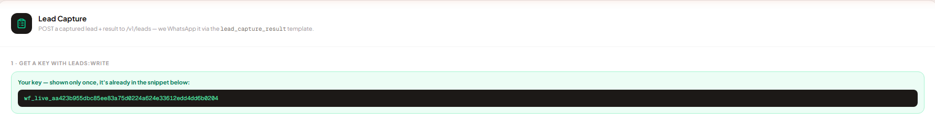

What to capture & mark: Screenshot the Lead Capture card right after clicking “Generate API Key,” showing the revealed key panel. Circle the “Generate API Key” button. Before sharing this screenshot with anyone, black out / blur the actual key string — treat it exactly like a password.

Step 2 — Understand the request
Every capture is a single request containing the customer's phone number, an optional display name, a source tag, the result text you've already computed, and any extra attributes you want stored (age, gender, quiz answer, etc.).
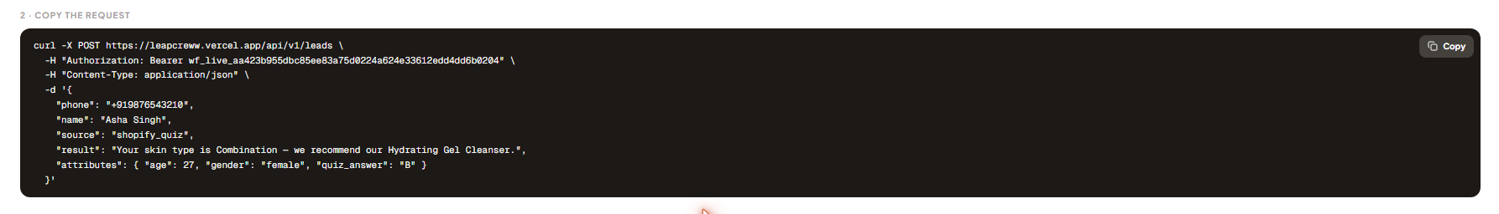
What to capture & mark: Screenshot the “Copy the request” card on the same Lead Capture page (it shows a fully worked example). Draw an arrow from each field name to a short label: phone → “customer's WhatsApp number”, name → “optional display name”, source → “a tag you choose, e.g. shopify_quiz”, result → “the result text your system already computed”, attributes → “any extra data — age, gender, quiz answer, etc.” Redact the API key visible in the Authorization line the same way as Screenshot 1.

Step 3 — Send it from your backend
Once your system has computed the customer's result, your own backend server sends the request described above to our endpoint. This call must come from your server — never from a browser or your quiz page's JavaScript. The Security Requirements section below explains exactly why.

Step 4 — What the customer sees
If WhatsApp is connected for your account, the customer receives a message with a “See My Result” button moments after your request succeeds.
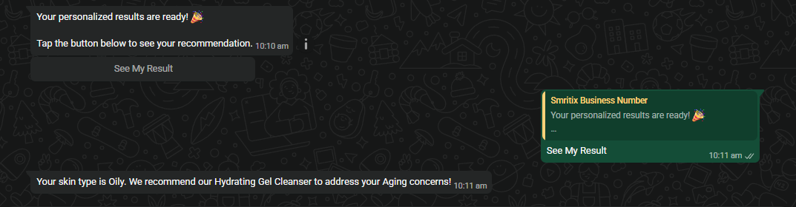
What to capture & mark: Screenshot the WhatsApp conversation showing the template message and the “See My Result” button. Circle the button itself.

Step 5 — Confirm delivery
Back on the Lead Capture card, the Recent Submissions table shows every capture and whether its result has been delivered yet.
What to capture & mark: Screenshot the Recent Submissions table with at least one row showing “Delivered: Yes.” Circle the Delivered column for that row.

Security Requirements
Please read this section before going live. It is not optional.
⚠️ Never put your API key in client-side code
- Your quiz page's JavaScript runs in every visitor's browser — anyone can open “View Source” or the browser's network tab and read it.
- A leaked key lets a stranger send WhatsApp messages and consume paid credits on your account, or read/write your captured leads.
- The key must live only on your own backend server. Your quiz page should call your backend; your backend calls LeapCreww.
Other safeguards already in place
- Only an admin-level, logged-in user on your LeapCreww account can ever generate a key — keys cannot be created anonymously or by an unauthenticated request.
- Each key is scoped: a Lead Capture key can only submit leads and write contact details — it has no access to messaging, billing, or account settings.
- If a key is ever exposed (committed to a public repo, logged accidentally, etc.), revoke it immediately from Settings → Developer and generate a fresh one. Revoking takes effect instantly and cannot be undone, by design.

Troubleshooting & FAQ
“Delivered” still shows No — is something broken?
No — “No” simply means the customer hasn't tapped the “See My Result” button yet. Delivery only happens on that tap; it is not automatic after capture.
The customer never received a WhatsApp message.
Check that WhatsApp is connected on your LeapCreww account (Settings → WhatsApp Business Connection) and that the phone number you submitted is in international format.
Can I reuse one key across multiple quizzes or sources?
Yes. Use the source field to tag each submission (e.g. shopify_quiz, landing_page_survey) so you can tell them apart in your own records.

