**HTML & CSS**

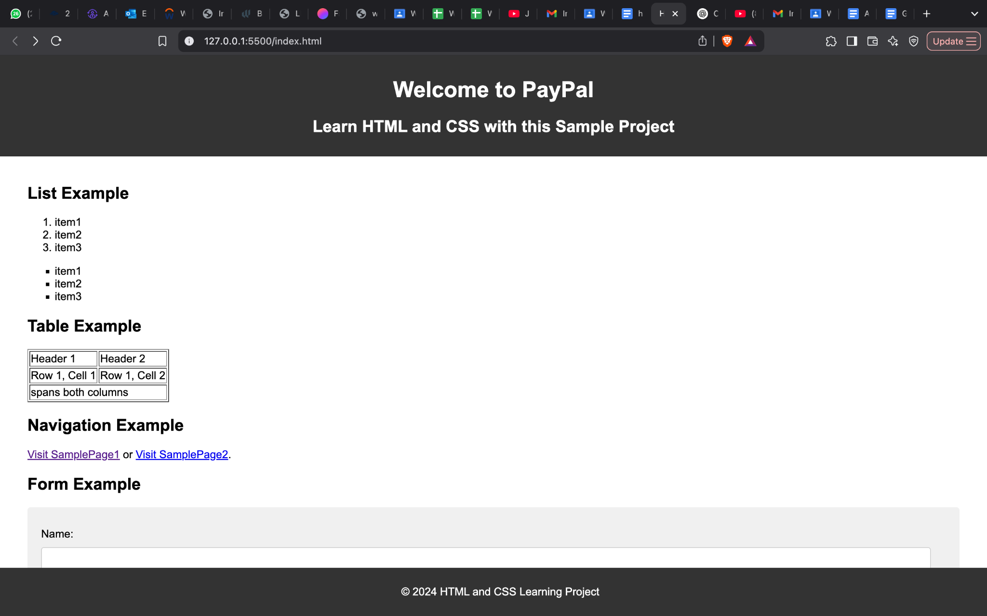

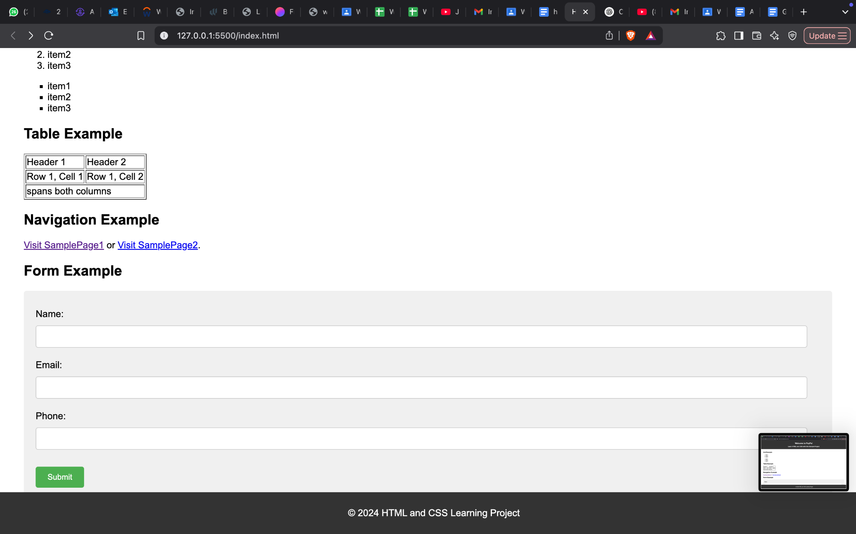

Code added to rg-assignments repo (link below)

**Git and IntelliJ**

1. What is the use of the git add command?

Ans: The git add command stages changes in the working directory for the next commit. It tells Git which files to include in the commit.

1. Write the command to create a branch “feature-group”.

Ans: git branch feature-group

1. What is a pull request? Write the steps involved in creating a pull request.

Ans: A pull request lets us propose changes to a repository for review and merging. Steps: push your branch to GitHub, go to the repo on GitHub, click "Compare & pull request", write a message, then click "Create pull request”.

1. How do you add collaborators?

Ans: Go to the repository on GitHub, click on “Settings” > “Collaborators”. Then enter the GitHub username or email and click "Add collaborator”.

1. What is the command used to commit our changes in github repo?

Ans: git commit -m "Commit message”

1. Create a github account and repository to save all your assignment tasks. Example repository name: rg-assignments

Link: <https://github.com/Akshit24Sharma/rg-assignments/tree/main>

1. Install IntelliJ IDE. Create a simple java project displaying “Hello World!!”and share the screenshot.

