Assignment 1

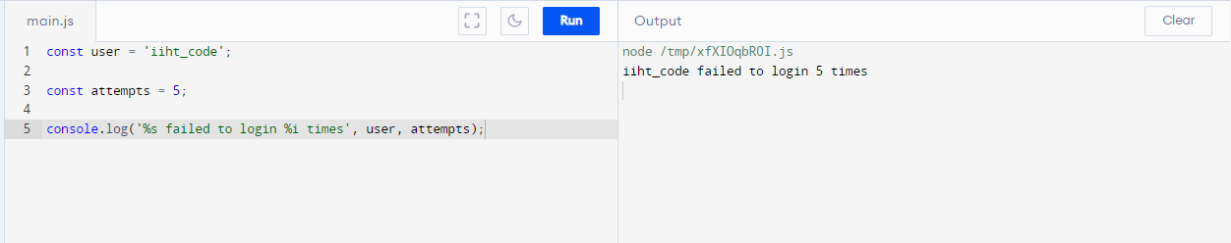

Show the output.

2. Get the console log output?

Yes

3. Using const can we define a variable in above code or not.

Yes

4. %s and %i are replaced with values of user and attempts. The specifier %s is converted to a _iiht_code_, while %i is converted to a _5_