Final Report — Comparison of Tripod Turnstile, Flap Barrier, and Swing Barrier Gates
This report compares three common pedestrian access-control gate hardware options. Costs below are gate-only estimates and exclude facial recognition, biometric/RFID readers, access-control software, cabling, civil work, and installation unless stated otherwise:

1. Tripod Turnstile
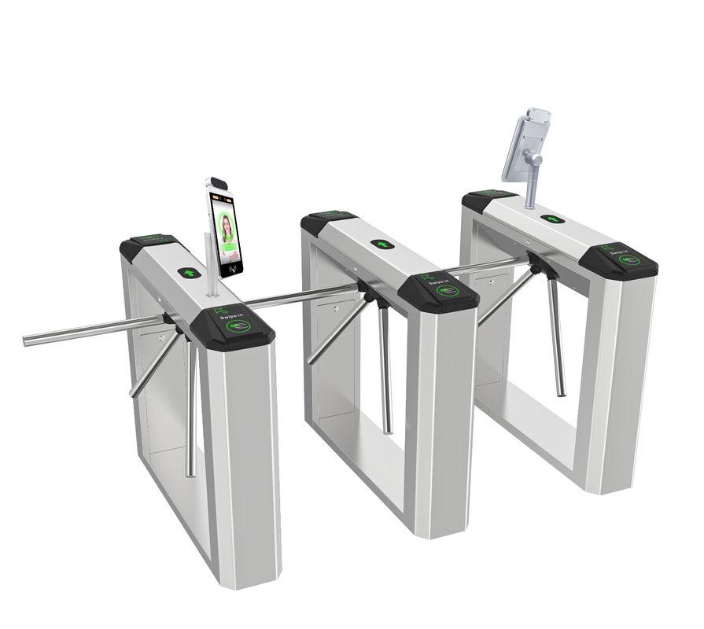
Tripod turnstiles are waist-high rotating mechanical gates consisting of three stainless-steel arms. After authentication, one rotation cycle is unlocked, allowing a single person to pass.
Advantages:
• Lowest cost
• Very durable
• Simple mechanical system
• Low maintenance
Disadvantages:
• Poor accessibility
• Industrial appearance
• Not suitable for luggage or strollers
• Can be bypassed more easily
Estimated gate-only cost for 2 units: ₹1.3L - ₹2.5L
Purchase link: Detec Tripod Turnstile Gate

2. Flap Barrier / Optical Speed Gate
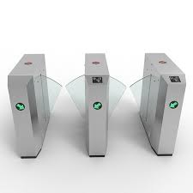
Flap barriers are high-speed optical access-control systems using retractable glass wings or flaps. Security relies heavily on optical sensors and AI-based anti-tailgating analytics.
Advantages:
• Modern premium appearance
• Very fast pedestrian flow
• Strong anti-tailgating detection
• Excellent office aesthetics
Disadvantages:
• Lower physical resistance
• Higher maintenance complexity
• Sensitive sensor calibration
• Less forgiving for luggage and pets
Estimated gate-only cost for 2 lanes: ₹4.5L - ₹8L
Purchase link: Godrej Vigiguard Flap Barriers

3. Swing Barrier / Paddle Gate
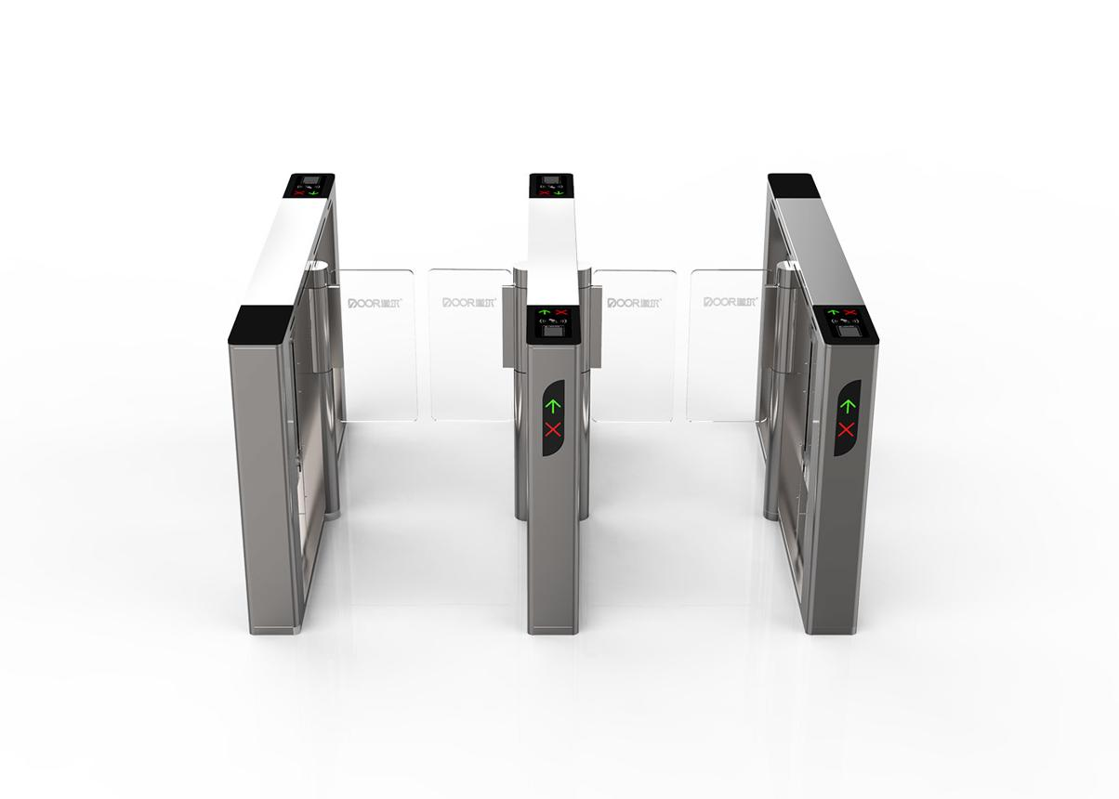
Swing barriers use motorized glass panels mounted on pivot hinges that swing open like mini automatic doors. They offer the best balance between security, comfort, and accessibility.
Advantages:
• Better physical blocking
• Excellent accessibility
• Premium hotel-like feel
• Ideal for residential projects
Disadvantages:
• Higher cost
• Larger footprint
• More complex motor assembly
Estimated gate-only cost for 2 lanes: ₹2.5L - ₹6L
Purchase link: High Quality Swing Barrier Turnstile Gate
Premium branded/custom swing barrier implementation for 2 lanes can reach ₹10L - ₹12L+.

Comparative Analysis
Factor | Tripod | Flap Barrier | Swing Barrier
Cost | Low | Medium-High | High
Security | Medium-Low | Medium | Medium-High
Accessibility | Poor | Good | Excellent
Aesthetics | Industrial | Futuristic | Luxury
Residential Suitability | Medium-Low | Good | Excellent
Throughput | Medium | Very High | High
Maintenance | Low | Medium-High | Medium

Final Recommendation
For modern residential environments, Swing Barrier Gates are the most suitable solution. They provide the best combination of premium appearance, accessibility, user comfort, family friendliness, and physical security.
Tripod turnstiles remain useful for budget or service/staff entry systems, while flap barriers are ideal for high-throughput office environments.

