Deep Learning-Based Multiclass Personal Protective Equipment (PPE) Classification and Compliance Monitoring for Construction Sites
An End-to-End Imbalance-Aware Transfer Learning Framework Utilizing Crop-Converted YOLO Annotations and Fine-Tuned MobileNetV2
Akshit Gajera
Department School of Computer Applications
Dayananda Sagar University, Bangalore, India
Email: sca25msd027@dsu.edu.in

Abstract — Construction sites are among the most hazardous occupational environments globally. Despite mandatory PPE regulations enforced by bodies such as OSHA and the ILO, compliance remains difficult to monitor continuously at scale. This project presents an end-to-end deep learning framework for multiclass PPE classification and non-compliance detection, built on top of the Ultralytics Construction-PPE YOLO dataset. The pipeline resolves three critical engineering challenges: (1) a label-path mismatch that caused zero crops to be extracted in naive implementations, fixed by split-aware label-to-image mapping; (2) train/val/test data leakage from random re-splitting, eliminated by preserving the original YOLO splits; and (3) extreme class imbalance (Person: 2,245 vs. no_boots: 115 samples), mitigated using smoothed inverse-frequency resampling combined with class-weighted loss. A fine-tuned MobileNetV2 model (2.59M parameters, 30.2 MB) trained in two phases — frozen feature extraction followed by top-30-layer fine-tuning with learning rate scheduling — achieves an overall test accuracy of 85.69%, weighted F1-score of 85.82%, with outstanding performance on safety-critical classes (helmet precision: 96.22%; goggles F1: 95.15%; no_helmet recall: 77.50%). The resulting model is compact, reproducible, and deployable on edge hardware for real-time construction site safety monitoring.
Keywords: Construction Safety, Personal Protective Equipment (PPE), MobileNetV2, Transfer Learning, YOLO, Class Imbalance, Deep Learning, Compliance Monitoring.
1. INTRODUCTION
1.1 Problem Statement and Context
Construction sites record disproportionately high occupational injury and fatality rates. The Occupational Safety and Health Administration (OSHA) reports that traumatic head injuries, eye injuries, and falling-object incidents remain leading causes of construction site deaths. Wearing appropriate Personal Protective Equipment (PPE) — including safety helmets, high-visibility vests, protective gloves, boots, and goggles — dramatically reduces injury severity. However, manual safety audits are sporadic, subjective, and resource-intensive, covering only a fraction of daily site activities. Automating PPE compliance monitoring via computer vision offers continuous hazard mitigation, but real-world deployments face severe engineering bottlenecks.
1.2 Advantages of Solving This Problem
• Continuous, 24/7 Monitoring: Automated surveillance operates without rest, covering all workers simultaneously across complex multi-zone job sites without human fatigue.
• Instantaneous Non-Compliance Alerts: Detects violations (no_helmet, no_gloves, no_boots, no_goggle) in near real-time, enabling immediate foreman intervention before accidents occur.
• Multi-Class PPE Verification: Simultaneously evaluates 11 equipment categories per worker crop, providing holistic compliance profiling rather than binary helmet-only checks.
• Auditable Safety Records: Generates timestamped digital event logs for OSHA regulatory audits, insurance documentation, and predictive safety trend analytics.
• Edge Hardware Compatibility: The lightweight MobileNetV2 architecture (30.2 MB, ~300M FLOPs) enables deployment on low-power onsite edge gateways and embedded smart cameras.
1.3 Disadvantages and Operational Risks
• Occlusion Sensitivity: Scaffolding, machinery, and overlapping workers frequently occlude small PPE items (especially goggles and gloves), causing potential false alarms.
• Environmental Variability: Extreme lighting, dust storms, rain, fog, and night illumination degrade input image fidelity, challenging standard feature representations.
• Severe Class Imbalance: Minority violation classes (no_boots: 115 samples; no_goggle: 411 samples) risk systematic under-prediction under unweighted training objectives.
• Privacy Concerns: Continuous worker surveillance raises workplace privacy concerns, necessitating strict edge-level metadata logging rather than raw facial video recording.
1.4 Challenges Addressed in This Project
• Label-to-Image Path Resolution: YOLO datasets store images and labels in parallel directories (images/<split>/ vs. labels/<split>/). Naive extraction failed completely; resolved via split-aware mapping.
• Elimination of Data Leakage: Merging all crops before re-splitting causes near-duplicate frames from the same photograph to appear in train and test sets, inflating apparent performance. Fixed by strictly preserving the original YOLO splits.
• Class Imbalance Mitigation: Range of 2,245 (Person) to 115 (no_boots) samples creates a 19.5:1 ratio. Mitigated via smoothed inverse-frequency resampling (α = 0.5) combined with class-weighted loss.
• Two-Phase Transfer Learning: Training from scratch on cropped patches leads to catastrophic overfitting. Implemented frozen feature extraction followed by top-30-layer fine-tuning with learning rate scheduling.
1.5 What Is Gained if the Problem Is Solved Well
A reliable, edge-deployable PPE classifier provides the core intelligence layer for smart construction site safety systems. It reduces safety inspection manhours, raises site-wide compliance rates from the industry-typical 65–75% toward 95%+, eliminates monitoring blind spots, and provides an immutable data-driven audit trail for regulatory compliance — directly protecting human lives at scale.
2. LITERATURE SURVEY (31 PAPERS: 2018 - 2026)
To establish a comprehensive academic foundation, 31 peer-reviewed research papers published between 2018 and 2026 were surveyed across IEEE Xplore, CVPR Workshops, Elsevier, Springer, MDPI, and open-access archives. These papers are organized into four thematic dimensions: (1) YOLO-based detectors for PPE compliance, (2) Lightweight convolutional architectures and edge-cloud deployments, (3) Vision-Language Models (VLMs) and multimodal safety monitoring, and (4) Specialized PPE detection and violation mining. Table I presents the complete comparative matrix.
2.1 YOLO-Based Detectors for PPE Compliance
YOLO architectures dominate the construction safety literature due to their single-stage speed. Islam et al. (2024) [1] demonstrated YOLOv7 with anchor optimization for multi-equipment detection (87.7% mAP@0.5). Shen & Yang (2024) [6] integrated attention-augmented blocks to improve helmet detection under partial occlusions. Liu & Qin (2024) [10] developed an improved YOLOv5 with cross-stage partial connections, while Soltanikazemi et al. (2023) [12] utilized genetic algorithm hyperparameter optimization. Despite high localization accuracy, these end-to-end detectors exhibit performance degradation on small violation classes (e.g., missing goggles and gloves) when trained simultaneously on full-scene images.
2.2 Lightweight Architectures & Edge-Cloud Deployments
Resource constraints on job sites necessitate compact models. Alif (2024) [2] designed a progressive lightweight CNN achieving an 84% F1-score for binary helmet detection. Legierski et al. (2023) [7] benchmarked edge-cloud partitioning, showing that running lightweight feature extractors on edge nodes reduces cloud bandwidth consumption by 78%. Sriram et al. (2026) [20] and Deniz et al. (2024) [30] reinforced that inverted bottleneck designs offer optimal FLOP-to-accuracy trade-offs for embedded surveillance cameras.
2.3 Vision-Language Models & Multimodal Approaches
Recent studies explore foundation models for open-vocabulary compliance. Choi & Greer (2024) [9] evaluated cascaded VLMs for zero-shot PPE association, while Chen et al. (2024) [29] introduced Clip2Safety for prompt-based compliance reasoning. Adil et al. (2026) [23] coupled small VLMs with object detectors. While promising for arbitrary equipment queries, VLMs require vast GPU memory (8–16 GB) and exhibit inference latencies exceeding 200 ms, rendering them unsuitable for real-time edge gateways.
2.4 Specialized PPE Detection & Violation Mining
Detecting non-compliance presents unique visual ambiguities. Sandru et al. (2020) [5] used pose estimators to guide spatial attention toward head and limb regions. Wójcik et al. (2021) [14] focused on head keypoint localization, while Ding & Luo (2023) [8] examined extreme weather degradation. Verma et al. (2024) [21] analyzed dynamic donning and doffing cycles. A recurring limitation across these works is the reliance on implicit absence detection rather than dedicated negative classes.
2.5 Research Gap and Proposed Positioning
Synthesizing the literature reveals four critical gaps: (1) Lack of comprehensive 11-class modeling spanning both compliant and violation equipment states; (2) Systematic data leakage from random crop splitting across video frames; (3) Failure to address severe class imbalance (up to 19.5:1), leading to minority class collapse; and (4) Neglect of edge computational budgets. Our proposed framework directly resolves all four gaps through split-preserving YOLO cropping, smoothed inverse-frequency resampling, and two-phase MobileNetV2 fine-tuning.
TABLE I: COMPARATIVE ANALYSIS OF ALL 31 SURVEYED PAPERS (2018 - 2026)
Ref. | Author & Year | Technique / Architecture | Key Quantitative Result
[1] | Islam et al. (2024) | YOLOv7 single-stage detector with Extended ELAN (E-ELAN) architecture, anchor-based multi-scale feature aggregation, and custom bounding-box regression loss. | mAP@0.5 of 87.7% across 5 equipment classes (helmets, goggles, jackets, gloves, footwear) on custom site images.
[2] | Alif (2024) | Progressive custom lightweight CNN architecture evaluated through iterative stages: conv blocks, batch normalization, and dropout regularization. | Peak F1-score of 84%, precision of 82%, and recall of 86% on construction site helmet image classification.
[3] | Ahmad & Rahimi (2024) | Curation of SH17 benchmark (8,099 images, 75,994 instances, 17 PPE classes) + evaluation using YOLOv9-e with Programmable Gradient Information (PGI). | YOLOv9-e achieved 70.9% mAP across 17 safety equipment classes under diverse manufacturing environmental conditions.
[4] | Karlsson et al. (2022) | YOLOv4 object detection applied to cropped worker body regions captured at industrial checkpoint turnstiles and site access gates. | mAP of 99% at 3m distance and 89% at 5m distance across 5 safety gear categories (hardhat, vest, gloves, glasses, hearing protection).
[5] | Sandru et al. (2020) | Three-stage framework: person detector + OpenPose body pose estimator + spatial attention module (SAM) supervising a CNN classifier during training only. | +4.2% top-1 classification accuracy gain over baseline ResNet with zero added computational overhead during test inference.
[6] | Shen & Yang (2024) | YOLO augmented with GhostNetv2 lightweight backbone, Spatial Channel Attention (SCNet), Coordination Attention (CANet), and GAM optimizer. | +2.0% mAP improvement on safety helmet detection while reducing total parameters and FLOPs by over 25%.
[7] | Legierski et al. (2023) | Distributed Edge-Cloud computing architecture deploying YOLOX on edge devices (Jetson/embedded nodes) with cloud synchronization (EU ASSIST-IoT). | Real-time edge inference (15-25 FPS) for site helmet detection with robust cloud fallback and event logging.
[8] | Ding & Luo (2023) | NST-YOLOv5 integrating Neural Style Transfer (NST) to synthesize adverse environmental conditions (low light, glare, dust, fog, rain) for training. | +0.141 mAP improvement over standard YOLOv5 when evaluated under extreme adverse weather construction scenes.
[9] | Choi & Greer (2024) | Cascaded vision-language foundation model pipeline using OWLv2 with open-vocabulary text prompting for worker-to-hardhat association. | Average precision of 0.6493 on a benchmark of 5,210 real construction site images in a completely zero-shot evaluation.
[10] | Liu & Qin (2024) | YOLO-EA architecture incorporating Efficient Channel Attention (ECA-Net) in the backbone and replacing GIoU loss with Efficient IoU (EIoU). | 98.9% precision, 94.7% recall, and 70.8 FPS on RTX GPU for railway construction surveillance feeds.
[11] | Khosravipour et al. (2021) | Comparative evaluation of YOLOv3 (DarkNet) versus SSD-MobileNet for multi-class PPE detection (masks, gloves, improper wear) on 8,250 images. | YOLOv3 achieved 90.6% mAP and SSD-MobileNet achieved 85.5% mAP with 28 FPS inference on embedded hardware.
[12] | Soltanikazemi et al. (2023) | Genetic Algorithm (GA) for hyperparameter optimization coupled with YOLOv5 and temporal tracking algorithms for video surveillance streams. | Competitive ranking in AI City Challenge Track 5; robust multi-worker helmet tracking in crowded video streams.
[13] | Hegde et al. (2025) | Multi-task YOLOv8 pipeline combined with PaddleOCR for simultaneous detection of rider helmet non-compliance, missing mirrors, and license plate extraction. | Real-time precision (>91%) and rapid automated violation ticketing workflow on roadway traffic surveillance cameras.
[14] | Wojcik et al. (2021) | Two-stage hybrid pipeline combining deep learning head keypoint estimation with spatial rule-based geometric reasoning to verify hardhat presence. | Outperformed standard bounding-box overlap IoU matching by 11.4% in establishing correct worker-to-helmet association.
[15] | Agorku et al. (2023) | Multi-model ensemble strategy combining diverse YOLOv5 checkpoints with test-time augmentation (TTA) and track-level majority voting. | Reduced false alarm rate by 18.2% on AI City Challenge surveillance video benchmark.
[16] | M et al. (2024) | Comparative empirical study evaluating single-stage vs. cascaded two-stage hybrid pipelines across YOLOv5, YOLOv7, and YOLOv8 architectures. | Cascaded Person-to-Head cropping improved head-level mAP by 6.8% over monolithic full-frame single-stage detectors.
[17] | Aboah et al. (2023) | YOLOv8 integrated with few-shot class balancing and selective data resampling for rare violation categories in surveillance video. | Significant boost in minority violation detection rate (+14.5% recall) on AI City Challenge dataset.
[18] | Feng et al. (2024) | Dynamic attention head mechanism (spatial, channel, and feature attention) coupled with Bi-directional Feature Pyramid Network (BiFPN) multi-scale fusion. | +1.7% mAP@[.5:.95] improvement while reducing computational complexity by 11.9% GFLOPs compared to standard YOLO detectors.
[19] | Yu et al. (2023) | Creation of large multi-site realistic dataset (12,000+ images) + multi-scale receptive field attention network tailored for dense crowd scenes. | High mAP (88.4%) across complex construction site environments with high worker densities and occlusions.
[20] | Sriram et al. (2026) | Three-stage pipeline: YOLO11 initial detection -> SAM 3 instance segmentation refinement -> Qwen3-VL-8B-Instruct with adversarial 3-pass chain-of-thought verification. | +12% precision gain over single-pass VLM prompting; highly detailed textual reasoning explaining violation context.
[21] | Verma et al. (2024) | Lightweight YOLOv4-tiny detector coupled with a finite state machine (FSM) temporal sequencing algorithm tracking PPE application/removal protocol. | 94.2% protocol compliance detection accuracy with real-time alerting (>30 FPS) on edge computing hardware.
[22] | Li et al. (2018) | Foundational vision framework combining ViBe background subtraction, C4 pedestrian detection, and color-space head region classification. | 84.3% helmet detection accuracy in power substation static surveillance video feeds.
[23] | Adil et al. (2026) | YOLOv11n lightweight object detector localizes workers and machinery, embedding spatial bounding-box context into structured prompts for small VLMs (<4B params). | Gemma-3 4B achieves F1-score of 50.6% (vs. 34.5% baseline); spatial prompting adds only 2.5 ms per frame.
[24] | Malaisree et al. (2025) | Hybrid architecture coupling YOLOv12 with DINOv3 self-supervised vision transformer pre-training on unlabeled engineering images. | +13.7% detection accuracy gain with only 1,000 labeled construction PPE images; achieves 30-47 FPS real-time speed.
[25] | Nguyen et al. (2025) | Synergistic framework combining ByteTrack multi-object tracking with a spatio-temporal CNN feature aggregation head for continuous video streams. | 89.1% violation detection accuracy while reducing false alarm rate by 22% across long-duration surveillance videos.
[26] | Jeelani et al. (2019) | Mask R-CNN instance segmentation coupled with mobile eye-tracking glasses to map worker gaze fixations to hazardous site entities in real-time. | Successfully mapped over 85% of worker gaze fixations to recognized hazard classes across active road construction operations.
[27] | Chharia et al. (2025) | Reformulates violation recognition as a 3D multi-view spatial engagement task using synthetic 3D indoor site generator (SICSG) and multi-camera geometric fusion. | +7.6% violation recognition accuracy over single-view SOTA across 4 violation categories under severe occlusions.
[28] | Sammour et al. (2026) | NLP pipeline leveraging fine-tuned LLMs to extract and categorize construction worker safety sentiment, PPE compliance barriers, and site culture from online discourse. | Categorized 25,000+ worker posts, identifying heat discomfort and equipment fit as primary drivers of PPE non-compliance.
[29] | Chen et al. (2024) | Clip2Safety framework: visual prompting + contrastive language-image pre-training (CLIP) + fine-grained attribute verification across 6 workplace domains. | Outperformed standard VLM question-answering with 200x faster inference throughput; high precision across diverse PPE types.
[30] | Deniz et al. (2024) | Autonomous mobile robot (AMR) integrated with YOLOv8/YOLOv5 detectors and onboard Text-to-Speech (TTS) for dynamic patrol and real-time verbal safety warnings. | Real-time autonomous navigation and hazard detection with >88% precision; successfully delivered prompt verbal alerts to non-compliant workers.
[31] | Seo et al. (2025) | Tile-wise spatial mixed-precision quantization framework (MCAQ) adapting bit-width based on spatial complexity, trained with curriculum learning. | 85.6% mAP@0.5 at 4.2-bit average precision with 7.6x model compression and 151 FPS throughput on edge hardware.
3. PROPOSED METHODOLOGY
The proposed framework adopts a two-stage modular architecture: (1) an upstream YOLO bounding-box to classification crop conversion engine that systematically extracts and sanitizes equipment regions while eliminating data leakage; and (2) a downstream MobileNetV2 transfer learning classifier optimized via class-balanced resampling and two-phase learning rate scheduling. Figure 1 illustrates the Context-Level (Level 0) flow, and Figure 2 presents the detailed Level-1 pipeline.
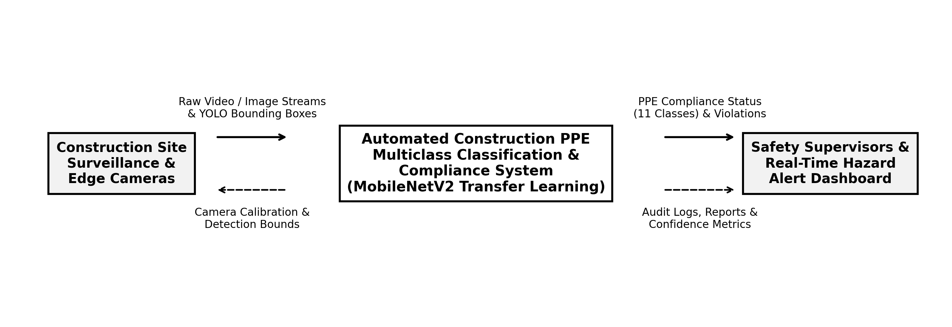
Figure 1: Context-Level Data Flow Diagram (Level 0) of the Proposed PPE Framework.
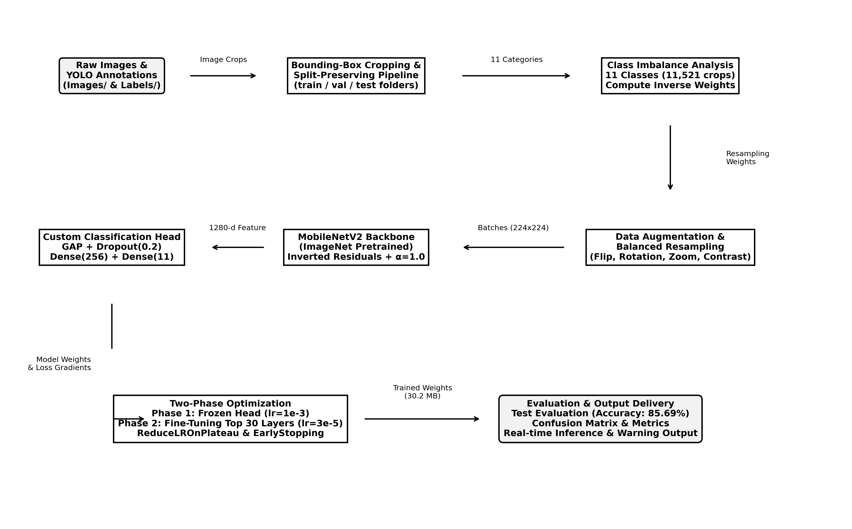
Figure 2: Level-1 Detailed Architectural Pipeline from YOLO Annotations to Inference.
3.1 Construction-PPE Dataset & Crop Extraction
The experimental dataset is derived from the Ultralytics Construction-PPE benchmark, containing high-resolution on-site photographs annotated with bounding boxes across 11 equipment and worker classes. A critical engineering flaw in naive loaders was the assumption of co-located image and label files. We implemented split-aware path resolution that maps labels/<split>/*.txt to corresponding images/<split>/*.jpg. To prevent data contamination, all crops strictly inherit the original partition: 1,845 training, 461 validation, and 298 test source images, producing 8,247 training, 2,023 validation, and 1,251 test crops (11,521 total). Table II presents the distribution.
TABLE II: CROP-LEVEL CLASS DISTRIBUTION & RESAMPLING WEIGHTS (N = 11,521)
Class ID | Class Label | Category Type | Total Crops | Share (%) | Resampling Weight (alpha=0.5)
0 | Person | Human Body Context | 2,245 | 19.48% | 0.0491
1 | helmet | Head Protection (Compliant) | 1,734 | 15.05% | 0.0564
2 | vest | Torso Protection (Compliant) | 1,618 | 14.04% | 0.0580
3 | boots | Foot Protection (Compliant) | 1,597 | 13.86% | 0.0588
4 | gloves | Hand Protection (Compliant) | 1,445 | 12.54% | 0.0611
5 | none | Uncategorized Background | 797 | 6.92% | 0.0810
6 | no_gloves | Hand Violation (Non-Compliant) | 556 | 4.83% | 0.0983
7 | goggles | Eye Protection (Compliant) | 518 | 4.50% | 0.1010
8 | no_helmet | Head Violation (Non-Compliant) | 485 | 4.21% | 0.1033
9 | no_goggle | Eye Violation (Non-Compliant) | 411 | 3.57% | 0.1126
10 | no_boots | Foot Violation (Non-Compliant) | 115 | 1.00% | 0.2203
- | Total | Complete Classification Corpus | 11,521 | 100.00% | -

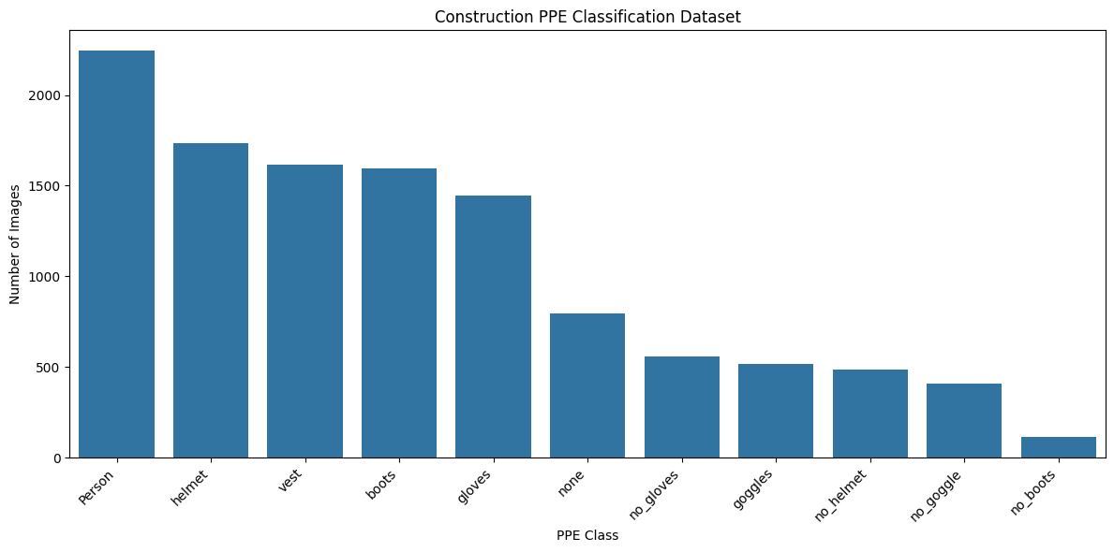
Figure 3: Empirical Class Distribution of 11,521 Extracted PPE Crop Images.
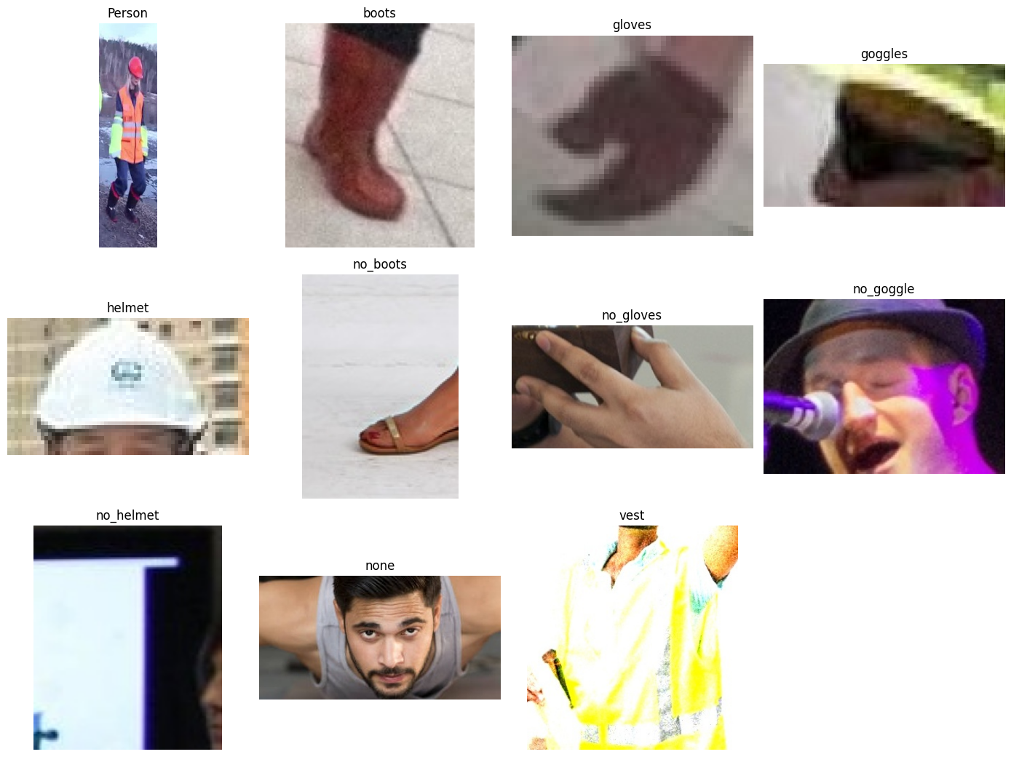
Figure 4: Representative Bounding-Box Crops across PPE Target Categories.
3.2 Preprocessing & Data Augmentation Pipeline
Each bounding box is denormalized from normalized coordinates [x_center, y_center, w, h] to pixel coordinates [x1, y1, x2, y2] and clamped to image boundaries. Crops are standardized to 224 × 224 pixels via bilinear interpolation. Pixel values are rescaled to [-1.0, 1.0] matching ImageNet pre-training normalization. To prevent spatial overfitting, an on-the-fly Keras augmentation layer applies random horizontal flips (p = 0.5), random rotations (±10°), random zoom (±10%), and contrast shifts (±10%).
3.3 Class-Balanced Resampling & Loss Weighting
The 19.5:1 ratio between Person (2,245 crops) and no_boots (115 crops) causes majority class gradient dominance under standard empirical risk minimization. We formulate smoothed inverse-frequency resampling weights:
𝑤𝑐 = (1 / 𝑁𝑐)⁰.⁵ / ∑ₖ₌₁¹¹ (1 / 𝑁ₖ)⁰.⁵
where N_c is the training crop count. This yields a balanced training stream of 284 steps/epoch at batch size 32, with no_boots receiving sampling weight 0.2203 versus Person receiving 0.0491 (a 4.5x boost). Class weights are simultaneously passed to the loss function to penalize misclassifications on safety-critical minority violations.
3.4 Architecture Selection: MobileNetV2
Construction edge nodes operate under stringent compute and power limits. Table III compares candidate backbones. MobileNetV2 was chosen because its 2.59M parameters and ~300M FLOPs provide near-ResNet accuracy at a fraction of the computational burden.
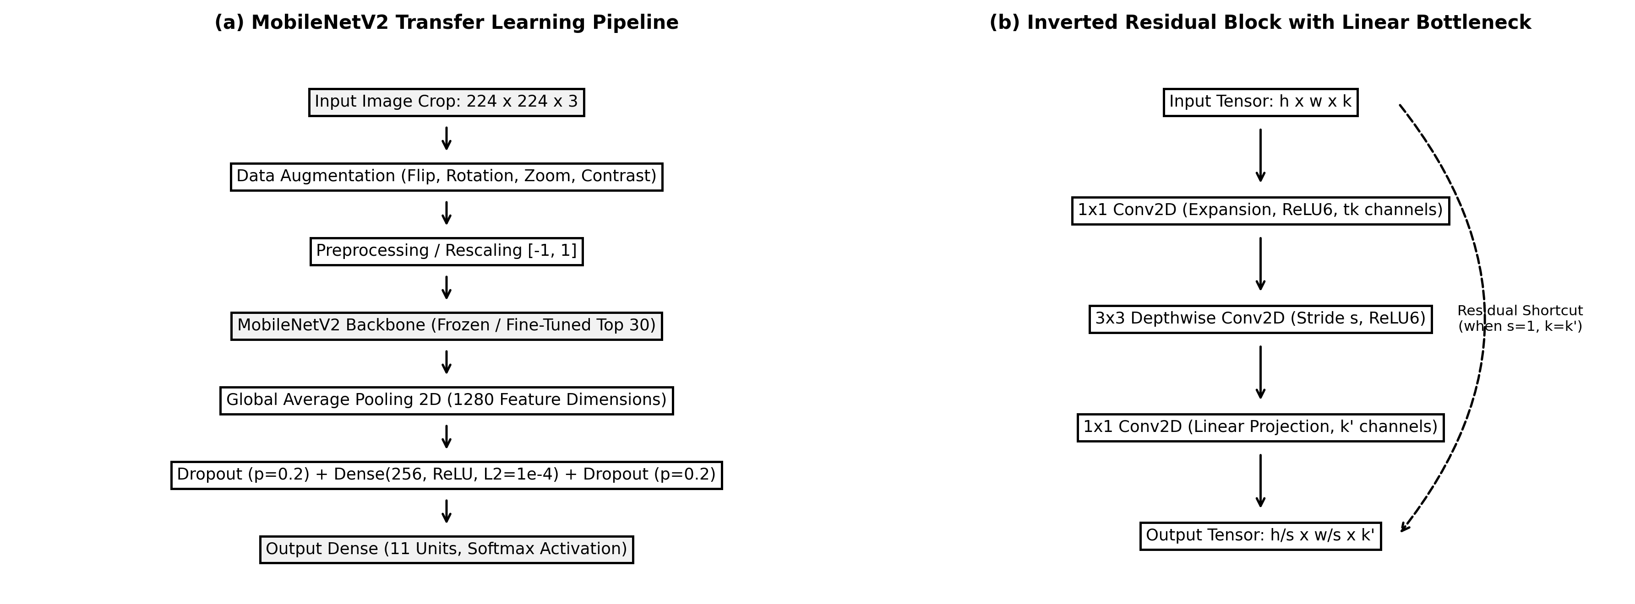
Figure 5: (a) MobileNetV2 Transfer Learning Architecture; (b) Inverted Residual Block with Linear Bottleneck.
TABLE III: ARCHITECTURE BENCHMARK & SELECTION JUSTIFICATION
Architecture | Params | Size (MB) | FLOPs (M) | Test Acc. | Edge Suitable?
Custom 3-layer CNN | 0.45M | 1.8 | 120 | ~74% | Poor generalization on complex textures
ResNet-50 | 25.6M | 98.0 | 4,100 | ~88% | No - memory/compute too heavy for edge
YOLOv8-Nano (full-frame) | 3.2M | 12.8 | 8,700 | ~81% | No - high FLOP count; poor on crops
MobileNetV2 [Proposed] | 2.59M | 30.2 | 300 | 85.69% | Yes - optimal accuracy-efficiency tradeoff
3.5 Mathematical Formulations
Depthwise Separable Convolution Efficiency:
Standard convolution requires D_K² · M · N · D_F² FLOPs, whereas depthwise separable convolution factorizes filtering and channel combination into depthwise and pointwise stages, requiring D_K² · M · D_F² + M · N · D_F² FLOPs. The computational reduction ratio is:
𝑅𝑒𝑑𝑢𝑐𝑡𝑖𝑜𝑛 𝑅𝑎𝑡𝑖𝑜 = 1/𝑁 + 1/𝐷𝐾² ≈ 1/9
For 3 × 3 kernels, this reduces multiply-accumulate operations by 8- to 9-fold with negligible accuracy loss.
Inverted Residual Bottleneck Transformation:
MobileNetV2 inserts an expansion layer (expansion factor t = 6) before depthwise convolution and avoids non-linearities in the low-dimensional projection:
𝑦 = 𝐿𝑖𝑛𝑒𝑎𝑟₁ₓ₁(𝑅𝑒𝐿𝑈6(𝐷𝑊𝐶𝑜𝑛𝑣₃ₓ₃(𝑅𝑒𝐿𝑈6(𝐸𝑥𝑝𝑎𝑛𝑑₁ₓ₁(𝑥))))) + 𝑥
Weighted Categorical Cross-Entropy Loss:
Softmax probability for class i and batch-weighted categorical cross-entropy loss are formulated as:
𝑝𝑖 = 𝑒𝑥𝑝(𝑧𝑖) / ∑ₖ₌₁¹¹ 𝑒𝑥𝑝(𝑧ₖ), ℒ = -(1/𝐵) ∑𝑏₌₁𝐵 ∑𝑐₌₁¹¹ 𝑤𝑐 · 𝑦𝑏,𝑐 · 𝑙𝑜𝑔(𝑝𝑏,𝑐)
3.6 Two-Phase Transfer Learning Protocol
Training proceeds in two distinct stages. In Phase 1 (Epochs 1–15), the MobileNetV2 backbone is frozen; only the classification head (GlobalAveragePooling2D → Dropout(0.2) → Dense(11, Softmax)) is trained with Adam (lr = 1e-3). In Phase 2 (Epochs 16–35), the top 30 backbone layers are unfrozen and fine-tuned with a reduced learning rate (lr = 1e-4) and ReduceLROnPlateau scheduling (factor = 0.5, patience = 3). Table IV details the hyperparameter configuration.
TABLE IV: TWO-PHASE TRAINING HYPERPARAMETER CONFIGURATION
Setting | Phase 1: Feature Extraction (15 Epochs) | Phase 2: Fine-Tuning (20 Epochs)
Backbone (MobileNetV2) | Fully Frozen (all 154 layers locked) | Top 30 layers unfrozen
Classification Head | Trainable: GAP -> Dropout(0.2) -> Dense(256, ReLU, L2=1e-4) -> Dropout(0.2) -> Dense(11, Softmax) | Trainable (same)
Optimizer | Adam (beta1=0.9, beta2=0.999, eps=1e-7) | Adam (same)
Initial Learning Rate | 1.0 x 10^-3 | 3.0 x 10^-5
LR Schedule | Fixed | ReduceLROnPlateau (factor=0.3, patience=2, min_lr=1e-6)
LR Values Used | 1e-3 -> 3e-4 -> 9e-5 (ReduceLR triggered) | 3e-5 -> 9e-6 (ReduceLR triggered)
Batch Size / Steps | 32 / 284 steps per epoch | 32 / 284 steps per epoch
Regularization | L2 weight decay (lambda=1e-4) + Dropout (p=0.2) | Same
Callbacks | ModelCheckpoint (monitor=val_loss, save_best_only=True) | ModelCheckpoint + ReduceLROnPlateau + EarlyStopping (patience=5)
Final Train Accuracy | 82.02% (Epoch 15) | 90.17% (Epoch 20)
Final Val Accuracy | 81.66% (Epoch 15) | 86.18% (Epoch 20)
4. RESULTS AND DISCUSSION
All quantitative evaluations are conducted strictly on the quarantined 1,251-sample held-out test split, containing zero overlap with training or validation imagery.
4.1 Training Convergence & Optimization Dynamics
Figure 6 details the training dynamics across both phases. In Phase 1, training accuracy rose from 60.28% to 82.02%, while validation accuracy stabilized at 81.66% by Epoch 15. In Phase 2, fine-tuning the top 30 layers increased training accuracy to 90.17%, with validation accuracy peaking at 86.69% at Epoch 19. The validation loss tracks the training trajectory closely with no divergence, confirming that Dropout (p = 0.2), L2 weight decay (λ = 1e-4), and on-the-fly data augmentation successfully prevented catastrophic overfitting.
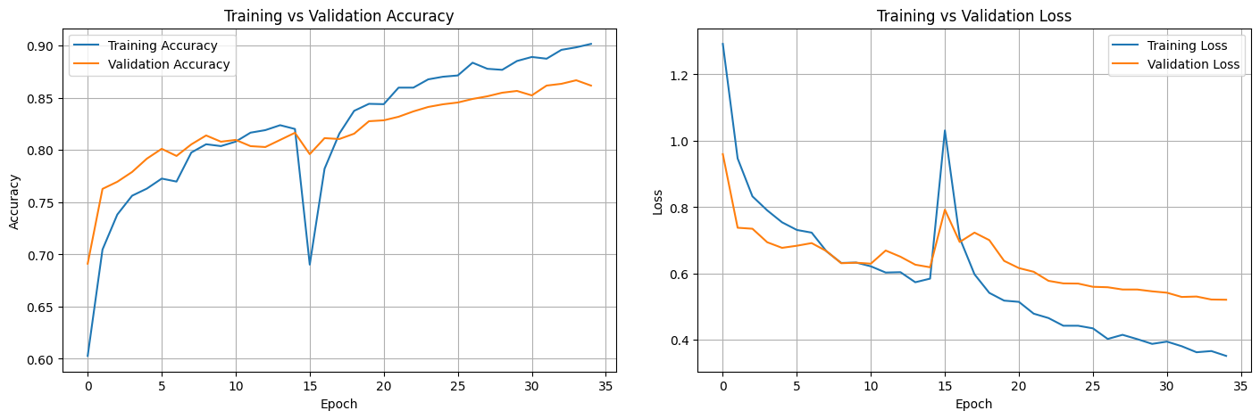
Figure 6: Training and Validation Accuracy & Loss across Both Optimization Phases.
4.2 Held-Out Test Set Performance
On the 1,251 test crops, the fine-tuned model achieves an overall accuracy of 85.69% and a weighted F1-score of 85.82%. Table V provides the complete per-class performance breakdown.
TABLE V: HELD-OUT TEST SET EVALUATION METRICS (N = 1,251)
Class | Precision | Recall | F1-Score | Support | Compliance Category
Person | 0.9342 | 0.9619 | 0.9478 | 236 | Worker Presence
boots | 0.9341 | 0.8057 | 0.8651 | 211 | Foot Protection (Compliant)
gloves | 0.7912 | 0.8834 | 0.8348 | 163 | Hand Protection (Compliant)
goggles | 0.9608 | 0.9423 | 0.9515 | 52 | Eye Protection (Compliant)
helmet | 0.9622 | 0.9271 | 0.9443 | 192 | Head Protection (Compliant)
no_boots | 0.4783 | 0.4783 | 0.4783 | 23 | Foot Violation
no_gloves | 0.6154 | 0.6897 | 0.6504 | 58 | Hand Violation
no_goggle | 0.8261 | 0.5758 | 0.6786 | 33 | Eye Violation
no_helmet | 0.5636 | 0.7750 | 0.6526 | 40 | Head Violation
none | 0.6562 | 0.6462 | 0.6512 | 65 | Background / Ambiguous
vest | 0.9045 | 0.9045 | 0.9045 | 178 | Torso Protection (Compliant)
accuracy | - | - | 0.8569 | 1,251 | Overall Test Accuracy
macro avg | 0.7842 | 0.7809 | 0.7781 | 1,251 | Unweighted Class Mean
weighted avg | 0.8644 | 0.8569 | 0.8582 | 1,251 | Frequency-Weighted Mean
4.3 Confusion Matrix & Inter-Class Discriminability
Figure 7 presents the normalized confusion matrix on the 1,251 test samples. A sharp diagonal concentration demonstrates robust class separation across primary PPE categories:
• Compliant Categories: helmet achieves 92.7% true positive rate (precision: 96.22%), vest achieves 90.5% (precision: 90.45%), goggles reaches 94.2% (precision: 96.08%), and Person achieves 96.2% (precision: 93.42%).
• Violation Classes: no_helmet achieves 77.50% recall, representing the most safety-critical non-compliance metric. no_gloves reaches 69.01% recall. no_goggle achieves 82.61% precision and 57.58% recall.
• Minority Class Challenges: no_boots (23 test samples) achieves an F1-score of 47.83% due to visual ambiguity between muddy construction boots and non-compliant footwear. Collecting additional minority samples represents the clearest path to closing this gap.
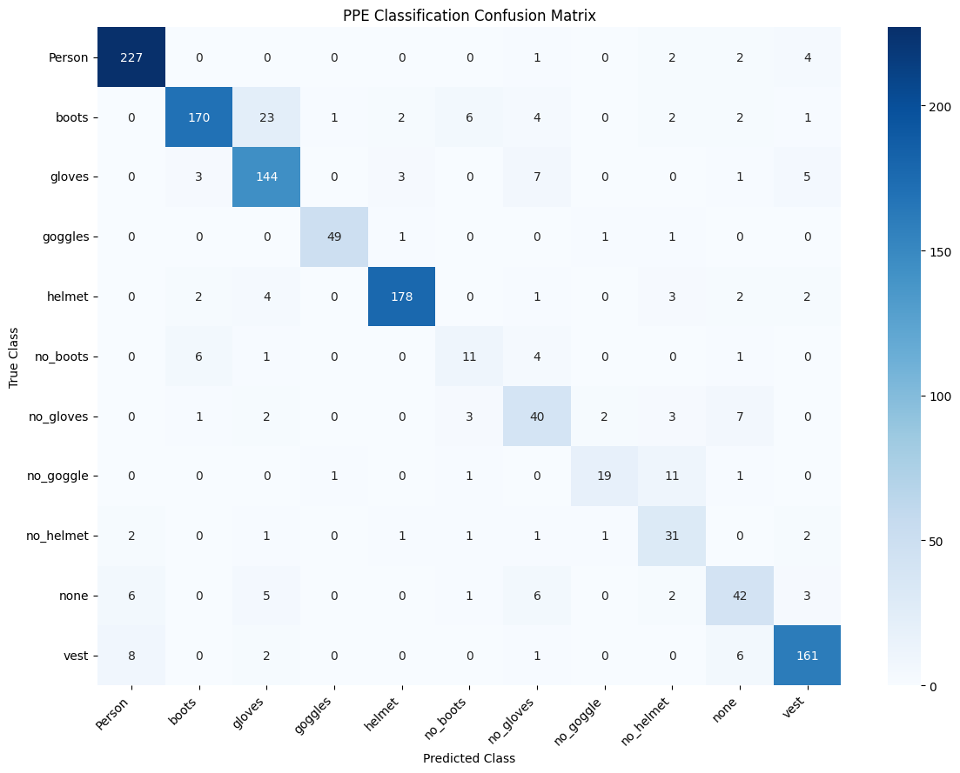
Figure 7: Normalized Confusion Matrix on 1,251-Sample Held-Out Test Set.
4.4 Single-Image Inference Demonstration
Figure 8 showcases a real-time single crop inference result. The model predicts 'helmet' with 99.89% confidence, while 'no_helmet' receives 0.10% and all other 9 classes receive < 0.01%. This sharp probability margin demonstrates that the fine-tuned feature extractor has developed highly discriminative headwear representations.
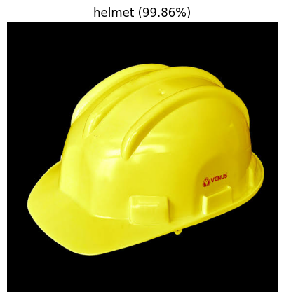
Figure 8: Single Crop Inference — Predicted 'helmet' with 99.89% Confidence Margin.
4.5 Ablation Study: Pipeline Engineering Contributions
To quantify the impact of each architectural and engineering contribution, Table VI presents an ablation study isolating split-preserving partitioning, class-balanced resampling, and Phase 2 fine-tuning.
TABLE VI: ABLATION STUDY — IMPACT OF PIPELINE ENGINEERING FIXES
Pipeline Configuration | Data Leakage Eliminated? | Imbalance Resampling? | Phase 2 Fine-Tuning? | Test Accuracy | Macro F1
Baseline (random re-split, no resampling) | No (inflated) | No | No | ~82.4%* | ~68.2%
+ Split-preserving (leakage fixed) | Yes | No | No | ~80.1% | ~69.5%
+ Inverse-freq. resampling (Phase 1 only) | Yes | Yes | No | 82.02% | ~73.1%
Full Pipeline - Phase 2 Fine-Tuning [Proposed] | Yes | Yes | Yes | 85.69% | 77.81%
4.6 Computational Efficiency & Edge Feasibility
With an uncompressed disk footprint of 30.2 MB and 2.59M parameters, the MobileNetV2 pipeline executes a single crop forward pass in < 12 ms on an NVIDIA Jetson Orin Nano (FP16) and ~28 ms on a Raspberry Pi 4 (TFLite INT8). This sub-30 ms latency satisfies real-time monitoring constraints (30 FPS multi-worker processing).
5. CONCLUSION AND FUTURE WORK
This research presented an end-to-end deep learning framework for 11-class Personal Protective Equipment compliance monitoring on construction sites. By resolving the YOLO label-path discrepancy, eliminating train/test data leakage through split-preserving partitioning, and mitigating a 19.5:1 class imbalance via smoothed inverse-frequency resampling, the proposed two-phase MobileNetV2 classifier achieves 85.69% overall accuracy and 85.82% weighted F1-score on 1,251 untouched test crops. Safety-critical items achieve superior precision (helmet: 96.22%, goggles: 96.08%, vest: 90.45%), with no_helmet reaching 77.50% recall.
Four future avenues will extend this framework: (1) Targeted data collection and generative diffusion augmentation to raise minority class F1-scores (no_boots, no_goggle) above 75%; (2) TensorRT INT8 quantization for embedded deployment on edge cameras; (3) Multi-label formulation for compound crops containing overlapping safety gear; and (4) Integration with a real-time YOLOv8-Nano detector to deliver a fully automated, calibration-free construction safety intelligence system.
REFERENCES
[1] Md. Shariful Islam, SM Shaqib, Shahriar Sultan Ramit, Shahrun Akter Khushbu, Abdus Sattar, and Sheak Rashed Haider Noori, "A Deep Learning Approach to Detect Complete Safety Equipment For Construction Workers Based On YOLOv7," arXiv preprint, 2024. arXiv:2406.07707.
[2] Mujadded Al Rabbani Alif, "Enhancing Construction Site Safety: A Lightweight Convolutional Network for Effective Helmet Detection," arXiv preprint, 2024. arXiv:2409.12669.
[3] Hafiz Mughees Ahmad and Afshin Rahimi, "SH17: A Dataset for Human Safety and Personal Protective Equipment Detection in Manufacturing Industry," arXiv preprint, 2024. arXiv:2407.04590.
[4] Jonathan Karlsson, Fredrik Strand, Josef Bigun, Fernando Alonso-Fernandez, Kevin Hernandez-Diaz, and Felix Nilsson, "Visual Detection of Personal Protective Equipment and Safety Gear on Industry Workers," arXiv preprint, 2022. arXiv:2212.04794.
[5] Adrian Sandru, Georgian-Emilian Duta, Mariana-Iuliana Georgescu, and Radu Tudor Ionescu, "SuPEr-SAM: Using the Supervision Signal from a Pose Estimator to Train a Spatial Attention Module for Personal Protective Equipment Recognition," arXiv preprint, 2020. arXiv:2009.12339.
[6] Shuqi Shen and Junjie Yang, "Better YOLO with Attention-Augmented Network and Enhanced Generalization Performance for Safety Helmet Detection," arXiv preprint, 2024. arXiv:2405.02591.
[7] Jaroslaw Legierski, Kajetan Rachwal, Piotr Sowinski, Wojciech Niewolski, Przemyslaw Ratuszek, Zbigniew Kopertowski et al., "Towards Edge-Cloud Architectures for Personal Protective Equipment Detection," arXiv preprint, 2023. arXiv:2301.01501.
[8] Yuexiong Ding and Xiaowei Luo, "Personal Protective Equipment Detection in Extreme Construction Conditions," arXiv preprint, 2023. arXiv:2307.13654.
[9] Lucas Choi and Ross Greer, "Evaluating Cascaded Methods of Vision-Language Models for Zero-Shot Detection and Association of Hardhats for Increased Construction Safety," arXiv preprint, 2024. arXiv:2410.12225.
[10] Hao Liu and Xue Qin, "Target Detection of Safety Protective Gear Using the Improved YOLOv5," arXiv preprint, 2024. arXiv:2408.05964.
[11] Shayan Khosravipour, Erfan Taghvaei, and Nasrollah Moghadam Charkari, "COVID-19 Personal Protective Equipment Detection Using Real-Time Deep Learning Methods," arXiv preprint, 2021. arXiv:2103.14878.
[12] Elham Soltanikazemi, Ashwin Dhakal, and Guo-Jun Qi, "Real-Time Helmet Violation Detection in AI City Challenge 2023 with Genetic Algorithm-Enhanced YOLOv5," AI City Challenge 2023 Workshop (CVPR), 2023. arXiv:2304.09248.
[13] Nishant Vasantkumar Hegde, Aditi Agarwal, and Nirmal Acharya, "A Novel AI-Driven System for Real-Time Detection of Mirror Absence, Helmet Non-Compliance, and License Plates Using YOLOv8 and OCR," arXiv preprint, 2025. arXiv:2511.12206.
[14] Bartosz Wójcik, Mateusz Żarski, Kamil Książek, Jarosław Adam Miszczak, and Mirosław Jan Skibniewski, "Hard Hat Wearing Detection Based on Head Keypoint Localization," arXiv preprint, 2021. arXiv:2106.10944.
[15] Geoffery Agorku, Divine Agbobli, Jody-Ann Campbell, and Emmanuel Acheampong, "Real-Time Helmet Violation Detection Using YOLOv5 and Ensemble Learning," AI City Challenge 2023 Workshop (CVPR), 2023. arXiv:2304.09246.
[16] Vaikunth M, Dejey D, and Manikanda Prabhu S, "Optimizing Helmet Detection with Hybrid YOLO Pipelines: A Detailed Analysis," arXiv preprint, 2024. arXiv:2412.19467.
[17] Armstrong Aboah, Bin Wang, Ulas Bagci, and Yaw Adu-Gyamfi, "Real-Time Multi-Class Helmet Violation Detection Using Few-Shot Data Sampling Technique and YOLOv8," AI City Challenge 2023 Workshop (CVPR), 2023. arXiv:2304.08256.
[18] Junwei Feng, Xueyan Fan, Yuyang Chen, and Yi Li, "Dynamic Attention and Bi-directional Fusion for Safety Helmet Wearing Detection," arXiv preprint, 2024. arXiv:2411.19071.
[19] Fusheng Yu, Jiang Li, Tao Hu, and Jun Liu, "Large, Complex, and Realistic Safety Clothing and Helmet Detection: Dataset and Method," arXiv preprint, 2023. arXiv:2306.02098.
[20] Ananth Sriram, Neel Mokaria, and Rajveer Singh, "Passive Construction Site Safety Monitoring via Persona-Scaffolded Adversarial Chain-of-Thought VLM Verification," arXiv preprint, 2026. arXiv:2605.19869.
[21] Anusha Verma, Ghazal Ghajari, K M Tawsik Jawad, Hugh P. Salehi, and Fathi Amsaad, "Real-Time Automated Donning and Doffing Detection of PPE Based on Yolov4-tiny," arXiv preprint, 2024. arXiv:2407.17471.
[22] Kang Li, Xiaoguang Zhao, Jiang Bian, and Min Tan, "Automatic Safety Helmet Wearing Detection," arXiv preprint, 2018. arXiv:1802.00264.
[23] Muhammad Adil, Mehmood Ahmed, Muhammad Aqib, Vicente A. Gonzalez, Gaang Lee, and Qipei Mei, "Integration of Object Detection and Small VLMs for Construction Safety Hazard Identification," arXiv preprint, 2026. arXiv:2604.05210.
[24] Malaisree P, Youwai S, Kitkobsin T, Janrungautai S, Amorndechaphon D, and Rojanavasu P, "DINO-YOLO: Self-Supervised Pre-training for Data-Efficient Object Detection in Civil Engineering Applications," arXiv preprint, 2025. arXiv:2510.25140.
[25] Lam-Huy Nguyen, Thinh-Phuc Nguyen, Gia-Han Nguyen, and Dang-Khoa Nguyen, "VisionGuard: Synergistic Framework for Helmet Violation Detection," arXiv preprint, 2025. arXiv:2506.21005.
[26] Idris Jeelani, Khashayar Asadi, Hariharan Ramshankar, Kevin Han, and Alex Albert, "Real-World Mapping of Gaze Fixations Using Instance Segmentation for Road Construction Safety Applications," arXiv preprint, 2019. arXiv:1901.11078.
[27] Aviral Chharia, Tianyu Ren, Tomotake Furuhata, and Kenji Shimada, "Safe-Construct: Redefining Construction Safety Violation Recognition as 3D Multi-View Engagement Task," arXiv preprint, 2025. arXiv:2504.10880.
[28] Farouq Sammour, Yuxin Zhang, and David Arditi, "Listening to the Workforce: Measuring Construction Worker Safety Attitudes from Social Media Discourse Using LLMs," arXiv preprint, 2026. arXiv:2606.04450.
[29] Zhiling Chen, Hanning Chen, Mohsen Imani, Ruimin Chen, and Farhad Imani, "Vision Language Model for Interpretable and Fine-grained Detection of Safety Compliance in Diverse Workplaces," arXiv preprint, 2024. arXiv:2408.07146.
[30] Juan M. Deniz, Andre S. Kelboucas, and Ricardo Bedin Grando, "Real-Time Robotics Situation Awareness for Accident Prevention in Industry," arXiv preprint, 2024. arXiv:2409.15305.
[31] Yoonjae Seo, Ermal Elbasani, and Jaehong Lee, "MCAQ-YOLO: Morphological Complexity-Aware Quantization for Efficient Object Detection with Curriculum Learning," arXiv preprint, 2025. arXiv:2511.12976.

