MINI PROJECT REPORT

xv6 Plus Operating System Extensions
Memory Management Threads Synchronization Signals and Debugging
Submitted in partial fulfillment of the requirements for the degree of
Bachelor of Engineering
in
Computer Science and Business System
Submitted By
Akshit Mishra and Nikunj Trehan
Roll Numbers ______________________________
Under the supervision of
________________________________________
Supervisor name and designation

DEPARTMENT OF COMPUTER SCIENCE AND ENGINEERING
THAPAR INSTITUTE OF ENGINEERING AND TECHNOLOGY
PATIALA 147004
December 2026

DECLARATION
We declare that this report records the xv6 Plus project implementation, integration and experiments carried out during the fifth semester in 2026. The project extends MIT xv6 and uses established operating system techniques and cited academic resources. Inherited software, project additions, related assignments and assistance are identified in the report. We do not claim authorship of the original xv6 operating system.
The report presents the combined project. Statements about experimental behavior refer to the recorded source versions and configurations. Institutional approval, signatures, similarity reports and AI review artifacts must be completed through the department process.
Date ____________________
Roll Number | Name | Signature
________________ | Akshit Mishra | ________________
________________ | Nikunj Trehan | ________________

Counter Signed By
Faculty Mentor ______________________________

ABSTRACT
xv6 Plus extends the RISC V xv6 teaching kernel with demand allocation, copy on write fork, observable memory statistics, FIFO and Clock disk swapping, shared address space kernel threads, futex based synchronization, system call tracing, asynchronous user signals and an in guest debugger. The implementation coordinates page table ownership, fault recovery, sleepable I/O and member lifecycle rather than treating each extension as an isolated utility.
The historical eager checkpoint cannot immediately back a 200 MiB request or duplicate an 80 MiB resident process in a 128 MiB guest. Deferred reservation and COW change these outcomes in the tested workloads. Disk paging allows a checked 12 MiB workload to finish under an 8 MiB managed memory limit. The thread and synchronization tests verify shared results and lifecycle invariants, while tracing, signals and debugging add runtime observation and control.
The report describes file purposes, important functions, before and after behavior, installation, repairs, experiments and evidence without reproducing full source files. Historical captures and fresh final integration runs remain distinct. Limitations include single CPU eviction, finite backing store, restricted thread operations, compact signal semantics and best effort debugger unwinding. Timing observations are not presented as universal speedups.

TABLE OF CONTENTS
1 Introduction 1
1.1 Project overview 1
1.2 Problem statement 1
1.3 Scope and comparison boundary 2
1.4 Main outcomes 2
2 Background 3
2.1 Host environment and target machine 3
2.2 xv6 execution model 3
2.3 Pages and address translation 4
2.4 Allocation and process duplication 4
2.5 Paging and replacement 5
2.6 Threads and synchronization 5
2.7 Tracing signals and debugging 6
3 Objectives 7
3.1 Improve memory use and supported working capacity 7
3.2 Support shared execution and coordinated applications 7
3.3 Make the integrated system inspectable and reproducible 7
4 Methodology 8
4.1 Development sequence 8
4.2 Environment installation and verification 8
4.3 Setup repairs and baseline selection 9
4.4 Integrated architecture 10
4.5 Lazy allocation implementation 11
4.6 Copy on write implementation 12
4.7 Memory statistics interface 14
4.8 Swap mechanism and managed memory limit 15
4.9 FIFO and Clock replacement 17
4.10 Thread compatible memory foundation 18
4.11 Kernel thread creation and lifecycle 18
4.12 Futex wait and wake 20
4.13 User synchronization library 21
4.14 Application demonstrations 21
4.15 System call tracing 22
4.16 Signal delivery and restoration 22
4.17 Kernel debugger support 23
4.18 Interactive debugger tool 24
4.19 Final subsystem integration 24
4.20 Regression strategy and evidence preservation 25
5 Observations and Findings 26
5.1 How to read the comparisons 26
5.2 Lazy reservation and sparse access 26
5.3 COW capacity and isolation 27
5.4 Fork benchmark measurements 28
5.5 Paging before and after 29
5.6 Fork while memory is swapped 31
5.7 FIFO and Clock observations 31
5.8 Thread and synchronization observations 33
5.9 Trace signal and debugger comparisons 35
5.10 Debugger walkthrough 36
5.11 Fresh final integration validation 37
5.12 Failures encountered and repairs 39
5.13 What the evidence establishes 41
6 Limitations 42
6.1 Memory and paging boundaries 42
6.2 Thread and library boundaries 42
6.3 Signals tracing and debugger boundaries 42
6.4 Measurement and evidence boundaries 43
7 Conclusions and Future Work 44
7.1 Conclusions 44
7.2 Future work 44
8 Bibliography and References 46
Appendix A Complete implementation file inventory 49
A.1 Modified original xv6 files 49
A.2 Added kernel and library modules 51
A.3 Added tests workloads and demonstration targets 53
Appendix B Reproduction and evaluator demonstration 56
B.1 Normal integrated demonstration 56
B.2 Memory pressure and policy comparison 57
B.3 Interactive debugger sequence 57
B.4 Evidence for oral explanation 57
Appendix C Plagiarism report 58
Appendix D AI assistance and verification record 59

1 Introduction

1.1 Project overview
xv6 Plus extends the RISC V edition of MIT xv6 with demand allocated memory, copy on write process creation, memory statistics, disk backed paging, kernel threads, synchronization primitives, system call tracing, asynchronous signals and an in guest debugger. The project retains xv6 as a small teaching operating system and makes its mechanisms directly observable through commands, controlled workloads and regression tests.
The principal outcome is an integrated kernel and user library rather than a collection of independent demonstrations. A memory fault may require allocation or disk access; the calling context may be a thread sharing its page table with other members; a debugger may stop a process before its first user instruction; and a signal may redirect a saved user context. Correct integration therefore requires consistent ownership, locking, trap handling and lifecycle rules across these paths.
This report explains the original behavior, the purpose of every added or modified source file, the important functions and data structures, implementation steps, observed comparisons and practical limits. Complete source files are not reproduced. File inventories and concise descriptions identify what was written and why, while embedded captures and console excerpts document results. Work is presented as one project without dividing technical chapters by individual contribution.

1.2 Problem statement
The selected eager allocation baseline immediately backs a positive sbrk request with physical pages and duplicates resident user pages during fork. Large reservations can fail before their pages are used, and a large resident process can be unable to fork even when its child would initially read the same data. The baseline has no disk swapping, project memory statistics interface, shared address space kernel thread API, futex based user synchronization, selectable system call tracing, user signal handlers or parent controlled in guest debugger.
The project addresses these limitations while preserving the original process, filesystem and system call behavior exercised by usertests. Functional expansion is distinguished from performance optimization: signals and debugger facilities add observability and control; they do not inherently accelerate ordinary application execution. Likewise, swapping increases the working capacity of memory constrained runs at the cost of disk transfers.

1.3 Scope and comparison boundary
The comparison reference is the historical upstream commit c4de4b0 and the project checkpoint v0.0. The initially cloned upstream revision f780d78 already contained lazy allocation, so it would be inaccurate to describe every current MIT xv6 release as eager. Historical comparisons use the recorded eager checkpoint, with later results labelled by their own milestone and configuration.
Memory milestones v0.1 through v0.4 introduce lazy allocation, copy on write, memstat and swapping. The thread foundation covers the v0.5 preparation and v0.6 through v0.9 implementation. The remaining work introduces tracing, signals and debugger facilities. Final integration incorporates both development lines, retains their actual authorship and tests the combined code. A version label is a checkpoint name, not a mathematical decimal or a substitute for test evidence.

1.4 Main outcomes
The historical 200 MiB reservation changes from failure with eager backing to success with deferred backing. A sparse 256 MiB workload completes after explicitly writing 656 pages. A custom 80 MiB process test changes from fork failure to successful parent and child isolation using copy on write. Recorded fork loop timings fall from 38 ticks before COW to 3 or 4 in COW only observations, with later integrated observations reported separately.
With an 8 MiB xv6 managed memory limit, a 12 MiB checked workload fails before swapping and completes with zero detected data mismatches after swapping. Shared address space threads support coordinated work with mutexes, conditions and semaphores. Tracing reveals selected system call returns, signals invoke user handlers and restore execution state, and the debugger stops a child, inspects its registers and memory, inserts software breakpoints and produces symbolized frame traces. The observations chapter distinguishes these measured outcomes from properties not established by the tests.

2 Background

2.1 Host environment and target machine
Windows is the host operating system. Ubuntu runs through Windows Subsystem for Linux version 2 and provides the build environment. The RISC V compiler executes in Ubuntu and emits target machine code; QEMU then emulates the RISC V machine that boots xv6. Ubuntu is therefore the development system, while xv6 is the separate experimental operating system under test. The project does not replace Windows or install xv6 as the laptop operating system. [1]
The layers are Windows, WSL2 Linux, the build tools and QEMU, and finally the xv6 kernel with its user programs. Paths under /mnt/c expose the Windows C drive to Ubuntu. Keeping the project inside the supplied Windows workspace makes the same source visible to Windows editors and the Linux toolchain, although filesystem operations can be slower than in a native Linux home directory.
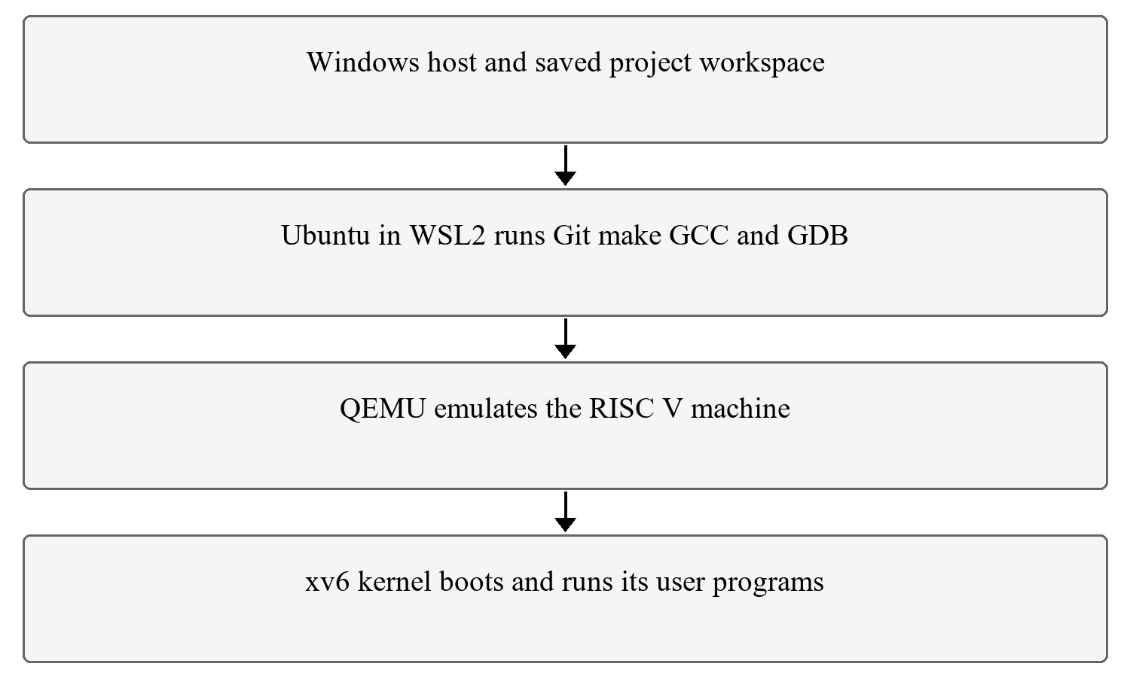
Figure 1 Development and execution environment

2.2 xv6 execution model
xv6 provides processes, virtual address spaces, a scheduler, traps, system calls, a filesystem and device drivers. A user program enters the kernel using a system call trap. The kernel decodes the system call number from the saved argument register, invokes a handler and places its result in the saved return register. The trampoline switches page tables and restores user registers on the return path. These inherited components provide the basis for the added interfaces. [2]
The project modifies selected original files and adds new modules. It does not recreate the scheduler, filesystem or instruction set. Original license and upstream history remain intact. Existing tests and utilities are retained unless an integration change is explicitly identified in the file inventory.

2.3 Pages and address translation
The basic page size is 4096 bytes, or 4 KiB. The project uses the RISC V Sv39 page table layout with three levels of translation. User virtual addresses are translated to physical frames using page table entries. Permission bits determine whether a mapping is valid, accessible to user mode, readable, writable or executable. A denied or missing translation raises a fault that records the faulting virtual address and access cause. [2], [3]
The software bits PTE_COW and PTE_SWAP distinguish a protected shared page from a page whose contents reside in the swap area. PTE_A is the hardware accessed indication used by Clock. These meanings are separate: a missing lazy page has never needed physical backing, whereas a swapped page contains earlier program data that must be recovered. Treating both cases as an empty zero page would corrupt a program.

2.4 Allocation and process duplication
sbrk changes a process heap boundary and returns the previous boundary, or a failure value. In the eager reference, a positive request calls growproc and uvmalloc to allocate and map physical pages immediately. Lazy allocation records the new permitted address range and defers frame allocation until access. The reservation is an address space commitment within the implementation limits, not a guarantee that every reserved byte can remain resident. [4]
fork creates a new process. Eager duplication allocates and copies each resident user page. COW shares the existing frames while removing write permission from originally writable mappings. A later write obtains a private copy if the frame remains shared. Reference counting prevents a frame from being returned to the allocator until its final owner releases it. The MIT COW lab describes the same established mechanism; this project integrates it with its own fault module and swapping rules. [5]

2.5 Paging and replacement
When resident memory is insufficient, disk backed paging transfers eligible pages to secondary storage and later retrieves them on demand. Replacement policy decides which eligible resident page to remove; it is separate from the disk transfer mechanism. FIFO selects the oldest tracked eligible frame. Clock inspects recent access information and grants an accessed page a second chance. Neither policy creates more physical memory. [6], [7]
The hot and cold terminology describes locality in an access pattern. Frequently revisited pages form a hot subset, while other pages are visited less frequently. The workload supplies the references, the CPU updates accessed bits, and Clock responds to those bits. The policy does not read the workload source or attach permanent hot or cold labels. Denning's working set paper provides research context, and the Belady paper explains why simple replacement policies require workload specific evaluation. The project does not reproduce either paper's experiment. [8], [9]

2.6 Threads and synchronization
Threads provide distinct execution contexts that share an address space. The project represents each member with its own schedulable proc entry and trapframe while the leader owns the shared heap size and page table. Shared variables allow direct communication, but concurrent read modify write operations can lose updates unless protected. Mutexes provide mutual exclusion, conditions support waiting for predicates, and semaphores count available permits. [10], [11]
A futex combines user memory state with a kernel sleep and wake service. The uncontended library operation can complete through atomic instructions without entering the kernel; contention causes the caller to sleep. The compare and sleep transition must be coordinated with wake to avoid a lost notification. The project has its own educational implementation, not the Linux futex ABI or a POSIX threads library. MIT also provides a related user level thread switching exercise, which differs from the kernel scheduled shared address space members implemented here. [16]

2.7 Tracing signals and debugging
Tracing observes selected system call names and return values at dispatch. The mask follows process creation and, after integration, thread creation. The design corresponds conceptually to the MIT system calls lab. Its console output adds diagnostic work, so an enabled trace can alter timing. The implementation does not record every system call argument. [12]
Signals are asynchronous notifications represented by pending bits and user handler addresses. Delivery saves the interrupted user state, redirects execution to a handler and arranges a restorer that invokes sigreturn. This is a compact Unix inspired interface, not full POSIX signal semantics. MIT's traps and alarm exercises provide related background in returning from a user handler; they are not an identical specification for this signal module. [13]
The debugger is a user program supported by six kernel calls. A child opts into parent control, stops after exec and stops again on a breakpoint exception. The user tool reads ELF function symbols, modifies eligible target instructions and unwinds a frame pointer chain. RISC V instruction encoding, the calling convention, page permissions and instruction cache synchronization all matter to this facility. [3], [14]

3 Objectives

3.1 Improve memory use and supported working capacity
Implement lazy allocation and COW so that unused reservations and unchanged forked data do not require immediate duplicate physical backing. Add controlled disk swapping with FIFO and Clock, and expose memory counters that make faults, allocations and transfers observable. Validate data correctness and distinguish virtual reservation from resident usage.

3.2 Support shared execution and coordinated applications
Extend the process model with kernel threads, per member trapframes and explicit create, join and exit semantics. Add futex based mutexes, condition variables and semaphores. Demonstrate shared computation, bounded queues, resource limits, lifecycle handling and memory interactions under both single CPU and SMP configurations.

3.3 Make the integrated system inspectable and reproducible
Provide selective tracing, user signal handlers and a parent controlled debugger; preserve original behavior through regression testing; and record source versions, build configuration, command output and known limits. Present one coherent architecture, an auditable file map and reproducible demonstrations suitable for evaluation.

4 Methodology

4.1 Development sequence
The implementation proceeds through a verified eager baseline, memory extensions, thread compatible memory preparation, kernel thread lifecycle, futexes, a user synchronization library, application demonstrations, tracing, signals, debugger primitives and the debugger tool. Each stage adds a narrow behavior and checks the earlier features before the next stage is integrated. This sequence exposes interaction failures that a demonstration of only the newest command would miss.
The baseline and feature versions are preserved by Git commits and tags. Branches were used to isolate simultaneous development and documentation revisions. They are not required for naming versions: a single main branch can contain every integrated version, with tags identifying stable points. Completed branches can be removed after their commits are reachable from main and preserved by the repository history.

4.2 Environment installation and verification
From Windows, WSL2 and Ubuntu were installed and Ubuntu initialized. Inside Ubuntu, the package index was updated and the RISC V toolchain, debugger, Git and build utilities were installed. The update and installation are separate commands; combining them without an appropriate separator was an early setup mistake. Package versions were checked before cloning and building.
sudo apt update
sudo apt install -y git build-essential gdb-multiarch qemu-system-misc gcc-riscv64-linux-gnu binutils-riscv64-linux-gnu perl
git --version
riscv64-linux-gnu-gcc --version
qemu-system-riscv64 --version
gdb-multiarch --version
The main recorded environment uses Ubuntu 26.04.1 LTS under a microsoft standard WSL2 kernel, GCC 15.2.0, QEMU 10.2.1, GDB 17.1 and Git 2.53.0. A second recorded workstation uses Ubuntu 24.04 with GCC 13.3.0, QEMU 8.2.2, GDB 15.1 and Git 2.43.0. These are separate observations rather than one inconsistent environment. The final validation records retain the actual build outputs and configuration.
The source was cloned into the supplied Windows workspace and built from its /mnt/c equivalent. The original clone name xv6 plus is a project directory, not a separate operating system installation. The build creates the kernel executable, user executables and a filesystem image; QEMU boots these artifacts and presents the xv6 shell.
cd "/mnt/c/Users/akshi/OneDrive/Documents/TIET/Sem-5/Mini Project/xv6-plus"
make clean
make qemu CPUS=1 RAM_MB=128 SWAP_POLICY=1
The shell prompt inside xv6 is different from the Ubuntu prompt. Commands such as memstat and usertests run inside xv6. Git and make run after leaving QEMU. Ctrl A followed by X exits QEMU. A laptop shutdown ends the emulator, not saved source changes or commits; work resumes by reopening Ubuntu, returning to the repository and rebuilding or booting as needed.

4.3 Setup repairs and baseline selection
The project directory contains a space. An unquoted deterministic build flag containing CURDIR was split into separate compiler arguments and GCC rejected the ffile prefix map option. The project removed that problematic flag from this historical Makefile rather than moving the required workspace. Quoting the working directory alone does not correct an unquoted flag constructed inside make.
An early kernel boot also stopped before reaching the xv6 shell. The captured monitor state showed a program counter of zero. The retained build repair explicitly selected the rv64gc ISA for compilation and assembly. Subsequent captures show the kernel booting and starting sh. The report records the observed repair and resulting boot; it does not infer that every apparent terminal pause has this cause. GCC's target option reference explains the march selection. [15]
Because the initially cloned upstream already supported lazy allocation, the project selected an older eager revision as the reference. baseline.c was added to make the large reservation comparison visible as a single reproducible command. The baseline was first built and checked with the inherited regression suite, and its source identity was retained before the feature stages.

4.4 Integrated architecture
User commands call library wrappers and generated system call stubs. The trap entry saves registers to the current member's trapframe. Dispatch routes the request to a process, memory, thread, futex, signal or debugger handler. Shared page table changes use ptlock; thread membership and process parent relationships use wait_lock and member locks; swap disk transfers use a sleep lock and run outside spinlocks.
The fault module centralizes the three recovery cases: an untouched lazy page receives zeroed memory, a writable COW access receives private backing when needed, and a swapped mapping is restored from its encoded disk slot. The same module is consulted by kernel copies when the current process's user buffer requires recovery. New subsystem code therefore extends the original kernel paths instead of requiring applications to handle ordinary page faults themselves.
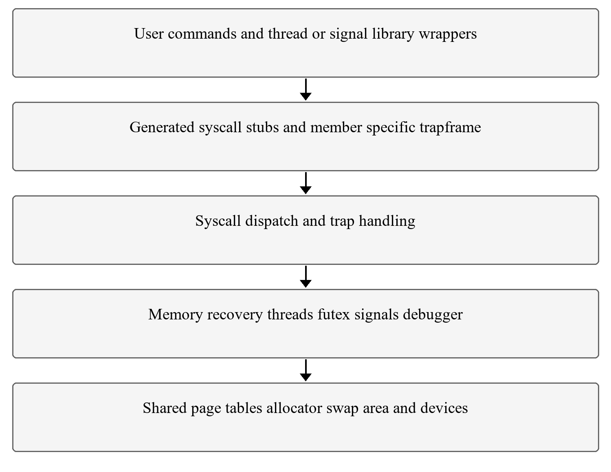
Figure 2 Integrated xv6 Plus architecture

4.5 Lazy allocation implementation

4.5.1 Earlier allocation path
In the eager reference, sys_sbrk obtains the requested byte count, remembers the current process size, calls growproc and returns the old size. growproc invokes uvmalloc for growth. uvmalloc iterates over pages, calls kalloc, zeroes each frame and installs a user mapping. Failure tears down the partial allocation and returns an error. This is why a 200 MiB request cannot be eagerly backed by the 128 MiB QEMU configuration after kernel overhead.

4.5.2 Changed reservation and fault behavior
sys_sbrk now handles positive growth by validating arithmetic and the permitted user limit, then updating the authoritative heap size without mapping new pages. The integrated version stores that size on the process leader and serializes it with ptlock so two members cannot reserve the same heap range. Negative growth retains actual deallocation, but is rejected while multiple members exist because removing a mapping without remote TLB invalidation would be unsafe.
The new kernel/pgfault.c defines handle_page_fault. It checks the requested access and user limit, rounds the virtual address down to a page boundary, inspects the PTE and allocates a frame for a valid untouched heap page. The frame is zeroed, mapped readable and writable for user access, registered for replacement and counted. Instruction fetches from lazy heap pages are rejected; guard pages and genuinely forbidden accesses remain invalid.
kernel/trap.c identifies instruction, load and store fault causes and calls this handler with an access classification. Successful recovery retries the interrupted user instruction; failure kills the process. kernel/vm.c changes unmapping and copying to tolerate sparse address spaces and makes user copy operations fault aware. A hole inside a valid lazy reservation is different from an arbitrary address outside the process size.
The integrated handler releases ptlock before an allocation that may sleep, then reacquires it and rechecks the mapping. Another member may have populated the page during that interval. Rechecking prevents duplicate mappings and permits the unused temporary allocation to be released. This is essential when multiple threads first touch the same page.

4.5.3 Files and effect
Original files sysproc.c, trap.c, vm.c, defs.h and the Makefile receive reservation, dispatch, sparse mapping and build wiring changes. pgfault.c is a newly created kernel module and is later extended for COW and swap. baseline.c and lazytest.c are new project test programs. The effect is deferred physical backing and demand zero behavior, with failure still possible when real backing is exhausted.
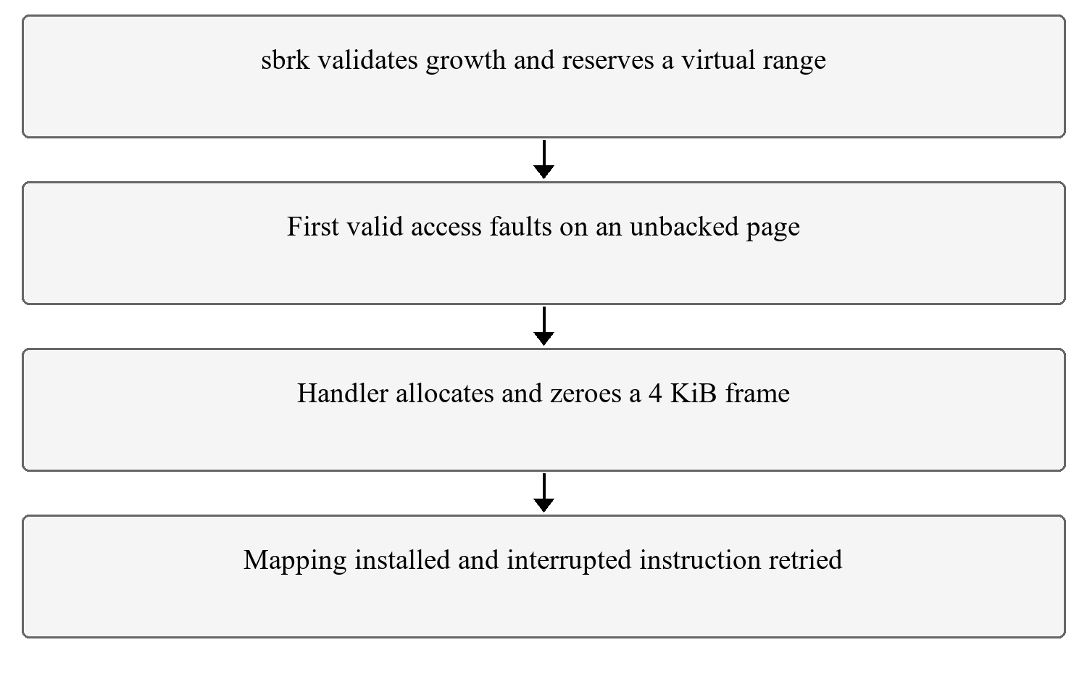
Figure 3 Reservation and first access allocation

4.6 Copy on write implementation

4.6.1 Earlier eager fork
The original uvmcopy allocates a frame for each resident parent page, copies the full page and maps the child copy with the appropriate permissions. This consumes time proportional to the resident pages and requires the child data footprint to fit alongside its parent. The custom 80 MiB workload makes this limitation visible in a machine exposing 128 MiB.

4.6.2 Sharing and reference ownership
The modified uvmcopy initially maps parent and child to the same resident frames. Originally writable mappings lose PTE_W and acquire PTE_COW; genuine read only mappings remain read only. The allocator in kernel/kalloc.c maintains a protected reference count for physical pages. Sharing increments ownership, and kfree decrements it, returning a frame to the freelist only when no owner remains.
On a valid COW write, handle_page_fault examines that count. If the current mapping is the final owner, it restores write permission and clears PTE_COW without a copy. Otherwise it allocates a new page, copies the previous contents, installs a private writable mapping, releases the old reference and flushes the local translation. stat_cow counts actual copies, not every permission restoration.
copyout must also honor COW. A kernel writing a system call result into user memory cannot bypass the sharing rule merely because the copy is executed in supervisor mode. The user copy helper therefore obtains a writable, recoverable user mapping before copying. Originally read only code remains protected from ordinary writes.

4.6.3 Later thread compatibility
A multi member process may have translations cached on another CPU. Without a general TLB shootdown protocol, changing its shared page permissions during fork could leave another member accessing an old translation. The integrated implementation uses a private copy path when a process with multiple members forks. Before the first SMP worker is published, inherited writable COW pages are made private while the process is still single member. Single member fork retains the COW optimization.
This is a deliberate safety boundary, not a claim that every fork in the final kernel uses COW. The benchmark description must identify the single member workload, and the report must not infer the same savings for a threaded parent's private copy path.

4.6.4 Files and effect
kernel/vm.c supplies sharing and private copy helpers; kernel/kalloc.c supplies references and final release; kernel/riscv.h defines PTE_COW; pgfault.c gains the write recovery branch. cowtest.c checks capacity, inherited values and parent isolation. forkbench.c measures a fixed loop of fork, child exit and parent wait. These test files are project additions, not the unchanged MIT usertests source.
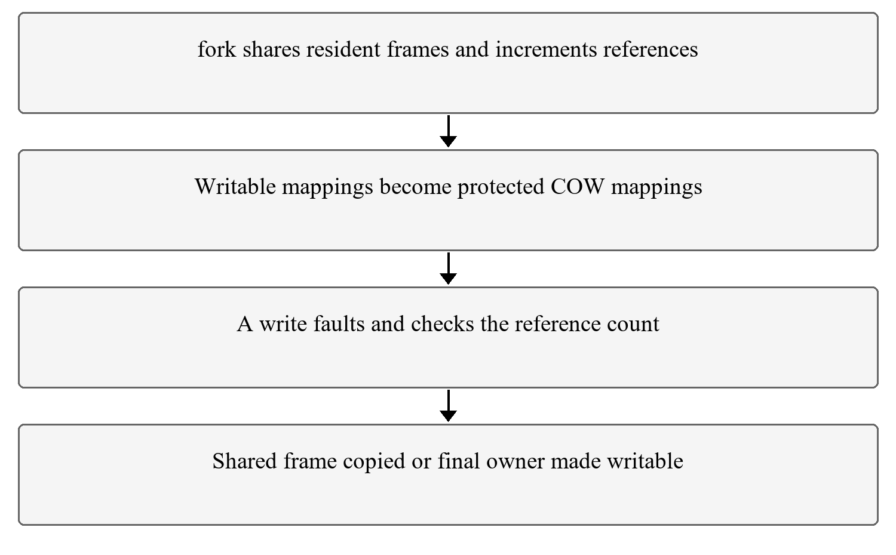
Figure 4 Sharing before a write and private backing after a write

4.7 Memory statistics interface
kernel/memstat.h is a new shared definition containing seven counters. sys_memstat obtains a user destination pointer, asks memstat_fill to snapshot the counters, and uses copyout to transfer the structure to the caller. The syscall number, dispatch entry, public prototype and generated stub are added in syscall.h, syscall.c, user.h and usys.pl. user/memstat.c invokes the call and prints labelled values.
kernel/swap.c initially supplied the statistics collection and later became the swap engine. memstat_fill collects handler calls, successful lazy allocations, actual COW page copies, swap outs, swap ins, currently free frames and occupied swap slots. ptlock coordinates the snapshot with page metadata, and the allocator supplies its free count. The interface is conceptually related to MIT's sysinfo exercise but has a different structure and purpose. [12]
The fault counter measures calls to the memory fault recovery handler, including kernel initiated user buffer recovery. It is not restricted to raw hardware exceptions. Transfer and allocation counters are cumulative since boot, while free pages and occupied slots describe current state. An application snapshot and a later shell memstat can differ because the shell and measurement command also execute and access memory.

4.8 Swap mechanism and managed memory limit

4.8.1 Creating controlled pressure
The Makefile passes RAM_MB to the kernel. kernel/memlayout.h derives PHYSTOP from that value so that RAM_MB=8 limits the physical range managed by xv6. QEMU still exposes 128 MiB through its machine option. The 8 MiB range includes kernel code, metadata and other allocations; it is not 8 MiB of application only free memory.
The swap area is appended after the filesystem image. It contains 16384 blocks of 1024 bytes, giving 16 MiB of backing store. A 4096 byte page occupies four blocks, so there are 4096 swap slots. SWAPSTART uses FSSIZE, preserving the boundary when the filesystem grows to accommodate additional executables. The later filesystem size is 4096 blocks; its growth does not change the configured RAM limit.

4.8.2 Tracking and selecting a frame
kernel/swap.c maintains a frame record containing an owning page table, virtual address and insertion sequence, together with a bitmap of occupied slots. swap_track, swap_untrack and swap_untrack_owner update the replacement metadata. Candidate validation confirms that the page table remains live, the PTE is resident and user accessible, the frame matches the PTE, and the page has a single reference and is not COW.
Kernel pages and shared COW frames are excluded from eviction. This simplifies the ownership model at the cost of reducing the available candidates. kalloc_user triggers reclamation below a low water mark, leaving headroom for kernel operations. The current build enables eviction only with one CPU, and avoids entering reclaim when the interrupt disable nesting indicates a locking context that cannot safely sleep.

4.8.3 Transferring out and restoring
swap_out_one serializes the operation with swap_lock, obtains a victim and free slot, changes the PTE to an invalid PTE_SWAP record with its slot and saved permissions, and removes the resident tracking entry. It releases ptlock before copying the page to disk through the buffer cache. After the transfer it frees the physical frame and increments the transfer counter. Disk I/O is never performed while holding the page table spinlock.
When the virtual page is accessed again, the fault handler recognizes PTE_SWAP and obtains a frame. swap_in rechecks the mapping, reads the four backing blocks without holding ptlock and then verifies that the expected PTE still exists. It reinstalls a valid resident mapping, frees the slot, records the frame and increments the swap in count. The recheck prevents a concurrent unmap from being undone after a sleeping disk operation.

4.8.4 Cleanup and occupied slots
The inherited process teardown reaches uvmfree and uvmunmap when a parent reaps a terminated process. Modified uvmunmap releases a PTE_SWAP slot and clears the entry; resident pages use reference aware kfree. Shrinking an eligible address space also traverses this unmap path. swap_in frees its old backing slot when restoration succeeds. These are explicit cleanup paths rather than a separate standalone cleanup program.
A nonzero occupied slot count at the shell prompt is not automatically a leak. A live shell or init process may own a swapped page. However, stable free counts and successful tests do not establish ownership. The historical one or two remaining slots were not cross referenced against every live PTE. A definitive audit would map each allocated slot to a process and virtual address at a stable point, excluding in flight transfers, and identify an allocated slot with no owner as an orphan. The report leaves this as an unverified ownership question.
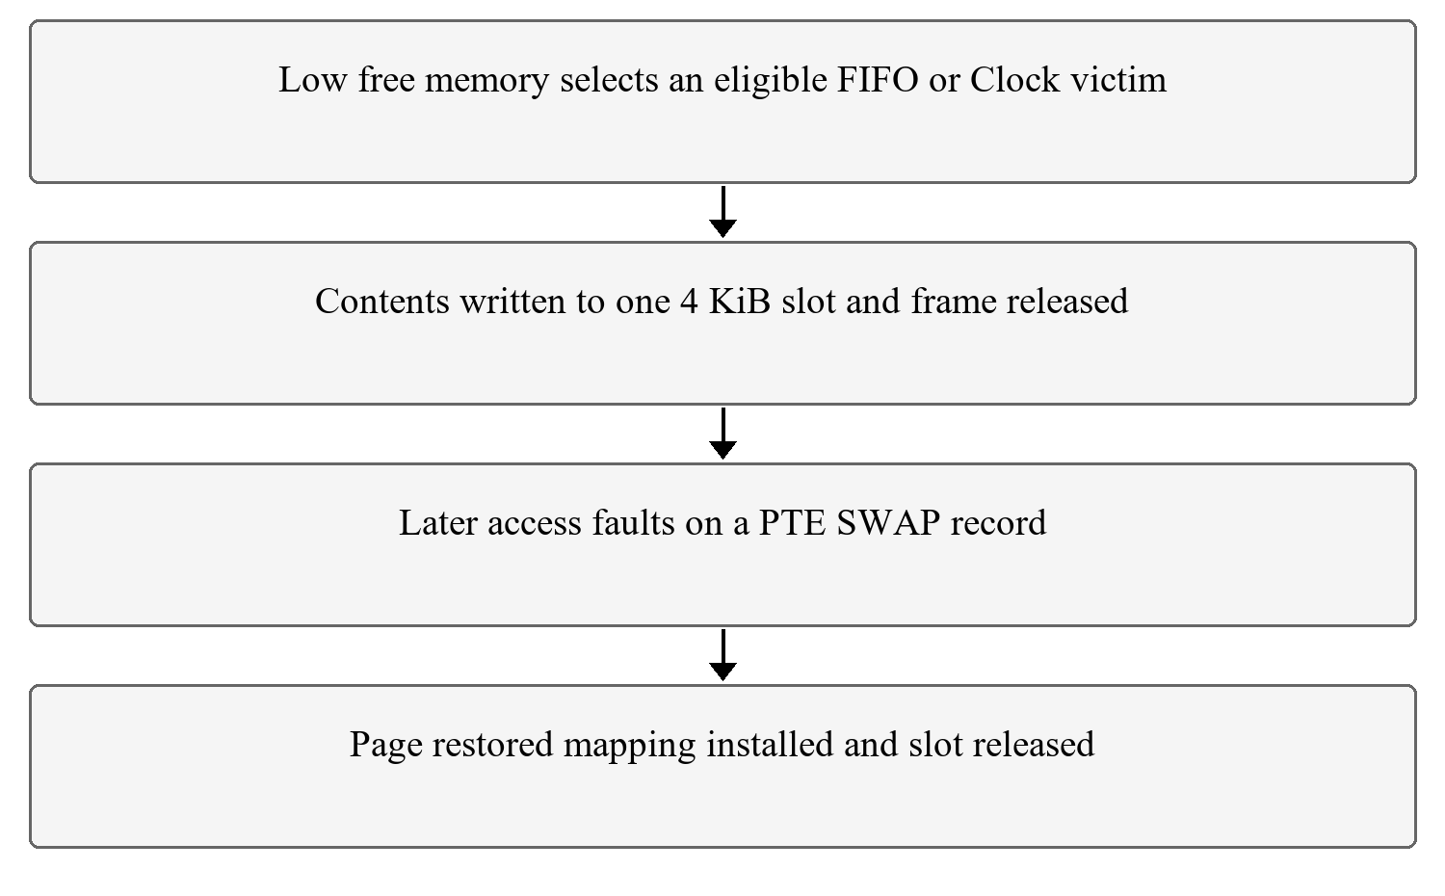
Figure 5 Eviction restoration and slot release

4.9 FIFO and Clock replacement
Both policies are implemented inside kernel/swap.c rather than in separate FIFO and Clock source files. pick_victim selects the policy through the SWAP_POLICY build definition. Policy 1 implements FIFO by scanning eligible frames and choosing the smallest tracked sequence number. Accessing a page does not move it to the end of the FIFO order.
Policy 2 implements Clock with a circular frame index. It scans at most two full rotations. An eligible page with PTE_A set has the bit cleared and receives another chance; an eligible page encountered with the bit clear is selected. The local sfence_vma makes the accessed bit sampling effective for the supported single CPU paging configuration. The algorithm approximates recent use; it is not exact least recently used replacement. [3], [7]
hotcold.c deliberately creates a reproducible access pattern. It reserves and initializes 12 MiB, then uses a hot region of 512 pages and a cold region containing the remainder. The frequent subset visits every eighth page in the hot region. Across three rounds, the workload scans cold pages and revisits that subset every twentieth cold iteration. The tool takes its initial statistics snapshot after initialization and prints transfer deltas for the measured phase.
This construction asks whether a recent use policy can retain useful pages under a given pattern. Its output is a policy workload observation, not a full byte by byte integrity check and not a general proof of superiority. Identical clean builds, fresh boots, multiple repetitions, elapsed time and separate fault or transfer counters would strengthen a comparison. Historical single phase counts are retained with those limits.

4.10 Thread compatible memory foundation
kernel/vm.c introduces ptlock to serialize shared mappings and pinned user copies. A successful pin_user_page returns with ptlock held and the caller must release it after the copy. This explicit contract is necessary because a page cannot be evicted or unmapped while it is being accessed through the kernel direct map. It also replaces earlier interrupt only protection that was insufficient for shared page tables on multiple CPUs.
kernel/proc.h adds a leader pointer, group local TID, member count, occupied TID mask and per member trapframe virtual address. The leader owns the shared size. kernel/memlayout.h reserves trapframe addresses for the supported members below the trampoline, and defines a user limit that excludes this reserved area. kernel/param.h defines the group size limit. These changes precede the thread API because allocation and trap return must first understand shared ownership.
The fault handler rechecks shared state after sleeping allocations. Swap metadata changes and copies use the same page table lock. The build disables SMP eviction because no remote TLB shootdown is implemented. Growth is shared, shrinking is constrained, and exec is limited to the main member of a single member group. These restrictions are part of the actual interface and are tested instead of hidden.

4.11 Kernel thread creation and lifecycle

4.11.1 Create and return path
kthread_create validates the entry function, exit stub and 16 byte aligned stack top. It finds an unused group TID, allocates a proc entry and a private trapframe, maps that frame at the reserved address and increments group membership. The new context starts at the supplied function with its argument in a0 and its return address set to a user exit stub. It becomes runnable only after its resources are prepared.
Each member has its own kernel stack, user stack, context and trapframe but shares the leader's user page table and PID. kernel/trampoline.S exchanges the saved user register through sscratch and uses the current member's trapframe address. kernel/trap.c passes both the user page table token and that address to the trampoline return routine. The original single fixed trapframe assumption is therefore replaced by member specific selection.

4.11.2 Join exit and group behavior
kthread_exit closes the member's file references and makes it a zombie without freeing the shared address space. kthread_join waits for a particular group TID, unmaps and frees its trapframe, returns its TID slot and reaps the proc metadata. Ordinary wait remains the process child interface. User stack ownership is managed by the caller or by the matching user library join.
Calling process exit from any member requests termination of the entire group. The first exit status is preserved, sleeping members are awakened, worker zombies are collected and the leader finally becomes a process zombie for its parent. kill of a PID marks and wakes all members. This avoids leaving threads operating on an address space after its leader has been freed.
Each new member obtains references to the creator's open files and current directory. The descriptor table entries belong to that member, so changing a descriptor table is not a complete POSIX process wide descriptor table implementation. Shared underlying open file references preserve normal xv6 file offset behavior. The implementation supports at most eight members including the main thread.
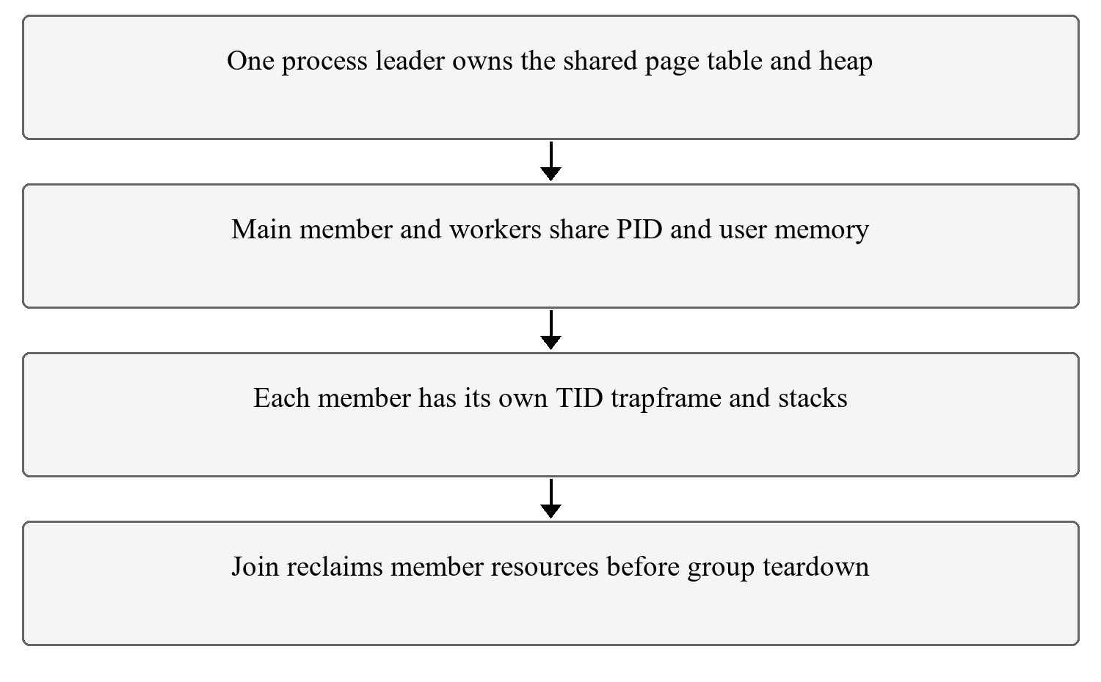
Figure 6 Shared address space and separate member contexts

4.12 Futex wait and wake
kernel/futex.c creates 64 hash buckets with locks and one waiter record per proc slot. A key consists of the process leader and aligned user address. Hash collisions do not make different addresses the same wait object, and the same virtual address in two processes remains a different key. Invalid or unaligned addresses are rejected.
futex_wait prefaults the word before taking the bucket lock, copies its current integer value and sleeps only if it still equals the expected value and the caller is not killed. Its waiter record and the transition to sleep use the same bucket lock as wake. A changed value causes an immediate return, preventing a notification between user inspection and actual sleeping from being lost.
futex_wake scans waiters under the bucket lock, checks the exact leader and address and makes matching sleepers runnable. It returns the number woken. It wakes all matching waiters; it does not promise fairness, ownership transfer or that an application predicate is now true. Applications must keep the word allocated while waiting and recheck their predicate after waking.

4.13 User synchronization library
user/thread.c and thread.h provide thread_create, thread_join, thread_exit, thread_self, mutexes, condition variables and semaphores. The library allocates a 16 KiB user stack, aligns its top and supplies a stub that ends a returning worker. A private allocation guard serializes library owned stack metadata. Join remembers the exact allocation before blocking so kernel TID reuse cannot cause a newer member's stack to be freed.
The mutex states are free, locked and contended. An uncontended acquisition uses atomic compare and swap in user space; a contended caller marks the state and waits through the futex service. Unlock publishes previous writes and wakes waiters when required. Condition wait snapshots a sequence number while the application mutex is held, releases the mutex, waits only while the sequence is unchanged and then reacquires the mutex. [10], [11]
Both cond_signal and cond_broadcast currently wake all matching waiters. Applications use a while loop around the protected predicate. A semaphore combines a mutex, condition and permit count; wait blocks while the count is zero and post increments it and notifies. The library does not make arbitrary application malloc and free calls thread safe. Applications must serialize those independently, and must not mix raw stack ownership with library joins.

4.14 Application demonstrations
The project adds tests for raw thread limits, identity, invalid operations and TID reuse; lifecycle and group exit; futex handshake and key isolation; nested library create and join; shared lazy faults and heap growth; and memory checking during swap. These are described individually in Appendix A so the evaluator can distinguish API tests from workloads.
racetest compares a shared counter without synchronization to the same updates under a mutex. prodcons exercises bounded queue predicates with two producers and two consumers. philosophers imposes an ascending fork lock order to avoid the demonstrated circular wait. semtest limits concurrent operations with two permits. exittest checks that a worker's process exit status is delivered to the external parent.
speedup divides a fixed 40 million iteration workload across one, two or three workers, verifies checksums and prints guest ticks. All three historical observations rounded to one tick, so they demonstrate checked parallel work but do not establish a measurable speedup. threadswap checks boundary words across 3072 shared pages with four workers under the one CPU 8 MiB paging configuration.

4.15 System call tracing
kernel/proc.h adds trace_mask. Allocation and final reap reset it; fork copies it and exec preserves it. sys_trace records the integer mask. kernel/syscall.c adds a syscall name table and, after dispatch, prints PID, name and return value when the corresponding bit is selected. user/trace.c sets the mask and executes the requested command.
The integrated syscall namespace uses 22 for memstat, 23 through 26 for thread operations, 27 and 28 for futexes, 29 for trace, 30 through 33 for signal services and 34 through 39 for debugger services. Tracing uses a guarded shift for syscall numbers below 31. Thus higher debugger calls are callable but are not selectable in this int mask design. The guard prevents an unsafe shift beyond the supported mask range.
Integration adds trace inheritance at kthread_create and reset through member reap, and includes thread and futex names in the lookup table. The new tracethread.c turns on kgettid tracing, creates a real member, then turns tracing off and reuses a member slot. Its console output checks inheritance and the absence of stale tracing after reset. The main member can also legitimately generate a kgettid trace when the join library checks its own identity.

4.16 Signal delivery and restoration
kernel/sigdefs.h defines a 16 entry signal namespace with usable numbers 1 through 15, including SIGINT, SIGKILL, SIGUSR1, SIGUSR2, SIGALRM and SIGTERM. The names do not imply an automatic alarm timer. kernel/signal.c implements sigaction, sigsend, sigreturn and pause. Pending bits, per signal handler and restorer addresses, a saved trapframe and an in handler flag extend proc metadata.
sigsend validates the number; SIGKILL delegates to the existing group kill mechanism. Other sends set a pending bit for the process leader and wake pause sleepers. Delivery occurs on the leader's return from a user trap, selects a pending signal, ignores SIG_IGN or terminates for the default action, and otherwise saves the interrupted trapframe. It redirects the saved program counter to the handler, a0 to the signal number and ra to the user restorer.
user/sig.c supplies signal as a wrapper and a restorer that invokes sigreturn. The kernel then restores the saved trapframe and returns its original a0 so normal system call return handling does not overwrite the interrupted result. Only one handler is active per context; pending bits coalesce repeated instances of the same signal. exec resets caught handlers while retaining ignore dispositions. The current implementation has no general blocked signal mask API or POSIX signal stack and queuing semantics.
The integrated policy routes process directed notifications to the leader, not an arbitrary member sharing the PID. A leader sleeping in pause wakes through its channel; ordinary sleep checks pending signals on its loop and returns early, potentially at the next timer wake. This is an educational delivery policy, not complete POSIX thread signal selection.

4.17 Kernel debugger support
kernel/dbg.h defines three stop reasons and the exported register snapshot. kernel/dbg.c implements child authorization, opt in, waiting, continuing, register inspection, memory reading and memory writing. Debugging is limited to a direct child that opts in and to a single execution context. A traced target is prevented from creating a thread group; multi member stop and resume is not claimed.
The exec syscall stops an opted in child with DBG_EXEC after the image is installed but before user execution. A traced breakpoint exception stops it with DBG_BREAK rather than following the ordinary fatal unhandled exception path. dbg_wait reports stops or an exit, and dbg_cont clears the stop state and wakes the target. Parent abandonment releases and kills a traced child rather than leaving an indefinitely frozen orphan.
dbg_peek and dbg_poke transfer at most 64 bytes per request. copyout_force in kernel/vm.c supports instruction patching through an otherwise read only user mapping, while refusing frames shared with another process. Ordinary user copy permissions are unchanged. The helper follows the integrated pin_user_page locking contract and releases ptlock after access; preserving the old interrupt only release would have left the lock held. Instruction cache synchronization uses fence.i before resumed execution.

4.18 Interactive debugger tool
user/dbg.c opens the target ELF, extracts function symbols, creates an opted in child and waits for its exec stop. The interactive commands are break by function, run or continue, bt, regs, info and quit. The implementation does not provide a general source line debugger, hardware stepping command, arbitrary attach operation or full GDB protocol.
A breakpoint stores the original instruction and installs a 2 byte compressed or 4 byte ebreak instruction as appropriate. Breakpoint placement rejects an initial control flow instruction that the simple sequential step over cannot handle. On continue from a breakpoint, the tool restores the real instruction, installs a temporary breakpoint immediately after it, resumes once and then restores both locations before continuing. This is software breakpoint step over within the supported instruction case, not general hardware single stepping.
bt starts with the saved PC and return address, then follows frame pointer records using the RISC V convention. It resolves addresses against the ELF symbol table and prints function names with offsets. It is a best effort trace: corrupted stack contents, optimized frame layouts or invalid return addresses can terminate or mislead an unwinder. Debugger correctness is checked on the explicit noinline target with a known outer, middle and inner call chain. [14]

4.19 Final subsystem integration
The development branch had an obsolete draft description and conflicts with the later thread foundation. Conflict resolution retained the real kernel thread API and user library, all syscall allocations and the access classified page fault handler. The prototype header that invoked workers synchronously and supplied no operation mutexes was removed in favor of the integrated library. The corrected finaldemo checks creation and join results and prints real nonzero TIDs.
The combined test reserves 6 MiB lazily, creates three workers touching separate 2 MiB regions, serializes a shared page counter and receives SIGUSR1 from a child. It joins members and reaps the child before taking its final snapshot. This verifies the selected interaction among shared threads, lazy allocation, synchronization and signal delivery. It does not by itself establish leak freedom, all signal interleavings or SMP swapping.

4.20 Regression strategy and evidence preservation
Focused tests are followed by the inherited full usertests suite when shared kernel paths change. Normal SMP runs use three CPUs and 128 MiB managed memory. Single CPU normal runs use 128 MiB; pressure runs use one CPU and 8 MiB under each policy. make clean is required when changing these definitions so stale objects cannot silently preserve an earlier configuration.
Console logs preserve commands and observed output. Validation metadata records configuration, source file hashes and transcript hashes. Screenshots from earlier milestones are labelled historical; newly executed final integration excerpts are labelled separately. Elapsed host automation time includes emulation and disk scheduling and is not substituted for guest CPU time. The report does not replace expected output with a claim of an executed pass.

5 Observations and Findings

5.1 How to read the comparisons
The tables compare either a recorded historical checkpoint or the newly integrated source. A missing command in the eager baseline establishes absence of that interface, not a runtime speed ratio. A completed integrity test establishes that its checked values matched for that execution, not correctness for every possible input. Resource and timing measurements include the stated build and workload boundaries.
The program strings historically print MB but compute sizes with 1024 times 1024 bytes. The report uses MiB for these quantities: 1 MiB is 1048576 bytes. Each page is 4 KiB. Thus 4 MiB contains 1024 pages, 12 MiB contains 3072 pages, and 200 MiB contains 51200 pages. The unit change is a correction in notation rather than a different request.

5.2 Lazy reservation and sparse access
Experiment | Earlier eager checkpoint | After lazy allocation | Interpretation
200 MiB baseline request | sbrk fails | Reservation succeeds | Virtual range can exceed available RAM before access
Sparse 256 MiB workload | Immediate backing required by eager growth | lazytest OK with 656 pages touched | Only selected pages require immediate data frames

baseline.c was written for the project and calls sbrk for 200 times 1024 times 1024 bytes. It checks the return value but does not write the entire reservation. This is the exact request referred to by the historical failure; no external memory request was implied. The same program succeeds after lazy allocation because the reservation no longer requires 200 MiB of immediate physical backing.
Earlier v0.0
$ baseline
baseline: sbrk(200MB) failed (expected on stock xv6)
After lazy allocation
$ baseline
baseline: sbrk(200MB) succeeded
$ lazytest
lazytest: OK (656 pages touched)
lazytest reserves 256 MiB, representing 65536 pages, and writes one page out of every hundred starting at zero. The resulting 656 explicitly write touched pages represent 2686976 bytes or 2.5625 MiB of page payload. This arithmetic is not a measurement of the complete resident set, which also includes code, stack, metadata and other accesses. The test also checks demand zero reading and a system call copying into a previously untouched buffer.
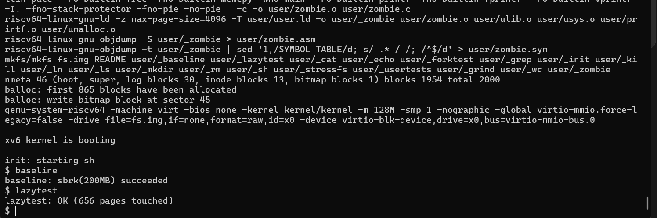
Figure 7 Historical reservation and sparse access capture

5.3 COW capacity and isolation
The project cowtest touches the first byte of all 20480 pages in an 80 MiB range and forks. The child checks inherited values and changes selected pages; the parent waits and confirms that its own values did not change. Eager duplication would need the large parent and a separate large child data footprint simultaneously. COW can share the frames initially and copy only modified pages.
Before COW
$ cowtest
cowtest: fork failed
After COW
$ cowtest
cowtest: OK
The test is custom and is not the official MIT cowtest grader. It checks selected positions and isolation, not every byte of every page or every lifetime race. Originally read only mappings remain protected, and reference counts govern release of shared physical pages.
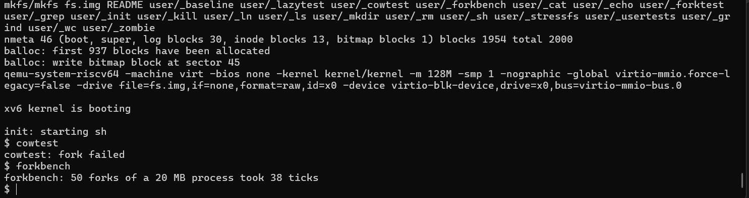
Figure 8 Historical eager fork failure and benchmark result

5.4 Fork benchmark measurements
Observation | Fixed workload | Guest ticks
Before COW | 50 sequential fork exit wait cycles after touching 20 MiB | 38
COW only historical run | Same loop description | 3
COW only repeated observation | Same loop description | 4
Historical v0.4 integrated memory run | Same loop description | 6

forkbench starts its timer after the initial 20 MiB has been touched, then performs fifty sequential fork, child exit and wait cycles. Its output is not the duration of one isolated fork and it does not create fifty simultaneous children. uptime differences count guest timer ticks. The timer interval is approximately a tenth of a second in this kernel configuration, but guest tick timing is coarse and affected by scheduling and emulation.
The lower observations are consistent with avoiding eager page copying in this single member workload. They are individual captures rather than controlled averages. Ratios calculated from them should not be presented as a universal speedup, and the later integrated source has additional overhead. The final run's own timing is recorded in the final validation section rather than replacing these historical numbers.

5.5 Paging before and after
Workload under 8 MiB managed RAM | Before swap | After swap
memhog 4 | Completes with 1024 pages and zero bad checks | Completes without initial pressure transfers
memhog 12 | Child terminates with status minus 1 | 3072 pages checked with zero bad checks and status 0

memhog.c creates a child, reserves the requested range, writes patterns at the first and last byte of each page and reads those positions back. bad counts mismatches in those checks. A zero count means those locations were preserved across the run, not that every byte was compared. The child exit status is separately checked and printed.
Before swap
$ memhog 12
memhog: starting 12 MB workload
memhog: child exit status -1
After swap
memhog: 12 MB, 3072 pages, 0 bad, swap outs 4369, swap ins 3072
memhog: child exit status 0
The transfer counters on the memhog line are cumulative snapshots, so later repetitions must be interpreted using differences rather than treating the total as that repetition alone. Repeated swapping of the same virtual page can produce many more transfers than the number of distinct workload pages. The gain is the ability to finish a resident capacity exceeding workload, with additional I/O cost; it is not a claim that disk is as fast as RAM.
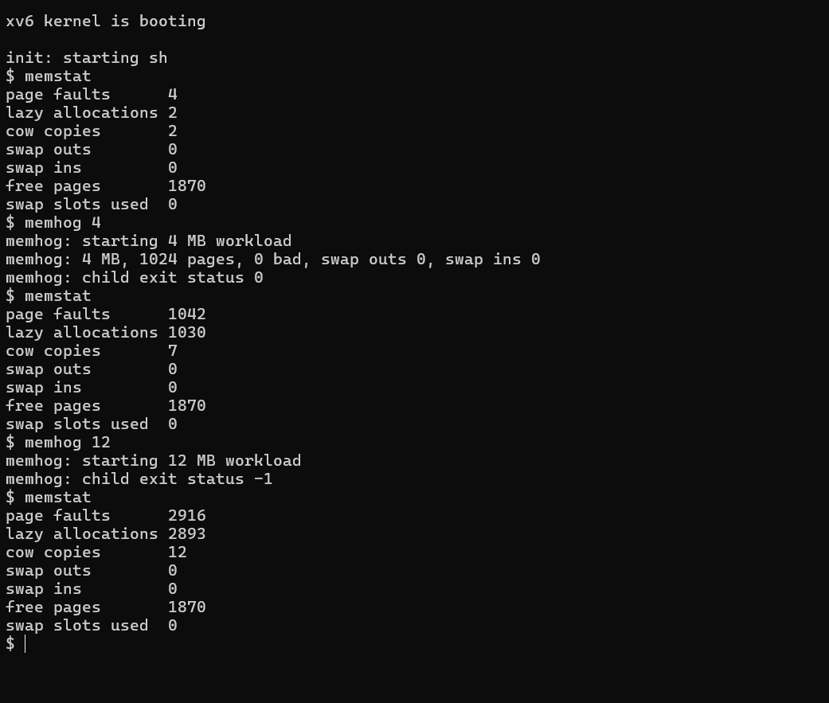
Figure 9 Historical 8 MiB control and pressure failure before swapping
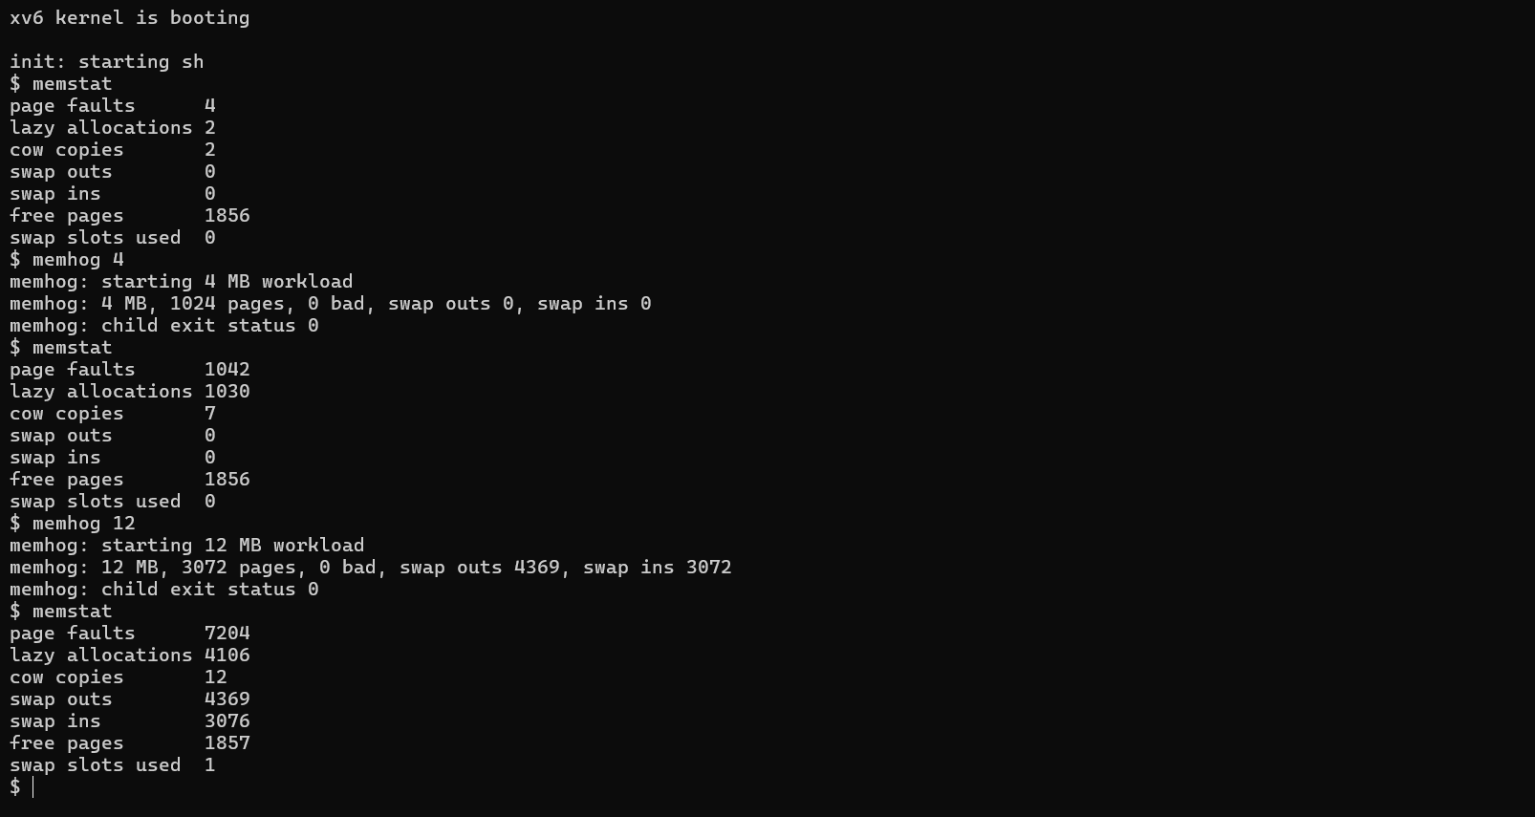
Figure 10 Historical successful pressure run after swapping

5.6 Fork while memory is swapped
swapfork.c initializes a 6 MiB parent region, forks and checks the child view. The child writes the second byte of every page to 77 and checks that the first bytes remain intact. The parent reaps it, checks the original first bytes and confirms its own second bytes remain zero. Parent and private child data together create pressure under the 8 MiB limit.
$ swapfork
swapfork: child bad=0
swapfork: OK
The recorded capture begins with zero transfers and ends with 2839 outs and 1540 ins, free pages changing from 1856 to 1857 and one occupied slot. These counters show real paging activity while isolation checks passed. Their exact values include process and shell activity. The remaining slot was not traced to an owner, so this capture alone cannot establish whether it belongs to a live process or is orphaned.
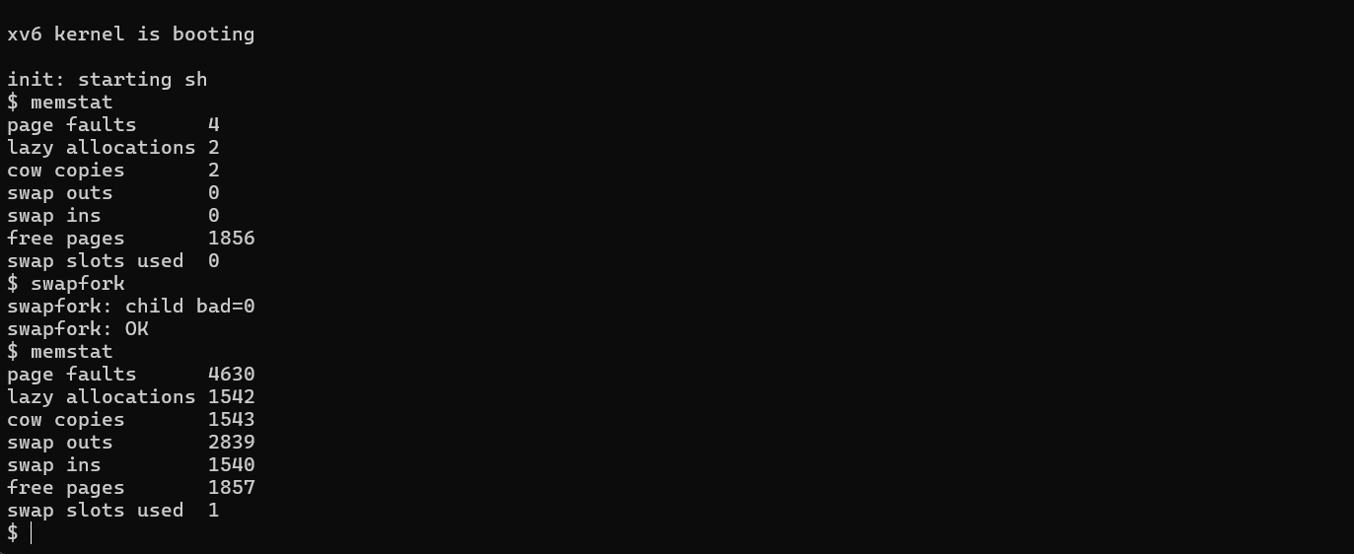
Figure 11 Historical COW and swap isolation capture

5.7 FIFO and Clock observations
Historical hotcold measured phase | Swap ins | Swap outs
FIFO | 8006 | 8007
Clock | 7691 | 7684

These fresh boot observations use the instructed one CPU 8 MiB configurations and predate the final pipe repair. Clock generated 315 fewer ins and 323 fewer outs in these individual phases. This is evidence of lower transfer counts for the recorded access pattern, not a controlled runtime result or proof that Clock always wins. The original screenshots do not themselves show the compile flags, so configuration association relies on the recorded build sequence.
The hotcold totals exclude initialization because the program snapshots statistics after initialization. The shell's later memstat includes initialization and surrounding process activity. Consequently the FIFO program's 8007 measured outs differ from a later cumulative 9299, and its 8006 measured ins differ from 8010. No inconsistency is implied by those different measurement windows.
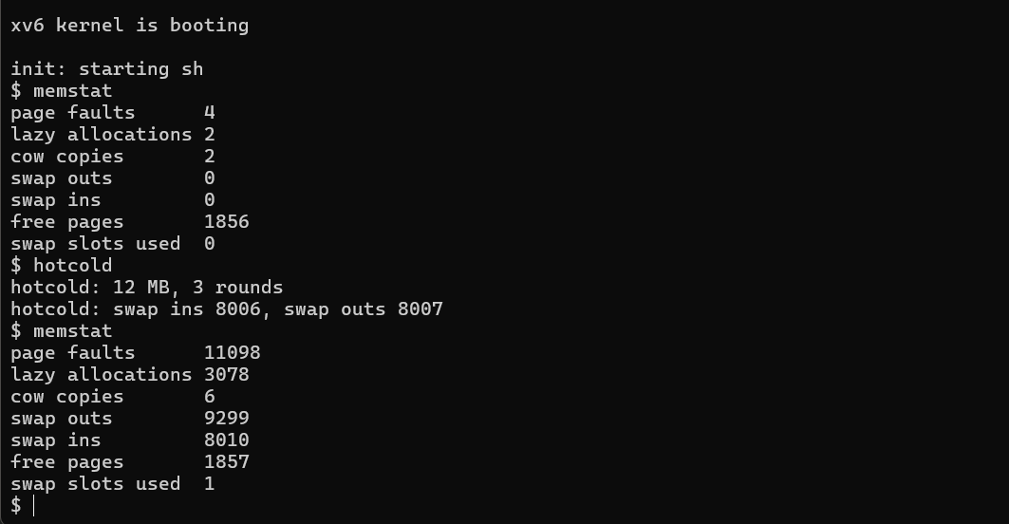
Figure 12 Historical FIFO measured phase and later cumulative snapshot
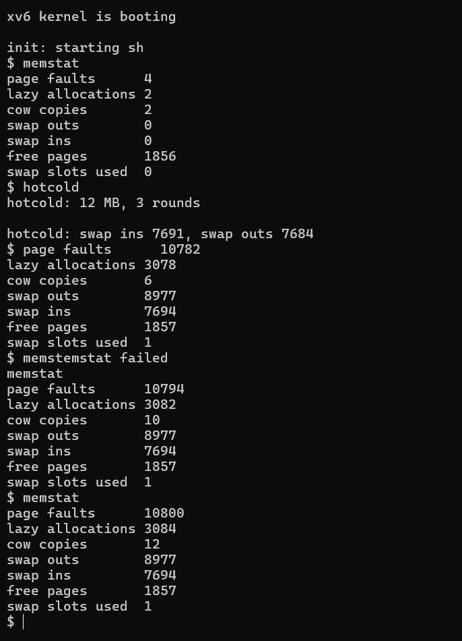
Figure 13 Historical Clock capture with corrected command entry

5.8 Thread and synchronization observations
Test | Checked behavior | Recorded result
kthreadtest | Limits joins identity reuse threaded fork and exec restrictions | OK
threadlife and exittest | Worker process exit and whole group kill | Parent receives status 3
futextest | 200 handshakes mismatch invalid address key separation and kill | OK
libtest | Nested create join mutex condition barrier semaphore | 60 nested operations and protected count 3000
threadtest | Partitioned shared sum | 499500 equals expected sum
racetest | Unsynchronized and protected increments | Protected count 200000
prodcons | Bounded queue with two producers and two consumers | 200 items total 10100
philosophers | Ascending fork acquisition order | Five workers complete 20 meals each
semtest | Two permit bound | 60 completions peak 2
threadmem | Concurrent first touch unique growth and COW visibility | OK
threadswap | Four workers check shared 12 MiB | 3072 pages zero bad checks

Historical racetest produced 183587 without a lock and 200000 with a mutex. The final run can produce a different unprotected value, including the correct total by scheduling coincidence. The important deterministic assertion is the protected total. The unprotected experiment is a demonstration of a race, not a portable correctness guarantee for a program containing concurrent unsynchronized accesses.
The historical speedup command reports one tick for each of one, two and three workers on its 40 million iteration workload. Because this coarse measurement does not separate the durations, no numeric scalability improvement is claimed. The thread API still adds shared execution and coordinated applications, which are functional improvements independently of a speedup ratio.

5.9 Trace signal and debugger comparisons
Capability | Eager baseline interface | Integrated implementation
Tracing | No trace command or syscall | Selected PID name and result lines
User signal handlers | Existing uncatchable kill only | Handler ignore default action return and pause
Debugger control | No project parent controlled debug API | Exec stop breakpoint stop continue registers memory
Symbolized inspection | No in guest dbg command | Function breakpoints and best effort backtrace

The baseline comparisons showing exec trace failed, exec sigtest failed or exec dbg failed indicate that these user commands and their kernel services were absent. They do not imply that upstream xv6 cannot be inspected using an external GDB; external QEMU and GDB debugging is a different facility from the in guest debugger created here.
$ trace 128 echo hi
79: syscall exec -> 2
hi
$ sigtest
sigtest: 1 ok, signal to self
sigtest: 2 ok, signal to another process
sigtest: 3 ok, default action ended the child
sigtest: 4 ok, ignored signal
sigtest: 5 ok, signal interrupted sleep
sigtest: ALL OK
The PID is an observation of that run and may change. The exec return value reflects argument count in xv6, not a conventional success boolean. The read trace prints the actual number of bytes returned, including zero at end of file. The signal tests check handler return state, interprocess notification, default termination, ignore behavior and interruptible sleep. They do not exercise complete POSIX signal semantics.
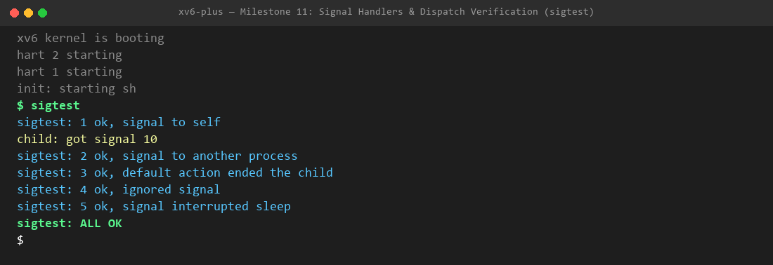
Figure 14 Historical signal functional test supplied with the development branch

5.10 Debugger walkthrough
The test target calls outer with 5; outer calls middle, which calls inner and adds one; outer adds one again. The expected final result is 12. Setting breakpoints at middle and inner should stop in that order. Registers expose the target PC, return address, stack and argument values; the backtrace resolves the known inner, middle, outer, main chain.
The fresh integrated run reaches the exec stop, installs both breakpoints, stops at middle, prints registers, continues to inner and then exits with outer(5) equal to 12. The source uses frame pointers and explicit noinline functions to keep the demonstration interpretable. Any extra frame inferred from stack data outside the known chain must be treated cautiously rather than presented as a guaranteed caller.
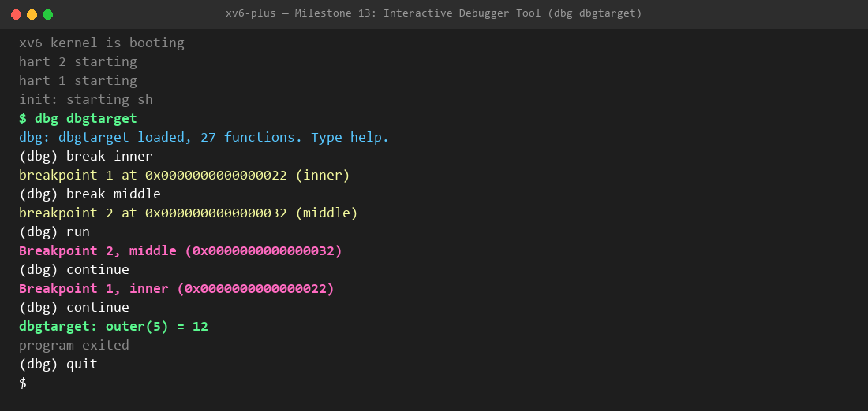
Figure 15 Historical interactive debugger session

5.11 Fresh final integration validation
The evaluated integrated kernel user programs and build definitions are preserved by commit 09d752e5fdbe80bd377b9f84e32562dc1f75e260. Subsequent presentation commits change documentation and evidence organization without changing that implementation. The source version is identified here so the results remain tied to concrete code rather than a moving branch name.
Run | Configuration | Observed completion
smp-reviewed | 3 CPU 128 MiB policy 1 | Completed 36 commands
fifo-final | 1 CPU 8 MiB policy 1 | Completed 7 commands
clock | 1 CPU 8 MiB policy 2 | Completed 7 commands
onecpu-final | 1 CPU 128 MiB policy 1 | Focused checks completed; full suite capture timeout
smp-final | 3 CPU 128 MiB policy 1 | Completed 37 commands

These new executions were captured on 2 November 2026. The SMP reviewed run precedes the last debugger orphan repair. Final SMP full regression and one CPU focused and pressure checks validate the repaired source. The one CPU full-suite capture reached its 1200 second limit during outofinodes, after execout and diskfull had printed OK; it is incomplete and is not a full-suite pass. Each manifest records source and console hashes. Selected actual output and the incomplete record are retained separately.

Results from fifo-final
memhog 12
memhog: starting 12 MB workload
memhog: 12 MB, 3072 pages, 0 bad, swap outs 4386, swap ins 3072
memhog: child exit status 0
$
swapfork
swapfork: child bad=0
swapfork: OK
$
threadswap
threadswap: OK (4 workers, 12 MB, 3072 pages, 0 bad)
threadswap: swap outs 2870, swap ins 1548 (workload deltas)
$
hotcold
hotcold: 12 MB, 3 rounds
hotcold: swap ins 8006, swap outs 8007
$

Results from clock
memhog 12
memhog: starting 12 MB workload
memhog: 12 MB, 3072 pages, 0 bad, swap outs 4386, swap ins 3068
memhog: child exit status 0
$
swapfork
swapfork: child bad=0
swapfork: OK
$
threadswap
threadswap: OK (4 workers, 12 MB, 3072 pages, 0 bad)
threadswap: swap outs 4387, swap ins 3076 (workload deltas)
$
hotcold
hotcold: 12 MB, 3 rounds
hotcold: swap ins 7611, swap outs 7616
$

Results from smp-final
forkbench
forkbench: 50 forks of a 20 MB process took 6 ticks
$
racetest
without lock: expected 200000, got 180476
with mutex: expected 200000, got 200000
racetest: OK (unprotected result depends on scheduling)
$
tracethread
tracethread: inherited mask begins
80: syscall kgettid -> 0
80: syscall kgettid -> 1
tracethread: cleared mask begins
tracethread: OK
$
dbglife
dbglife: OK (8 abandoned targets and traced thread guard)
$
finaldemo
finaldemo: worker 0 running as tid 1
finaldemo: worker 1 running as tid 2
finaldemo: worker 2 running as tid 3
finaldemo: 3 threads touched 1536 pages, signal 10 received
finaldemo: lazy allocations 1541, page faults 1544
$
test sbrk8000: OK
test badarg: OK
usertests slow tests starting
test bigdir: OK
test manywrites: OK
test badwrite: OK
test execout: OK
test diskfull: balloc: out of blocks
balloc: out of blocks
OK
test outofinodes: ialloc: no inodes
OK
ALL TESTS PASSED
$
The finaldemo output includes three nonzero TIDs and 1536 touched pages, demonstrating actual kernel scheduled workers. A zero mismatch result in the pressure programs applies to their explicitly checked byte or word positions. A successful dbglife result checks the formerly unsafe abandoned target path and traced thread restriction. Stable or returned memory counters remain observations rather than a substitute for a complete backing ownership audit.

5.12 Failures encountered and repairs
Observed failure | Diagnosis and implementation response | Validation
Compiler rejects ffile prefix map | Space in CURDIR split an unquoted build argument; removed that historical flag | Build completes in required workspace
Early guest does not reach shell | ISA selection made explicit as rv64gc in compiler and assembler settings | Kernel boot and shell captured
sbrkfail fails after COW | Waiting status copy could need memory before child resources were released | Reap before faultable copy; focused and full tests pass
countfree write failure and apparent lost pages | Pipe copying user buffers while holding a spinlock conflicted with faultable paging | Stage pipe writes and copy outside pipe lock
Thread shared mapping races | Interrupt only protection did not serialize CPUs | ptlock and post allocation rechecks
COW visibility across SMP members | Permission remapping lacked remote TLB shootdown | First worker COW preparation and private threaded fork path
Draft branch merge conflicts | Shared kernel files evolved independently | Preserve real threads all syscall entries and fault access modes
Prototype final demo claims threads | Temporary header ran workers synchronously with empty mutex operations | Link real library validate creation and print worker TIDs
Abandoned debugger target could deadlock | reparent already holds wait_lock; avoid calling kill which reacquires it | Use the internal group-stop helper and test eight abandoned targets
Debugger copy release mismatch | Old pop_off contract differed from integrated pin helper | Release ptlock after debug access

An exec failure followed by a successful retry and simple command spelling errors were also captured during development. These observations are retained privately; where no root cause was established, the report does not invent one. Rebuilding or rebooting can change behavior but is not itself a demonstrated explanation.

5.13 What the evidence establishes
The comparisons establish deferred allocation, successful tested COW isolation, completion of a checked memory pressure workload with disk backing, shared thread operation, synchronization invariants, selected tracing, tested user signal delivery and basic debugger control on the supported target. Full usertests pass evidence establishes that the inherited suite completed for its recorded source and configuration.
The evidence does not establish a universal performance improvement, complete absence of memory leaks, correct behavior for arbitrary concurrent programs, POSIX compliance or SMP swapping. Source hashes and labelled logs make these boundaries reviewable. A professor can inspect the named source functions, run a selected command sequence and connect the printed assertions to the mechanism described here.

6 Limitations

6.1 Memory and paging boundaries
Reservations can exceed immediate physical capacity but not guarantee eventual backing for every byte. The swap area is fixed and finite. Kernel memory and shared COW pages are not eviction candidates. Page table metadata still requires physical memory, and low water reclamation is a simple educational policy rather than a production memory pressure controller. Writing every page in a 200 MiB reservation can still exhaust the available RAM and swap backing; baseline.c does not perform that complete write, and no successful 200 MiB fully touched experiment is claimed.
Swapping is enabled only for one CPU. There is no general inter CPU TLB shootdown. SMP builds can demonstrate threads and normal memory behavior with ample RAM but do not evict active mappings. An 8 MiB managed range includes the kernel and metadata. Occupied slots at a prompt remain an ownership audit question; freeing them blindly could discard live process data.

6.2 Thread and library boundaries
The group limit is eight members, including the main member. User stacks are fixed 16 KiB allocations without individual guard pages. Exec and shrinking are restricted with multiple members. Threaded fork uses private copies, and after such a fork the child should exec or exit before using copied user library lock state. General application allocator operations require their own synchronization.
Descriptor tables are per member references rather than a fully shared POSIX descriptor table. Locks are nonrecursive, conditions wake all waiters for both signal and broadcast, and fairness is not guaranteed. The project does not implement POSIX TLS, floating point context management or general pthread compatibility. A demonstration's lock ordering does not prove deadlock freedom for arbitrary application code.

6.3 Signals tracing and debugger boundaries
Signal numbers are bit pending events with no general blocking mask, realtime queue or alternate signal stack. Repeated identical sends can coalesce. Delivery targets the leader for process directed notifications. Defining a signal name does not implement a corresponding alarm generator. Kernel preemption and handler interleavings are not exhaustively explored by the supplied tests.
The tracing int mask covers system call numbers below 31 and prints only PID, name and return result. It cannot select debugger syscalls 34 through 39. Console output perturbs execution timing. The debugger supports an opted in direct single context child, a limited register set and at most 64 bytes per memory call. Target pages must be suitable for its pinning and ownership checks; it is not a general debugger for swapped remote memory or multithreaded targets.
Software step over assumes a supported sequential instruction and rejects unsuitable breakpoint locations. Frame pointer unwinding is best effort and can be fooled by stack contents or optimized code. The CLI has no general step command, source line mapping, attach command or GDB remote protocol. Debugger memory patching refuses shared physical frames rather than implementing a generalized private code copy service.

6.4 Measurement and evidence boundaries
Historical fork and policy observations are individual runs rather than a statistical study. Their exact configurations and code revisions must remain attached to the values. Tick resolution is too coarse to infer scaling from the recorded speedup outputs. FIFO and Clock phase counts are not end to end runtime and predate later integration repairs. The final results are reproduced separately and do not retroactively strengthen an earlier capture. The final one CPU full-suite capture was limited to 20 minutes and timed out during outofinodes; earlier tests had printed OK, but that run is not called a complete suite pass. Final full-suite completion is established by the separately recorded SMP run.
The project tests selected page positions and application invariants, not every byte or all schedules. Full regression success is valuable but finite evidence. Generated diagrams and formatted excerpts illustrate code and real outputs; they are not presented as literal terminal screenshots. Original captures remain embedded with historical labels.

7 Conclusions and Future Work

7.1 Conclusions
xv6 Plus provides an integrated educational operating system that makes deferred allocation, shared backing, paging, shared execution, synchronization, asynchronous control and runtime inspection directly testable. The most concrete memory improvements are successful large virtual reservation, a formerly failing large fork completing with isolation, lower observed single member fork loop cost and completion of a checked 12 MiB workload under an 8 MiB managed memory limit.
The thread layer adds shared address space execution with explicit lifetime and synchronization rules. Tracing, signals and the debugger add facilities absent from the selected baseline and expose the relationship between syscalls, traps and user execution. Integration required changes to ownership and lock contracts, not merely linking additional commands. The corrected final demonstration verifies actual kernel workers rather than sequential prototype wrappers.
The report's file inventory identifies the purpose of each addition and original source change without reproducing full C files. Historical captures, fresh validation, version checkpoints and mapped references provide a traceable basis for evaluation. Algorithms are established OS techniques; the project contribution is their implementation, integration, workloads, repairs and documented evidence in this teaching kernel.

7.2 Future work
The highest priority extension is a read only audit that cross references occupied swap slots with every live process mapping and transfer in progress. Repeated checks after process reaping would distinguish legitimate backing from orphaned allocations. A remote TLB shootdown protocol and stronger lifetime coordination would be needed before enabling SMP eviction or relaxing current shared mapping restrictions.
Performance work should use longer timed workloads, repeated fresh boots, controlled CPU counts and medians or distributions rather than isolated tick samples. FIFO and Clock should be compared on sequential scans, locality rich patterns and adversarial reference strings, recording page recovery calls, swap traffic and elapsed time separately. Memory savings should be measured as resident frame counts for each process, not inferred only from virtual reservation size.
Thread stacks could gain guards, allocator support could become generally thread safe, and condition signal could wake a bounded number of waiters. Signals could add masks, a clearer process wide disposition model and broader concurrent tests. The debugger could add checked instruction decoding, stronger frame validation, remote swapped page recovery and stop coordination for thread groups. These are future capabilities and are not included in current completion claims.

8 Bibliography and References
The numbered references are primary course pages specifications textbooks or research records. They explain established mechanisms and related assignments; they do not certify the project or establish that an MIT grader was run. Access dates for the final review are 2 November 2026. Research papers provide context and were not experimental protocols reproduced here.
[1] Microsoft, Windows Subsystem for Linux overview. [Online]. Available: https://learn.microsoft.com/en-us/windows/wsl/about. Accessed: Nov. 2, 2026.
Used in Sections 2.1 and 4.2 host environment.
[2] R. Cox F. Kaashoek and R. Morris, xv6 a simple Unix like teaching operating system revision 5 MIT 2025. [Online]. Available: https://pdos.csail.mit.edu/6.1810/2025/xv6/book-riscv-rev5.pdf. Accessed: Nov. 2, 2026.
Used in Sections 2.2 2.3 and 4.4 kernel structure traps page tables and locking.
[3] RISC V International, Supervisor Level ISA version 1.13. [Online]. Available: https://docs.riscv.org/reference/isa/v20260120/priv/supervisor.html. Accessed: Nov. 2, 2026.
Used in Sections 2.3 4.5 4.9 and 4.17 faults PTE accessed bits and translation invalidation.
[4] MIT PDOS, 6.S081 Lab xv6 lazy page allocation 2020. [Online]. Available: https://pdos.csail.mit.edu/6.S081/2020/labs/lazy.html. Accessed: Nov. 2, 2026.
Used in Sections 2.4 4.5 and 5.2 direct conceptual assignment correspondence.
[5] MIT PDOS, 6.1810 Lab Copy on Write Fork for xv6 2025. [Online]. Available: https://pdos.csail.mit.edu/6.1810/2025/labs/cow.html. Accessed: Nov. 2, 2026.
Used in Sections 2.4 4.6 and 5.3 sharing reference counts and copyout. Project cowtest differs from MIT grader.
[6] R. H. Arpaci Dusseau and A. C. Arpaci Dusseau, Operating Systems Three Easy Pieces chapter 21 Beyond Physical Memory Mechanisms. [Online]. Available: https://pages.cs.wisc.edu/~remzi/OSTEP/vm-beyondphys.pdf. Accessed: Nov. 2, 2026.
Used in Sections 2.5 4.8 and 5.5 paging mechanism context.
[7] R. H. Arpaci Dusseau and A. C. Arpaci Dusseau, Operating Systems Three Easy Pieces chapter 22 Beyond Physical Memory Policies. [Online]. Available: https://pages.cs.wisc.edu/~remzi/OSTEP/vm-beyondphys-policy.pdf. Accessed: Nov. 2, 2026.
Used in Sections 2.5 4.9 and 5.7 FIFO Clock and workload dependence.
[8] P. J. Denning, The working set model for program behavior Communications of the ACM vol 11 no 5 pp 323 to 333 May 1968 doi 10.1145/363095.363141. [Online]. Available: https://doi.org/10.1145/363095.363141. Accessed: Nov. 2, 2026.
Used in Sections 2.5 and 4.9 research context for locality only; no working set scheduler claimed.
[9] L. A. Belady R. A. Nelson and G. S. Shedler, An anomaly in space time characteristics of certain programs running in a paging machine Communications of the ACM vol 12 no 6 pp 349 to 353 June 1969 doi 10.1145/363011.363155. [Online]. Available: https://research.ibm.com/publications/an-anomaly-in-space-time-characteristics-of-certain-programs-running-in-a-paging-machine. Accessed: Nov. 2, 2026.
Used in Sections 2.5 and 5.7 policy evaluation context; anomaly experiment not reproduced.
[10] R. H. Arpaci Dusseau and A. C. Arpaci Dusseau, Operating Systems Three Easy Pieces chapter 28 Locks. [Online]. Available: https://pages.cs.wisc.edu/~remzi/OSTEP/threads-locks.pdf. Accessed: Nov. 2, 2026.
Used in Sections 2.6 4.13 and 5.8 critical section and atomic lock context.
[11] R. H. Arpaci Dusseau and A. C. Arpaci Dusseau, Operating Systems Three Easy Pieces chapter 30 Condition Variables. [Online]. Available: https://pages.cs.wisc.edu/~remzi/OSTEP/threads-cv.pdf. Accessed: Nov. 2, 2026.
Used in Sections 2.6 and 4.13 predicate loops and producer consumer context.
[12] MIT PDOS, 6.S081 Lab System calls 2020. [Online]. Available: https://pdos.csail.mit.edu/6.S081/2020/labs/syscall.html. Accessed: Nov. 2, 2026.
Used in Sections 2.7 4.7 and 4.15 trace mask and sysinfo related design. Our memstat has a different API.
[13] MIT PDOS, 6.S081 Lab Traps 2020. [Online]. Available: https://pdos.csail.mit.edu/6.S081/2020/labs/traps.html. Accessed: Nov. 2, 2026.
Used in Sections 2.7 and 4.16 user handler restoration and backtrace context; signal framework is not identical to sigalarm.
[14] MIT PDOS, RISC V Calling Convention lecture slides 2024. [Online]. Available: https://pdos.csail.mit.edu/6.828/2024/lec/l-riscv-cc-slides.pdf. Accessed: Nov. 2, 2026.
Used in Sections 2.7 and 4.18 frame pointer convention for debugger unwinding.
[15] Free Software Foundation, GCC RISC V Options. [Online]. Available: https://gcc.gnu.org/onlinedocs/gcc/RISC-V-Options.html. Accessed: Nov. 2, 2026.
Used in Section 4.3 explicit architecture selection in the boot repair.
[16] MIT PDOS, 6.1810 Lab Multithreading 2023. [Online]. Available: https://pdos.csail.mit.edu/6.1810/2023/labs/thread.html. Accessed: Nov. 2, 2026.
Used in Sections 2.6 and 4.11 background comparison. MIT exercise is user level switching; this project adds kernel scheduled shared address space members.

Appendix A Complete implementation file inventory
The inventory compares the historical eager source c4de4b0 with the integrated project. Added means the file was created in this project; modified means an inherited xv6 file was changed. A file created for an early milestone and later extended remains an added project file. Complete source stays in the code tree. Every item below states its role and important behavior instead of reproducing the entire implementation.
user/usertests.c is inherited and unchanged against the eager reference. Original scheduling filesystem drivers and stock commands remain the foundation. pgfault.c and swap.c were created early and extended later. FIFO and Clock are branches inside swap.c rather than separate policy files.
The inventory contains 63 source and build files: 21 modified originals and 42 additions. Images outputs and documentation support the implementation but are not kernel modules.

A.1 Modified original xv6 files
File and role | Purpose important behavior and impact
Makefile  Build configuration | Registers objects libraries and commands; passes CPU RAM and replacement definitions and appends swap backing to the filesystem image.
kernel/defs.h  Shared declarations | Declares added memory thread futex signal debugger and statistics helpers so original modules can call them consistently.
kernel/exec.c  Exec lifecycle | Rejects unsupported multi member exec and resets caught signal state when installing a new user image.
kernel/kalloc.c  Physical ownership | Adds kref helpers and free page accounting; kfree releases a physical page only after its last reference.
kernel/main.c  Initialization | Initializes swap metadata page table locking futex buckets and signal state before user processes start.
kernel/memlayout.h  Address space layout | Derives PHYSTOP from RAM_MB and reserves separate trapframe virtual addresses with a shared user limit.
kernel/param.h  Capacity definitions | Defines MAXTHREADS and expands filesystem capacity for the added executable set; does not increase managed RAM.
kernel/pipe.c  Faultable user I O | Stages pipe data so memory recovery and potentially sleeping copies happen outside the pipe spinlock.
kernel/proc.c  Process and member lifetime | Adds thread creation join group exit and kill; COW versus private fork selection; trace and signal inheritance; safe reap and debugger abandonment.
kernel/proc.h  Execution metadata | Adds leader TID member and trapframe metadata plus trace mask pending signals saved handler context and debugger stop state.
kernel/riscv.h  PTE representation | Adds COW and swap software flags accessed bit and swap slot encode decode macros used by VM recovery and replacement.
kernel/spinlock.c  Reclaim guard | Exposes interrupt disable nesting through nlocks_held to avoid entering sleepable reclaim from protected contexts; not an exact ownership census.
kernel/syscall.c  Dispatch and tracing | Registers the new handlers and names; uses leader size in argument checks and prints selected returns through a guarded trace mask.
kernel/syscall.h  Stable syscall numbers | Allocates the added interfaces in numbers 22 through 39 without collisions between subsystems.
kernel/sysfile.c  File syscall integration | Prefaults I O buffers and stops an opted in debugger target after a successful exec image installation.
kernel/sysproc.c  Process syscall wrappers | Changes heap growth to shared lazy reservation and exposes memstat threads trace and interruptible sleep handling.
kernel/trampoline.S  Member trap context | Replaces the fixed trapframe assumption with sscratch and per member trapframe selection on entry and return.
kernel/trap.c  Trap routing | Classifies faults dispatches breakpoint stops delivers signals and returns through the current member trapframe with instruction synchronization.
kernel/vm.c  Mapping and copy rules | Supports holes COW swap unmapping shared lock protected copies private threaded fork and constrained debugger code writes.
user/user.h  Public syscall API | Declares memory thread futex tracing signal and debugger calls and required shared structure forward declarations.
user/usys.pl  Generated syscall stubs | Adds entries that generate assembly ecall wrappers for every implemented user kernel interface.

A.2 Added kernel and library modules
File and role | Purpose important behavior and impact
kernel/dbg.c  Debugger protocol | Implements six direct child control calls with exec breakpoint and exit reasons plus safe abandoned target handling.
kernel/dbg.h  Debug interface data | Defines stop reasons and the PC stack frame return and argument register snapshot exported to the debugger.
kernel/futex.c  Kernel wait service | Implements 64 keyed buckets expected value wait exact key wake and waiter records shared with proc sleep states.
kernel/memstat.h  Shared counter record | Defines the seven field structure copied by sys_memstat and read by monitoring and workload programs.
kernel/pgfault.c  Fault recovery module | Created for lazy faults then extended for COW swap permissions and concurrent first touch; handle_page_fault rechecks mappings after allocations.
kernel/sigdefs.h  Signal constants | Defines namespace size supported named signals and default ignore dispositions used by both kernel and user wrappers.
kernel/signal.c  Signal services | Implements signal_init pending delivery handler registration send pause and trapframe restoration through sigreturn.
kernel/swap.c  Statistics and paging module | Created for memstat then extended with frame slot tracking disk I O FIFO Clock and cleanup counters.
user/dbg.c  Interactive debugger | Loads ELF function symbols handles breakpoint patch and software step over and prints registers and bounded frame traces.
user/sig.c  Signal wrapper | Implements signal registration convenience and the user restorer that invokes sigreturn after a handler returns.
user/sig.h  Signal user API | Exposes shared signal constants and the convenience wrapper to signal tests and applications.
user/thread.c  User thread library | Creates and reclaims 16 KiB stacks; implements mutex condition semaphore and TID reuse safe join bookkeeping.
user/thread.h  Synchronization API | Declares real library functions and state types; replaces the development branch sequential placeholder header during integration.
user/threadcheck.h  Assertion support | Provides common checked assertion reporting used by thread and synchronization tests; no kernel service itself.
user/trace.c  Trace command | Parses a mask sets tracing and execs a chosen program so selected calls and child activity become visible.

A.3 Added tests workloads and demonstration targets
File and role | Purpose important behavior and impact
user/baseline.c  Reservation comparison | Requests 200 MiB through sbrk and prints success or failure; does not touch the entire reservation.
user/cowtest.c  COW isolation test | Touches 80 MiB forks checks inherited patterns and verifies child writes do not change parent values.
user/dbglife.c  Debugger lifetime regression | Eight controllers abandon stopped targets; checks completion without recursive wait lock acquisition and rejection of traced threads.
user/dbgmini.c  Debug primitive demonstration | Creates an opted in exec child reads its registers and instruction bytes continues it and observes exit reason three.
user/dbgtarget.c  Known debugger target | Uses noinline outer middle and inner functions; final outer five result must be twelve.
user/exittest.c  Exit status test | Worker calls process exit and external parent verifies whole group termination with status three.
user/finaldemo.c  Combined subsystem test | Real kernel workers touch three lazy 2 MiB ranges under a mutex and receive a child signal; prints TIDs and checks joins.
user/forkbench.c  Fork loop timing | Touches 20 MiB before timing and measures 50 sequential fork child exit wait cycles in guest ticks.
user/futextest.c  Futex semantic test | Checks 200 handshakes mismatch invalid addresses exact key isolation and termination behavior.
user/hotcold.c  Policy workload | Creates a 12 MiB locality pattern for three rounds and prints measured phase swap deltas after initialization.
user/kthreadtest.c  Raw thread API test | Checks limits invalid creation identity joins slot reuse threaded fork and exec restrictions.
user/lazytest.c  Demand paging test | Reserves 256 MiB touches every hundredth page checks zero fill and lazy syscall buffers; reports 656 write touched pages.
user/libtest.c  Library stress test | Checks nested create join mutex increments a condition barrier and semaphore coordination including allocation metadata.
user/memhog.c  Pressure integrity test | Child writes and checks first and last byte of each requested page; prints mismatch count cumulative swaps and child status.
user/memstat.c  Monitoring command | Prints the seven statistics returned by memstat; it is an observer rather than a pressure workload.
user/philosophers.c  Lock order demonstration | Five workers acquire forks in a fixed ascending order and each completes 20 meals.
user/prodcons.c  Bounded queue demonstration | Two producers and two consumers coordinate capacity eight and verify item count total and multiplicity.
user/racetest.c  Mutual exclusion demonstration | Compares unprotected shared increments with mutex protected increments; protected expected total is 200000.
user/semtest.c  Permit bound test | Six workers perform 60 operations with two permits and verify peak concurrent use does not exceed two.
user/sigtest.c  Signal functionality test | Checks self delivery state preservation interprocess pause default termination ignore and interrupted sleep.
user/speedup.c  Checked timing workload | Partitions 40 million iterations over selected workers verifies checksums and prints coarse guest ticks.
user/swapfork.c  Paging and COW test | Checks first bytes across a fork while child writes second bytes and parent verifies isolation under pressure.
user/threadlife.c  Group lifetime test | Verifies worker triggered process exit status and whole group kill with parent observation.
user/threadmem.c  Shared VM integration test | Concurrent lazy first touch shared unique sbrk growth and inherited COW visibility without intervening reader syscalls.
user/threadswap.c  Shared paging integrity test | Four workers write and verify boundary words across 3072 shared pages with a condition barrier.
user/threadtest.c  Shared computation test | Partitions a sum and checks the combined shared result equals 499500.
user/tracethread.c  Trace integration regression | Checks inherited kgettid tracing with a real member then absence of stale trace events after disabling and reusing slots.

Appendix B Reproduction and evaluator demonstration

B.1 Normal integrated demonstration
In Ubuntu, run make clean then make qemu CPUS=3 RAM_MB=128 SWAP_POLICY=1. Execute each command separately at the guest prompt. Exit QEMU with Ctrl A then X before rebuilding.
memstat
baseline
lazytest
cowtest
forkbench
kthreadtest
threadlife
futextest
threadtest
libtest
racetest
prodcons
philosophers
semtest
exittest
threadmem
trace 32 cat README
trace 128 echo hi
tracethread
sigtest
dbgmini
finaldemo
usertests
memstat
For a short presentation, select lazytest, cowtest, forkbench, racetest, prodcons, trace, sigtest and debugger commands. Explain the tested invariant; use the recorded full-suite transcript for the longer regression.

B.2 Memory pressure and policy comparison
Rebuild clean with make qemu CPUS=1 RAM_MB=8 SWAP_POLICY=1. Run memstat, memhog 4, memhog 12, swapfork, threadswap and memstat. Compare hotcold after separate fresh boots, selecting SWAP_POLICY=2 for Clock. Keep source, workload and managed RAM identical.
Historical outputs are embedded for direct comparison. Reproducing an earlier result requires its recorded version, configuration and test program; checking out a current version alone is insufficient.

B.3 Interactive debugger sequence
dbg dbgtarget
break inner
break middle
run
bt
regs
continue
bt
continue
quit
The first command runs at the xv6 prompt; the remaining commands run at the debugger prompt. The expected semantic order is exec stop, middle breakpoint, inner breakpoint, target result 12, exit. Addresses vary with the exact compiled binary. A code lookup should focus on dbg_stop, copyout_force and the target's known function chain rather than memorizing absolute addresses.

B.4 Evidence for oral explanation
For lazy allocation, point to sys_sbrk and handle_page_fault and distinguish reservation from backing. For COW, point to uvmcopy, kref helpers and the write fault branch and explain why parent data remains unchanged. For swapping, show the 8 MiB managed definition, slot encoding, victim selection and restore path, then connect zero bad checks to the workload's actual checked positions.
For threads, show the shared page table and separate trapframes, then protected increments. Explain trace masks, saved signal context and the debugger call chain. State the one CPU swap limit and the unverified slot ownership.

Appendix C Plagiarism report
The supplied institutional format requests a plagiarism report. No institution generated similarity report or score was provided or produced during implementation. Insert the official checker output here before submission if required. No score, certificate, approval or supervisor signature is invented in this document.
The report attributes the MIT xv6 foundation, related teaching assignments and OS literature. Standard mechanisms and inherited source are distinguished from project extensions and integration work. This attribution does not substitute for the institution's own similarity review.

Appendix D AI assistance and verification record
AI assistance was used for implementation support, debugging, organization, documentation and final integration testing. The source and captured command outputs are the basis for technical claims; generated explanations and diagrams were checked against the code and observed results. The report does not claim unaided authorship of inherited MIT software or certification by an MIT grader.
No institution generated AI detection report or percentage was supplied. Insert any official report required by the department separately. AI detector output, when required, is an external administrative artifact rather than an experimental performance metric. Student declaration and supervisor approval must be completed by the appropriate people.

