Memory Management in xv6 Plus
  - Draft technical report and teacher demonstration guide
Akshit Mishra
Thapar Institute of Engineering and Technology
Mini Project
28 October 2026
Draft for discussion and feedback. This is not the final institutional submission; formal submission details and any required college template will be added later.
We extended a pinned historical MIT xv6 RISC-V baseline with lazy allocation, copy-on-write fork, memory statistics and a disk swap engine with FIFO and Clock policies. This report explains the implementation and the observed before-and-after results, and provides the exact evidence and demonstration steps to present to a teacher.
Historical memory release: v0.4 at 93fa86d. Later memory and thread integration: v0.9 source history. The report separates those versions so a historical measurement is not silently presented as a result of a later build.
Project repository
Memory evidence and original screenshots
Core topics: virtual reservation and residency, COW ownership, fault recovery, swap storage, replacement policy, kernel-copy integration, validation limits and classroom evidence.

1 Purpose and scope
This draft documents the memory-management part of xv6 Plus for discussion with a teacher. The work adds lazy heap allocation, copy-on-write fork, a memory-statistics interface, disk swapping, and FIFO and Clock replacement to a pinned historical xv6 baseline. It records what changed, how the mechanisms interact, the experiments that were actually observed, and the evidence suitable for a classroom demonstration.
The principal memory release is v0.4 at commit 93fa86d. Later v0.5–v0.9 work makes that memory subsystem usable with the project's thread foundation and adds explicit concurrency boundaries. Those later checks are identified separately. This report does not claim completion of Nikunj's tracing, signals or debugger work.
MIT xv6 supplies the original operating system, scheduler, filesystem, device drivers and source structure. Lazy allocation and COW are established techniques used in MIT laboratory assignments. The contribution here is their implementation and adaptation in this project, integration with a swap engine and diagnostic interface, regression repairs, and preserved experimental evidence. The supplied project guides and AI-assisted development supported the work; the report does not claim a new memory-management algorithm. [R1] [R3] [R4]

Main observations
Experiment | Recorded result and interpretation
200 MiB reservation | The eager checkpoint rejected it; the lazy checkpoint accepted the virtual reservation.
Sparse 256 MiB range | lazytest completed 656 sparse-write touches and checked their values.
80 MiB process fork | The pre-COW run failed; the COW run preserved parent and child data correctly.
12 MiB under an 8 MiB limit | Without swap the child terminated; with swap all 3072 pages were checked with zero bad pages.
Regression | Full usertests passed for v0.4 after the integration repair; later identical-source integration checks are recorded separately.

How to use this draft
Read sections 2–4 for provenance and environment, 5–11 for implementation, and 12–16 for results and limitations. Sections 17–19 provide the teacher demonstration, evidence checklist and viva preparation. Section 20 maps claims to the source and checkpoints. The final two pages contain verified reference links. Formal submission details and a college-specific cover can be added later.

2 Relationship to MIT coursework
The reference review was added on 28 October 2026 at the student's request. The official MIT pages establish that the underlying memory techniques are taught as xv6 exercises; they do not establish that this repository is an MIT submission, an endorsed solution, or a pass on MIT's grading infrastructure.
Project feature | Related primary reference | Relationship and difference
Lazy allocation | MIT 6.S081 2020 lazy lab [R3] | Direct conceptual correspondence: defer heap-page allocation until access. Our handler is combined with COW and swap.
COW fork | MIT 6.1810 2025 COW lab [R4] | Direct conceptual correspondence: share protected pages, track references and recover writes. Our cowtest is a custom project test.
Memory statistics | MIT 6.S081 2020 sysinfo exercise [R5] | Related syscall exercise. Our memstat has seven memory fields; MIT's described sysinfo collects free bytes and process count.
Disk-backed pages | OSTEP mechanisms chapter [R6] | Theoretical reference for moving pages between RAM and backing storage.
FIFO and Clock | OSTEP policies chapter [R7] | Replacement-policy background. This project's specific swap engine and experiments are not attributed to an identical MIT assignment.

The upstream source and book repositories are the appropriate repository references. Course-specific starter repositories can differ from the book's xv6-riscv tree; MIT documents that distinction. We therefore cite official source and course material rather than treating an unverified student solution repository as evidence. [R1] [R12] [R13]
The inherited MIT copyright and license remain in the repository. Old file dates and the large inherited commit history identify upstream work; they are not dates on which this team wrote those files. Project milestones are identified by their own commits and tags.

3 Baseline selection and development history
The first checkout reported upstream revision f780d78. Its sbrk implementation already supported lazy allocation, so presenting it as an eager starting point would have made the comparison misleading. The project instead selected historical upstream revision c4de4b0, then created its own verified eager checkpoint v0.0. Current official xv6 material also describes an upstream lazy-allocation path. [R11]
Every before-and-after claim in this report refers to a named project checkpoint. It is not a statement that all current xv6 versions lack the feature.
Checkpoint | Commit | Meaning
Upstream parent | c4de4b0 | Historical source before the upstream lazy-allocation change; message Check qemu version.
v0.0 | 24d9570 | Verified eager baseline plus the project's baseline command.
v0.1 | f41e293 | Lazy allocation and sparse-memory handling.
Before COW tests | 28c7475 | Comparison commands added before the COW change.
v0.2 | 87437a0 | COW fork and the wait cleanup repair.
v0.3 | 712951e | Memory-statistics syscall and user command.
before-swap | c325f8f | Constrained-memory control before the swap engine.
v0.4 | 93fa86d | FIFO and Clock swap with safe pipe copies.

Memory development was recorded across 22–26 October 2026. On 28 October, thread-compatible memory changes and the later thread milestones were tested and integrated through PRs 3 and 4. That integration preserved the individual commits. It was owner-directed after local review and testing; an external GitHub approval is not claimed.
The source comparison v0.0 to v0.4 changes 27 kernel/user/build files, with 1253 insertions and 96 deletions in that scope. This is a source-scope statistic, not an originality measure. The usertests.c comparison is empty: the inherited regression checks were not weakened to obtain the reported passes.

4 Environment and setup
The project was developed on Windows using Ubuntu under WSL2. The Linux toolchain builds RISC-V binaries; QEMU provides the emulated RISC-V machine on which xv6 boots. Ubuntu and xv6 are different operating systems in this arrangement. WSL2 runs a Linux kernel in a managed utility VM; the xv6 kernel in QEMU is a separate guest. [R10]
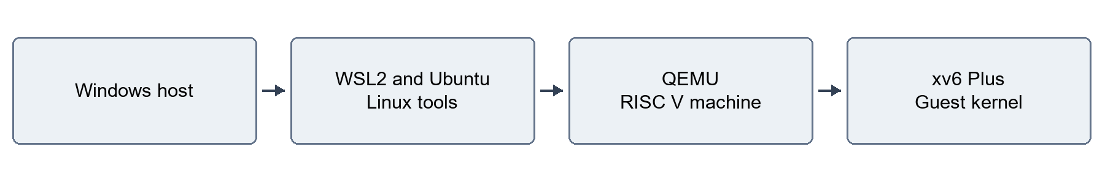
Figure 1 Development and execution layers authored for this report
Component | Captured environment
Ubuntu | 26.04.1 LTS, Resolute Raccoon
WSL2 kernel | 6.18.54.1-microsoft-standard-WSL2
Git | 2.53.0
RISC-V GCC | 15.2.0, Ubuntu package 15.2.0-16ubuntu1
QEMU | 10.2.1
GDB multiarch | 17.1
Workspace | Windows Mini Project folder, accessed in WSL under /mnt/c/Users/akshi/OneDrive/Documents/TIET/Sem-5/Mini Project/xv6-plus

These are the owner's captured tool versions, not the teammate's different tool versions. The separate Windows WSL application-package version was not collected.
The initial path contained a space in Mini Project. An unquoted -ffile-prefix-map argument split at that space and failed. The original setup repair quoted the complete mapping. A later historical-source boot problem was resolved operationally by explicitly targeting rv64gc and rebuilding clean. The preserved architecture attributes showed a much wider compiler-default ISA; the exact first triggering instruction was not isolated. GCC documents the role of march in selecting the target ISA. [R9]

5 Memory subsystem design
The design uses the page table as the record connecting a process's virtual pages to resident frames or saved disk slots. The allocator maintains physical-page ownership counts. The combined fault handler selects the recovery path according to the mapping state and access. This keeps lazy allocation, sharing and restoration in one memory subsystem rather than three disconnected demonstrations.
The relevant software markers are PTE_COW at bit 8 and PTE_SWAP at bit 9; the accessed marker PTE_A is used by Clock. The architecture provides permission and software-reserved fields and a local translation-fence mechanism. Those hardware meanings are specified independently of the project's policy choices. [R8]
State | Valid | Marker | Project meaning
Untouched lazy range | No | Neither | The address is reserved in the process size but has no resident user mapping.
Private resident page | Yes | Neither | PTE contains a physical frame and normal permissions.
Shared COW page | Yes | COW | Originally writable content is shared with write permission removed.
Swapped page | No | SWAP | Upper PTE bits identify a disk slot and permission information is retained.
Read-only program page | Yes | No COW | A genuine write protection rule; it must not become writable merely because a fault occurred.

The invariants are concrete: do not free a shared frame before its last reference disappears; do not allocate the same shared-table mapping twice; do not confuse a swap entry with an untouched page; restore saved contents and permissions; and perform sleeping disk work outside a spinlock.
The historical v0.4 design uses a one-CPU model with interrupt guards. The later foundation adds ptlock for shared page-table mutations, rechecks mappings after sleeping, and distinguishes read, write and execute fault handling. Disk I/O remains outside the page-table spinlock.

6 Lazy allocation implementation
The eager baseline calls growproc when a positive sbrk request arrives. That path tries to allocate and map physical pages before returning. The lazy implementation records the larger virtual size first. Kernel work for an untouched user page occurs when an access needs that mapping.
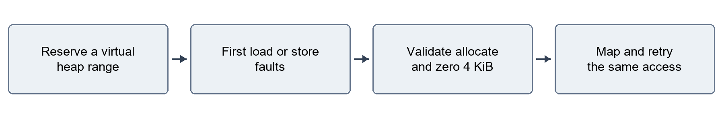
Figure 2 Project lazy allocation path

Fault recovery and cleanup
The project handler checks the requested address against the process's permitted range, aligns the page address, allocates a frame, clears its contents and installs a readable/writable user mapping. Zeroing prevents a new page from exposing the previous owner's data. Returning from the trap retries the faulting instruction.
The VM helpers must accept holes: fork skips untouched lazy pages, and unmap does not panic solely because an otherwise valid heap range lacks a resident page. A negative sbrk request follows the shrink path and releases actual mappings or saved slots as appropriate. Kernel copies also need the fault path, because read can target a user buffer that has not yet been touched.
Explanatory outline rather than a full source listing
positive sbrk: validate the new size and reserve the range
first valid access: obtain a zero-filled frame and map it
subsequent access: use the resident mapping
unmap: release a resident frame or saved slot; tolerate holes
The main implementation locations are kernel/sysproc.c, kernel/pgfault.c, kernel/vm.c and kernel/trap.c. This behavior corresponds to the educational lazy-allocation exercise, while the project handler also has to coexist with COW and swapping. [R3]
Accepting a reservation changes when allocation failure appears: later first touch can fail if backing capacity is exhausted. Reservation success therefore cannot be read as proof that the entire request is resident in RAM.

7 Lazy allocation evidence
At v0.0 the 200 MiB baseline request failed. At the lazy milestone the same reservation succeeded, and lazytest completed. The historical command prints MB, but its sizes use 1024 multiplied by 1024 bytes; this report uses MiB for those quantities.
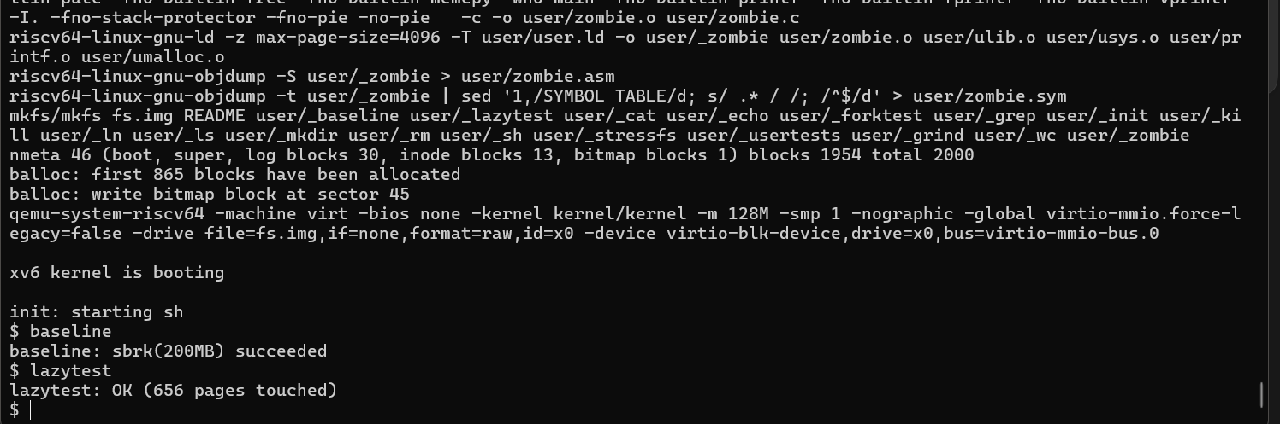
Figure 3 Original capture showing large reservation and sparse test success Open original capture
The sparse program reserves 256 MiB, representing 65536 pages of 4096 bytes. It writes one page out of every 100, starting at index zero: 656 explicitly sparse-write-touched pages. Their page payload totals 2686976 bytes, or 2.5625 MiB. This arithmetic describes those touches, not the whole process's resident set.
The test reads the written values back, reads a fresh page to verify zero initialization, and performs read into another newly reserved buffer. That checks useful integration behavior beyond merely printing that sbrk returned successfully. The fresh-page read, syscall buffer, code, stacks and page-table pages are additional memory activity.

What to tell the teacher
The useful result is that a large sparse address range can be reserved while physical allocation follows actual access. Do not say the 200 MiB command proves 200 MiB of physical RAM was available, or that exactly 656 physical frames constituted the entire process.
Evidence: docs/results/memory/screenshots/lazy-allocation.png and user/lazytest.c. The baseline failure transcript is preserved separately as report-evidence/03-eager-baseline-result.txt.

8 Copy on write implementation
COW changes the fork path for a single-threaded process. The child gets its own page-table structure while resident data pages can refer to the parent's frames. Originally writable mappings lose write permission and receive the COW marker. Ordinary read-only mappings remain protected. The project's allocator increments and decrements physical-frame reference counts as ownership changes.
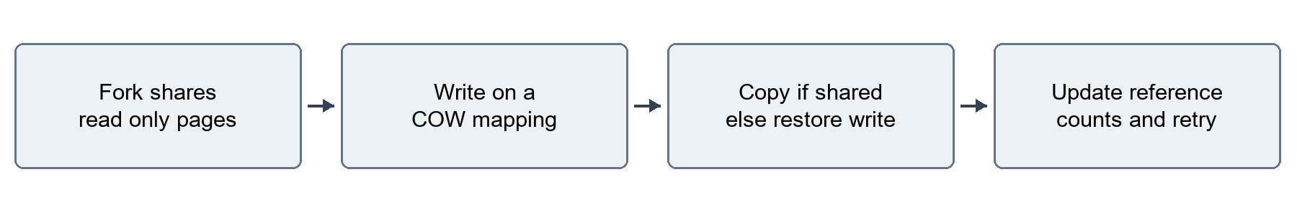
Figure 4 Project copy on write path
On a COW write, a page with multiple references is copied into a newly allocated private frame; the old reference is released. If only one reference remains, the handler restores write permission without copying. The actual-copy statistic increases only for a real page copy. Changed translations are followed by the appropriate local fence.
The final-free decision belongs in kfree: a page returns to the free list only when the reference count reaches zero. A child exit must not invalidate the parent's mapping. copyout must use the same write-recovery rules when the kernel writes to a COW user buffer.
Explanatory decision outline
fork: share mapped frames, protect writable pages, increment refs
write fault on COW:
refs greater than one -> copy and replace writer mapping
refs equal to one -> restore write permission
drop mapping: decrement refs; return frame only at zero
These design requirements correspond directly to the COW lab's sharing, ownership and kernel-copy concerns. Our implementation and tests are integrated with the project fault handler rather than presented as a separately graded MIT lab solution. [R4]
Relevant source: kernel/kalloc.c, kernel/vm.c, kernel/riscv.h and kernel/pgfault.c. In the later thread-capable build, a multi-member group instead uses a private-copy fork path to avoid changing mappings beneath another CPU's cached translation; that boundary is discussed in section 16.

9 Copy on write results
The project's custom cowtest reserves and touches 80 MiB before fork. The child checks the inherited pattern and changes selected pages. The parent waits for the child's status and checks that its own data did not change. The pre-COW run failed to fork; the recorded COW runs report OK.
The benchmark touches 20 MiB and measures 50 sequential fork/wait cycles using uptime ticks. The child exits, so most data pages do not need private copies. This measures the whole loop, including scheduling and cleanup, rather than isolating one kernel function's latency.
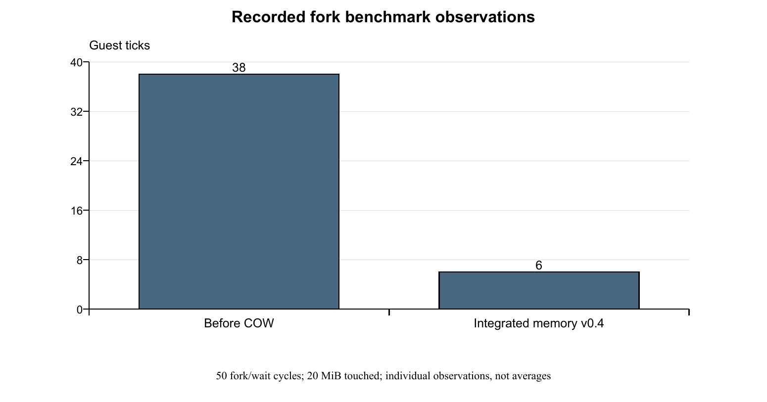
Figure 5 Historical individual fork benchmark observations
Stage | Ticks | Evidence and scope
Before COW | 38 | One captured pre-COW observation.
COW only | 3 and 4 | Separate captured runs after the COW and wait repair.
Integrated memory v0.4 | 6 | One captured observation after the complete memory integration.

The final observation has 32 fewer ticks than the earlier 38-tick observation, an arithmetic reduction of about 84.2 percent. This is not a repeated controlled average or a general operating-system speedup. The earlier 3–4 tick observations and the later six-tick result describe different stages.
Our cowtest is not MIT's complete cowtest program, and the MIT grading harness was not run. The custom test and the unchanged project's usertests suite provide the reported evidence.

10 Memory statistics
memstat provides a shared structure, syscall 22 and a user command. Kernel wiring retrieves the user pointer, fills the structure, and copies the snapshot through the normal user-copy path. The command prints the fields in a consistent order. The related MIT sysinfo exercise is a useful syscall reference, but the interfaces differ. [R5]
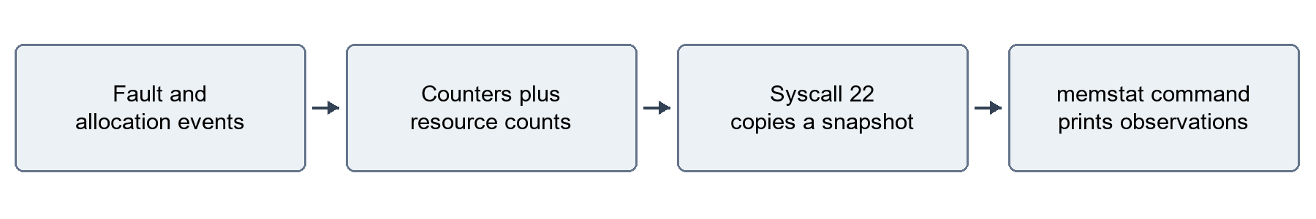
Figure 6 Memory observation path
Field | Interpretation
page_faults | Calls through the project's page-fault handler, including recovery invoked by kernel copies; not solely a hardware-trap count.
lazy_allocs | Successful first allocations for previously untouched lazy pages.
cow_copies | Actual private page copies; single-owner permission restoration is not counted as a copy.
swap_outs and swap_ins | Cumulative completed swap transfers since boot.
free_pages | Current free physical-page count, rather than reserved virtual bytes.
swap_slots_used | Occupied backing slots at the observation point.

At v0.3, a recorded sequence showed 32500 free pages initially, after cowtest, and after lazytest. Handler calls increased from 4 to 20518 to 21188; lazy allocations from 2 to 20486 to 21148; COW copies from 2 to 27 to 31. The screenshot and full-suite result are preserved in the evidence archive.
Counters include the shell and the measurement command. A program's internal snapshot and a later shell snapshot can differ. Use two snapshots from the same boot to discuss a workload delta; do not subtract unrelated runs or interpret a cumulative value as a fresh per-command count.

11 Swap storage and page lifecycle
The swap engine supplies backing storage once a valid working set cannot remain in usable RAM. It maintains frame metadata containing a page table, virtual address and tracking sequence. Eligible pages are written through the existing block I/O path into a reserved area after the filesystem. This is a project extension grounded in standard disk-backed memory mechanisms. [R6]
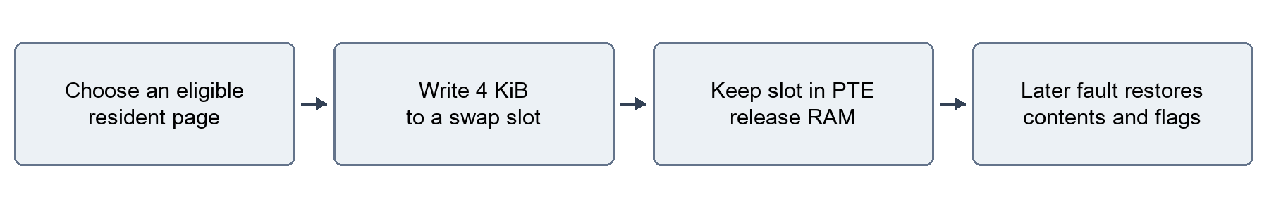
Figure 7 Eviction and restoration in the project
The swap area contains 16384 blocks of 1024 bytes: 16 MiB. Each 4096-byte page uses four blocks, yielding 4096 slots. A swapped PTE clears the valid bit, sets the swap marker and retains the slot identifier and permission information. A later fault allocates a frame, reads the saved bytes and restores the mapping. Unmapping must release the slot too.
Image property | Historical v0.4 | Current integrated build
Filesystem blocks | 2000 | 4096 to fit added thread executables
Swap blocks | 16384 | 16384 unchanged
Swap location | Starts after filesystem | SWAPSTART follows FSSIZE
Expected image bytes | 18825216 | 20971520

The historical image-size check of 18825216 bytes confirms the reserved layout at that stage. It is not the expected image length after the filesystem capacity change. Storage capacity and usable RAM are separate quantities.
Shared frames and COW-marked mappings are excluded from eviction. A simple low-water allocation policy attempts eviction before all physical pages disappear, and a sleep lock serializes swap transfers. The full source is in kernel/swap.c; flag and slot helpers are in kernel/riscv.h. The implementation is finite-capacity and does not promise that every large allocation can succeed.

12 Swap correctness evidence
The constrained experiment leaves QEMU configured with 128 MiB physically but limits the RAM managed by xv6 to 8 MiB through RAM_MB. It is a controlled guest-kernel memory limit, not a claim that the host or emulated machine physically contains only 8 MiB.
Configuration | Workload | Observed outcome | Meaning
Before swap | 4 MiB control | 1024 pages, zero bad, status 0 | The small workload runs normally.
Before swap | 12 MiB | Child exit status -1 | Lazy reservation alone does not supply backing capacity.
With swap | 12 MiB | 3072 pages, zero bad, status 0 | The touched region is verified despite the 8 MiB usable-RAM limit.
With swap | swapfork | Child bad=0 and OK | COW and swap interact successfully in this test.

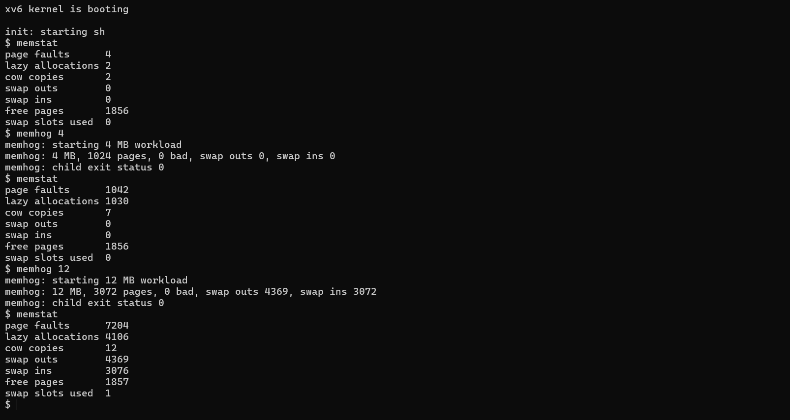
Figure 8 Original active swap control and pressure results Open original capture
The first pressure workload reports 4369 swap outs and 3072 swap ins. The following shell snapshot reports 3076 ins, illustrating measurement-command overhead. Three historical repeated runs completed with stable post-run resources of 1857 free pages and one occupied slot. The slot owner was not traced; the observation supports stability for that sequence, not universal leak freedom.
The earlier no-swap capture and the full repeated-run records remain available through the evidence index. The 6 MiB swapfork command checks child and parent contents; its pass is a correctness result, not a measurement of maximum concurrent workload capacity.

13 FIFO and Clock replacement
FIFO selects the eligible frame with the oldest tracking sequence. This implementation scans the frame table to find it. It is straightforward to explain, but repeated full scans are not a claim of a scalable production design.
Clock advances a hand through candidates. If an eligible mapping has its accessed bit set, the policy clears that bit, fences the local translation state and grants another chance. An eligible mapping encountered without that recent-use indication can be selected. It is an approximation using hardware activity information rather than an exact LRU ordering. [R7] [R8]
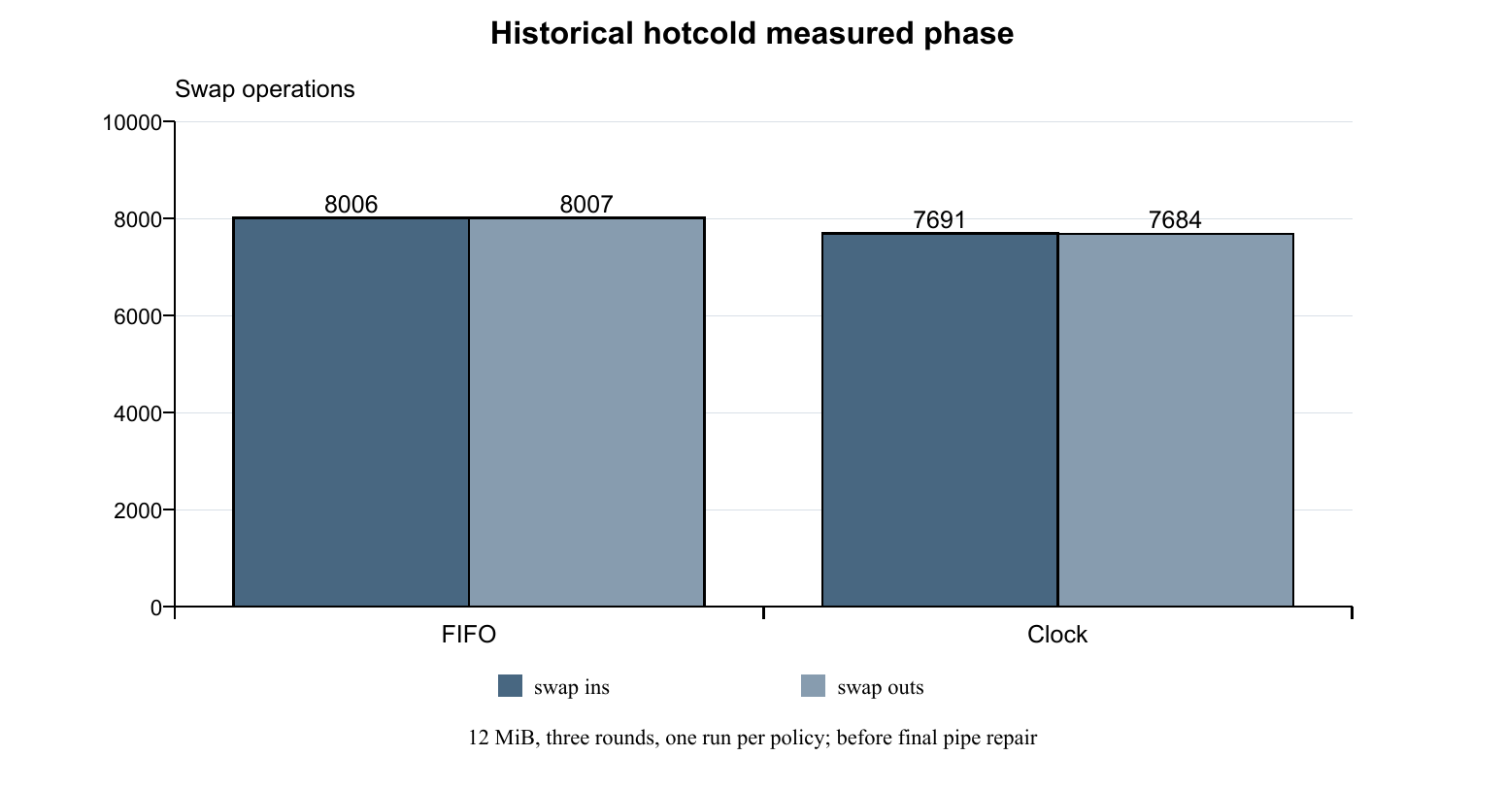
Figure 9 Historical hotcold measured phases
Policy | Swap ins | Swap outs | Measurement scope
FIFO | 8006 | 8007 | One measured phase
Clock | 7691 | 7684 | One measured phase

hotcold initializes 12 MiB, then executes three measured rounds: it streams over the cold region and periodically revisits selected pages in the first 512-page hot region. The printed values are differences between two internal memstat snapshots, rather than the final cumulative shell counters.
Clock showed 315 fewer ins and 323 fewer outs in those individual observations, approximately 3.9 and 4.0 percent fewer respectively. No elapsed-time measurement was collected. The runs preceded the final pipe repair, the screenshot labels follow the instructed matching build sequence, and the captures do not themselves display compiler flags. These data do not establish that Clock is faster or always superior.

14 Integration with existing system calls
Fault recovery has consequences beyond trap.c. A kernel user-copy operation can need allocation, COW recovery or swap I/O. The memory implementation therefore has to cooperate with wait, pipes and ordinary reads and writes rather than succeeding only in isolated heap tests.

Wait status under pressure
The first COW full-suite run failed at sbrkfail. The working diagnosis was that copying a status into the parent's COW memory could require an allocation while the child's pages were still held. The adopted ordering saves the status, reaps the child, releases locks and then copies status into the parent. The targeted test and the full suite passed afterward. The exact failing allocation branch was not internally traced, so the mechanism is a supported diagnosis rather than a captured instruction-level proof.
If the later status copy fails, this implementation can return -1 after the child has already been reaped. That cleanup behavior is part of the implementation description.

Pipe copies and the regression measurement
The initial swap full-suite run reached a final countfree failure, reporting 31876 pages versus 32159 and first printing a write failure. countfree counts bytes received through a pipe, so a failed write means its reported difference is not sufficient to establish a physical-page leak.
The repair stages pipe writes in a kernel buffer and moves user-memory copying outside the pipe spinlock; pipe read user copies follow the same separation. Prefaulting alone does not pin a buffer for the entire syscall, so the user-copy path must still be correct if a page was evicted later.
Focused usertests pipe1 and then the complete unchanged usertests suite passed after the repair. That evidence supports the practical fix without claiming a trace of the precise original failure site. Disk work must remain outside spinlocks in all callers, not just the demonstrated pipe path.

15 Validation summary and provenance
Stage | Checks actually observed | Scope
v0.1 | baseline, lazytest, full usertests | Lazy allocation checkpoint
v0.2 | cowtest, lazytest, targeted sbrkfail, full usertests | After wait cleanup repair
v0.3 | memstat sequences and full usertests | Free pages recovered to 32500 in recorded sequences
v0.4 | Control/pressure, repeated memhog, swapfork, hotcold, full usertests | Historical memory release
v0.9 source snapshot | Full usertests with 1 and 3 CPUs; FIFO and Clock pressure tests | Later thread-compatible memory implementation
Integrated main | Clean build and focused memory/thread checks | Same kernel/user/build source manifest as the four final configurations

The v0.4 full-suite capture ends with ALL TESTS PASSED. Its normal-RAM memstat changes from 32306 free pages and zero slots initially to 32307 free pages and one slot after the suite. Fault-handler calls are 803901, lazy allocations 751596, COW copies 163, swap outs 82554 and swap ins 693 at that later snapshot.
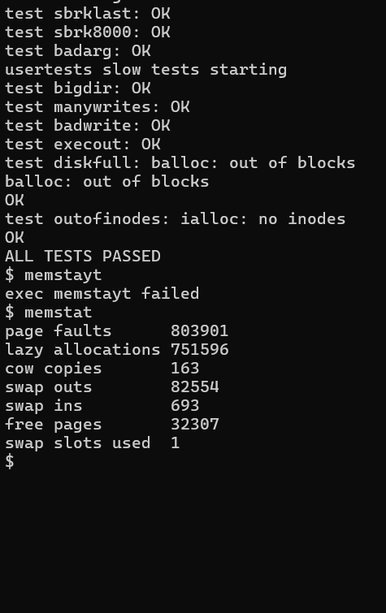
Figure 10 Original historical full-suite pass and post-suite counters Open original capture
For the later source snapshot, ten SMP rounds retained 32300 free pages and zero slots. FIFO pressure included ten shared-thread 12 MiB checks and Clock included three, all with zero bad pages. Their post-pressure counts were stable at 1852 free pages and two occupied slots. The integrated-main smoke run retained 32300 free pages and zero slots before/after. Do not compare free-page constants across different kernel builds as if they were a single leak experiment.

16 Errors fixes and known limits
Observed issue | Repair or response | Strength of conclusion
Path split in compiler flag | Quote the full file-prefix mapping | Build argument error and operational repair recorded
Historical-source boot stall | Explicit rv64gc and clean rebuild | Boot recovered; original first faulting instruction not proven
forkbench launch failure | File existence checked; later fresh-boot runs passed | Specific original cause unresolved
sbrkfail regression | Reap child and release locks before status copy | Targeted and complete suites passed afterward
countfree write failure | Stage pipe data and move user copies outside pipe spinlock | Focused and complete suites passed afterward
Command typos | Correct the command spelling | Shell-input incidents, not memory-kernel defects

The memory subsystem remains an educational implementation. Eviction is supported only with one CPU. The current SMP build disables it because a general cross-CPU TLB shootdown protocol is absent. A single-threaded fork uses COW; a multi-member group's fork uses private copies, and inherited COW pages are made private before the first SMP worker starts. Exec requires a single main member, and shrink is refused while multiple members remain.
Only eligible private pages can be evicted. COW-marked and multiply referenced frames can therefore limit recovery under fork-heavy pressure. Swap capacity is fixed at 16 MiB, FIFO's search is linear in the frame table, and memstat does not directly measure peak RSS or fault latency.
The timing observations are not controlled averages. Policy evidence is one measured phase per policy before the final pipe repair. Remaining occupied slots were observed to be stable but their ownership was not traced. No universal absence of leaks, MIT grader pass, production readiness or general speedup is claimed.
Useful future work would measure repeated policy trials, trace slot ownership, add stronger memory observability, improve victim-selection efficiency, and implement the synchronization needed for multiprocessor eviction. These are future extensions rather than completed features in this draft.

17 Teacher demonstration script
Plan for a short live demonstration supported by the saved evidence. Build before the meeting. Show historical screenshots as historical observations, and label any new live result with its current build configuration.
Order | Show or run | Explain to the teacher
1 | GitHub overview and reference map | Identify MIT xv6 as the base, MIT lab correspondence, and the project's integration work.
2 | Eager screenshot then baseline and lazytest | Show reservation changing from failure to success; distinguish virtual size from physical residency.
3 | cowtest and forkbench | Explain sharing, child writes, parent isolation and the measured loop; keep old 38 and current ticks separate.
4 | memstat before and after work | Describe cumulative counters and resource snapshots without claiming peak RSS.
5 | Prepared 8 MiB swap build: memhog 4 then memhog 12 | Contrast the control and pressure workloads; show zero bad pages and swap activity.
6 | swapfork and saved usertests pass | Show interaction correctness and broader regression evidence.
7 | FIFO/Clock evidence and limitations | Compare the recorded I/O counts; state why this is not a universal winner or runtime result.

Normal build and live commands
Run these in Ubuntu/WSL from the project repository. A clean rebuild is required when changing configuration.
make clean
make qemu CPUS=1 RAM_MB=128 SWAP_POLICY=1
At the xv6 prompt run individually
memstat
baseline
lazytest
cowtest
forkbench
memstat
Explain the output that actually appears; do not require the historical six-tick result to repeat exactly. The full usertests command can take much longer, especially with swapping under exhaustion. Use the existing completed transcript or screenshot during a short presentation and offer a fresh full run separately.

18 Teacher evidence checklist
Claim | Evidence to open | What it establishes
Eager baseline | v0.0 and 03-eager-baseline-result.txt | That named checkpoint rejected the large request
Lazy behavior | lazy-allocation.png and user/lazytest.c | Large reservation, sparse values, zeroing and syscall-buffer checks
COW isolation | fork-before-cow.png, cow-validation.png and user/cowtest.c | Before failure and later custom parent/child check
Fork observation | fork-benchmark.png and user/forkbench.c | The reported workload and tick observation
Swap capacity | no-swap-pressure.png and swap-pressure.png | The 4 MiB control and verified 12 MiB after-swap workload
Policy comparison | fifo-hotcold.png, clock-hotcold.png and user/hotcold.c | The two internal measured-phase I/O counts
Regression | regression-tests.png and unchanged usertests.c | A completed historical suite without weakening that test source
Progress history | Tags, commits and preserved patches | The staged development rather than an unsupported final claim

The screenshot files above are under docs/results/memory/screenshots on GitHub. The baseline transcript and extra development captures remain in the private report archive; its relevant baseline excerpt is also published with the presentation guide. Open the full original image when terminal text is small in the Word page.

Swap presentation setup
Exit QEMU using Ctrl+A then X, rebuild clean and use the following configuration and commands. Repeat a fresh build with SWAP_POLICY=2 for Clock.
make clean
make qemu CPUS=1 RAM_MB=8 SWAP_POLICY=1
memstat
memhog 4
memhog 12
swapfork
memstat
Present the reference list, feature source map, actual output and stated limits together. The strongest defensible statement is that the specified workloads and regression tests passed for the recorded source and configurations, not that every workload or every form of paging has been solved.

19 Viva preparation

Why can a 200 MiB reservation succeed with less usable RAM
The lazy call grows the permitted virtual range. Physical frames are obtained as pages are used. A later access can still fail when eligible RAM and backing capacity are exhausted.

Why must a new lazy page be cleared
The frame can contain data from an earlier owner. Zero filling supplies predictable new-memory contents and prevents that old data from becoming visible to the process.

Why is a COW marker needed in addition to read only permission
An originally writable shared page may be made private on a write. A genuinely read-only program page must remain protected. The handler needs to distinguish those cases.

Why do reference counts matter
Several process mappings can refer to the same physical frame after fork. Freeing it on the first exit would invalidate a surviving process. Final release happens only when all references are gone.

Why does copyout need special handling
The kernel can write into a user's protected or missing page during a syscall. It must honor the same ownership and allocation rules as a user store rather than silently modifying a shared frame.

What does Clock add beyond FIFO
Clock considers the accessed bit and gives recent users another chance. The historical workload produced fewer swap operations with Clock, but the evidence is insufficient for a general performance guarantee.

Why is swapping limited to one CPU
A page can be removed or remapped while another CPU retains an old translation. The project does not implement general remote TLB invalidation; the integrated SMP build therefore disables eviction.

Is Ubuntu the operating system being modified
Ubuntu supplies the development tools inside WSL2. xv6 is the separate RISC-V guest running in QEMU. The source changes described here are in xv6.

Why do GitHub files show old dates
The repository retains MIT's history. A file's displayed date reflects its last change in that history; project additions are identified through the milestone commits and comparisons.

20 Source map and reproducibility record
Source area | Role in the memory implementation
kernel/sysproc.c | sbrk behavior and the memory-statistics syscall
kernel/pgfault.c | Combined lazy, COW and swapped-page recovery
kernel/vm.c | Mapping, copying, user-copy recovery, holes and cleanup
kernel/kalloc.c | Physical-page allocation, reference counts and free-page accounting
kernel/swap.c | Frame/slot metadata, FIFO/Clock, transfers and statistics
kernel/riscv.h | Software flags, permissions and swap-slot helpers
kernel/pipe.c and proc.c | User-copy lock separation and wait cleanup integration
Makefile and memlayout.h | Usable-RAM and policy settings, swap image and target flags
user memory commands | baseline, lazytest, cowtest, forkbench, memstat, memhog, swapfork and hotcold

The historical memory report source is tag v0.4, commit 93fa86df3ddda8691cc2c260b373dd58f726620f. The eager comparison is v0.0, commit 24d95707e371f5bba684c601f7841f7488a17ccc. The later integrated implementation source is committed in 1e7591b and preserved in the v0.9 history. Its kernel/user/build manifest matches the four final validation configurations and the post-merge smoke build.
Common later source manifest SHA256
b61837d90722e94e33583db7157c32e7f9e3a449475897ea5301d4665ce88b34
For a historical experiment, use a separate clean checkout at the required checkpoint. Some comparison commands were introduced after the earliest tags, so an old tag does not necessarily contain every later test. The pre-COW comparison commands are preserved at 28c7475; the no-swap workload checkpoint is before-swap. Do not infer a fresh historical run merely from checking out a tag.
The public repository keeps feature explanations, selected outputs, original screenshots, references and this draft report in separate folders. Full console transcripts, original screenshots, intermediate patches and chronological development records remain in the local report-evidence archive. That archive preserves failed runs as well as passing runs.
The draft should be revised after teacher feedback. Add any required institutional template, submission information and new experiments explicitly, retaining the distinction between observed results, explanatory diagrams and future work.

References for design and provenance
R1 MIT PDOS xv6 for RISC V source repository
https://github.com/mit-pdos/xv6-riscv
The upstream operating system and retained MIT license. The project's eager baseline is pinned to c4de4b0 and checkpoint v0.0; newer upstream versions differ. Accessed 28 October 2026.
R2 xv6 a simple Unix like teaching operating system
https://mit-pdos.github.io/xv6-riscv-book/
Official book by Russ Cox, Frans Kaashoek and Robert Morris. Background reading for page tables, traps, allocation, locking and the xv6 source. Accessed 28 October 2026.
R3 MIT 6 S081 2020 lazy page allocation lab
https://pdos.csail.mit.edu/6.S081/2020/labs/lazy.html
Direct assignment correspondence for deferred sbrk allocation and fault-driven zero-filled pages. This report uses the archived year explicitly. Accessed 28 October 2026.
R4 MIT 6 1810 2025 copy on write fork lab
https://pdos.csail.mit.edu/6.1810/2025/labs/cow.html
Direct assignment correspondence for read-only sharing, COW recovery, reference counts and copyout integration. Our custom cowtest is not MIT's full lab grader. Accessed 28 October 2026.
R5 MIT 6 S081 2020 system calls lab
https://pdos.csail.mit.edu/6.S081/2020/labs/syscall.html
The sysinfo exercise is related to kernel information collection. Our seven-field memstat API is a project-specific extension, not the identical sysinfo interface. Accessed 28 October 2026.
R6 OSTEP chapter 21 Beyond Physical Memory Mechanisms
https://pages.cs.wisc.edu/~remzi/OSTEP/vm-beyondphys.pdf
Primary textbook reference by Remzi H Arpaci-Dusseau and Andrea C Arpaci-Dusseau for disk-backed memory and page-in/page-out mechanisms. Accessed 28 October 2026.
R7 OSTEP chapter 22 Beyond Physical Memory Policies
https://pages.cs.wisc.edu/~remzi/OSTEP/vm-beyondphys-policy.pdf
Primary textbook reference for replacement-policy reasoning including FIFO and approximations based on recent use. The project results do not establish universal policy superiority. Accessed 28 October 2026.

References for architecture and environment
R8 RISC V supervisor level ISA version 1 13
https://docs.riscv.org/reference/isa/v20260120/priv/supervisor.html
Official specification for page-table permission and software bits, accessed bits, page-fault causes and SFENCE.VMA. The reference is pinned to the published 20260120 documentation version. Accessed 28 October 2026.
R9 GCC RISC V target options
https://gcc.gnu.org/onlinedocs/gcc/RISC-V-Options.html
Official documentation for the march target selection used in the recorded build-compatibility repair. Accessed 28 October 2026.
R10 Microsoft Learn Windows Subsystem for Linux overview
https://learn.microsoft.com/en-us/windows/wsl/about
Primary environment reference for Ubuntu on Windows and WSL2's managed Linux-kernel virtual machine; xv6 runs separately inside QEMU. Accessed 28 October 2026.
R11 Current xv6 book page faults chapter
https://mit-pdos.github.io/xv6-riscv-book/pgfault.html
Explains the current upstream lazy allocation path. This is why our historical eager checkpoint, rather than a claim about all current xv6 releases, is the comparison reference. Accessed 28 October 2026.
R12 MIT PDOS xv6 RISC V book source repository
https://github.com/mit-pdos/xv6-riscv-book
Official source repository for the xv6 book; included as a second authentic MIT repository reference rather than an unverified student solution. Accessed 28 October 2026.
R13 MIT 6 S081 2020 utilities lab and starter repository provenance
https://pdos.csail.mit.edu/6.S081/2020/labs/util.html
Documents the course-specific xv6-labs-2020 starter repository and explains its difference from the book's xv6-riscv source. Its historical clone command is not a project build instruction. Accessed 28 October 2026.

