Memory Management Extensions in xv6
  - Kernel implementation walkthrough
We extended a historical xv6 RISC-V baseline with demand-zero heap allocation, copy-on-write fork, disk-backed paging, FIFO and Clock replacement, and a memory-statistics syscall. This walkthrough connects each mechanism to the kernel changes and the observed behavior.
The comparison starts at project tag v0.0 and follows the memory implementation through v0.4. The baseline is derived from historical upstream c4de4b0; later upstream xv6 versions already contain lazy allocation. Page size is 4 KiB. Quantities printed as MB by the test programs use 1024 x 1024 bytes and are expressed here as MiB.

Lazy heap allocation
Earlier code. sys_sbrk called growproc(n), which used uvmalloc to allocate and map physical pages before returning. A 200 MiB request could not fit in the 128 MiB configuration. What we changed. For positive growth, sys_sbrk now validates the range and updates p->sz, the process address-space limit. It reserves virtual addresses; it does not create resident mappings at this point.
Earlier eager path | Implemented positive growth branch
addr = myproc()->sz;  if(growproc(n) < 0)  return -1;  return addr; | if(addr + n < addr || addr + n > TRAPFRAME)  return -1;  p->sz = addr + n;

Added recovery code. We introduced handle_page_fault in kernel/pgfault.c and invoked it from usertrap in kernel/trap.c. On a valid first access, it checks the address and permissions, rounds down to a page boundary, allocates and zeroes a frame, and installs a user mapping. The instruction then retries. Invalid access or unrecoverable allocation failure terminates the process.
The VM helpers were also changed: unmap and fork tolerate untouched lazy holes, and kernel user-copy operations can resolve a valid missing page. Negative sbrk growth continues to release memory through the shrink path.
baseline at v0.0: sbrk(200MB) failed
baseline at v0.1: sbrk(200MB) succeeded
lazytest: OK (656 pages touched)
Test files we added. user/baseline.c calls sbrk(200 * 1024 * 1024) and checks its return value without populating the range. Its later success establishes virtual reservation. user/lazytest.c reserves 256 MiB and checks sparse writes, zero-filled pages and a syscall buffer. Later access can still fail when available physical and swap backing are exhausted.
Modified existing code: kernel/sysproc.c sys_sbrk, kernel/trap.c usertrap, and sparse/user-copy helpers in kernel/vm.c. Added code: kernel/pgfault.c handle_page_fault. Resources [1], [2], [7]. Embedded comparison E1.

Copy on write fork
Earlier code. fork used uvmcopy to allocate a separate frame and copy each resident parent page into the child. What we changed. uvmcopy now shares the data frames through separate page tables. Originally writable mappings lose PTE_W and gain PTE_COW in both processes. A write then triggers private-copy recovery. Existing read-only mappings retain their protection.
Earlier uvmcopy allocation and copy excerpt
if((mem = kalloc()) == 0)
goto err;
memmove(mem, (char*)pa, PGSIZE);

Changed fork path
if(*pte & PTE_W){
// Writable pages become COW in both processes.
*pte = (*pte & ~PTE_W) | PTE_COW;
}
flags = PTE_FLAGS(*pte);
// Map the same physical page into the child.
if(mappages(new, i, PGSIZE, pa, flags) != 0)
goto err;
kref_inc((void*)pa);
Code excerpt: modified kernel/vm.c, uvmcopy, COW milestone v0.2. The child maps pa rather than an eagerly copied frame.
The new mappages call uses pa rather than an allocated copy. kref_inc records the additional owner. We added per-frame reference accounting, so kfree releases a shared frame only after its final reference is dropped.

Write fault recovery
Mapping condition | Kernel action
COW mapping with multiple references | Allocate a frame, copy 4 KiB, replace the writer mapping with a writable private mapping, and release its old reference.
COW mapping with one reference | Restore PTE_W and clear PTE_COW without copying the page.
Read-only mapping without PTE_COW | Reject the write; ordinary protection faults must not create write permission.

Permission and mapping updates are followed by the appropriate local translation fence. copyout also resolves COW before a kernel write to a user buffer; otherwise a syscall could modify a frame still shared with another process. Partial-fork failure and process cleanup release the references they acquired.

Observed change
Workload | Before COW | After implementation
80 MiB custom cowtest | fork failed | OK; child writes preserve parent contents
50 fork/wait cycles with 20 MiB touched | 38 ticks | 6 ticks in historical integrated v0.4

The fork benchmark measures the complete fork/wait loop. These are individual recorded observations, not controlled averages. The custom cowtest checks inherited contents and isolation; it is separate from the full MIT lab grader.
Modified existing code: kernel/vm.c uvmcopy and copyout, kernel/kalloc.c kfree and reference-count helpers, and software PTE flags in kernel/riscv.h. Resources [3], [7]. Embedded comparisons E2 and E3.

Disk backed paging
Earlier behavior. When physical frames ran out, allocation failed; no disk paging path existed. The 12 MiB memhog workload failed under an 8 MiB managed limit. What we added. We extended kernel/swap.c into a paging engine and updated allocation, fault recovery, fork and cleanup to recognize swap entries.

Backing store and mapping state
The implementation reserves 16384 blocks of 1024 bytes after the filesystem inside fs.img. A 4 KiB page occupies four blocks, providing 4096 slots and 16 MiB of backing storage. The Makefile reserves this trailing region; RAM_MB controls the guest kernel memory boundary.
Page state | PTE interpretation | Required recovery
Untouched lazy page | No valid resident mapping and no PTE_SWAP | Allocate a demand-zero frame.
Resident page | PTE_V set; PPN identifies a frame | Access the existing frame subject to permissions.
Swapped page | PTE_V clear; PTE_SWAP set; slot and permissions retained | Read saved data rather than zero-filling the page.

Eviction and restoration
kalloc_user attempts reclamation below a free-page low-water mark. swap_out_one selects an eligible tracked frame, allocates a slot, changes its PTE to a swap entry, invalidates the local translation, writes the contents through block I/O and releases the frame. The swap sleep lock serializes transfers; disk operations execute outside spinlocks.
On a fault to a swapped entry, handle_page_fault obtains a frame and invokes swap_in. The core restoration statements are:
swap_read(slot, (uint64)mem);
*pte = PA2PTE(mem) | perm | PTE_V;
swap_slot_free(slot);
Code excerpt: added restoration path in kernel/swap.c, swap_in, integrated memory milestone v0.4.
The restored page retains its saved permissions and is tracked again. Unmapping a swapped page releases its slot. Frame metadata records the owning page table, virtual address and tracking sequence. Victim eligibility excludes COW-marked and multiply referenced frames and checks that the live PTE still identifies the candidate frame.

Observed capacity change
8 MiB usable RAM, before swap:
memhog 12: child exit status -1
With the swap engine:
memhog: 12 MB, 3072 pages, 0 bad, swap outs 4369, swap ins 3072
memhog: child exit status 0
The 4 MiB control also succeeds. swapfork reports child bad=0 and OK, exercising COW and swap together. The usable-RAM limit is imposed by xv6; QEMU still exposes 128 MiB physically. Swap capacity is finite and eviction is supported with one CPU.
Added relative to v0.0: kernel/swap.c. The v0.3 statistics stub was extended into swap_out_one, swap_in, frame tracking and slot management. Modified existing code: kernel/vm.c, kernel/riscv.h, kernel/memlayout.h, kernel/main.c and Makefile. Resources [5], [7]. Evidence E4 to E6.

FIFO and Clock replacement
Earlier behavior. The original allocator had no page replacement policy because it could not evict user data to disk. What we added. pick_victim in kernel/swap.c selects FIFO with SWAP_POLICY=1 or Clock with SWAP_POLICY=2. Both policies use the same eligibility checks and transfer code. A clean rebuild is required when changing the setting.

FIFO selection
swap_track assigns an increasing sequence number when a frame is tracked. FIFO scans eligible frames and chooses the smallest sequence number. It uses tracking order rather than recent-access information.
for(int i = 0; i < NFRAMES; i++){
if(frames[i].pt != 0 &&
frames[i].seq < best_seq &&
evictable(i)){
best = i;
best_seq = frames[i].seq;
}
}
return best;
Code excerpt: added FIFO branch in kernel/swap.c, pick_victim, v0.4.

Clock selection
Clock maintains a circular hand. For an eligible candidate with PTE_A set, it clears the accessed bit, executes a local translation fence and continues. An eligible candidate encountered without the accessed indication can be evicted.
if(*pte & PTE_A){
*pte &= ~PTE_A;
sfence_vma();
continue;
}
return i;
Code excerpt: added Clock branch in kernel/swap.c, pick_victim, v0.4; the enclosing loop advances clock_hand.
The enclosing loop advances the hand and examines at most two frame-table passes. This is a second-chance approximation using hardware access information; it does not maintain an exact LRU order.

Recorded policy comparison
hotcold measured phase | FIFO | Clock
Swap ins | 8006 | 7691
Swap outs | 8007 | 7684

hotcold initializes 12 MiB and performs three measured rounds containing cold scans and repeated hot-region accesses. The values are differences between internal memstat snapshots. Clock used fewer transfers in these historical observations. One phase per policy was recorded before the final pipe repair; no elapsed-time or universal policy advantage is established.
Added policy code: kernel/swap.c pick_victim selects FIFO or Clock at build time. Modified hardware-flag support: kernel/riscv.h. Resources [6], [7]; locality and policy research context [8], [9]. Embedded comparisons E7 and E8.

Memory statistics and syscall integration
Earlier interface. The v0.0 kernel exposed no project memstat syscall or monitoring command. What we added. kernel/memstat.h defines the structure; syscall 22 invokes sys_memstat. memstat_fill collects its fields, and copyout returns them to the caller. user/memstat.c calls this interface and prints the results. syscall.h, syscall.c, user.h and usys.pl provide the registration and stub.
Field | Meaning in this implementation
page_faults | Memory-recovery handler invocations, including recovery requested by kernel user copies.
lazy_allocs | Successful demand-zero page allocations.
cow_copies | Actual private COW page copies; permission restoration with one owner is excluded.
swap_outs and swap_ins | Completed page transfers, cumulative since boot.
free_pages | Current physical free-list page count.
swap_slots_used | Currently occupied backing-store slots.

The allocator maintains its free-page count as kalloc and final-reference kfree remove or insert frames. Counters include shell and measurement activity. They expose event counts and current resources rather than peak RSS or an atomic system-wide performance measurement.

Example observation
v0.3 snapshot | Fault handler calls | COW copies | Free pages
Before cowtest | 4 | 2 | 32500
After cowtest | 20518 | 27 | 32500

The workload changes the event counters while the recorded free-page count returns to its initial value. Swap transfer counters can exceed workload page counts because pages may be evicted and restored repeatedly.

Integration changes required by fault recovery
In wait, we save the child exit status, reap the child and release the process locks before copying status to the parent. The copy can require COW allocation, so releasing the child frames first improves availability. If the later status copy fails, wait can return -1 after reaping the child.
In the pipe paths, user-memory copying is separated from the pipe spinlock. Writes are staged through a kernel buffer, and reads perform the user copy outside the lock. This permits page recovery and sleeping disk I/O during normal syscall execution. Prefaulting alone is insufficient because a page can later be evicted.
These changes addressed the observed sbrkfail regression and the countfree pipe-write failure. Targeted checks and the complete unchanged usertests suite passed after the respective repairs.
Added interface: kernel/memstat.h and user/memstat.c. Modified existing syscall, allocator, wait and pipe code. Resource [4] supplies the related syscall/sysinfo exercise; resource [1] supports trap and locking integration. Embedded observations E9 and E10.

Implementation map and evidence
The kernel files implement the features. We also added seven user-space workload/test files and the user/memstat.c observation command to exercise and measure those features. user/baseline.c was created before lazy allocation so the same request could be checked at both milestones. The test-file sections identify every file, its introduction point and its verification role.
Kernel area | Concrete change
sysproc.c, pgfault.c and trap.c | Reserve heap ranges, classify faults and perform lazy/COW/swap recovery.
vm.c and riscv.h | Handle sparse mappings, COW permissions, slot encoding, fork and user-copy recovery.
kalloc.c | Reference counts and physical free-page accounting.
swap.c, memlayout.h and Makefile | Frame/slot metadata, policies, transfers, usable RAM and backing-store layout.
proc.c, pipe.c and syscall wiring | Integrate recovery with wait, pipes and the memstat API.

What the recorded tests establish
Test or comparison | Observed behavior
baseline and lazytest | Eager 200 MiB request failed; lazy reservation succeeded; sparse test passed with 656 write-touched pages.
cowtest and forkbench | Large-process fork changed from failure to success with isolation checks; historical loop observation changed from 38 to 6 ticks.
memhog and swapfork | 12 MiB under an 8 MiB usable limit verified 3072 pages with zero bad pages after swap; combined fork test passed.
hotcold and usertests | Recorded policy I/O comparison and complete regression pass after integration repairs.

A sparse reservation is not a residency measurement. Backing capacity remains finite. Current multiprocessor builds disable eviction because general cross-CPU TLB shootdown is absent; COW/shared-frame exclusions also constrain reclamation. Later thread-compatible memory checks are recorded separately from the historical v0.4 measurements.

Relationship to coursework and research
Lazy allocation and COW correspond to the MIT exercises [2] and [3]. memstat is related to the sysinfo exercise [4] but has a different seven-field interface. Paging mechanisms and replacement policies are grounded in [5] and [6]. The resource list states the specific sections and implementation concerns each source supports.
Denning's working-set paper [8] supplies locality and active-memory-demand context; this implementation does not include its working-set scheduler. The FIFO anomaly paper [9] supplies historical policy context; our hotcold comparison is not a reproduction of that experiment.

Explicit changes to the xv6 code
The following classification compares v0.0 with the memory implementation through v0.4. Existing OS services were modified where their allocation, mapping or locking behavior needed to change. New files provide recovery logic, observability and test workloads.
Status | Files and functions | Implemented change
Modified | kernel/sysproc.c sys_sbrk; kernel/trap.c usertrap | Replace eager positive heap growth with reservation; route load/store faults to recovery.
Added | kernel/pgfault.c handle_page_fault | Validate an access and supply demand-zero, COW or swapped-page recovery.
Modified | kernel/vm.c uvmcopy, uvmunmap and user-copy helpers | Share COW mappings, tolerate lazy holes, recover user buffers and release saved slots.
Modified | kernel/kalloc.c; kernel/riscv.h | Maintain frame references/free counts and define the COW/swap PTE encoding.
Added and extended | kernel/swap.c | Statistics stub at v0.3; eviction, restoration, FIFO/Clock and slot/frame metadata added before v0.4.
Added and wired | kernel/memstat.h; user/memstat.c; syscall.c/h, sysproc.c, user.h and usys.pl | Define the seven-field structure and implement syscall 22 and its command.
Modified | kernel/proc.c wait; kernel/pipe.c; sysfile.c and spinlock.c | Stage exit status, release child resources before copyout, and keep faulting user copies/I/O outside spinlocks.
Modified | kernel/defs.h, main.c, memlayout.h and Makefile | Declare/init the additions; configure usable RAM, policy, disk image and test commands.
Added tests | user/lazytest.c, cowtest.c, forkbench.c, memhog.c, swapfork.c and hotcold.c | Exercise sparse access, fork isolation, timing, pressure, combined swap/fork and locality. baseline.c already exists at v0.0.

Added physical allocation in the lazy fault handler
char *mem = kalloc();
if(mem == 0)
return -1;
memset(mem, 0, PGSIZE);
if(mappages(p->pagetable, va, PGSIZE, (uint64)mem,
PTE_R | PTE_W | PTE_U) != 0){
kfree(mem);
return -1;
}
New kernel/pgfault.c, handle_page_fault, v0.1. kalloc supplies a frame; memset clears it; mappages installs the user mapping. Address/permission validation occurs earlier in the function.
if(handle_page_fault(p, r_stval(), r_scause() == 15) < 0)
setkilled(p);
Modified kernel/trap.c, usertrap load/store-fault branch, v0.1. A failed recovery marks the process for termination. The main feature sections retain the exact sbrk, COW, swap-in, FIFO and Clock excerpts.

Function changes in allocation and mapping
These comparisons describe the earlier v0.0 behavior and the memory changes introduced through v0.4. Each row states what the function originally did and what changed. The existing feature sections retain the corresponding code excerpts and resource numbers.
Function and location | Earlier behavior | Implemented change and consequence
sys_sbrk  kernel/sysproc.c  Modified | Called growproc(n), including for positive requests, so heap growth attempted physical allocation before returning. | Positive requests validate the address bound and increase p->sz without allocating frames. Physical allocation moves to first access. Negative requests still use growproc.
growproc  kernel/proc.c  Retained | Used uvmalloc/uvmdealloc to grow or shrink mapped memory. | The function body is unchanged in this comparison. sys_sbrk bypasses it for positive lazy growth and retains it for shrinking.
usertrap  kernel/trap.c  Modified | An unhandled user page fault followed the unexpected-trap path and marked the process for termination. | The memory-fault branch calls handle_page_fault with the fault address and access information. Successful recovery resumes execution; failed recovery marks the process killed.
uvmalloc  kernel/vm.c  Modified | Allocated frames using kalloc, zeroed them and installed mappings. | Uses kalloc_user and tracks each new user frame for eviction. Zeroing, mapping and allocation-failure cleanup remain necessary.
uvmcopy  kernel/vm.c  Modified | Allocated a separate physical frame and copied each resident parent page into the child. | Skips lazy holes, resolves saved parent pages as needed, maps shared frames into the child, protects writable mappings with COW and increments references.
uvmunmap  kernel/vm.c  Modified | Expected mapped pages; missing/invalid entries could panic. Released mapped physical frames when requested. | Tolerates lazy holes. A swapped mapping releases its slot; a resident mapping releases its frame reference and tracking metadata.
copyin and copyinstr  kernel/vm.c  Modified | Translated user addresses through the existing mapping; missing mappings caused copy failure. | Use fault-aware page access to supply valid lazy or swapped pages before copying. Short copy windows protect the resolved mapping in the one-CPU memory design.
copyout  kernel/vm.c  Modified | Copied through the physical address returned by translation; there was no COW ownership decision. | Requests writable user access, invoking lazy/swap recovery or a private COW copy before the kernel writes the buffer.
kalloc and kfree  kernel/kalloc.c  Modified | Removed/inserted frames in a free list without shared-frame reference accounting. | Allocation initializes an ownership count and updates free-page statistics. kfree decrements the reference count and returns the frame only when it reaches zero.

This distinction is important for the baseline result: sys_sbrk changes the address-space reservation policy, while the fault handler supplies physical pages later. A successful reservation does not remove the finite backing-capacity limit.

Function changes in recovery and integration
New functions are identified as additions rather than described as replacements for nonexistent earlier code. The swap.c statistics stub at v0.3 was subsequently extended into the paging engine.
Function and location | Earlier behavior or interface | Implemented change and purpose
handle_page_fault  kernel/pgfault.c  Added | No combined lazy, COW and swap recovery helper existed at v0.0. | Classifies the mapping and access, allocates zero-filled lazy pages, recovers COW writes or restores saved pages. Invalid accesses and unrecoverable allocation failures return an error.
pin_user_page and prefault  kernel/vm.c  Added | User-copy paths relied on already valid translations; file syscalls did not prepare buffers through these helpers. | Recheck a mapping after fault recovery. prefault attempts buffer preparation before file I/O; it does not guarantee a page cannot later be evicted.
kref_inc, kref_get and kfreepages  kernel/kalloc.c  Added | No interface exposed shared-frame references or the maintained free-page count. | Support fork ownership, COW decisions, eviction eligibility and memory statistics.
kalloc_user  kernel/swap.c  Added | Direct allocation returned failure when no free frame was available; no swap reclaim wrapper existed. | When free pages are low and no spinlock is held, attempt eviction of eligible frames before calling kalloc. Reclamation can still fail.
swap_out_one, swap_in and tracking/slot helpers  kernel/swap.c  Added | The earlier statistics stub did not move page contents to disk or retain swap entries. | Track owners and slots, save eligible frames, encode nonresident mappings, restore contents/permissions and release slots during cleanup.
pick_victim  kernel/swap.c  Added | No swap victim-selection engine existed. | FIFO selects the oldest tracked eligible frame. Clock clears accessed indications and grants another chance while advancing a circular hand.
sys_memstat and memstat_fill  sysproc.c and swap.c  Added | No project memstat system call or seven-field user interface existed at v0.0. | Collect event/resource counts and copy the structure to the user buffer through syscall 22. The command prints the returned fields.
wait  kernel/proc.c  Modified | Copied child status while child resources and process locks were still held, then reaped the child. | Save status locally, reap the child and release locks before copyout, which may itself need COW allocation. A later copy failure can return -1 after reaping.
pipewrite and piperead  kernel/pipe.c  Modified | User-memory copying occurred while the pipe spinlock was held. | Stage writes through a kernel buffer and perform user copies outside the pipe lock, allowing allocation and sleeping recovery safely.
sys_read and sys_write  kernel/sysfile.c  Modified | Passed the user buffer directly to fileread/filewrite without the added preparation step. | Attempt prefault preparation before file I/O. Fault-aware copy helpers remain necessary because preparation alone does not pin every page for the entire syscall.

Memory limits and build configuration
The earlier PHYSTOP was fixed at KERNBASE + 128 * 1024 * 1024. We introduced the RAM_MB build parameter and changed the upper managed-memory boundary to:
#define PHYSTOP (KERNBASE + RAM_MB * 1024 * 1024)
Makefile compilation passes RAM_MB as a C preprocessor definition. This build restricts the kernel-managed range to 8 MiB, including kernel overhead; QEMU still exposes 128 MiB physically:
make clean
make qemu CPUS=1 RAM_MB=8 SWAP_POLICY=1
Policy 1 selects FIFO; policy 2 selects Clock. Clean rebuilding is required when changing these compilation settings. We also changed the Makefile UPROGS list so the newly added user programs are compiled and included in fs.img. Their relevant entries are:

$U/_baseline\
$U/_lazytest\
$U/_cowtest\
$U/_forkbench\
$U/_memstat\
$U/_memhog\
$U/_hotcold\
$U/_swapfork\
For example, user/baseline.c is compiled into user/_baseline on the host, then placed in the image as baseline. We run baseline at the xv6 shell, where it enters the kernel through the existing sbrk syscall. This user test does not implement lazy allocation; the changed kernel decides how to satisfy the request.
The same separation applies to cowtest and the swap workloads. They drive fork, user-memory accesses and file/syscall buffers so that the kernel mechanisms are exercised under controlled conditions. memstat observes the results. usertests is an inherited regression suite, rather than another file created for this project.

Test files we created for allocation and fork
We created the following four user-space source files for this project. They were absent from the chosen historical xv6 baseline. The baseline and fork comparison programs were added before changing their respective kernel mechanisms, allowing the same workloads to be used before and after implementation.
Source file we added | First added | What the test code does
user/baseline.c | v0.0 | Requests 200 MiB through sbrk and prints whether it was accepted. It does not write into the reserved range; this is a reservation comparison.
user/lazytest.c | v0.1 | Reserves 256 MiB, writes and verifies every hundredth page, checks a fresh page reads as zero, and reads README into an untouched user buffer. It reports 656 sparse write-touched pages.
user/cowtest.c | Before v0.2 COW | Allocates and touches 80 MiB, forks, checks inherited contents, changes every thousandth page in the child, and verifies the parent data remains unchanged.
user/forkbench.c | Before v0.2 COW | Touches 20 MiB and times 50 sequential fork/wait cycles using uptime ticks. It checks child exit status and prints the complete loop duration.

The baseline program was code we added
This is the actual request and result check from user/baseline.c. The historical output says MB; the expression requests 200 MiB.
char *p = sbrk(200 * 1024 * 1024);
if(p == (char*)-1)
printf("baseline: sbrk(200MB) failed (expected on stock xv6)\n");
else
printf("baseline: sbrk(200MB) succeeded\n");
At v0.0, this program reached sys_sbrk, then growproc and eager uvmalloc; insufficient physical memory caused sbrk to return -1. After lazy allocation, the same request was accepted as a virtual reservation because sys_sbrk no longer allocated all frames immediately. The added fault handler supplies frames when the range is accessed.

What the COW test demonstrates
We added cowtest.c as a custom capacity and isolation check. Touching 80 MiB makes the later fork demanding for eager copying. With COW, the initial frames can be shared; child writes require private copies. The parent checks its original pattern after wait. This is our test program, separate from the official MIT lab grader.

Test files we created for swapping and observation
We added three further workload/test files and the memstat monitoring command. The existing usertests.c suite supplies broader regression coverage and was retained unchanged in the v0.0 to v0.4 memory comparison.
Source file and origin | Introduced | What it exercises or observes
user/memhog.c  We added this test | Before swap | Runs a requested MiB workload in a child, writes and verifies the first and last byte of every page, and reports child status and cumulative swap counters. Zero bad pages covers those checked positions.
user/swapfork.c  We added this test | v0.4 | Fills 6 MiB, forks, and checks inherited data. The child writes 77 into the second byte of every page; the parent verifies its own second bytes remain zero. It exercises fork isolation together with paging.
user/hotcold.c  We added this workload | v0.4 | Initializes 12 MiB, then measures three rounds of cold scans and hot-region revisits. It prints swap-count differences between internal snapshots. It compares policies for that access pattern, rather than checking every stored value.
user/memstat.c  We added this command | v0.3 | Calls the new memstat syscall and prints seven counters/resource fields. It is an observation tool, not a memory-pressure workload, and does not reset the counters.
user/usertests.c  Existing xv6 file | Inherited | Exercises processes, copies, heap growth, pipes, files, invalid accesses and exhaustion. We used the unchanged suite to check that the new memory mechanisms did not break its tested behavior.

Kernel code behind the memstat command
The monitoring command required a new kernel interface as well as a new user file. The following is the added sys_memstat body in kernel/sysproc.c; memstat_fill gathers the fields and copyout returns the structure to user space.
uint64 addr;
struct memstat ms;
argaddr(0, &addr);
memstat_fill(&ms);
if(copyout(myproc()->pagetable, addr,
(char*)&ms, sizeof(ms)) < 0)
return -1;
return 0;
We added kernel/memstat.h for the shared structure and registered the call through the syscall table and user stub. The printed results, pressure tests and full-suite captures are embedded in the evidence pages that follow; they are preserved observations, not new executions during this document edit. Resource [4] explains the related syscall and sysinfo exercise.

Lazy allocation comparison evidence
The baseline command executes sbrk(200 * 1024 * 1024). The earlier eager result is preserved as the original supplied text transcript; the later success and sparse-access result are visible in the embedded original capture. The two observations belong to different named checkpoints.

Earlier eager baseline at v0 0
$ baseline
baseline: sbrk(200MB) failed (expected on stock xv6)
Original supplied baseline transcript. The historical stock wording refers to the project eager checkpoint, not every later upstream xv6 release.

After lazy allocation at v0 1
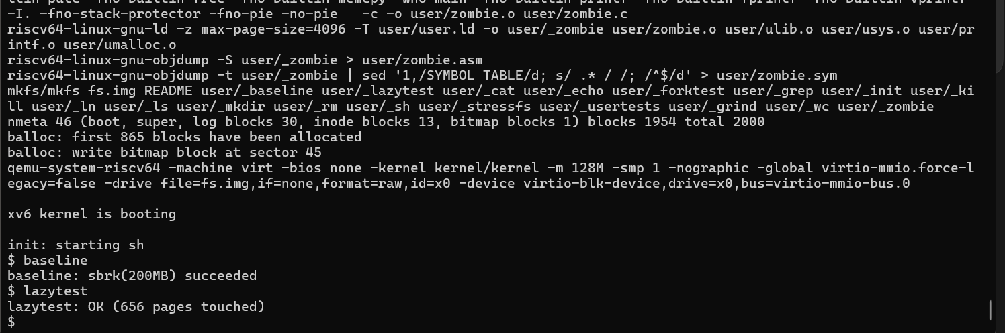
E1 Original lazy-allocation capture. The request is accepted as a virtual reservation and lazytest completes its sparse checks.
$ baseline
baseline: sbrk(200MB) succeeded
$ lazytest
lazytest: OK (656 pages touched)
The output quotes retain the original MB label. The implementation requests powers-of-two byte quantities, so the technical discussion uses MiB. The 656 count describes sparse write-touched pages, not the complete resident set. The successful reservation does not guarantee that all 200 MiB can subsequently be populated.

COW fork comparison evidence
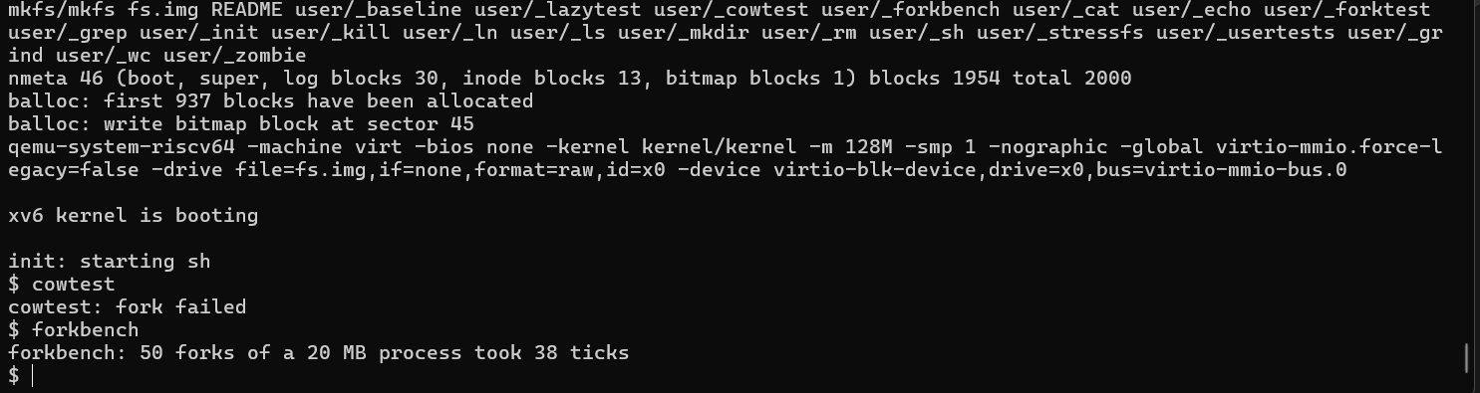
E2 Original pre-COW capture at the comparison-program checkpoint 28c7475: fork fails for cowtest and the 20 MiB fork loop reports 38 ticks.
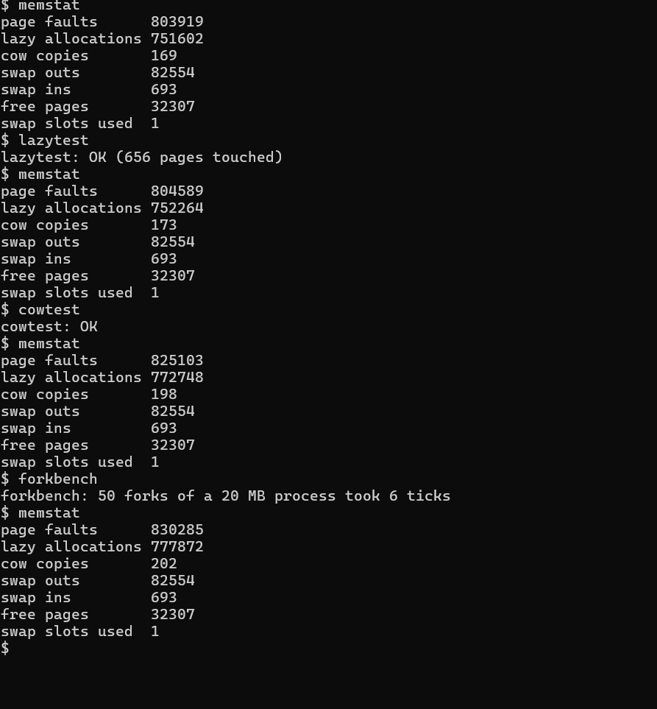
E3 Original integrated-memory capture: cowtest passes, forkbench reports 6 ticks, and memstat observations follow the workloads.
Before COW | Integrated memory observation
cowtest: fork failed  forkbench: 50 forks of a 20 MB process took 38 ticks | cowtest: OK  forkbench: 50 forks of a 20 MB process took 6 ticks

The comparison demonstrates the change in large-process fork behavior and the recorded loop observations. The two timing values are individual historical runs; they do not establish a controlled mean or a general operating-system speedup.

Capacity before disk swapping
The pressure comparison uses one CPU and an 8 MiB usable-memory limit. The 4 MiB control succeeds. Without disk swapping, the 12 MiB child cannot complete its actual page accesses and terminates with status -1.
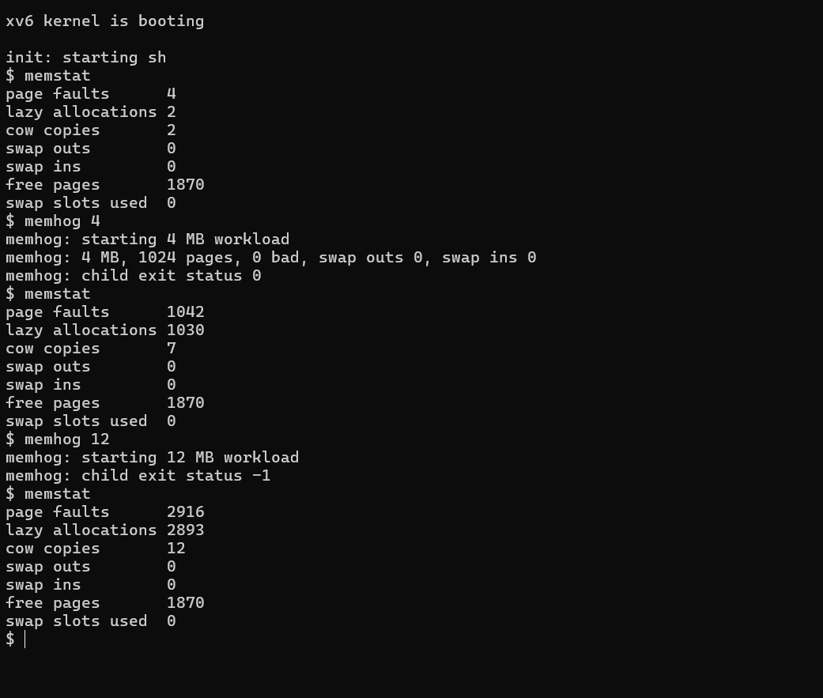
E4 Original no-swap control and pressure capture.
$ memhog 12
memhog: starting 12 MB workload
memhog: child exit status -1
This failure occurs when the workload populates its memory, even though lazy reservation can initially succeed. The following page shows the corresponding after-swap result. QEMU exposes 128 MiB physically; RAM_MB limits the memory managed by xv6.

Capacity after disk swapping
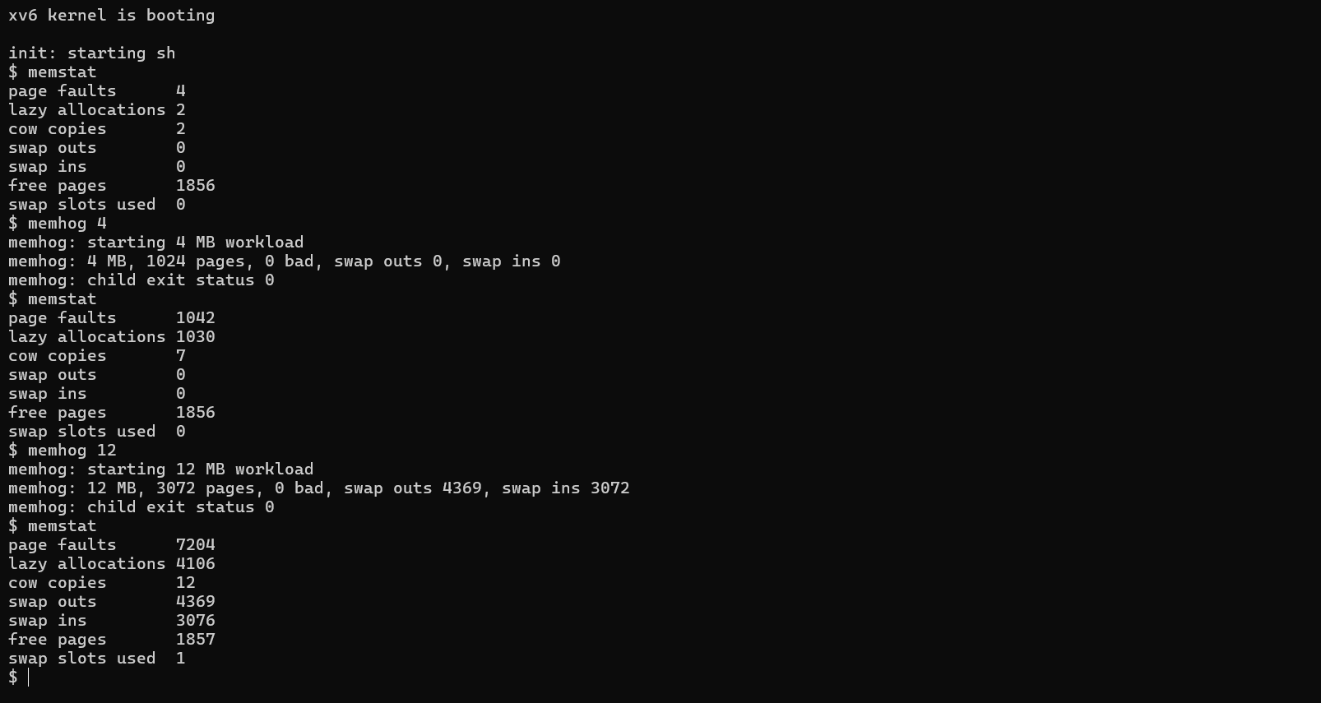
E5 Original FIFO swap development capture: the 12 MiB workload verifies all 3072 pages with zero bad pages and exits successfully.
memhog: 12 MB, 3072 pages, 0 bad, swap outs 4369, swap ins 3072
memhog: child exit status 0
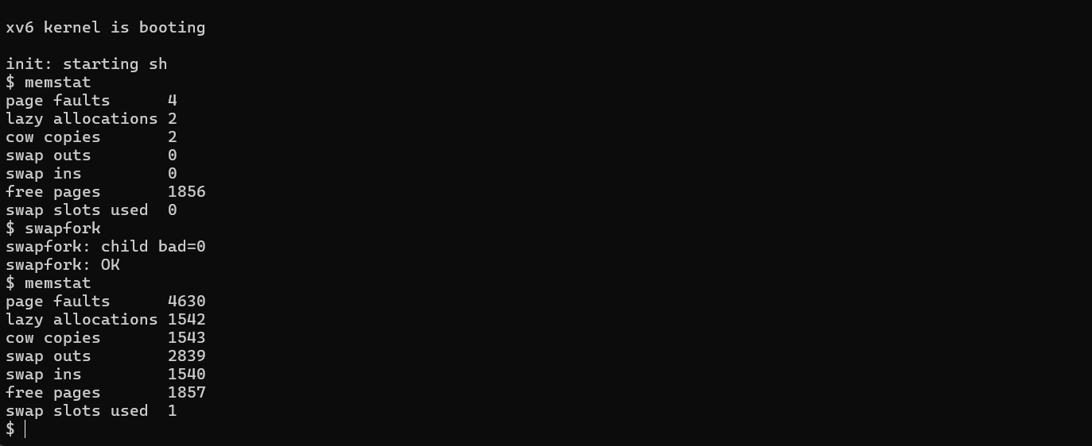
E6 Original combined COW/swap check. The child reports zero bad pages and swapfork reports OK.
swapfork: child bad=0
swapfork: OK
E5 and E6 precede the final pipe integration repair. The occupied post-workload slot is an observed snapshot; its ownership was not traced. These observations support the specified capacity and interaction checks, not universal leak freedom.

FIFO measured phase evidence
The hotcold policy comparison records one internal measured phase per policy. These observations precede the final pipe repair. The relevant figures are the command's phase deltas, not the later cumulative shell snapshots.
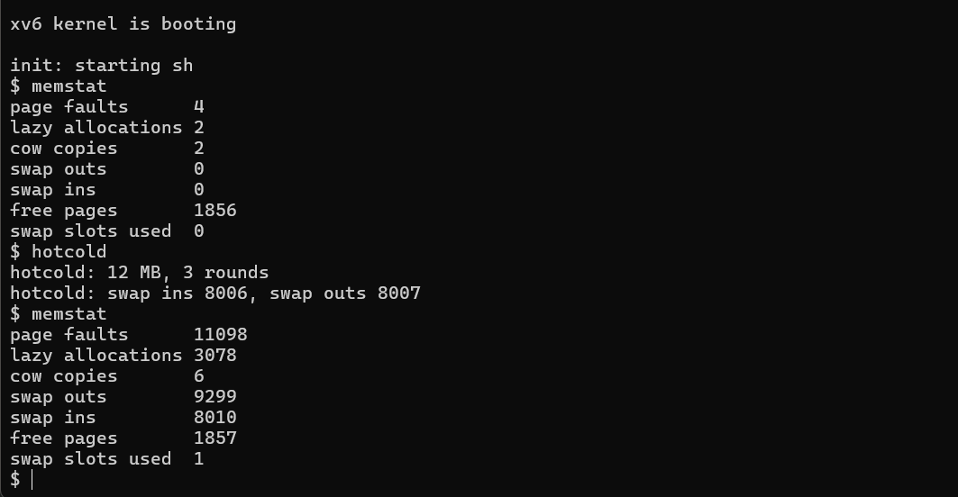
E7 Original FIFO measured phase for the 12 MiB workload and three rounds.
hotcold: 12 MB, 3 rounds
hotcold: swap ins 8006, swap outs 8007
Policy | Measured swap ins | Measured swap outs
FIFO | 8006 | 8007
Clock | 7691 | 7684

The following page embeds the Clock capture. Clock produces fewer transfers in these observations. No elapsed-time measurement or repeated controlled mean was collected, so this comparison does not establish a universal policy ranking.

Clock measured phase evidence
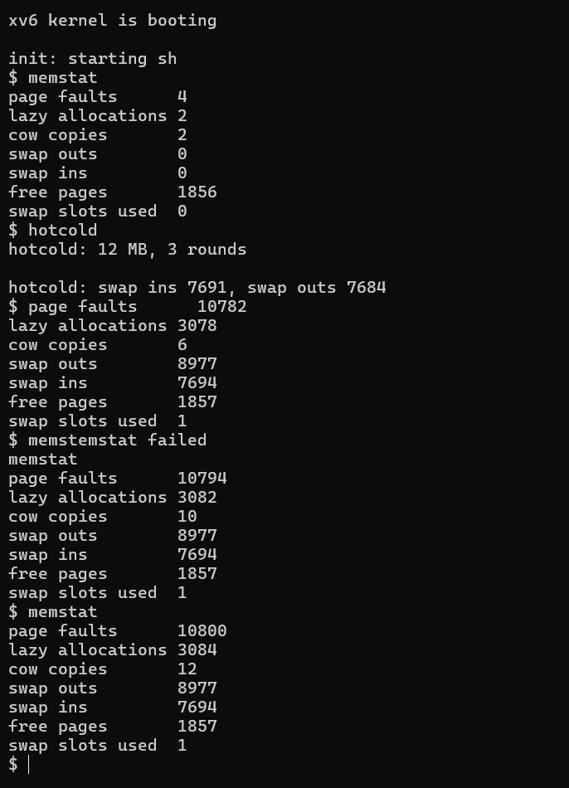
E8 Original Clock measured phase. The unrelated command typo below the result is preserved and is not a paging failure.
hotcold: 12 MB, 3 rounds
hotcold: swap ins 7691, swap outs 7684
The larger memstat values below the command are cumulative boot counters. The comparison uses 7691/7684 because these are the differences measured inside hotcold for its selected phase. They should not be replaced by a later shell snapshot.

Memory statistics evidence
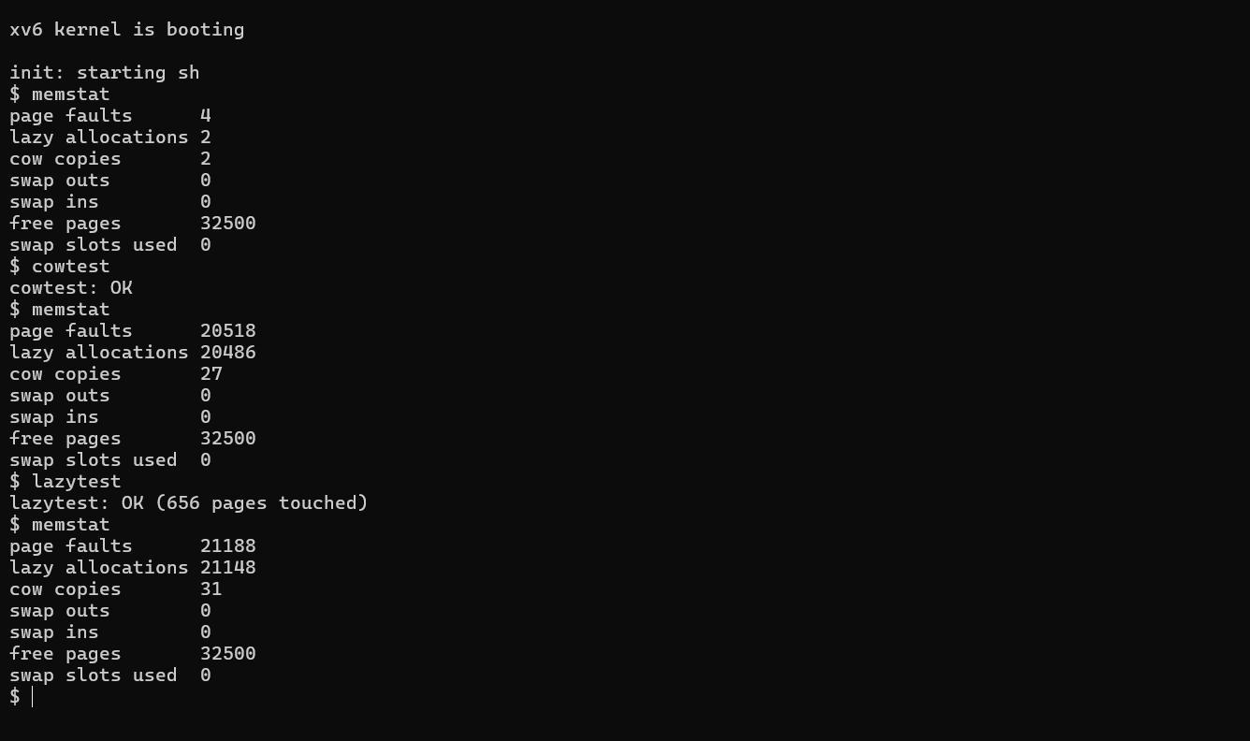
E9 Original v0.3 initial and post-workload memory-statistics sequence.
v0.3 observation | Handler calls | Lazy allocations | COW copies | Free pages
Initial | 4 | 2 | 2 | 32500
After cowtest | 20518 | 20486 | 27 | 32500
After lazytest | 21188 | 21148 | 31 | 32500

The event counters increase as the workloads run, while the observed free-page count returns to 32500. These readings include shell and measurement activity. They do not directly measure peak resident memory or supply an atomic snapshot across all kernel events.

Full regression evidence
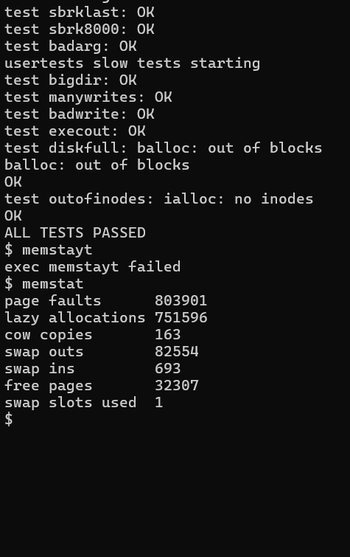
E10 Original final v0.4 full-suite pass and subsequent memory-statistics output.
ALL TESTS PASSED
The regression suite passed after the integration repair. The misspelled command after the test result is followed by a successful memstat call. user/usertests.c is unchanged between v0.0 and v0.4. These are preserved historical captures, not a fresh test execution during the document update.

Resources and where they are used
The numbered resources connect the walkthrough mechanisms to official coursework, architecture documentation and research. Implementation evidence consists of the local code excerpts and embedded captures E1 to E10. Assignment correspondence and research context do not constitute external certification of the project.
[1] Russ Cox, Frans Kaashoek and Robert Morris. xv6 a simple Unix like teaching operating system. 2 September 2025.
https://pdos.csail.mit.edu/6.1810/2025/xv6/book-riscv-rev5.pdf
Used in: Lazy heap allocation; Copy on write fork; Memory statistics and syscall integration. Background for page tables, physical allocation, page faults, traps and locking. Chapters 3 to 5 explain the underlying xv6 mechanisms; the project comparison remains pinned to its earlier eager baseline.
[2] MIT 6.S081 2020. Lab xv6 lazy page allocation.
https://pdos.csail.mit.edu/6.S081/2020/labs/lazy.html
Used in: Lazy heap allocation; Explicit changes to the xv6 code; E1. Direct assignment correspondence for removing eager allocation from positive sbrk, allocating zero-filled pages on faults, handling sparse mappings and recovering syscall buffers.
[3] MIT 6.1810 2025. Lab Copy on Write Fork for xv6.
https://pdos.csail.mit.edu/6.1810/2025/labs/cow.html
Used in: Copy on write fork; the uvmcopy and reference-count changes; E2 and E3. Direct correspondence for protected frame sharing, PTE flags, last-reference release and copyout recovery. The project cowtest is custom; an official MIT grading pass is not claimed.
[4] MIT 6.S081 2020. Lab System calls, including the sysinfo exercise.
https://pdos.csail.mit.edu/6.S081/2020/labs/syscall.html
Used in: Memory statistics and syscall integration; the memstat interface; E9. Reference for syscall numbering, dispatch, user stubs, argument access and returning kernel information. Our seven-field memstat structure differs from the lab sysinfo API.
[5] Remzi H. Arpaci-Dusseau and Andrea C. Arpaci-Dusseau. Operating Systems Three Easy Pieces. Chapter 21 Beyond Physical Memory Mechanisms.
https://pages.cs.wisc.edu/~remzi/OSTEP/vm-beyondphys.pdf
Used in: Disk backed paging; swap entries and transfer paths; E4 to E6. Conceptual basis for backing storage, nonresident pages, fault-driven restoration and finite-capacity tradeoffs. It is not an identical source implementation of this project swap engine.

Resources and where they are used continued
[6] Remzi H. Arpaci-Dusseau and Andrea C. Arpaci-Dusseau. Operating Systems Three Easy Pieces. Chapter 22 Beyond Physical Memory Policies.
https://pages.cs.wisc.edu/~remzi/OSTEP/vm-beyondphys-policy.pdf
Used in: FIFO and Clock replacement; pick_victim; E7 and E8. Reference for FIFO ordering, recency information and second-chance/Clock reasoning. The recorded I/O comparison is specific to the project workload and checkpoints.
[7] RISC-V International. Supervisor Level ISA, version 1.13, documentation release 20260120.
https://docs.riscv.org/reference/isa/v20260120/priv/supervisor.html
Used in: Lazy fault dispatch; COW protection; swapped PTE representation; Clock accessed-bit handling. Architectural definitions for page-fault causes, PTE permissions/software fields, the accessed bit and SFENCE.VMA. Project PTE_COW/PTE_SWAP meanings are software conventions.
[8] Peter J. Denning. The working set model for program behavior. Communications of the ACM 11(5), 323-333, May 1968. DOI 10.1145/363095.363141.
https://doi.org/10.1145/363095.363141
Used in: Locality interpretation in Lazy heap allocation and FIFO and Clock replacement; E1, E7 and E8. Research context for active memory demand and locality. The project does not implement the paper's working-set scheduler or claim to reproduce its experiments.
[9] L. A. Belady, R. A. Nelson and G. S. Shedler. An anomaly in space-time characteristics of certain programs running in a paging machine. Communications of the ACM, June 1969. DOI 10.1145/363011.363155.
https://research.ibm.com/publications/an-anomaly-in-space-time-characteristics-of-certain-programs-running-in-a-paging-machine
Used in: FIFO and Clock replacement and the interpretation of E7 and E8. Primary research record for FIFO anomaly context. Our historical phase comparison does not reproduce the anomaly experiment or establish a universal policy ranking.

