**Time_Series_Analysis_Retailstore**

(SQL Project)

Submitted By: Akshit Pathak

Submitted To: Chintan Patel

Dataset: [Retail](https://drive.google.com/file/d/1QZeGUAlv79_nQ1UVTdmkYydfsZ8ZyJ20/view?usp=sharing) Store Dataset

Source: <https://public.tableau.com/>

/*1. Calculating Total Sales, Profit and Quantity for each Sub_Category

SELECT Sub_Category , SUM(Sales), SUM(Quantity), SUM(Profit)

FROM retail.retail

Group by Sub_Category;

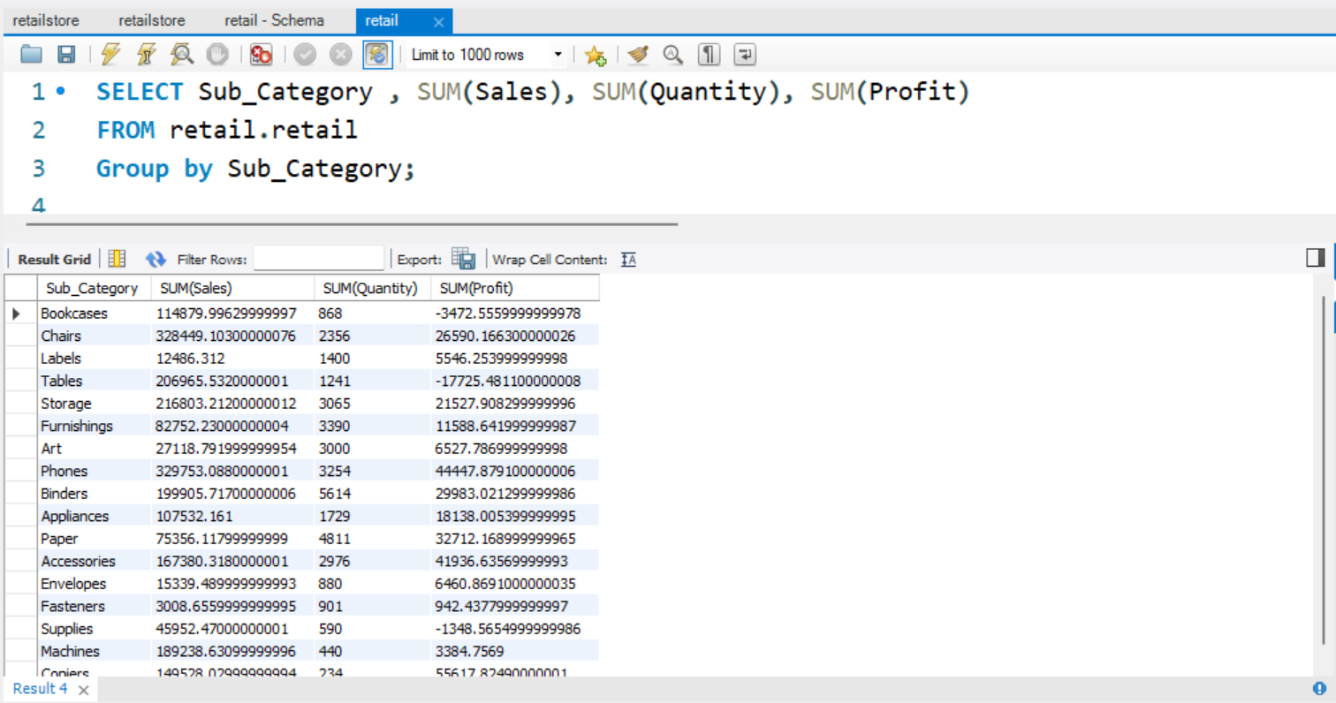

/*2. Find the customers with the highest lifetime value (total sales).

SELECT Customer_ID, Customer_Name, SUM(Sales) AS total_sales

FROM retail.retail

GROUP BY Customer_ID, Customer_Name

ORDER BY total_sales DESC

LIMIT 1;

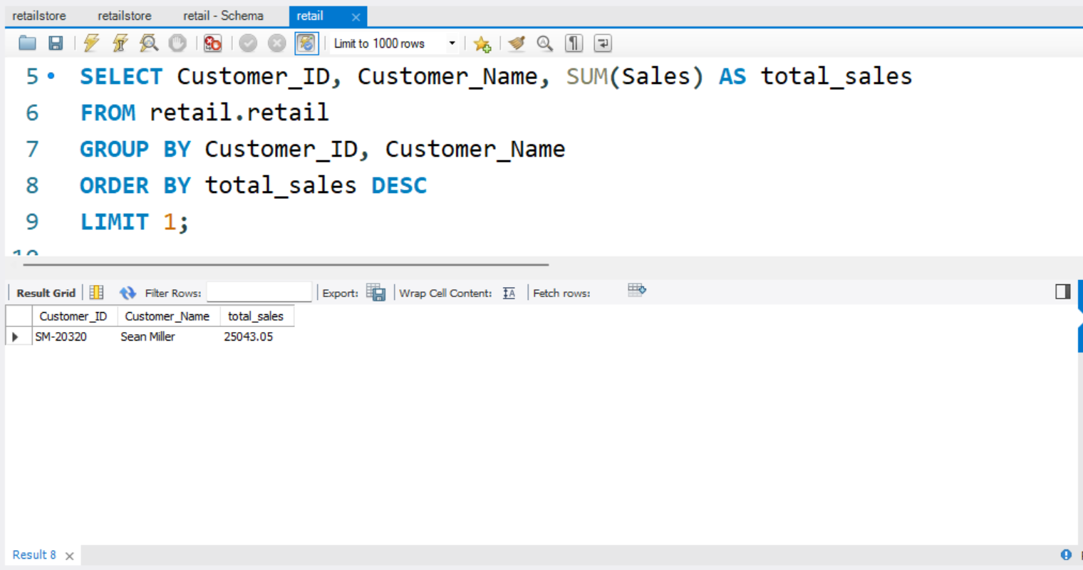

/*3. List the customers who have placed orders in multiple regions.

SELECT Customer_ID, Customer_Name, COUNT(DISTINCT Region) AS UniqueRegions

FROM retail.retail

GROUP BY Customer_ID, Customer_Name

HAVING UniqueRegions > 1;

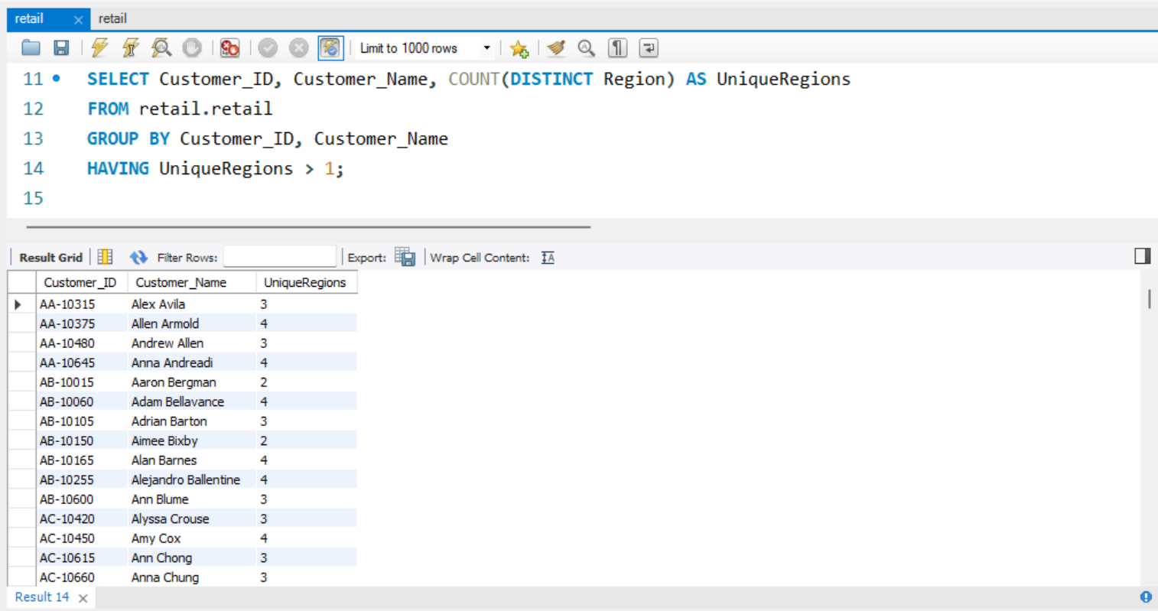

/*4. Determine the percentage contribution of each category to the total sales.

SELECT Category, (SUM(Sales) / (SELECT SUM(Sales) FROM retail.retail)) * 100 AS SalesPercentage

FROM retail.retail

GROUP BY Category;

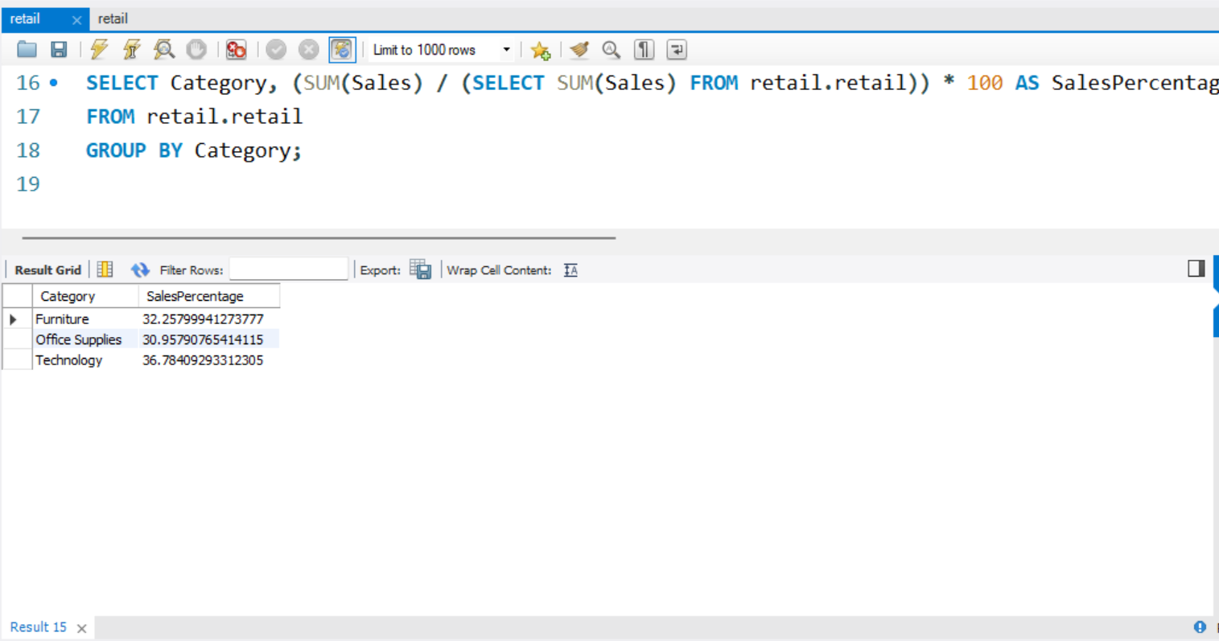

/*5. Identify the products that have consistently increased in sales over the past three months

SELECT Sub_Category, Order_Date, Sales

FROM (

SELECT Sub_Category, Order_Date, Sales,

LAG(Sales, 1) OVER (PARTITION BY Product_ID ORDER BY Order_Date) AS PrevMonthSales,

LAG(Sales, 2) OVER (PARTITION BY Product_ID ORDER BY Order_Date) AS TwoMonthsAgoSales

FROM retail.retail

) AS SalesComparison

WHERE Sales > PrevMonthSales AND PrevMonthSales > TwoMonthsAgoSales;

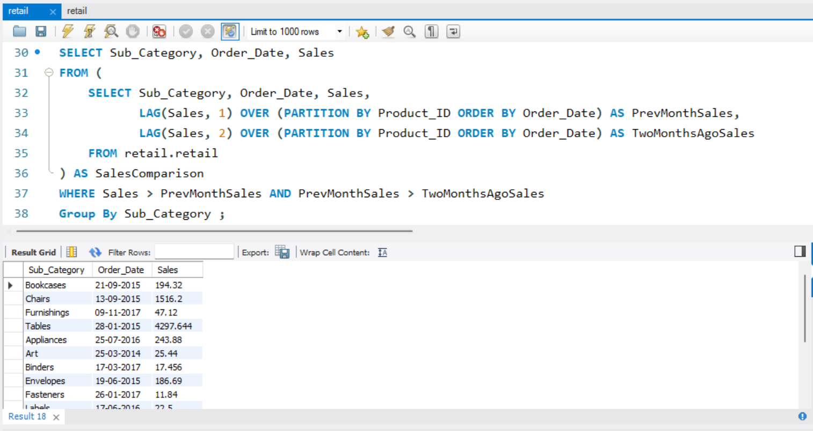

/*6. List the cities where the average profit per order is below the overall average

WITH AvgProfitPerOrder AS (

SELECT City, AVG(Profit) AS CityAvgProfit

FROM retail.retail

GROUP BY City)

SELECT City, CityAvgProfit

FROM AvgProfitPerOrder

WHERE CityAvgProfit < (SELECT AVG(Profit) FROM retail.retail);

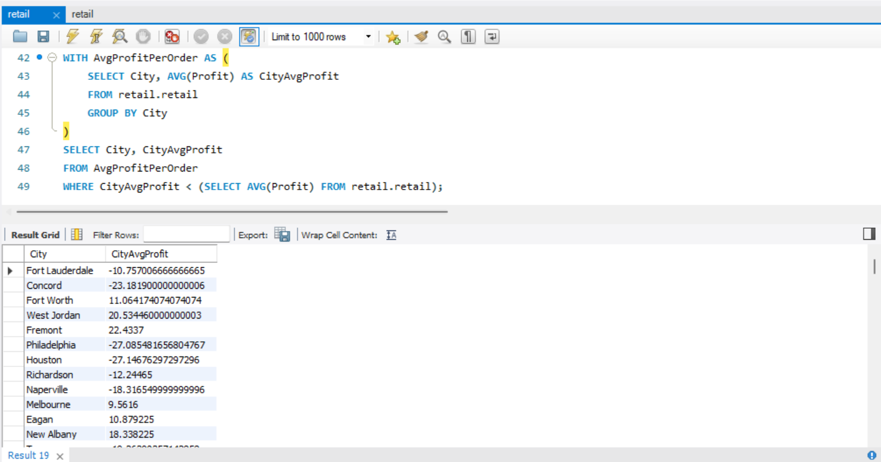

/*7. Calculate the cumulative profit for each category over time.

SELECT Category, Order_Date, Profit,

SUM(Profit) OVER (PARTITION BY Category ORDER BY Order_Date) AS CumulativeProfit

FROM retail.retail;

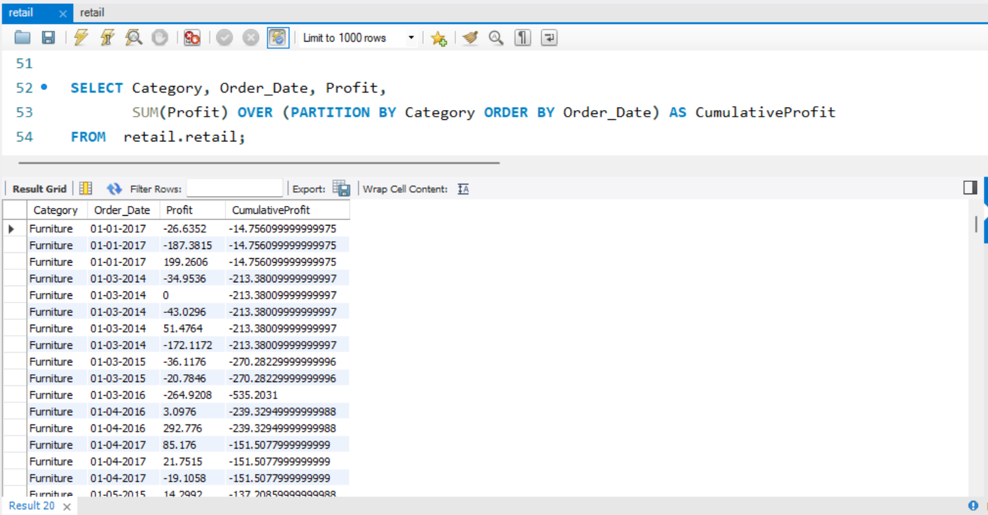

/*8. List all orders with a profit margin greater than 20%.

SELECT *

FROM retail.retail

WHERE (Profit / Sales) > 0.2

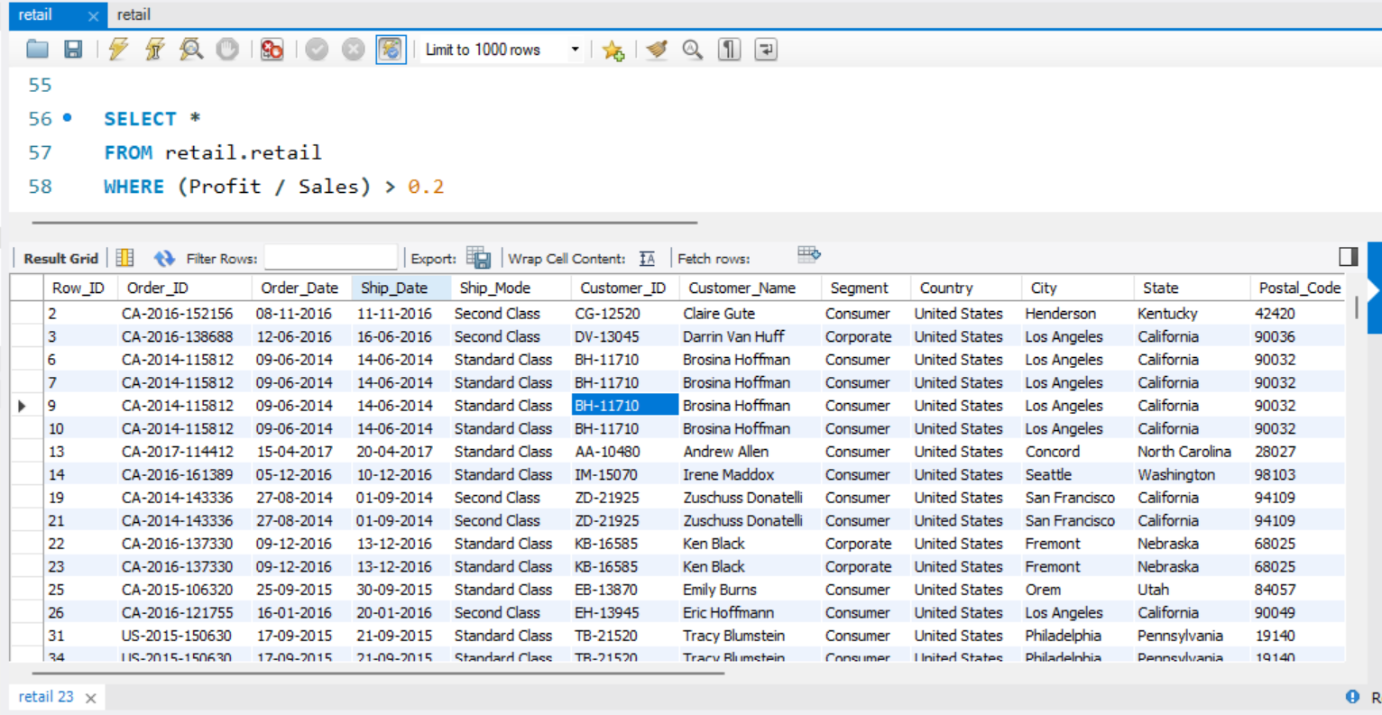

/*9. Determine the average shipping time (in days) for each ship mode

SELECT Ship_Mode, AVG(Ship_Date-Order_Date) AS AvgShippingTime

FROM retail.retail

GROUP BY Ship_Mode;

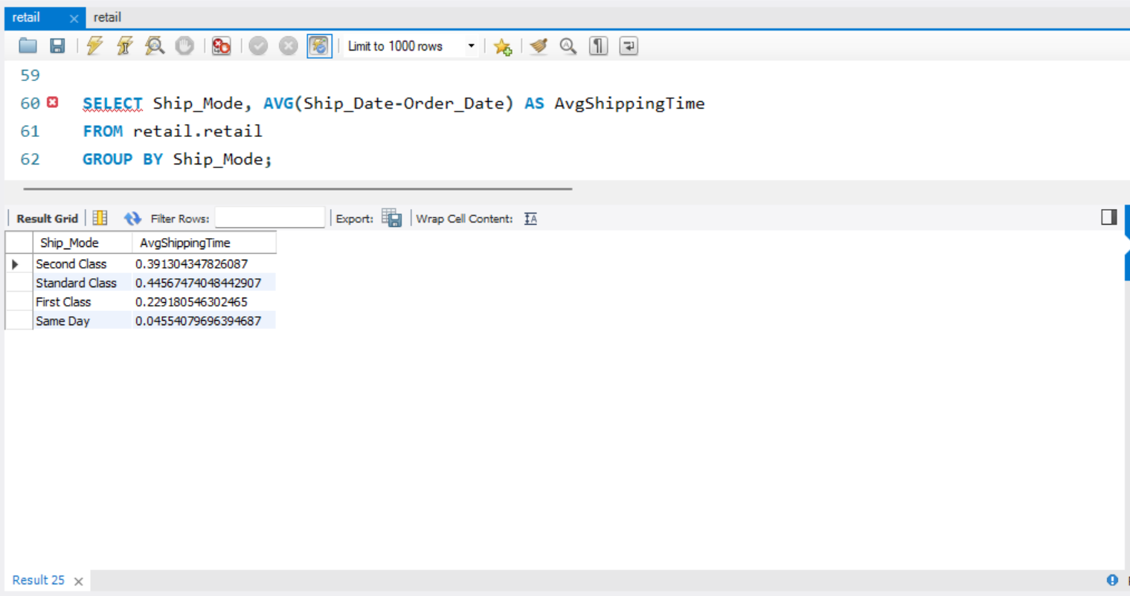

/*10. Calculate the total sales and profit for each month

SELECT YEAR(Order_Date) AS OrderYear, MONTH(Order_Date) AS OrderMonth,

SUM(Sales) AS TotalSales, SUM(Profit) AS TotalProfit

FROM retail.retail

GROUP BY OrderYear, OrderMonth

ORDER BY OrderYear, OrderMonth;

