Amazon Prime TV Shows & Movies Analysis
Power BI Project Documentation
Interactive dashboard, data model, transformations, measures, and visual analysis

Name: Akshit Thakur
GitHub: https://github.com/AkshitThakur/Amazon_PowerBI

1. Project Overview
This project is an interactive Power BI analysis of an Amazon Prime movies and TV shows dataset. The dashboard is designed to provide a compact view of title volume, content type, genres, production countries, release-year trends, runtime distribution, IMDb score distribution, and title popularity.
The report uses a main Amazon title table together with two exploded dimension-style tables—Genres and Countries—to handle multi-valued genre and production-country fields. A Title Metrics selector is used to switch the measure driving the main analytical visuals between Total Titles, Total Movies, and Total TV Shows.

2. Project Objectives
- Create an interactive executive-style dashboard for Amazon Prime content.
- Track the number of titles, movies, and TV shows using reusable Power BI measures.
- Analyze genre composition using an exploded Genres table.
- Analyze production-country composition using an exploded countries table.
- Study release-year trends and identify periods with higher title counts.
- Examine the distribution of runtimes and IMDb scores.
- Identify the top five titles by TMDB popularity.
- Allow the user to switch the main analytical visuals between Total Titles, Total Movies, and Total TV Shows.

3. Dashboard Preview
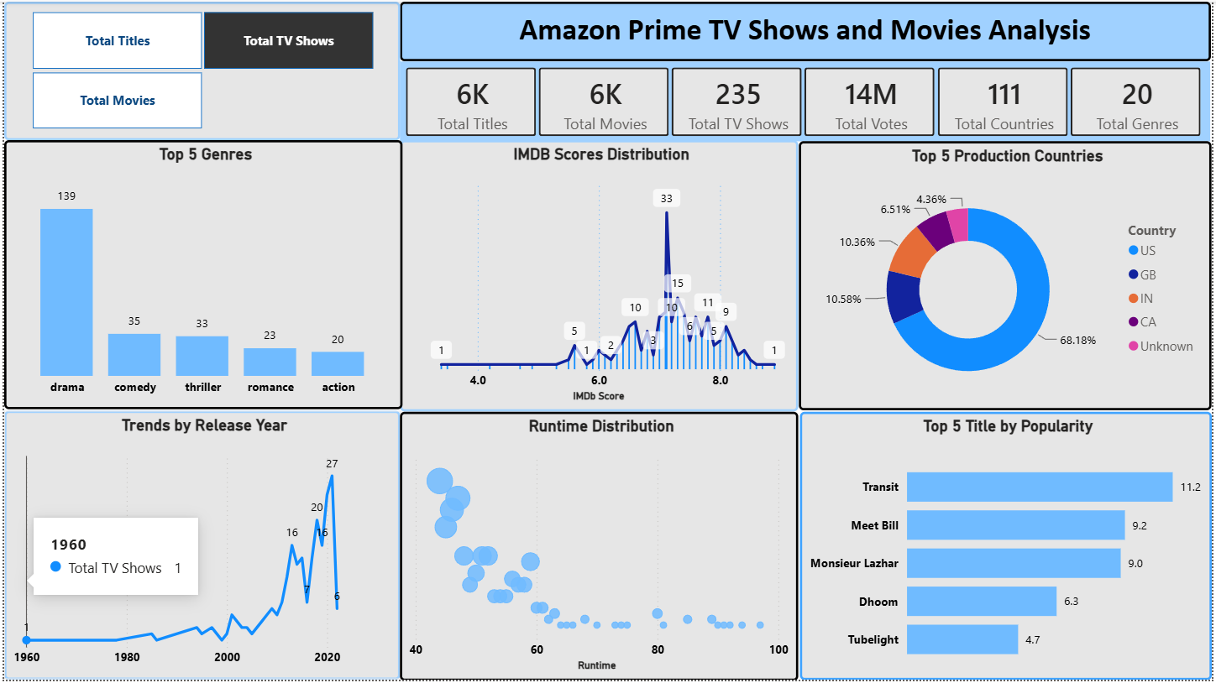
Figure 1. Amazon Prime TV Shows and Movies Analysis dashboard from the supplied PBIX project.

4. Dataset and Data Model
The PBIX contains a main table named amazon and supporting tables named Genres, Countries and Title Metrics. The report layout confirms these tables are part of the model.
Table | Purpose | Important fields / role
Amazon | Main title-level dataset | Title attributes, type, release_year, imdb_score, imdb_votes, runtime, tmdb_popularity, genres, and production_countries are source fields.
Genres | Exploded genre table | One genre value per row, allowing genre-level counting and Top 5 analysis.
Countries | Exploded production-country table | One country value per row, allowing country-level title analysis and percentage calculations.
Title Metrics | Metric selector | Provides the dashboard slicer options: Total Titles, Total Movies, and Total TV Shows.

5. Data Transformation: Exploding Multi-Valued Columns
The original title records can contain multiple values in the genres and production_countries fields. For example, a title may have genres such as ['comedy', 'drama'] or countries such as ['US', 'IN', 'CA']. Instead of treating the complete list as one category, the project creates separate Genres and Countries tables.
Conceptual transformation:
- One title + ['comedy', 'drama'] → two genre rows: comedy and drama.
- One title + ['US', 'IN', 'CA'] → three country rows: US, IN, and CA.
- The exploded tables make it possible to count and rank individual genres and countries.
- This approach also supports percentage calculations for the production-country donut chart.
A key modeling consideration is to keep title-level measures such as Total Titles based on the main amazon table, so that exploding multi-valued fields does not unintentionally multiply the overall title count.

6. Measures and Metric Selector
The dashboard uses reusable measures rather than relying only on implicit visual aggregations. The supplied PBIX contains measures named Total Titles, Total Movies, Total TV Shows, Total Votes, Total Countries and Total Genres.
Measure / selector | Purpose | Used in
Total Titles | Counts the title-level content in the main dataset. | Cards and metric-linked visuals
Total Movies | Counts titles classified as movies. | Card and metric-linked visuals
Total TV Shows | Counts titles classified as TV shows. | Card and metric-linked visuals
Total Votes | Summarizes the IMDb vote volume shown in the KPI area. | KPI card
Total Countries | Counts the countries represented in the Countries table. | KPI card
Total Genres | Counts the genres represented in the Genres table. | KPI card
Title Metrics | Metric selector used to switch the four main analytical charts. | Slicer
The Title Metrics slicer is the main interaction control. Selecting Total Titles, Total Movies or Total TV Shows changes the metric displayed in the linked genre, release-year, runtime and IMDb-score visuals.

7. Dashboard Visuals
KPI Cards
The top KPI area displays Total Titles, Total Movies, Total TV Shows, Total Votes, Total Countries and Total Genres. These cards provide a quick snapshot of the dataset before deeper analysis.
Metric Slicer
The slicer contains Total Titles, Total Movies and Total TV Shows. It acts as the control for the four linked analytical charts.
Top 5 Genres – Column Chart
Displays the five genres with the highest count under the selected metric. This helps identify which content genres contribute most to the selected title population.
Trends by Release Year – Line Chart
Shows the count of titles by release year. The selected metric determines whether the trend represents all titles, movies or TV shows.
Runtime Distribution – Bubble/Scatter Chart
Plots runtime on the X-axis and title count on the Y-axis, with bubble size also reflecting the selected title-count metric. It provides a quick view of where runtimes are concentrated.
IMDb Scores Distribution – Histogram-style Chart
Shows the number of titles at each IMDb score. The chart is metric-responsive, so the distribution can be viewed for total titles, movies or TV shows.
Top 5 Production Countries – Donut Chart
Displays the five leading production countries and their percentage contribution. The Countries table is used because production_country is multi-valued.
Top 5 Title by Popularity – Bar Chart
Ranks titles by TMDB popularity and displays the top five titles. This visual is title-level and is intended to highlight the most popular titles in the dataset.

8. Dashboard Interaction and Filtering
The intended interaction flow is:
- Choose a metric in the Title Metrics slicer.
- The selected metric drives the four linked analytical visuals: Top 5 Genres, Trends by Release Year, Runtime Distribution and IMDb Scores Distribution.
- The donut chart separately summarizes the Top 5 Production Countries and their percentage share.
- The popularity bar chart ranks individual titles by TMDB popularity.
- The KPI cards provide the overall context for the current report state.

9. Dashboard Insights Visible in the Supplied Snapshot
The supplied dashboard snapshot provides an example of the type of insights the report is designed to surface. The displayed state shows approximately 6K total titles, approximately 6K movies, 235 TV shows, about 14M votes, 111 countries and 20 genres. These are dashboard-state values and may change when the PBIX is filtered or when the underlying data is refreshed.
- Drama is the largest category among the displayed Top 5 Genres in the shown state.
- The release-year trend shows a marked increase in title counts in the later years represented by the dataset.
- The IMDb score distribution is concentrated around the middle-to-upper score range, with a visible peak around the 7-point region in the displayed state.
- The country donut is dominated by the United States, followed by other leading countries shown in the legend.
- The popularity ranking highlights Transit, Meet Bill, Monsieur Lazhar, Dhoom and Tubelight in the displayed Top 5 state.

10. Technical Architecture
The PBIX uses a single dashboard report page with a semantic model containing the main amazon table, exploded Genres and Countries tables, and a Title Metrics selector. The report layout contains the KPI card area, metric slicer, four metric-responsive analytical visuals, the country donut and the popularity bar chart.
High-level workflow:
- Raw Amazon Prime title data
- Data cleaning and standardization
- Explode genres and production countries
- Build the Amazon, Genres and Countries model tables
- Create reusable DAX measures
- Create Title Metrics selector
- Build interactive visuals
- Apply Top 5 filtering/ranking
- Publish the final dashboard

11. Analytical Methodology
Analysis | Method
Title counts | Use title-level measures from the main Amazon table.
Genre analysis | Use the exploded Genres table and rank genres by the selected title metric.
Country analysis | Use the exploded countries table, select the top 5, and calculate their share of the country-level total.
Release-year trend | Group release_year and plot the selected title metric over time.
Runtime analysis | Use runtime as the continuous X-axis and title count as the Y-axis; bubble size provides an additional visual encoding.
IMDb distribution | Group IMDb score and display title counts by score.
Popularity analysis | Sort titles by tmdb_popularity in descending order and retain the top 5.

