 LinkedIn

Name: Akshit Thakur

Github Link: https://github.com/AkshitThakur/ER_Linkedin

Product Dissection for LinkedIn

Company Overview:

LinkedIn, founded in 2002 by Reid Hoffman and his co-founders and officially launched in May 2003, has transformed the way professionals connect, communicate, and build their careers online. As a professional social networking platform, LinkedIn enables users to create professional profiles, connect with colleagues and industry experts, share knowledge, discover career opportunities, and engage with professional content.

Problem Statement and Real-World Challenges

Problem 1: Managing Professional Relationships
Real-World Challenge:
Professionals need an efficient way to build, maintain, and manage relationships with colleagues, industry experts, recruiters, and other professionals. As the number of connections grows, managing these relationships and interactions becomes increasingly complex.
LinkedIn's Solution:
LinkedIn provides a professional networking environment where users can create profiles, connect with other professionals, follow users, and interact with their content.
From a database perspective, this project manages these relationships through entities such as:
- Profile – stores users' professional information.
- Follower – maintains follower and following relationships.
- Post – stores professional content shared by users.
- Comment – records interactions with posts.
- PostLike – tracks user engagement with posts.
- Hashtag – organizes content based on topics and interests.
These entities and their relationships allow the system to efficiently represent professional connections and user interactions.

Problem 2: Managing Large Volumes of Professional Content
Real-World Challenge:
Professional networking platforms generate large amounts of data through posts, comments, likes, profiles, and other user activities. Without an organized data structure, retrieving and analyzing this information efficiently becomes difficult.
LinkedIn's Solution:
The project uses a relational database model to organize platform data into structured tables. Primary keys uniquely identify records, while foreign keys establish relationships between related entities.
Database techniques such as normalization, constraints, and indexes help reduce data redundancy, maintain data consistency, and improve query performance.
SQL queries can then be used to retrieve meaningful information, such as:
- Most active users
- Most-liked posts
- Posts with the highest engagement
- Users with the largest number of followers
- Popular hashtags
- User interaction patterns

Problem 3: Content Discovery and Organization
Real-World Challenge:
With thousands or millions of professional posts being created, users may find it difficult to discover relevant content based on their interests and professional fields.
LinkedIn's Solution:
LinkedIn organizes professional content through posts, hashtags, user profiles, and interactions. In this project, Hashtag and Post relationships can be used to categorize and retrieve content based on specific topics.
The database can support queries that identify:
- Frequently used hashtags
- Popular topics
- Posts associated with specific hashtags
- Highly engaged content
- Users contributing to particular topics
This demonstrates how relational databases can support structured content organization and analysis.

Problem 4: Measuring User Engagement
Real-World Challenge:
A professional networking platform needs to understand how users interact with content. Without reliable engagement data, it becomes difficult to identify popular content and understand user activity.
LinkedIn's Solution:
The project tracks user engagement through activities such as likes, comments, follows, and posts.
The database can be queried to calculate metrics such as:
- Total likes per post
- Total comments per post
- Engagement by user
- Most active users
- Most engaging posts
- Follower growth and activity
- Average engagement per post
These metrics can help demonstrate how SQL can transform raw interaction data into meaningful business insights.

Problem 5: Maintaining Data Integrity and Performance
Real-World Challenge:
As a professional networking platform grows, maintaining accurate and consistent data while handling large volumes of records becomes increasingly important.
LinkedIn's Solution:
This project applies core relational database principles to maintain data quality and improve performance.
The database incorporates:
- Primary Keys to uniquely identify records
- Foreign Keys to maintain relationships between tables
- NOT NULL and other constraints to enforce valid data
- Normalization to minimize redundancy
- Indexes to improve query performance
- SQL queries for data retrieval and analysis
These techniques provide a structured foundation for managing a LinkedIn-inspired professional networking platform.

Conclusion
This project demonstrates how a relational database can be used to model and manage the core functionality of a professional networking platform. By designing interconnected entities for profiles, posts, followers, comments, likes, and hashtags, the project represents how professional users interact with content and with one another.
The project also demonstrates practical applications of PostgreSQL, SQL, database normalization, relationships, constraints, indexing, and analytical queries. Overall, it provides a real-world case study for understanding how database systems can support professional networking applications and convert user activity into useful analytical insights.

Top Features of LinkedIn
LinkedIn is a professional networking platform designed to help users build professional relationships, share knowledge, discover career opportunities, and engage with industry-related content. Some of the major features that can be represented in this database project include:
- Professional Profiles: Users can create profiles containing their name, professional headline, summary, skills, and other professional information.
- Posts and Content Sharing: Users can publish professional updates, opinions, articles, images, and other content.
- Connections and Followers: Users can connect with and follow other professionals to build their professional network.
- Comments and Likes: Users can interact with posts through likes and comments.
- Hashtags: Hashtags help categorize professional content and make topics easier to discover.

Schema Description
The LinkedIn database schema represents the major entities and interactions involved in a professional networking platform. The database is designed using a relational model, where individual entities are represented as tables and relationships between entities are established using primary and foreign keys.
The core entities in the project include Profile, Post, Comment, PostLike, Follower, Hashtag, and PostHashtag.

1. Profile Entity
The Profile entity stores information about LinkedIn users and represents the central entity of the database.
Attributes:
- Profile_ID (Primary Key): Unique identifier for each user.
- User_Name: Username associated with the profile.
- Full_Name: Full name of the professional.
- Headline: Short professional description or current role.
- Email: Email address associated with the profile.
- Bio: Professional summary or description.
- Skills: Skills associated with the user's professional profile.
- Connection_Count: Number of professional connections.
- Profile_Date: Date on which the profile was created.

2. Post Entity
The Post entity stores professional content created and shared by users.
Attributes:
- Post_ID (Primary Key): Unique identifier for each post.
- Profile_ID (Foreign Key): Identifies the user who created the post.
- Caption: Text content of the post.
- Image_URL: URL of an image or media associated with the post.
- Post_Date: Date on which the post was created.
- Location: Location associated with the post, if applicable.

3. Comment Entity
The Comment entity stores comments made by users on posts.
Attributes:
- Comment_ID (Primary Key): Unique identifier for each comment.
- Post_ID (Foreign Key): Identifies the post being commented on.
- Profile_ID (Foreign Key): Identifies the user who created the comment.
- Text: Content of the comment.
- Comment_Date: Date on which the comment was created.

4. PostLike Entity
The PostLike entity records users' likes on posts.
Attributes:
- Like_ID (Primary Key): Unique identifier for each like.
- Post_ID (Foreign Key): Identifies the liked post.
- Profile_ID (Foreign Key): Identifies the user who liked the post.
- Like_Date: Date on which the like was created.

5. Follower Entity
The Follower entity represents relationships between LinkedIn users.
Attributes:
- Follower_ID (Primary Key): Unique identifier for each follower relationship.
- Following_User_ID (Foreign Key): Identifies the user being followed.
- Follower_User_ID (Foreign Key): Identifies the user who is following.
- Follow_Date: Date on which the relationship was established.
Because both users are stored in the Profile table, this represents a self-referencing relationship.

6. Hashtag Entity
The Hashtag entity stores hashtags used to categorize professional content.
Attributes:
- Hashtag_ID (Primary Key): Unique identifier for each hashtag.
- Tag: The text associated with the hashtag, such as #Python, #DataScience, or #SQL.

7. PostHashtag Entity
The PostHashtag entity establishes the relationship between posts and hashtags.
Attributes:
- PostHashtag_ID (Primary Key): Unique identifier for the association.
- Post_ID (Foreign Key): Identifies the associated post.
- Hashtag_ID (Foreign Key): Identifies the associated hashtag.
This entity represents a many-to-many relationship because a post can contain multiple hashtags and a hashtag can be associated with multiple posts.

Relationships Between Entities

1. Users Create Posts
- One user can create multiple posts.
- Each post belongs to one user.
- Relationship: Profile → Post = One-to-Many

2. Users Comment on Posts
- One user can create multiple comments.
- One post can contain multiple comments.
- Each comment belongs to one user and one post.
- Relationship: Profile → Comment = One-to-Many
- Relationship: Post → Comment = One-to-Many

3. Users Like Posts
- One user can like multiple posts.
- One post can receive likes from multiple users.
- The PostLike table resolves this many-to-many relationship.
- Relationship: Profile ↔ Post = Many-to-Many through PostLike

4. Users Follow Other Users
- One user can follow multiple users.
- One user can have multiple followers.
- The Follower table creates a self-referencing relationship within Profile.
- Relationship: Profile ↔ Profile = Many-to-Many

5. Posts Have Hashtags
- One post can contain multiple hashtags.
- One hashtag can be used in multiple posts.
- The PostHashtag table resolves this many-to-many relationship.
- Relationship: Post ↔ Hashtag = Many-to-Many

ER Diagram
The ER diagram for this project visually represents the entities, attributes, primary keys, foreign keys, and relationships within the LinkedIn database.
The central Profile entity is connected to major entities such as Post, Comment, PostLike, and Follower. The PostHashtag bridge entity connects Posts and Hashtags, demonstrating a many-to-many relationship.
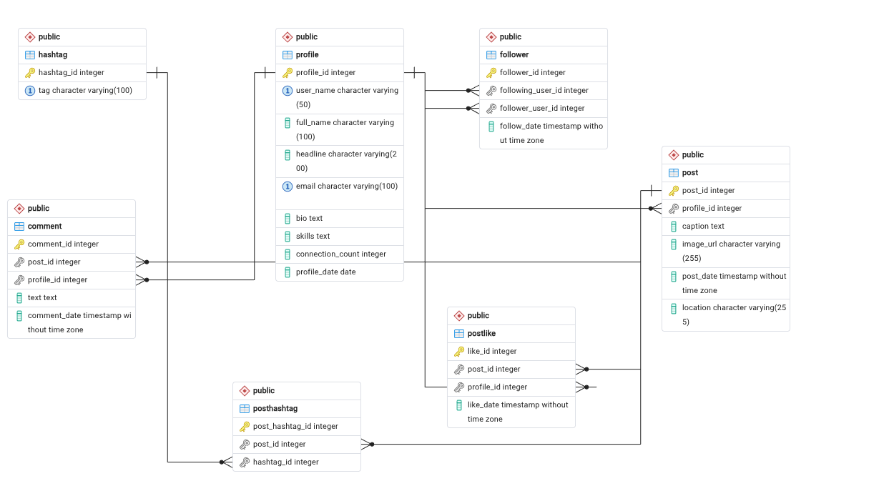

Conclusion
This case study focuses on designing a LinkedIn-inspired relational database system that models the major activities of a professional networking platform. The database captures essential entities such as profiles, posts, comments, likes, followers, and hashtags while demonstrating how users interact with professional content and other users.
The project applies important database concepts including entity-relationship modeling, primary keys, foreign keys, one-to-many and many-to-many relationships, normalization, constraints, indexing, and SQL queries.
By transforming real-world LinkedIn activities into a structured relational schema, the project demonstrates how PostgreSQL can be used to manage professional networking data efficiently and perform meaningful analysis such as identifying highly active users, popular posts, engagement patterns, follower relationships, and trending professional topics.

