**EXPERIMENT-10**

**Ques:10- Write a c++ program to create a super class named as figure. Derive two classes from super class named as rectangle and triangle. Create a member function of same name in all the three classes which will calculate area of shapes by making member function of super class as virtual.**

**CODE-#include<iostream>**

**using namespace std;**

**class super{**

**public:**

**int length;**

**int breadth;**

**public:**

**void getdata()**

**{**

**cin>>length>>breadth;**

**}**

**virtual void calculatearea()=0;**

**};**

**class rectangle:public super{**

**public:**

**void calculatearea()**

**{**

**cout<<"Area of Rectangle is: "<<length*breadth<<endl;**

**}**

**};**

**class triangle:public super{**

**public:**

**void calculatearea()**

**{**

**cout<<"Area of Triangle is: "<<0.5*length*breadth<<endl;**

**}**

**};**

**int main()**

**{**

**triangle tri;**

**rectangle rect;**

**int choice;**

**cin>>choice;**

**if(choice==1)**

**{**

**rect.getdata();**

**rect.calculatearea();**

**}**

**else if(choice==2)**

**{**

**tri.getdata();**

**tri.calculatearea();**

**}**

**}**

**OUTPUT:**

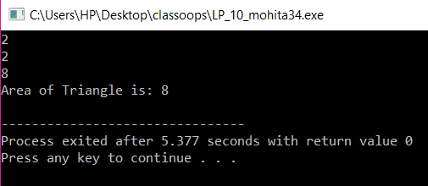

**EXPERIMENT-11**

**Ques-11A company pays its employees weekly. The employees are of three types: Salaried employees are paid a fixed weekly salary regardless of the number of hours worked, commission employees are paid a percentage of their sales and base-salary-plus-commission employees receive a base salary plus a percentage of their sales. For the current pay period, the company has decided to reward base-salary-plus-commission employees by adding 10 per cent to their base salaries. The company wants to implement a C++ program that performs its payroll calculations polymorphically.**

**CODE-#include<iostream>**

**using namespace std;**

**class employee{**

**public:**

**int basicsalary;**

**virtual void calculatetotalsal()=0;**

**};**

**class commision:public employee{**

**public:**

**int totalsal,n,sales[10],totalsales;**

**void comget()**

**{**

**cin>>basicsalary;**

**cin>>n;**

**}**

**void comsales()**

**{**

**for(int i=0;i<n;i++)**

**{**

**cin>>sales[i];**

**}**

**}**

**void comtotalsal()**

**{**

**totalsales=0;**

**for(int i=0;i<n;i++)**

**{**

**totalsales=totalsales+sales[i];**

**}**

**}**

**void calculatetotalsal()**

**{**

**totalsal=0.50*(basicsalary+totalsales);**

**cout<<totalsal<<endl;**

**}**

**};**

**class salary:public employee**

**{**

**public:**

**void salget()**

**{**

**cin>>basicsalary;**

**}**

**void calculatetotalsal()**

**{**

**cout<<basicsalary;**

**}**

**};**

**class base:public employee{**

**public:**

**int totalsal,n,sales[10],totalsales;**

**void baseget()**

**{**

**cin>>basicsalary;**

**cin>>n;**

**}**

**void basesales()**

**{**

**for(int i=0;i<n;i++)**

**{**

**cin>>sales[i];**

**}**

**}**

**void basetotalsal()**

**{**

**totalsales=0;**

**for(int i=0;i<n;i++)**

**{**

**totalsales=totalsales+sales[i];**

**}**

**}**

**void calculatetotalsal()**

**{**

**int newsalary;**

**newsalary=basicsalary*0.1+basicsalary;**

**totalsal=newsalary+0.2*totalsales;**

**cout<<totalsal<<endl;**

**}**

**};**

**int main()**

**{**

**salary sal;**

**commision com;**

**base bas;**

**int choice;**

**cin>>choice;**

**if(choice==1)**

**{**

**sal.salget();**

**sal.calculatetotalsal();**

**}**

**else if(choice==2)**

**{**

**com.comget();**

**com.comsales();**

**com.comtotalsal();**

**com.calculatetotalsal();**

**}**

**else if(choice==3)**

**{**

**bas.baseget();**

**bas.basesales();**

**bas.basetotalsal();**

**bas.calculatetotalsal();**

**}**

**return 0;**

**}**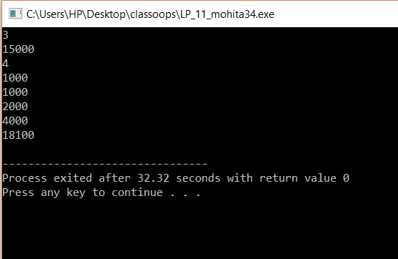

**EXPERIMENT-13**

**QUES-13** A university with different departments where each department has number of employees working for university. The Head office personal wants to access information of employees of a particular department from respective department clerk where clerk is same name used by each department. How information could be gathered by concept of polymorphism.

**CODE-#include<iostream>**

**using namespace std;**

**class faculty{**

**public:**

**int basicsal;**

**char name[20];**

**int age;**

**void get()**

**{**

**cin.ignore();**

**cin.getline(name,20);**

**cin>>age;**

**cin>>basicsal;**

**}**

**Virtual void display()=0;**

**};**

**class cse:public faculty{**

**public:**

**void display()**

**{**

**cout<<"Dept: CSE"<<endl;**

**cout<<"Name: "<<name<<endl;**

**cout<<"Age: "<<age<<endl;**

**cout<<"Salary: "<<basicsal<<endl;**

**}**

**};**

**class ece:public faculty{**

**public:**

**void display()**

**{**

**cout<<"Dept: ECE"<<endl;**

**cout<<"Name: "<<name<<endl;**

**cout<<"Age: "<<age<<endl;**

**cout<<"Salary: "<<basicsal<<endl;**

**}**

**};**

**class me:public faculty{**

**public:**

**void display()**

**{**

**cout<<"Dept: ME"<<endl;**

**cout<<"Name: "<<name<<endl;**

**cout<<"Age: "<<age<<endl;**

**cout<<"Salary: "<<basicsal<<endl;**

**}**

**};**

**int main()**

**{**

**cse c;**

**me m;**

**ece e;**

**int choice;**

**cin>>choice;**

**if(choice==1)**

**{**

**c.get();**

**c.display();**

**}**

**else if(choice==2)**

**{**

**e.get();**

**e.display();**

**}**

**else if(choice==3)**

**{**

**m.get();**

**m.display();**

**}**

**else**

**{**

**cout<<"quit"<<endl;**

**}**

**}**

**OUTPUT:**

