**MCQ SECTION  
Q1.Predict the output of following code(score-2)**

#include<iostream>  
using namespace std;  
class Baseclass1

{  
public:  
Baseclass1()  
{

cout << "Baseclass1's constructor called" << endl;

}  
~Baseclass1()

{

cout << " Baseclass1's destructor" << endl;

}  
};

 class Baseclass2

{  
 public:  
 Baseclass2()  
{

   cout << "Baseclass2's constructor called" << endl;

}

~Baseclass2()

{

cout << " Baseclass2's destructor" << endl;

}  
};  
   
class Derived: public Baseclass1, public Baseclass2

{  
  public:  
   Derived()  
    {

   cout << "Derived's constructor called" << endl;

    }  
    ~Derived()

{

cout << " Derived's destructor" << endl;

}  
};  
 int main()  
{  
   Derived d;  
   return 0;  
}

**A.Baseclass1′s constructor called Baseclass2′s constructor called Derived’s constructor called Derived's destructor Baseclass2's destructor Baseclass1's destructor**

B.Baseclass1′s constructor called Baseclass1's destructor Baseclass2′s constructor called Baseclass2's destructor Derived’s constructor called Derived's destructor

C.compiler dependent

D.Derived’s constructor called Derived's destructor Baseclass2′s constructor called Baseclass2's destructor Baseclass1′s constructor called Baseclass1's destructor

Q2.What is the output of this program? **(score-1)**

int main()

{

int x=5, y=20, z=10;

int *arr[]={&x,&y,&z};

cout<<arr[1]; return 0;

}

A. 5

B.20

C.10

**D.returns some random number**

Q3. Consider a class X, which includes a virtual function called X_output. The virtual function receives a float value and returns nothing. Find out the function prototype for the same. **(score-1)**

1. **virtual void X_output(float );**
2. X:: virtual void X_output(float );

c) virtual X:: void X_output(float );

d) virtual :: void X_output(float );

Q4.Predict the output of the given code.**(score-1)**

#define fun void fun1(int *a,int *b)

#define f int fun1(int a,int b)

fun;

f;

int main()

{ int a,b;fun1(&a,&b);

cout<<a<<b;

cout<<fun1(a,b);

}

fun

{ *a=*b!=*b+*a==*a; *b=*a==1-*a; }

f

{return a*a; }

A.111

**B.000**

C.101

D.Garbage Value.

**CODING SECTION**

*PROBLEM STATEMENT-1(5 marks)*

Aryan just finished reading about square and cube of the number and he has learned how to compute square and cube of the number. However, he doesn't know whether his answer is correct or not. He needs your help! Write a program for Aryan that verifies the square and cube of number using the concept of Hierarchical inheritance.

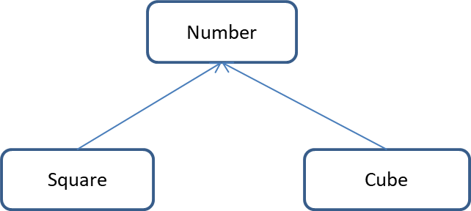**Sample Input Test Case 1:**

 5 // ’n’ denotes number

**Sample Output Test Case 1:**

25 // Square of given number

125 // Cube of given number

**Sample Input Test Case 2:**

 14 //’n’ denotes number

**Sample Output Test Case 2:**

196 // Square of given number

2744 // Cube of given number

**Constraints**: 1<=n<=100

**Explanation:**

**Sample Input:**

First line denote number

**Sample Output:**

First line denotes the square of number

Second line denotes the cube of number

**Formula Used:**

Square of number = n*n

Cube of number = n*n*n

**Head:**

#include <iostream>

using namespace std;

**Tail:**

int main()

{

int num;

Number n;

Square s;

Cube c;

num=n.getNumber();

s.cal(num);

c.cal(num);

return 0;

}

|  |  |  |  |  |  |  |
| --- | --- | --- | --- | --- | --- | --- |
| **Testcase0**  **(sample)**  **(Score-0)**  **Input**  5  **Output**  25  125 | **Testcase1**  **(sample)**  **(Score-0)**  **Input**  14  **Output**  196  2744 | **Testcase2**  **(Score-1)**  **Input**  12  **Output**  144  1728 | **Testcase3**  **(Score-1)**  **Input**  2  **Output**  4  8 | **Testcase4**  **(Score-1)**  **Input**  99  **Output**  9801  970299 | **Testcase5**  **(Score-1)**  **Input**  9  **Output**  81  729 | **Testcase6**  **(Score-1)**  **Input**  22  **Output**  484  10648 |

***PROBLEM STATEMENT2-(10 marks)***

Implement parameterized constructor in **MULTILEVEL INHERITANCE** to display total marks,percentage,division of a student

class student (base class)

class marks (intermediate base class)

class result (derived class)

Also consider that a student secures **first division** if percentage is greater than or equal to 60

student secures **second division** if percentage is greater than or equal to 50

otherwise student secures **third division**

Use **setprecision** as cout<<"area="<<fixed<<setprecision(2)<<area to display percentage upto 2 decimal places

**Sample input**

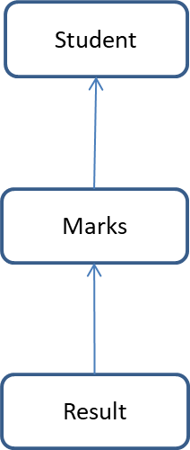12 //roll number

Anurag singh //name

CSE // course

60 45 35 //marks of three subjects

**Sample output**

In base class constructor

In marks class constructor

In derived class constructor

Rollno=12

Name=Anurag singh

Course=CSE

Total marks=140

Percentage=46.67

Division=THIRD

In derived class destructor

In marks class destructor

In base class destructor

**Explanation**

**Sample input**

First line is the rollno of the student.

Second line is the name of the student.

Third line is the course the student has opted for.

Fourth line represents the marks of three different subjects.

**Code**

**Head:**

#include<iostream>

#include<cstring>

#include<iomanip>

using namespace std;

class student

{

protected:

int rollno;

char stu_name[30];

char course[15];

public:

student(int rno,char *n,char *c)

{

**Tail:**

int main()

{

int rollno,marks1,marks2,marks3;

char name[30],course[30];

cin>>rollno;

cin.ignore();

cin.getline(name,30);

cin.getline(course,30);

cin>>marks1>>marks2>>marks3;

result r(rollno,name,course,marks1,marks2,marks3);

r.display();

return 0;

}

|  |  |  |  |  |
| --- | --- | --- | --- | --- |
| Testcases | T1(2 marks) | T2(3 marks) | T3(2 marks) | T4(3 marks) |
| Sample input | 12  Alisha  CSE  50 60 70 | 23  E Bala guru swamy  ECE  23 35 40 | 11  reema  ME  50 45 60 | 1  Anurag singh  CE  60 23 35 |
| Sample output | In base class constructor  In marks class constructor  In derived class constructor  Rollno=12  Name=Alisha  Course=CSE  Total marks=180  Percentage=60.00  Division=FIRST  In derived class destructor  In marks class destructor  In base class destructor | In base class constructor  In marks class constructor  In derived class constructor  Rollno=23  Name=E Bala guru swamy  Course=ECE  Total marks=98  Percentage=32.67  Division=THIRD  In derived class destructor  In marks class destructor  In base class destructor | In base class constructor  In marks class constructor  In derived class constructor  Rollno=11  Name=reema  COURSE=ME  Total marks=155  Percentage=51.67  Division=SECOND  In derived class destructor  In marks class destructor  In base class destructor | In base class constructor  In marks class constructor  In derived class constructor  Rollno=1  Name=Anurag singh  Course=CE  Total marks=118  Percentage=39.33  Division=THIRD  In derived class destructor  In marks class destructor  In base class destructor |