Q1.The correct statement for a function that takes pointer to a float, a pointer to a pointer to a char & returns a pointer to a pointer to a integer is**(score-1)**

A.int **fun(float**, char**)

B.int *fun(float*, char*)

**C.int ***fun(float*, char**)**

D.int ***fun(*float, **char)

Q2.Which operator returns address of unallocated blocks in memory?**(score-1)**

A.The delete operator

B.The empty operator

**C.The new operator**

D.All of them.

Q3.Predict the output**(score-2)**

#include<iostream>

using namespacestd;

class A

{

public:

void show()

{

cout<<" In class A ";

}

};

class B: public A

{

public:

int x;

void show()

{

cout<<"In class B ";

}

B()

{

x = 10;

}

};

int main(void)

{

A *bp,b;

B d;

bp = &d;

bp->show();

cout << bp->x;

return 0;

}

A.Compiler Error in line bp->show()

**B.Compiler Error in line cout <<bp->x**

C.In class A 10

D.In class B 10

Q4.Given a code snippet(**(score-1)**

class Base1

{

public:

void disp(){cout<<"function1";} //Function1

};

class Base2

{

public:

void disp(){cout<<"function2";} //Function2

};

class Der: public Base1, public Base2

{

public:

void disp(){cout<<"function3";} //Function3

};

int main()

{ Der *d=new Der;

d->disp(); //statement1

}

Which function will statement 1 execute?

1. Function1
2. Function2
3. **Function3**
4. Gives and error.

CODING SECTION  
**PROBLEM STATEMENT1-(5 marks)**

Shopkeeper tired of calculating cash and generating bill, so put request to an Account company that he needs a machine that has following features:

1. Generate bill on the basis of Item price and quantity i.e. **Bill = price of item * quantity**
2. Calculates cash from notes of Rs 2000, Rs 100, Rs 50, and Rs 10.
3. Match cash against bill and display “Clear” message if no balance was there otherwise print the amount needs to pay.

Account Company appoints you to program the machine according to shopkeeper requirement using the concept of inheritance so that code can be reuse by taking two class bill and cash.

**Sample Input 1:**

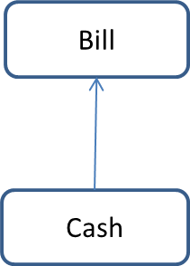1000     //item_price

100      //qty

4          //notes of 2000

0          //notes of 100

0         //notes of 50

10        //notes of 10

**Sample Output 1:**

Need to pay: 91900

**Constraints**: notes should be of Rs 2000, Rs 100, Rs 50, and Rs 10.

**Explanation:**

**Sample Input:**

First line denote item price

Second line denote quantity of item

Third, fourth, fifth and sixth lines denotes the count of notes

**Sample Output:**

Prints the pending amount need to be paid.

**Formula Used: Bill = price of item * quantity**

**Head:**

|  |
| --- |
| #include<iostream>  using namespace std;  class bill  { |

**Tail:**

|  |
| --- |
| int main()  {  cash d;  d.get_cash();  d.display();  return 0;  } |

|  |  |  |  |  |  |
| --- | --- | --- | --- | --- | --- |
| **Testcase0**  **(sample)**  **Score-0**  **Input**  1000  100  4  0  0  10  **Output**  Need to pay: 91900 | **Testcase1**  **Score-0**  **(sample)**  **Input**  10  10  0  1  0  0  **Output**  Clear | **Testcase2**  **Score-1**  **Input**  20  2  0  0  1  0  **Output**  Clear | **Testcase3**  **Score-2**  **Input**  30  2  0  0  1  0  **Output**  Need to pay: 10 | **Testcase4**  **Score-1**  **Input**  10  10  0  0  0  0  **Output**  Need to pay: 100 | **Testcase5**  **Score-1**  **Input**  10  10  0  0  0  9  **Output**  Need to pay: 10 |

**PROBLEM STATEMENT2-(10marks)**

A university with different departments where each department has number of employees working for university. The Head office personal wants to access information of employees of a particular department. How information could be gathered by concept of polymorphism? Make use of a function named clerk to display the details of the employee. All the inputs to be taken using function read in the emp class.

**Sample Input 1:**

3 // option 3 – 1 for CSE 2 for ECE 3 for ME 4 INVALID CHOICE

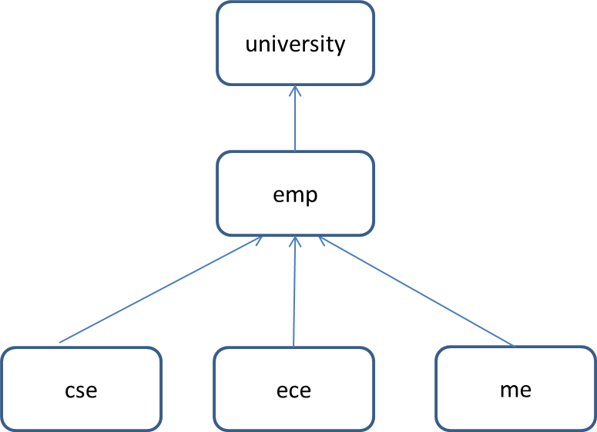Chitkara //university

Payal Rana // Name of ME faculty

27 //Age

35000 //Salary per month in Rupees

**Sample Output 1:**

University: Chitkara

Dept: ME

Name: Payal Rana

Age: 27

Salary: 35000

**Sample Input**

First line tells about the department– 1 for CSE 2 for ECE 3 for ME 4 INVALID CHOICE

Second line is the name of the institution

Third line, fourth line and fifth line is the name, age and salary respectively of the employee.

**SOLUTION:**

**Head:**

|  |
| --- |
| #include<iostream>  #include<iomanip>  using namespace std;  class university  {  protected:  char uni_name[20];  public:  virtual void clerk()=0;  virtual void read()=0;  };  class emp:public university  { |

**Tail:**

|  |
| --- |
| int main()  {  university *ptr;  int ch;  cin>>ch;  cin.ignore();  switch(ch)  {  case 1: {  cse c;  ptr=&c;  ptr->read();  ptr->clerk();  break;  }  case 2:{  ece e;  ptr=&e;  ptr->read();  ptr->clerk();  break;  }  case 3: {  me m;  ptr=&m;  ptr->read();  ptr->clerk();  break;  }  default:  cout<<"INVALID CHOICE";  }    return 0;  } |

|  |  |  |  |  |
| --- | --- | --- | --- | --- |
| Testcases | T1(3 marks) | T2(3 marks) | T3(3 marks) | T4(1 marks) |
| Sample input | 1  LPU  Rana partap  30  25000 | 2  Oxford  Ajay  25  30000 | 3  Vancouver  Chanderprasad Naidu  50  40000 | 4 |
| Sample output | University: LPU  Dept: CSE  Name: Rana partap  Age: 30  Salary: 25000 | University: Oxford  Dept: ECE  Name: Ajay  Age: 25  Salary: 30000 | University: Vancouver  Dept: ME  Name: Chanderprasad Naidu  Age: 30  Salary: 25000 | INVALID CHOICE |