**MCQ SECTION**

Q1.What is the output of this program?(score-1)

#include <iostream>

using namespace std;

int main()

{

char arr[20];

int i;

for(i = 0; i < 10; i++)

*(arr + i) = 65 + i;

*(arr + i) = '\0';

cout << arr;

return(0);

}

**A.ABCDEFGHIJ**

B.AAAAAAAAAA

C.JJJJJJJJ

D.None of the mentioned

Q2.During dynamic memory allocation in CPP, new operator returns _________ value if memory allocation is unsuccessful.(score-1)

A.False

**B.NULL**

C.Zero

D.None of these

Q3.#include<iostream>(score-2)  
using namespace std;  
class A  
{  
public:  
A(int a)  
{  
cout<<" "<<a;  
}  
};  
class B: public A  
{  
public:  
B(int a,int b):A(a)  
{  
cout<<" "<<b;  
}

};  
class C: public B  
{  
public:  
C(int a,int b,int c):B(a,b)  
{  
cout<<" "<<c;  
}  
};  
int main()  
{  
C c(10,20,30);  
return 0;  
}

A.garbage garbage 30

B.30 20 10

**C.10 20 30**

D.syntax error

Q4.What will be output of following code. (score-1)

int main()

{

int x=1;

int &y=x;

y=y+2;

int *t=&y;

*t=*t+1;

cout<<x<<" "<<y<<endl;

}

**A. 4 4**

B. Compile time error

C. 1 3

D. 3 3

**CODING SECTION**

*PROBLEM STATEMENT1(5 marks)*

**Q5-marks:**In a school students participated in various activities. Principal of school decides to add marks of extra curriculum activities with the subject marks. Criteria for revised result on basis of extra curriculum activities take sum of two highest marks in subject and marks for extra curriculum activities then find average of it. Help school teachers in preparing result using the concept of multiple inheritance with class information(to calculate and display) that inherits from class student(rollno and marks in two subjects) and extracurriculum (marks in one extra activity) so that she can use the data of already build classes.

**Sample Input Test Case 1:**

 111 // Roll No of student

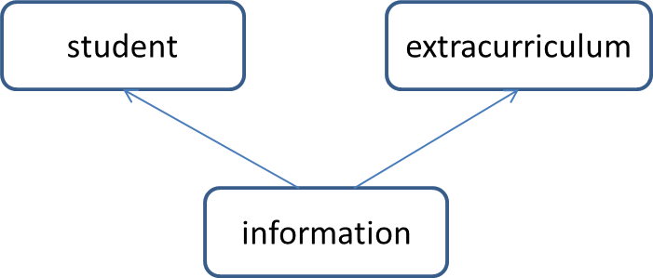34 // 1st highest marks

67 // 2nd highest marks

56 // marks in extra curriculum

**Sample Output Test Case 1:**

Roll No: 111 // Roll No of student

Total: 157 // Sum of marks

Average: 52 // Average of marks

**Constraints**: ignore decimal part after calculating average

**Explanation:**

**Sample Input:**

 First line denote Roll No of student

 Second and third line denotes two highest marks

Fourth line denotes mark for Extra Curriculum Activities

**Sample Output:**

First line display Roll No of student

Second line display total marks of student

Third line display average of two highest marks and marks in Extra Curriculum Activities

**Formula Used:**

Average: (sum of two highest marks + marks in extra curriculum activities)/3

**Head:**

|  |
| --- |
| #include <iostream>  using namespace std;  class student {  protected:  int roll, m1, m2;  public:  void get();  };  class extracurriculum { |

**Tail:**

|  |
| --- |
| int main()  {  information i;  i.get();  i.getsm();  i.display();  return 0;  } |

|  |  |  |  |  |  |
| --- | --- | --- | --- | --- | --- |
| **Testcase1**  **(sample)**  **(Score -0)**  **Input**  111  34  67  56  **Output**  Roll No: 111  Total: 157  Average: 52 | **Testcase2**  **(Score -1)**  **Input**  112  23  67  68  **Output**  Roll No: 112  Total: 158  Average: 52 | **Testcase3**  **(Score -1)**  **Input**  113  23  45  12  **Output**  Roll No: 113  Total: 80  Average: 26 | **Testcase4**  **(Score -1)**  **Input**  114  67  80  45  **Output**  Roll No: 114  Total: 192  Average: 64 | **Testcase5**  **(Score -1)**  **Input**  115  78  48  50  **Output**  Roll No: 115  Total: 176  Average: 58 | **Testcase6**  **(Score -1)**  **Input**  116  34  67  56  **Output**  Roll No: 116  Total: 157  Average: 52 |

*PROBLEM STATEMENT2(10 marks)*

A customer places an online order. After he is done choosing the item, he has two options to make the payment- 1. cash on delivery method and 2.by using credit/debit card. Implement this system of placing the order using inheritance.

Order being the base class has the four data members- number of items purchased, item_code, price of each item and the quantity of each item purchased. Class payment derived from order, calculates the bill of the purchase. Classes COD and card are used to display the bill

**Sample Input1:**

1 //choice (1 for cash, 2 for card)

2 //number of items

2 50 2 //item code,price per kg,quantity brought in kg for 1st item

3 60 1 //item code,price per kg,quantity brought in kg for 2nd item

**Sample output1:**

you chose to pay by cash

BILL:

Item number:2 Price:100

Item number:3 Price:60

160

keep the cash ready

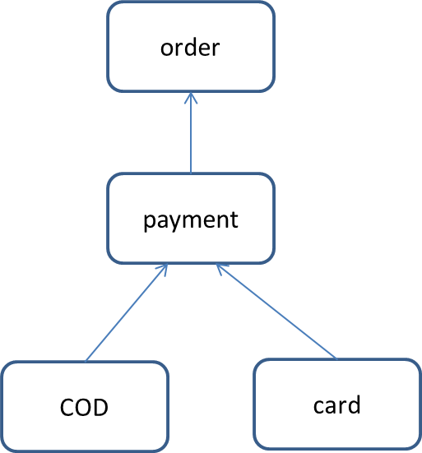**Sample input 2:**

2

2

1 50 1

2 60 2

12345678 //card number

Visa //card type

**Sample output2:**

you chose to pay by card

BILL:

Item number:1 Price:50

Item number:2 Price:120

Total bill:170

payment successful

**Explanation**

**Sample Input**

First line asks the user’s choice for payment (1 for cash, 2 for card)

Second line tells the number of items user purchases

Third line is the item code,price per kg,quantity brought in kg for 1st item

Fourth line is the item code,price per kg,quantity brought in kg for 2nd item

If the payment is made using card, two additional data are accepted namely, card number and type.

**Head:**

|  |
| --- |
| #include<iostream>  #include<iomanip>  using namespace std;  class order  {  protected:  int size;  int *item_no;  double *price;  double *quantity;  public:  virtual void bill()=0; |

**Tail:**

|  |
| --- |
| int main()  {  int n;  int option;  cin>>option;  cin>>n;  if(option==1)  {  cout<<"you chose to pay by cash\n";  COD cod(n);  cod.display();    }  else if(option ==2)  {  cout<<"you chose to pay by card\n";  card c(n);  c.display();  }  return 0;  } |

|  |  |  |  |  |
| --- | --- | --- | --- | --- |
|  | **TC1(score-3)** | **TC2(score-3)** | **TC3(score-2)** | **TC4(score-2)** |
| input | 2  2  1 50 1  2 60 2  12345678  visa | 1  1  82 70 5 | 2  4  4 20 1  2 50 2  8 20 1  6 55 4  12345975  master | 1  2  89 55 2  100 60 4 |
| output | you chose to pay by card  BILL:  Item number:1 Price:50  Item number:2 Price:120  Total bill:170  payment successful | you chose to pay by cash  BILL:  Item number:82 Price:350  Total bill:350  keep the cash ready | you chose to pay by card  BILL:  Item number:4 Price:20  Item number:2 Price:100  Item number:8 Price:20  Item number:6 Price:220  Total bill:360  payment successful | you chose to pay by cash  BILL:  Item number:89 Price:110  Item number:100 Price:240  Total bill:350  keep the cash ready |