**MCQ SECTION**

Q1.What is the output of this program? (score-1)

#include <iostream>

using namespace std;

int main ()

{

int numbers[5];

int * p;

p = numbers;

*p = 10;

p++;

*p = 20;

p = &numbers[2];

*p = 30;

p = numbers + 3;

*p = 40;

p = numbers;

*(p + 4) = 50;

for (int n = 0; n < 5; n++)

cout << numbers[n] << ",";

return 0;

}

A.10,20,30,40,50,

B.1020304050

**C.10,10,30,40,50,**

D.Run time error

Q2.Which of the following is illegal?(score-1)

A.int *ip;

B.string s, *sp = 0;

**C.int i; double* dp =&i;**

D.int * pi=0;

Q3.#include<iostream>(score-2)

using namespace std;

class B1

{

public:

void show()

{

cout<<"\n In base class 1";

}

};

class B2

{

public:

void show()

{

cout<<"\n In base class 2";

}

};

class D:public B1,public B2

{

public:

D()

{

cout<<"\n In derived class constructor ";

}

};

int main()

{

D d;

d.show();

return 0;

}

A. In base class 1 In base class 2 In derived class constructor

B. In derived class constructor In base class 2 In base class 1

C. None

**D. error**

Q4.What will be the output of the code given below? (score-1)

void main()

{

int a[4]={1,2};

int *s=a;

s++;

s++;

cout<<*s;

}

A. 1

B.2

**C. 0**

D. Garbage.

**CODING SECTION**

*PROBLEM STATEMENT-1(5 marks)*

**Q5-marks:**Following given a multi-level inheritance structure of classes that represents the student details, marks in three different subjects and Result respectively, generate the sample output.

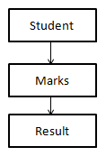

**Sample Input Test Case 1:**

151 // Roll no of student

Rahul // ‘Name of student

90// marks in 1st subject

75 // marks in 2nd subject

95 // marks in 3rd subject

**Sample Output Test Case 1:**

151 // Roll no of student

Rahul // Name of student

260// Total Marks

**Constraints**: marks <= 100

**Explanation:**

**Sample Input:**

 First line denotes roll no. of student.

 Second line denotes name of student.

Third, Fourth and fifth lines denote marks secured by student in three different subject.

**Sample Output:**

Display the roll no., name and total marks of student

**Head:**

|  |
| --- |
| #include<iostream>  #include<string.h>  using namespace std;  class student  {  public:  int rollno;  char name[20];  student(char name1[20],int x)  { |

**Tail:**

|  |
| --- |
| int main() {  int rno,i;  char name[20];  int marks[3];  cin>>rno;  cin>>name;  for(i=0;i<3;i++)  {  cin>>marks[i];  }  Result r(rno,name,marks);  return 0;  } |

|  |  |  |  |  |  |
| --- | --- | --- | --- | --- | --- |
| **Testcase0**  **(Score-0)**  **(sample)**  **Input**  151  Rahul  70  85  92  **Output**  151  Rahul  247 | **Testcase1**  **(Score-1)**  **Input**  152  Preeti  40  95  62  **Output**  152  Preeti  197 | **Testcase2**  **(Score-1)**  **Input**  153  Manisha  77  18  98  **Output**  153  Manisha  193 | **Testcase3**  **(Score-1)**  **Input**  154  Gagan  95  45  65  **Output**  154  Gagan  205 | **Testcase4**  **(Score-1)**  **Input**  155  Rohan  50  70  80  **Output**  155  Rohan  200 | **Testcase5**  **(Score-1)**  **Input**  156  Vansh  81  91  75  **Output**  156  Vansh  247 |

*PROBLEM STATEMENT-2(10 marks)*

**Q10-marks**Implement parameterized constructor in multiple inheritance to calculate the cost of construction for building a house.Derive a class **house** publicly from three base classes **cement,steel,wood.**

**Sample input**

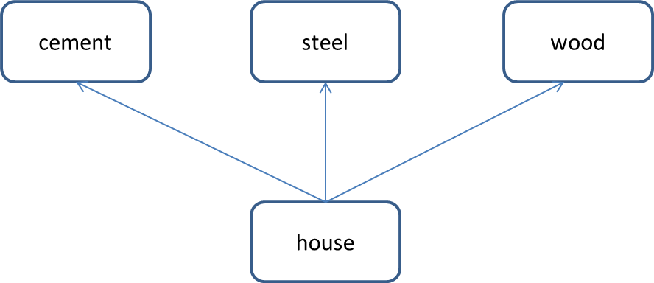150 //no of bags

500 //cost of each bag

3 //tons of steel

2000 //cost of steel

10 //cubic feet of wood

3500 //cost of wood

**Sample output**

Derived class constructor

cost of cement=75000 rupees

cost of steel=6000 rupees

cost of wood= 35000 rupees

total cost to construct a house=116000 rupees

**Explanation:**

**Sample input**

First line is the no of bags of cement used

Second line is the cost of each bag of cement

Third line is the tons of steel used.

Fourth line is the cost of steel per ton.

Fifth line is the cubic feet of wood used.

Sixth line is the cost of wood per cubic feet.

**Code**

**Head:**

|  |
| --- |
| #include <iostream>  using namespace std; |

**Tail:**

|  |
| --- |
| int main()  {  int no_of_bags,cost_cement, tons_of_steel,cost_steel,cubicfeet_of_wood,wood_cost;  cin>>no_of_bags>>cost_cement>>tons_of_steel>>cost_steel>>cubicfeet_of_wood>>wood_cost;  house h(no_of_bags,cost_cement, tons_of_steel,cost_steel,cubicfeet_of_wood,wood_cost);  return 0;  } |

|  |  |  |  |  |
| --- | --- | --- | --- | --- |
| Testcases | **T1(score-3)** | **T2(score-3)** | **T3(score-2)** | **T4(score-2)** |
| Sample input | 100  500  2  2000  5  3500 | 200  400  4  3000  4  2000 | 100  400  3  1000  4  3000 | 50  400  5  3000  10  2000 |
| Sample output | Derived class constructor  cost of cement=50000 rupees  cost of steel=4000 rupees  cost of wood=175000 rupees  total cost to construct a house=71500 rupees | Derived class constructor  cost of cement=80000 rupees  cost of steel=12000 rupees  cost of wood=8000 rupees  total cost to construct a house=100000 rupees | Derived class constructor  cost of cement=40000 rupees  cost of steel=3000 rupees  cost of wood=12000 rupees  total cost to construct a house=55000 rupees | Derived class constructor  cost of cement=20000 rupees  cost of steel=15000 rupees  cost of wood=20000 rupees  total cost to construct a house=55000 rupees |