**MCQ SECTION**

Q1.The most appropriate matching for the following pairs:(score-1)

X: m=new(5); m= NULL; 1: using dangling pointers

Y: delete n; n->value=5; 2: using uninitialized pointers

Z: char *p; *p = ’a’; 3. lost memory is:

A.X-1 Y-3 Z-2

B.X-2 Y-1 Z-3

C.X-3 Y-2 Z-1

**D.X-3 Y-1 Z-2**

**Q2.Predict the output**(score-2)

#include<iostream>  
using namespace std;  
class Base  
{  
public:  
void show()  
 {

cout<<" In Base \n";  
}  
};  
class Derived: public Base  
{  
public:  
void show()  
{

cout<<"In Derived \n";  
}  
};  
int main()  
{  
 Base *bp,b ;

Derived d;

bp=&b;  
 bp->show();  
 bp=&d;  
bp->show();

return 0;  
}

**a)In Base In Base**

b)In Base In Derived

c)In Derived In Base

d)error

Q3.what is the output of the following program:(score-1)

#include<iostream>

using namespace std;

void square(int * x)

{

*x=(*x+1)*(*x);

}

main()

{

int num=10;

square(&num);

cout<<num;

}

A.100

B.144

C.1000

**D.110**

**Q**4.A pointer to base class can hold the address of(score-1)

1. only base class object
2. Only derived class object
3. **Base class as well as derived class object.**
4. None of the above.

**CODING SECTION**

***PROBLEM STATEMENT-1(10-marks)***

**Q10-marks:**Anaya father wants to do white wash in the room of Anaya and also, re-do the carpet. He wants to calculate the total cost of white washing and carpet. Her father denotes the length, breadth and height of a room are p, q and r respectively in meters. Help Anaya’s father in calculating the total cost of white washing the walls of the room and the ceiling at the rate of X Rs.per sq m. Also calculate the cost of the carpet for the floor of the room at the rate of ‘Y’ Rs.per sq m using the concept of Hybrid inheritance. Create a class named Dimensions to be the base class for three classes name-floor,ceiling,walls. Extend these classes using class named cost to calculate the total cost spent on the room.

**Sample Input Test Case 1:**

 5 // ‘p’ length of the room

4 // ‘q’ length of the room

3// ‘r’ length of the room

7.50 // ‘X’ cost

9.00 //’Y’ cost

**Sample Output Test Case 1:**

735 // Total cost

**Sample Input Test Case 2:**

1 // ‘p’ length of the room

1 // ‘q’ length of the room

1 // ‘r’ length of the room

2.25 // ‘X’ cost

5.00 //’Y’ cost

**Sample Output Test Case 2:**

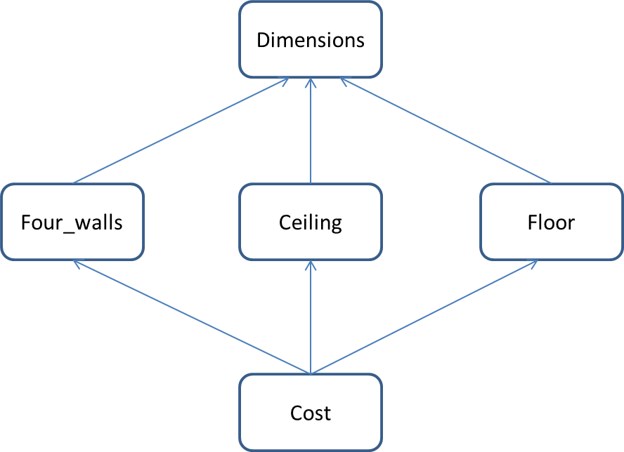16// Total cost

**Constraints**:

1<=p<=50

1<=q<=50

1<=r<=50

**Explanation:**

**Sample Input:**

First three lines denote thelength, breadth and height of a room.

Fourth denotes cost of white washing Rs. X per sq m.

Fifth line denotes the cost of carpet Rs.’Y’ per sq m.

**Sample Output:**

Total cost of white washing the walls of the room and the ceiling at the rate of X per sq m.

**FORMULAS USED:**

Area of four walls = 2*h*(l+b)

Area of the ceiling or floor = l * b

**Head:**

|  |
| --- |
| **#include <iostream>**  **using namespace std;**  **class Dimensions**  **{**  **protected:**  **int l,b,h;**  **float c,f;**  **public:**  **void input()**  **{**  **cin>>l;**  **cin>>b;**  **cin>>h;**  **cin>>c;**  **cin>>f;**  **}**  **};** |

**Tail:**

|  |
| --- |
| int main()  {  Cost c;  c.input();  c.total_cost();  return 0;  } |

|  |  |  |  |  |  |  |
| --- | --- | --- | --- | --- | --- | --- |
| **Testcase0**  **(sample)**  **Marks-0**  **Input**  5  4  3  7.50  **9.00**  **Output**  735 | **Testcase1**  **(sample)**  **(marks-0)**  **Input**  1  1  1  2.25  **5.00**  **Output**  16 | **Testcase2**  **Marks-1**  **Input**  12  6  3  7  **6.5**  **Output**  1728 | **Testcase3**  **Marks-3**  **Input**  **2**  **2**  **2**  **2**  **5.50**  **Output**  62 | **Testcase4**  **Marks-2**  **Input**  1  2  3  4.50  **6.66**  **Output**  **103** | **Testcase5**  **Marks-2**  **Input**  9  8  7  8.50  **10**  **Output**  **3355** | **Testcase6**  **Marks-2**  **Input**  2  8  4  3  **4**  **Output**  352 |

***PROBLEM STATEMENT-2(5-marks)***

Create a class Person with two data member: name, age and two member function get_person(), show_person() that take and display details of person. Write a program in which class Batsman inherits from class person and show all the details of Batsman.

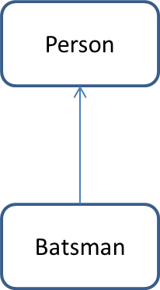**Sample Input Test Case 1:**

Sachin Tendulkar // Name of person

44 // Age of person

463 //no. of ODI Played

96 // no. of Half centuries made

18426 // no. of run made

44.83 // Batting Average

91.83 // Strike Rate

**Sample Output Test Case 1:**

Name: Sachin Tendulkar

Age: 44

ODI Played: 463

Half centuries made: 96

Run made: 18,426

Batting Average: 44.83

Strike Rate: 91.83

**Constraints**: (a) Age should not more than 50

(b) Take batting average and strike rate in float

**Explanation:**

**Sample Input:**

First line denotes Name of person

Second line denotes Age of person

Third line denotes no. of ODI Played

Fourth line denotes no. of Half centuries made

Fifth line denotes no. of run made

Sixth line denotes Batting Average

Seventh line denotes Strike Rate

**Sample Output:**

First line shows Name of person

Second line shows Age of person

Third line shows no. of ODI Played

Fourth line shows no. of Half centuries made

Fifth line shows no. of run made

Sixth line shows Batting Average

Seventh line shows Strike Rate

**Tail:**

|  |
| --- |
| int main()  {  char name[20];  int age;  int run,odi,half;  float avg,strike;  cin.getline(name,20);  cin>>age;  cin>>odi;  cin>>half;  cin>>run;  cin>>avg;  cin>>strike;  Batsman b(name,age,odi,half,run,avg,strike);  b.show();  return 0;  } |

|  |  |  |  |  |
| --- | --- | --- | --- | --- |
| **Testcase0**  **(sample)**  **Marks-0**  **Input**  Sachin Tendulkar  44  463  96  18426  44.83  91.83  **Output**  Name: Sachin Tendulkar  Age: 44  ODI Played: 463  Half centuries made: 96  Run made: 18426  Batting Average: 44.83  Strike Rate: 91.83 | **Testcase1**  **Marks-1**  **Input**  Rahul  34  43  6  34584  76.9  25.6  **Output**  Name: Rahul  Age: 34  ODI Played: 43  Half centuries made: 6  Run made: 34584  Batting Average: 76.9  Strike Rate: 25.6 | **Testcase2**  **Marks-1**  **Input**  Meenakshi  28  423  86  78126  58.6  25.9  **Output**  Name: Meenakshi  Age: 28  ODI Played: 423  Half centuries made: 86  Run made: 78126  Batting Average: 58.6  Strike Rate: 25.9 | **Testcase3**  **Marks-1**  **Input**  Rohan  34  46  56  87426  58.2  36.7  **Output**  Name: Rohan  Age: 34  ODI Played: 46  Half centuries made: 56  Run made: 87426  Batting Average: 58.2  Strike Rate: 36.7 | **Testcase4**  **Marks-2**  **Input**  Priya Verma  25  54  76  1426  51.8  89.5  **Output**  Name: Priya Verma  Age: 25  ODI Played: 54  Half centuries made: 76  Run made: 1426  Batting Average: 51.8  Strike Rate: 89.5 |