**MCQ SECTION**

**Q1.Choose the correct statement**(score-1)

A. An abstract base class can have pure virtual destructor

B. An abstract base class can have virtual destructor

C. An abstract base class can have non virtual destructor

**D. An abstract base class cannot have destructor**

Q2.#include<iostream>(score-2)  
using namespace std;  
class test  
{  
int a;  
public:  
test()  
{  
a=20;  
}  
void display()  
{  
cout<<"a="<<a;  
}  
virtual ~test()  
{  
cout<<"object t destroyed";  
}  
};  
int main()  
{  
test t;  
t.display();  
return 0;  
}

**A. a=20 object t destroyed**

B. error

C. garbage value

D. None

Q3.What will be output of following code. (score-1)

#include<iostream>

using namespace std;

int main()

{

int x[5]={5,3,2,1};

int &y=x[0];

y=y+2;

int *t=&y;

*t=*t+1;

cout<<x[0]<<" "<<y<<endl;

}

**A. 8 8**

B. Compile time error

C. 1 3

D. 3 3

Q4.Consider the following statements:(score-1)

Char *ptr;

Ptr=hello;

Cout<<*ptr;

What will be printed?

1. **first letter**
2. Entire string
3. Synatx error
4. Last letter.

**CODING SECTION**

***PROBLEM STATEMENT-1(5-Marks)***

**Q5-marks-**Create a base class 'Object' having two data members of type double i.e. r and h. /object class has two member functions one is get-data( ) to initialize base class data members and another one is pure virtual member function display-area( ) to compute and display the volume of the geometrical object.

Derive two specific classes 'Cone' and 'Cylinder' from the base class object. Using these three classes design a program that will accept dimension of a Cone / Cylinder interactively and display the volume.

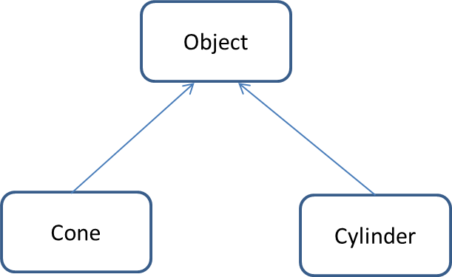**Sample Input Test Case 1:**

 5 // ‘r’ radius for cone

4 // ‘h’ height for cylinder

5// ‘r’ radius for cone

6 // ‘h’ height for cylinder

**Sample Output Test Case 1:**

104.667 // Volume of cone

471 // Volume of cylinder

**Sample Input Test Case 2:**

 5 // ‘r’ radius for cone

6 // ‘h’ height for cylinder

5// ‘r’ radius for cone

6 // ‘h’ height for cylinder

**Sample Output Test Case 2:**

157 // Volume of cone

471 // Volume of cylinder

**Constraints**:

1<=r<=50

1<=h<=50

**Explanation:**

**Sample Input:**

 First, second lines denote theradius and height of cone.

Third, Fourth lines denote theradius and height of cylinder.

**Sample Output:**

Denotes the volume of cone and cylinder.

**FORMULAS USED:**

Volume of cone = (pi*r^2*h)/3

Volume of cylinder = pi*r^2*h

pi is constant having value 3.14

**Head:**

|  |
| --- |
| using namespace std;  #include<iostream>  class Object  {  protected:  double r, h;  public:  void getdata() |

**Tail:**

|  |
| --- |
| int main()  {  Cone c1;  Cylinder c2;  c1.getdata();  c2.getdata();  c1.display_area();  c2.display_area();  return 0;  } |

|  |  |  |  |  |  |
| --- | --- | --- | --- | --- | --- |
| **Testcase0**  **(sample)**  **Marks-0**  **Input**  5  6  5  6  **Output**  157  471 | **Testcase1**  **Marks-1**  **Input**  7  5  9  4  **Output**  256.433  1017.36 | **Testcase2**  **Marks-1**  **Input**  24  5  24  5  **Output**  3014.4  9043.2 | **Testcase3**  **Marks-1**  **Input**  **2**  **3**  **2**  **2**  **Output**  12.56  25.12 | **Testcase4**  **Marks-1**  **Input**  25  35  25  35  **Output**  22895.8  68687.5 | **Testcase5**  **Marks-1**  **Input**  1  1  1  1  **Output**  1.04667  3.14 |

***PROBLEM STATEMENT-2(10-Marks)***

**Refer to the diagram of hybrid inheritance and complete the code below. Class person has the data members as name, age, sex. Class student has the data members as rollno and course. Class faculty has data members as designation and department. Class publication has data members as no of research and no of books published.**

**Sample input1**

1 //choice 1-for student,2 for faculty

Abhi //Name of student

20 //Age

M //Sex

123 Rollno

CSE //Course

**Sample output1**

Name:Abhi

Age:20

Sex:M

Rollno:123

Course:CSE

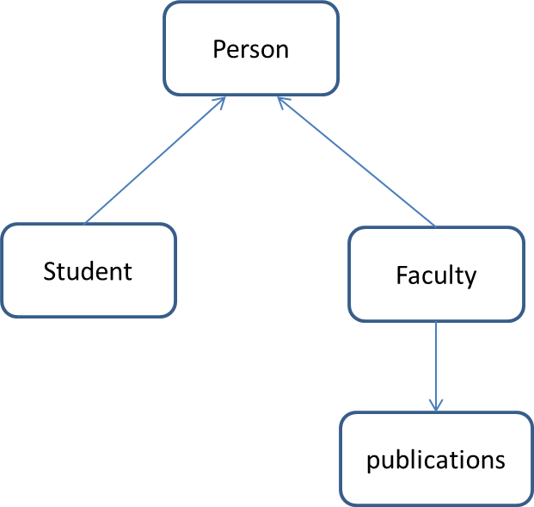**Sample input2**

2 //choice

Pallavi Shah //name

40 //age

F //sex

Prof //Designation

CSE //Department

12 //No.of research papers

2 //No.of books.

**Sample output2**

Name:Pallavi Shah

Age:40

Sex:F

Designation:Prof

Department:CSE

Research papers:12

Books:2

**Explanation:**

**Sample Input1**

First line is the choice 1-for student,2 for faculty

Second line is the name of student

Third line is the age

Fourth line tells the sex of the student.

Fifth line tells the Rollno of the student

Last line is the Course the student is enrolled in.

**Sample input2**

First line is the choice 1-for student,2 for faculty

Second line is the name of student

Third line is the age

Fourth line tells the sex of the student

Fifth line tells the Designation

Sixth line tells the Department

Seventh and eight lines tell the number of research papers and books published by the faculty respectively.

|  |  |  |  |  |
| --- | --- | --- | --- | --- |
|  | TC1(Marks-2) | TC2(Marks-3) | TC3(Marks-3) | TC4(Marks-2) |
| Input | 1  Dyna  16  f  14  Maths | 2  Freya Buffey  27  F  AP  ECE  3  0 | 1  Omna  12  F  45  History | 2  Alok Nath  55  M  Prof  CE  2  2 |
| Output | Name:Dyna  Age:16  Sex:f  Rollno:14  Course:Maths | Name:Freya Buffey  Age:27  Sex:F  Designation:AP  Department:ECE  Research papers:3  Books:0 | Name:Omna  Age:12  Sex:F  Rollno:45  Course:History | Name:Alok Nath  Age:55  Sex:M  Designation:Prof  Department:CE  Research papers:2  Books:2 |

**Head:**

|  |
| --- |
| #include<iostream>  using namespace std;  class person  {  protected:  char name[20];  int age;  char sex; |

**Tail:**

|  |
| --- |
| int main()  {  int choice;  cin>>choice;  if(choice==1)  {  char n[20],s,c[20];  int a,r;  cin.ignore();  cin.getline(n,20);  cin>>a;  cin>>s;  cin>>r;  cin>>c;  student stu(n,a,s,r,c);  stu.show_s_data();  }  else if(choice==2)  {  char n[20],s,des[20],dpt[20];  int a,rp,books;  cin.ignore();  cin.getline(n,20);  cin>>a;  cin>>s;  cin>>des;  cin>>dpt;  cin>>rp>>books;  publications p(n,a,s,des,dpt,rp,books);  p.show_pub_data();  }  return 0;  } |