Web Application Security Assessment Report

OWASP Juice Shop - Vulnerability Assessment

Table of Contents

1. Executive Summary
2. Scope & Methodology
3. Risk Matrix
4. Vulnerability Findings
4.1 SQL Injection – Authentication Bypass
4.2 Weak Authentication / Brute Force
4.3 Reflected XSS
4.4 Broken Access Control
4.5 Sensitive Data Exposure
5. Recommendations
6. Conclusion

1. Executive Summary
This report provides a comprehensive security assessment of the OWASP Juice Shop web application. Five major vulnerabilities were discovered, including SQL Injection, XSS, Broken Access Control, Weak Authentication, and Sensitive Data Exposure. All issues were validated manually using Burp Suite and mapped to the OWASP Top 10 2021 risks.

2. Scope & Methodology
Testing was performed using the OWASP Web Security Testing Guide methodology, Burp Suite Community Edition, manual testing, and local deployment of OWASP Juice Shop. The scope included authentication, session handling, input validation, access control, and sensitive data exposure analysis.

3. Risk Matrix

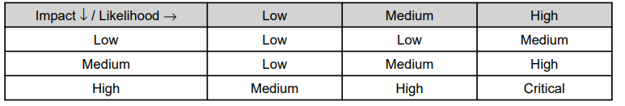

4. Vulnerability Findings

4.1 SQL Injection – Authentication Bypass
CVSS Score: 9.8 (Critical)
OWASP Category: A01 – Broken Access Control
The login endpoint is vulnerable to SQL Injection, allowing attackers to bypass authentication using crafted payloads.
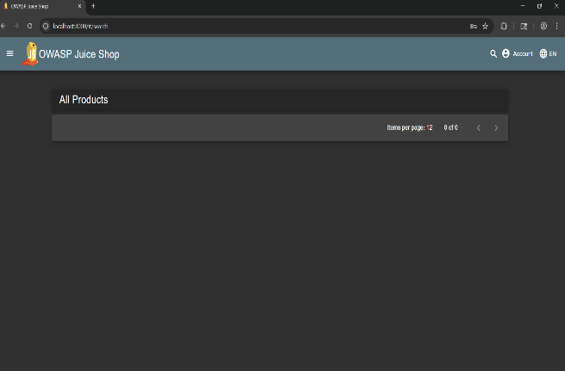

4.2 Weak Authentication / Brute Force
CVSS Score: 7.5 (High)
OWASP Category: A07 – Identification and Authentication Failures
The application allows weak passwords and lacks brute-force protections.
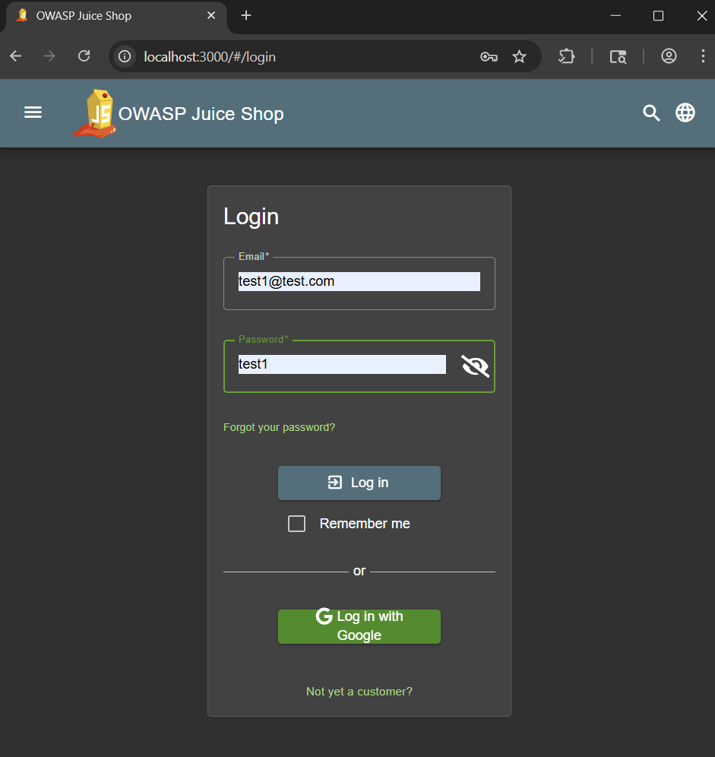

4.3 Reflected Cross-Site Scripting (XSS)
CVSS Score: 6.1 (Medium)
OWASP Category: A03 – Injection
Unsanitized search input allows JavaScript execution in the victim's browser.

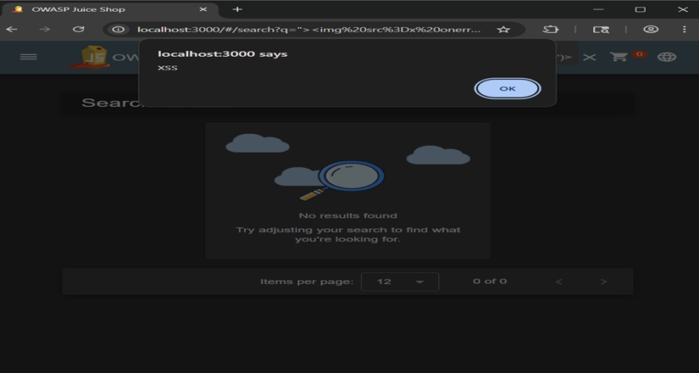

4.4 Broken Access Control (Admin API Exposure)
CVSS Score: 8.7 (High)
OWASP Category: A01 – Broken Access Control
Unauthorized users can access administrative API endpoints, revealing internal system data
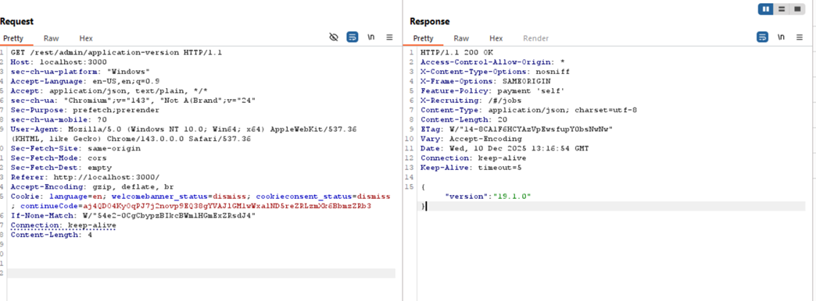
4.5 Sensitive Data Exposure / Insecure API
CVSS Score: 7.4 (High)
OWASP Category: A02 – Cryptographic Failures
Endpoint /api/Feedbacks/ leaks user IDs, masked emails, feedback messages, ratings, and timestamps without authentication.
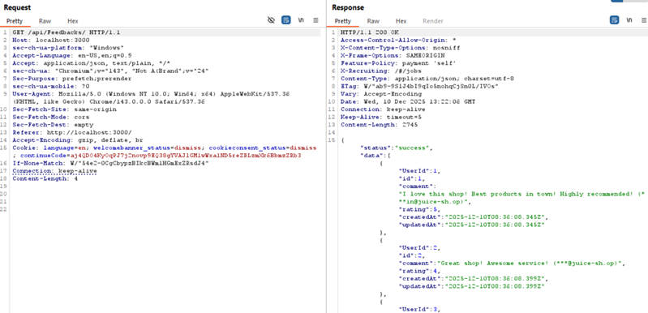

5. Recommendations
• Implement input validation and parameterized SQL queries.
• Enforce strict authentication, MFA, and strong password policies.
• Apply proper RBAC (Role-Based Access Control).
• Sanitize and encode all output to prevent XSS.
• Limit sensitive data returned by APIs using data minimization principles.
• Use rate limiting and CAPTCHA to prevent brute-force attacks.

6. Conclusion
The assessment found multiple critical vulnerabilities affecting the application's confidentiality, integrity,
and availability. Remediation should follow a prioritized approach, beginning with Broken Access
Control and SQL Injection vulnerabilities.

