SOC Assignment Report – Elastic + Splunk

1. Elastic Observability Configuration

1.1 Overview
This section documents the setup of Elastic Cloud, Elastic Agent, Fleet integrations, and the creation of dashboards for monitoring custom log data as part of SOC operations.

1.2 Elastic Deployment Setup
An Elastic Observability project was created with the following components:
• Fleet server
• Elastic Agent integration
• Custom Filestream log ingestion

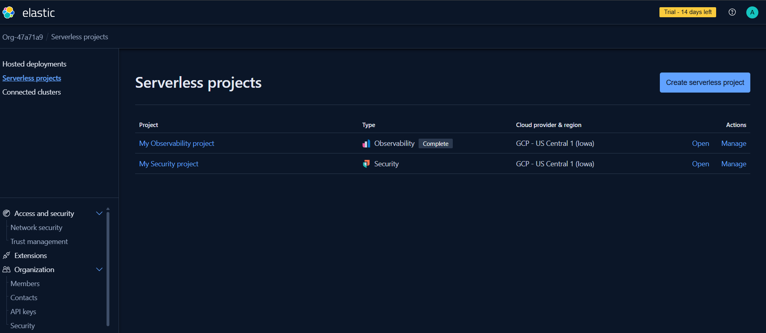

1.3 Elastic Agent Installation
Elastic Agent was installed on Windows using PowerShell in Administrator mode. The agent successfully enrolled into Fleet and began collecting logs.

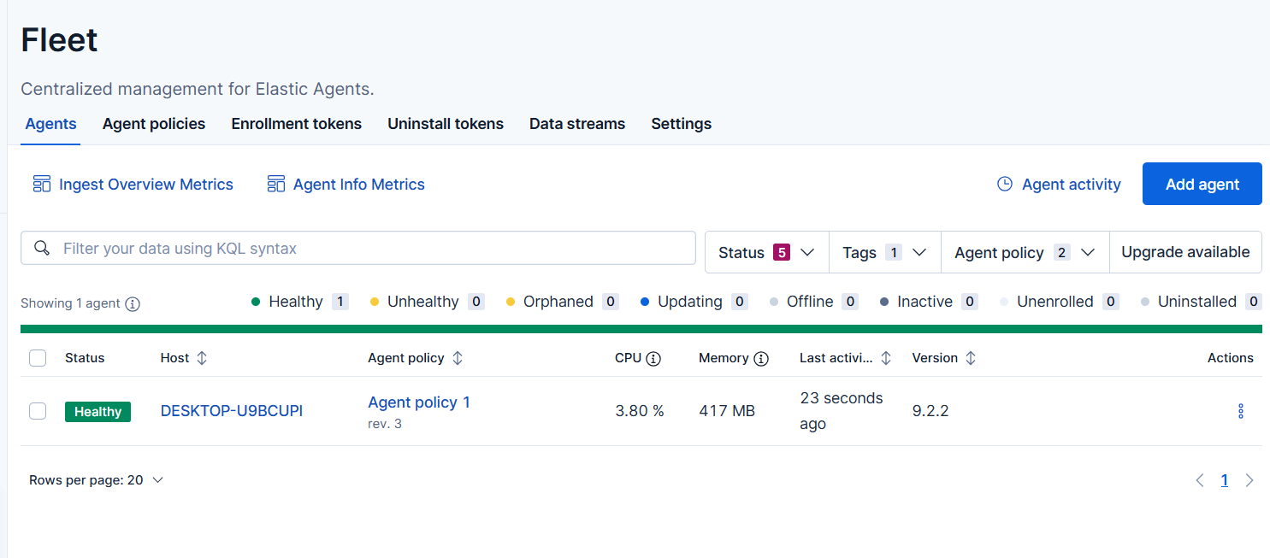

1.4 Log Ingestion – Filestream
Custom log file ingestion was accomplished through the Filestream integration. Logs appeared under dataset: filestream.generic.

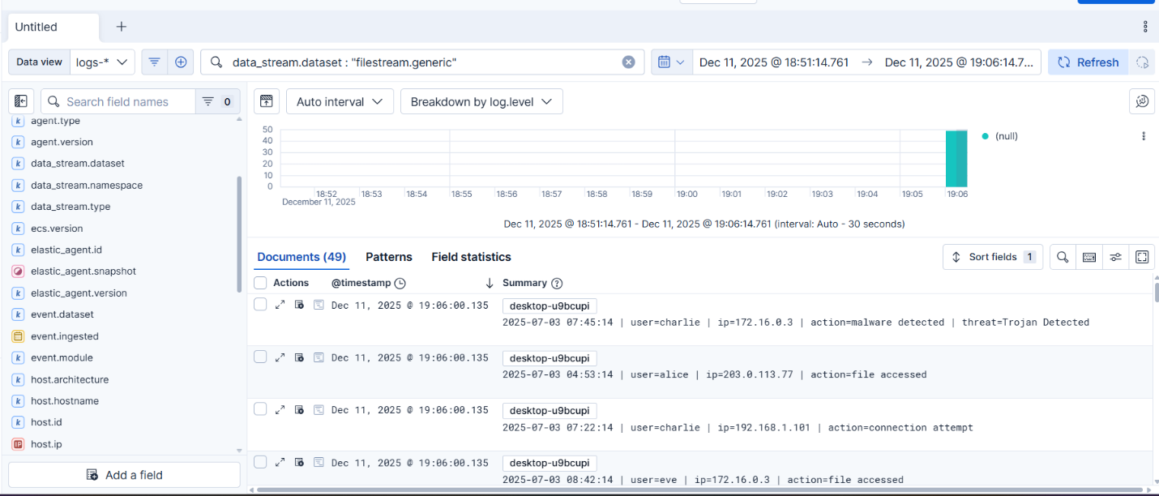

1.5 Dashboards & Visualizations
Three required visualizations were created:
• Bar/Line chart for event frequency
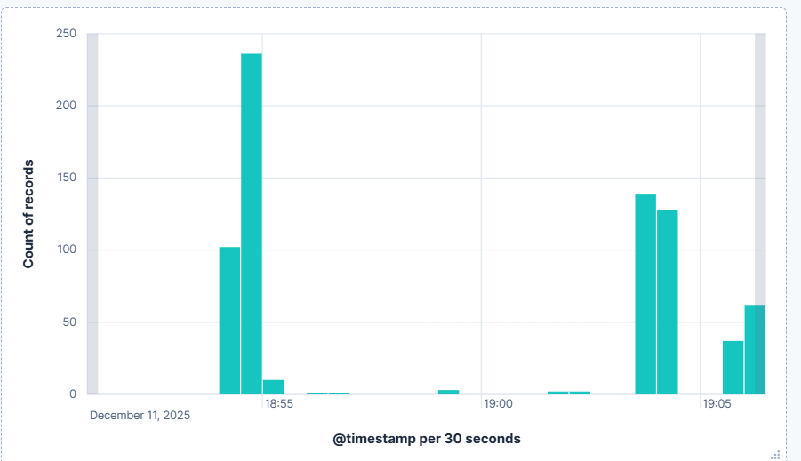

• Pie chart for event distribution
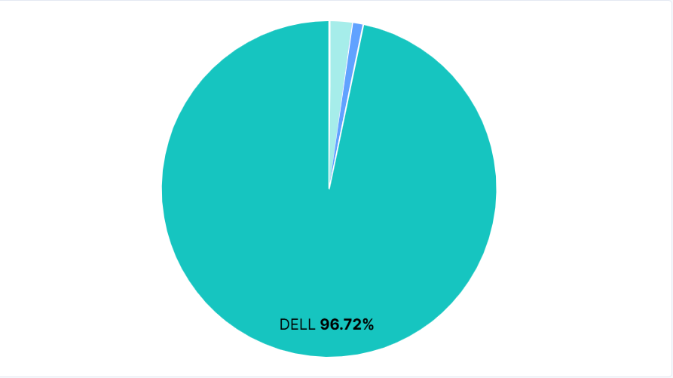

• Data table showing raw logs
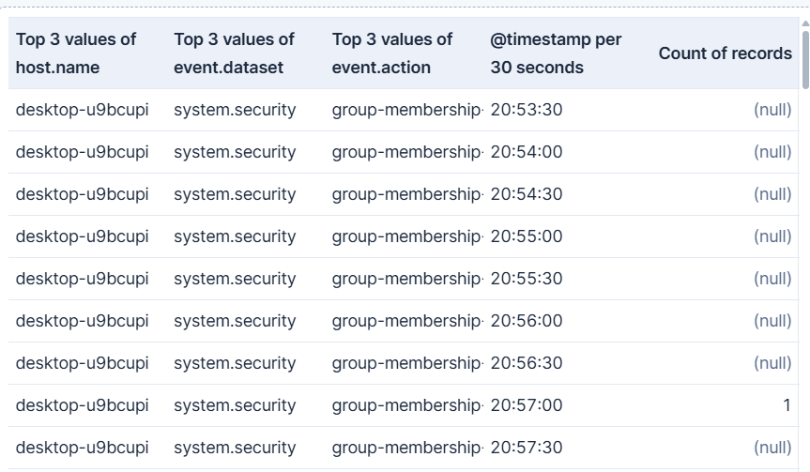

2. Splunk SIEM Configuration

2.1 Overview
This section details Splunk's configuration for analyzing the same SOC_Task2 log dataset. Using Splunk Free Trial / Splunk Enterprise, the logs were indexed, searched, and visualized to simulate real SOC alert analysis.

2.2 Splunk Login & Setup
Splunk Web was accessed via the browser, and an admin account was created to configure inputs, indexes, and dashboards.
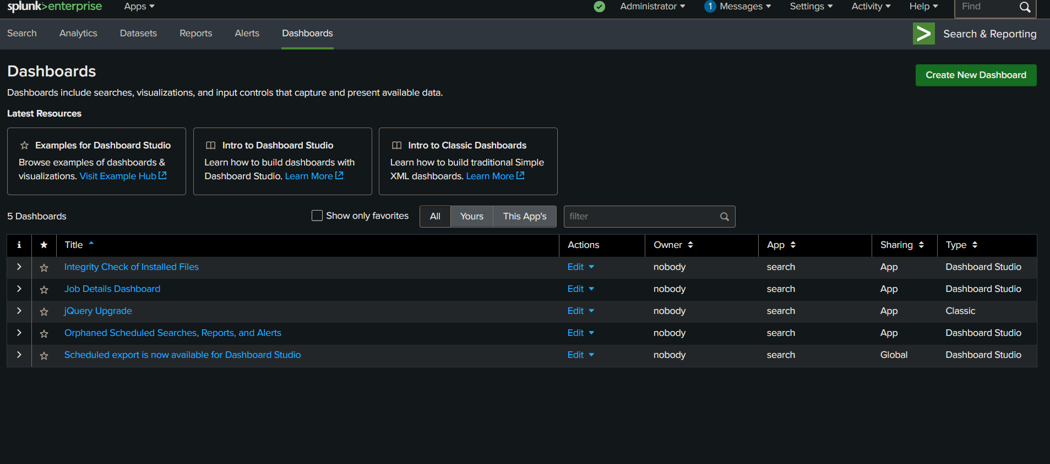

2.3 Creating an Index for SOC Logs
A new index was created to store the SOC_Task2 logs. Example index name: soc_task2 [PLACEHOLDER: Screenshot: Splunk Index Creation Page]

2.4 Uploading Log Files to Splunk
The SOC_Task2 sample logs were uploaded in Splunk using: Settings → Add Data → Upload Files The logs were assigned to the newly created index. [PLACEHOLDER: Screenshot: Splunk Add Data Wizard]
2.5 Searching Logs in Splunk Search Head
Splunk Search Processing Language (SPL) was used to analyze events, detect anomalies, and identify suspicious patterns such as failed logins and malware alerts. Example SPL queries:
1. Search all events: index="soc_task2"
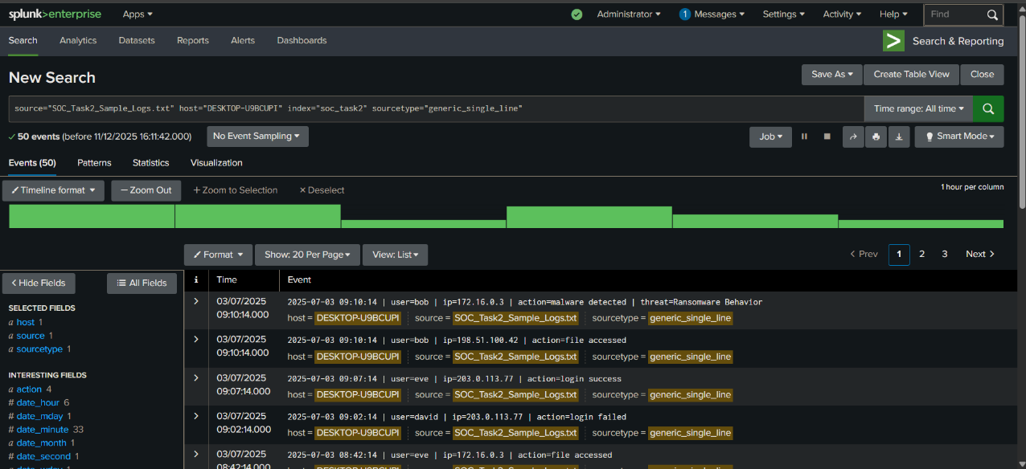

2. Filter malware detections: index="soc_task2" "malware detected"
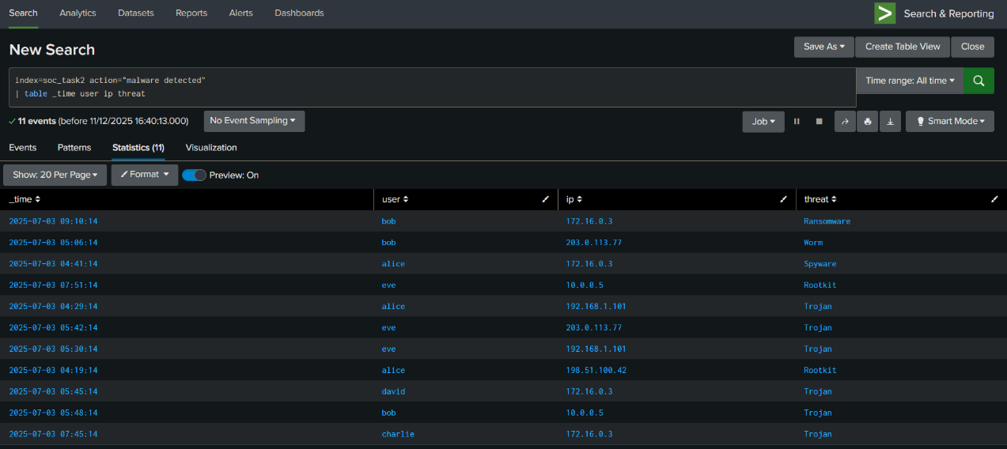

3. Count events by user: index="soc_task2" | stats count by user

