Assignment : Deploying a Live Website on AWS Cloud Using EC2 or S3

Name : Akshita Dhaka
Reg No: 12314208
Roll NO: 38
Name of Project : To-Do List Web App
Live URL : http://todoapp-akshita-20260519.s3-website.ap-south-1.amazonaws.com
GitHUB Repo link : https://github.com/Akshita42/Devops-Assignment/tree/main

Project Description
This is a fully functional, interactive To-Do List web application deployed on AWS S3.Features include adding tasks, marking complete/incomplete, deleting tasks, editing (double-click), filtering (All/Active/Completed), clearing completed tasks, and persistent local storage.

Deployment Summary with Screenshots

AWS Service Used: Amazon S3 (Free Tier)
Total Cost: $0.00

1 | Created S3 bucket: todoapp-akshita-20260519 (Mumbai region)
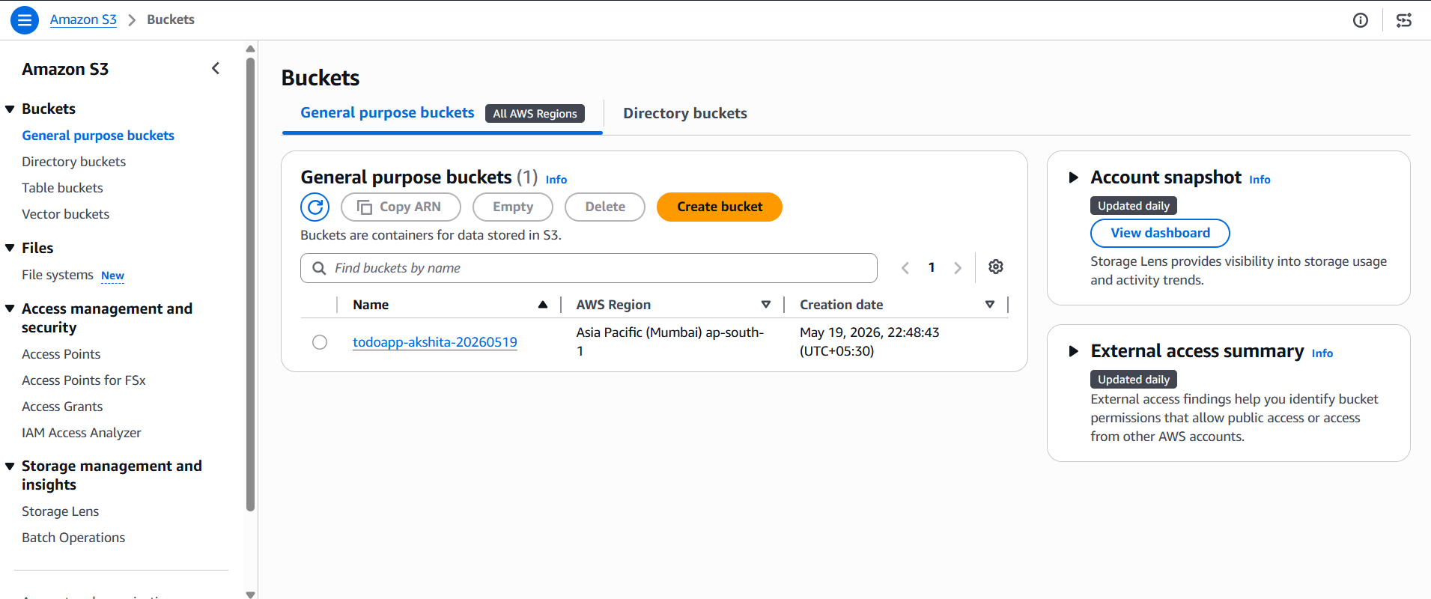

2 . Enabled Static Website Hosting with index.html 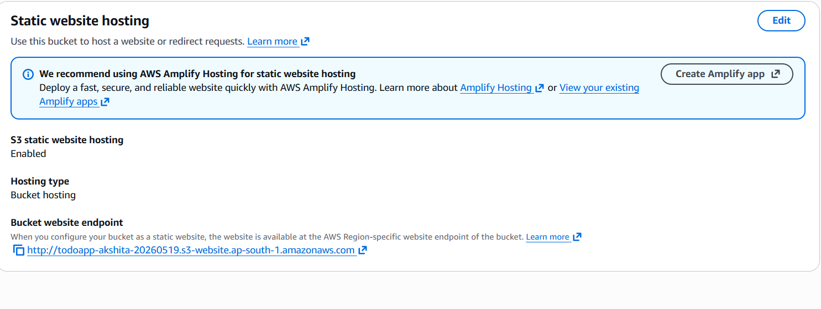

3 . Configured Bucket Policy for public read access
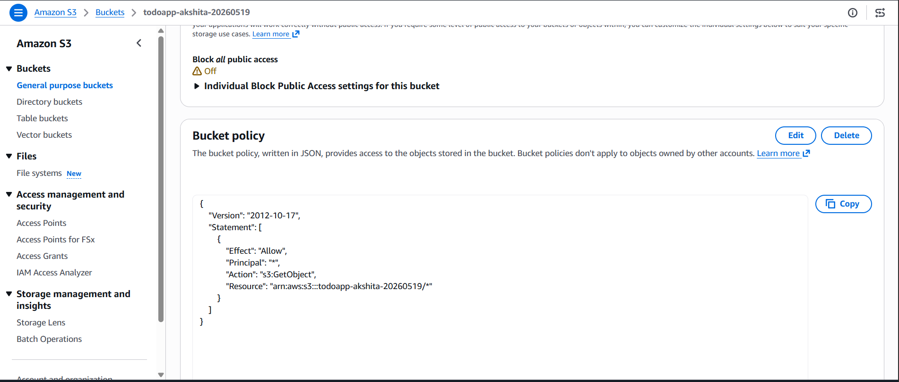

4 | Uploaded index.html (21.4 KB)
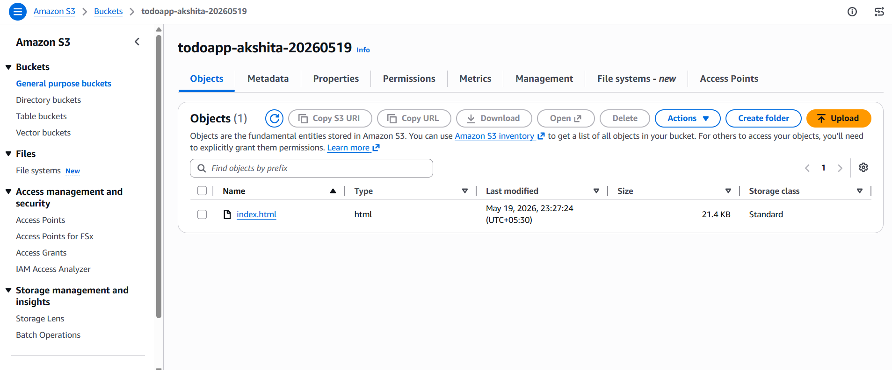

5 | Verified live website at endpoint URL
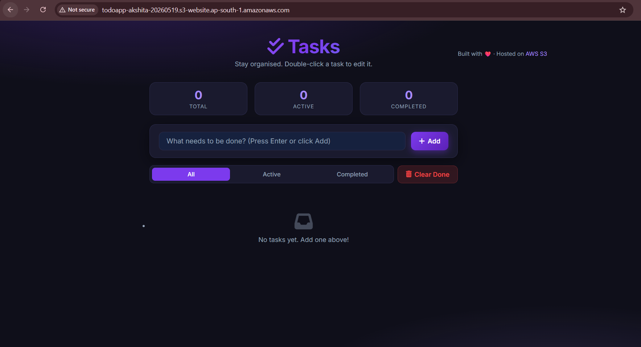

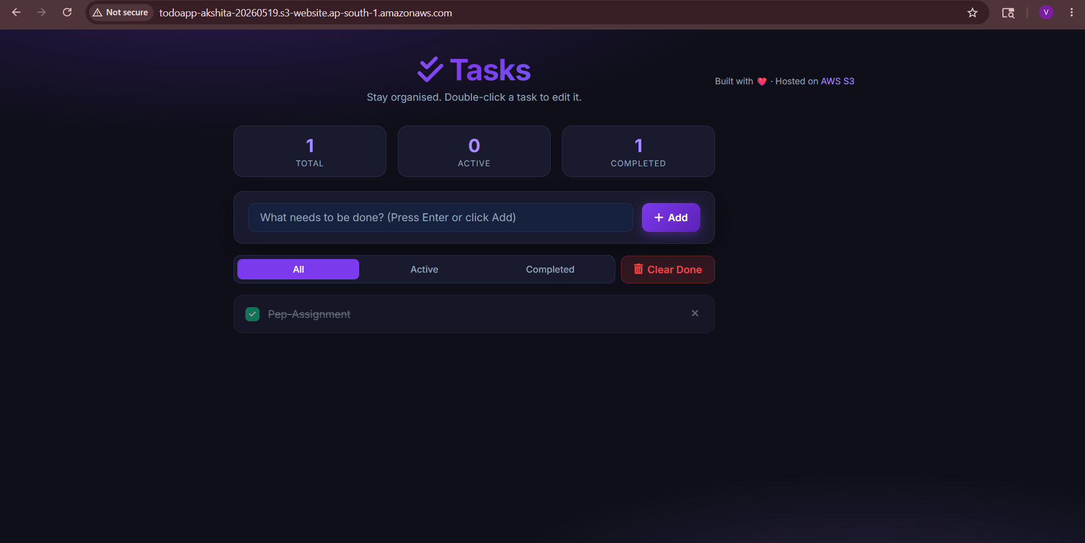
The website shows 'Not Secure' because S3 static hosting uses HTTP by default

