**LMI Editor**

we want to implement the following LMIs by the LMI Editor

https://fr.mathworks.com/help/examples/robust/win64/SpecifyLMISystemExample_06.png



https://fr.mathworks.com/help/examples/robust/win64/SpecifyLMISystemExample_08.png

Step by step

1. Write (lmiedit ) in the Matalb command window

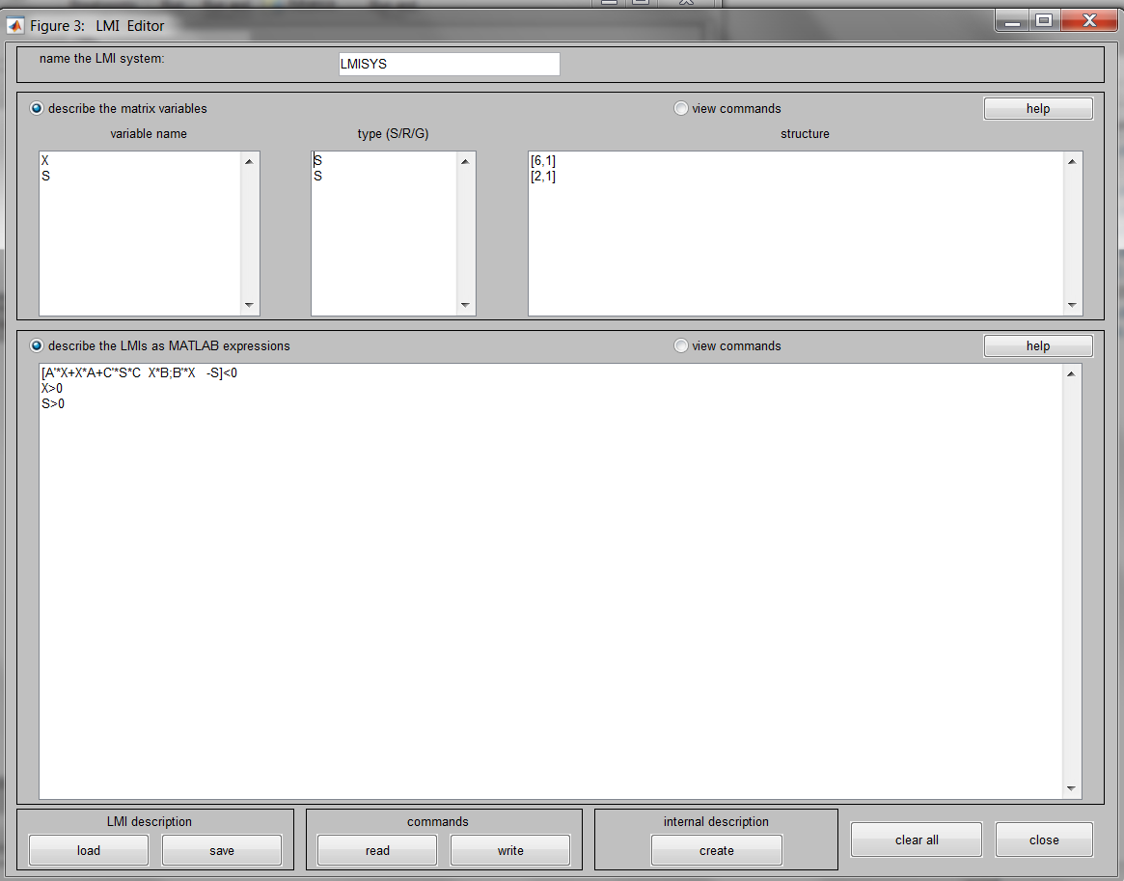2. Define the variables Q, R and S in the variable name window and write the LMIs equations in the describe the LMIs as MATLAB expression window as the following

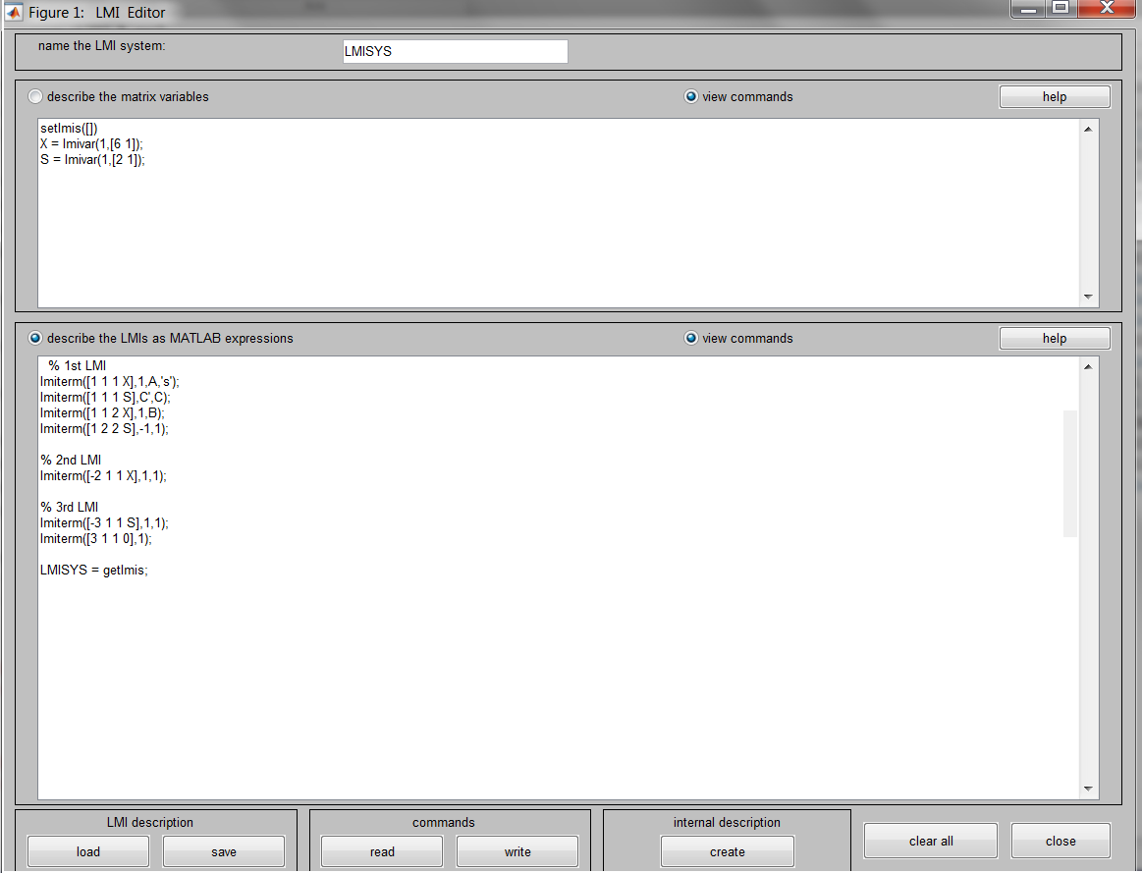3. Push the view commands to generate the matlab code

4. open new script and take copy from the editor and past it in the and write the following commands to compute the unknown variables

([TMIN,TFEAS]=feasp(LMISYS);

X=dec2mat(LMISYS,TFEAS,X)

S=dec2mat(LMISYS,TFEAS,S)

)

setlmis([])

X = lmivar(1,[6 1]);

S = lmivar(1,[2 1]);

% 1st LMI

lmiterm([1 1 1 X],1,A,'s');

lmiterm([1 1 1 S],C',C);

lmiterm([1 1 2 X],1,B);

lmiterm([1 2 2 S],-1,1);

% 2nd LMI

lmiterm([-2 1 1 X],1,1);

% 3rd LMI

lmiterm([-3 1 1 S],1,1);

lmiterm([3 1 1 0],1);

LMISYS = getlmis;

[TMIN,TFEAS]=feasp(LMISYS);

X=dec2mat(LMISYS,TFEAS,X)

S=dec2mat(LMISYS,TFEAS,S)