**PROJECT REPORT**

on

**EXPLORING INDIA’S CULTURE AND HERITAGE: TEXTILES OF INDIA**

Submitted in partial fulfillment of the requirements for the award of the degree of

**BACHELOR OF TECHNOLOGY**

in

**CSE (Artificial Intelligence & Machine Learning)**

Submitted by

**M. Sai Akshita 23UP1A6686**

**N. Greeshma 23UP1A6688**

**P. Shivani 23UP1A6694**

**M. Uma Maheshwari 24UP5A6609**

**Under the Guidance of**

**Mrs. A. Srilatha, M. Tech,(Ph.D)**

Assistant Professor



**DEPARTMENT OF CSE (ARTIFICIAL INTELLIGENCE & MACHINE LEARNING)**

**VIGNAN’S INSTITUTE OF MANAGEMENT AND TECHNOLOGY FOR WOMEN**

Accredited to NBA NAAC A+(CSE&ECE)

(An Autonomous Institution) Approved by AICTE and Affiliated to JNTUH

Kondapur (Village), Ghatkesar (Mandal), Medchal (Dist.), Telangana, Pincode-501301

[www.vmtw.edu.in](http://www.vmtw.edu.in/)

2024-2025



**DEPARTMENT OF CSE(AI&ML) CERTIFICATE**

This is to certify that project work entitled “**TEXTILES OF INDIA**” submitted by **M. Sai Akshita (23UP1A6686), N. Greeshma(23UP1A6688), P. Shivani (23UP1A6694), M. Uma Maheshwari (24UP5A6609)** in the partial fulfilment of the requirements for the award of the degree of Bachelor of Technology in CSE(AI&ML) **VIGNAN’S INSTITUTE OF MANAGEMENT AND TECHNOLOGY FOR WOMEN** is a record of Bonafide work carried by them under my guidance and supervision. The results embodied in this project report have not been submitted to any other University or institute for the award of any degree.

|  |  |  |
| --- | --- | --- |
| **PROJECT GUIDE**  **Mrs. A. Srilatha, M.Tech,(Ph.D)**  Assistance Professor | **PROJECT COORDINATOR**  **Mrs. D. Geetha ,M.Tech,(Ph.D.)**  Assistance professor | **HEAD OFDEPARTMENT**  **Dr. D. Shanti, Ph.D**  Professor |
|  |  |  |

**EXTERNAL EXAMINAR**



**DEPARTMENT OF CSE(AI&ML)**

**DECLARATION**

We here by declare that the work reported in the present project entitled “**EXPLORING INDIA’S CULTURE AND HERITAGE: TEXTILES OF INDIA**” is a record of Bonafide work duly completed by us in the Department of CSE (AI&ML) from Vignan’s Institute of Management and Technology for Women, affiliated to JNTU, Hyderabad. The reports are based on the project work done entirely by us and not copied from any other source. All such materials that have been obtained from other sources have been duly acknowledged.

The result embodied in this project report have not been submitted to any other University or Institute for the award of any degree to the best of our knowledge and belief.

|  |  |  |  |  |
| --- | --- | --- | --- | --- |
| **S.no** | **Roll Number** | **Student Name** |  | **Signature of the Student** |
| 1. | 23UP1A6686 | M. Sai Akshita |  |  |
| 2. | 23UP1A6688 | N. Greeshma |  |  |
| 3. | 23UP1A6694 | P. Shivani |  |  |
| 4. | 24UP5A6609 | M. Uma Maheshwari |  |  |

**ACKOWLEDGEMENT**

We would like to express our sincere gratitude and indebtedness to our project guide **Mrs. A. Srilatha, M.Tech,(Ph.D)** Assistant Professor, Department of CSE-Artificial Intelligence and Machine Learning from Vignan’s Institute of Management and Technology for women, for his valuable suggestions and interest throughout the course of this project. We would like to extend our gratitude to **Mrs. D. Geetha, M.Tech,(Ph.D)** Project Coordinator, Department of CSE- Artificial Intelligence and Machine Learning from Vignan's Institute of Management and Technology for Women, for his valuable suggestions and timely help while the project.

We are also thankful to **Dr. D. Shanthi,Ph.D** Head of the Department of CSE- Artificial Intelligence and Machine Learning from Vignan's Institute of Management and Technology for Women, Hyderabad for providing excellent infrastructure and a nice atmosphere for completing this project successfully as a part of our B.Tech. Degree (CSE-AI&ML).

We convey our heartfelt thanks to the lab staff for allowing us to use the required equipment whenever needed.

Finally, we would like to take this opportunity to thank our family for their support through the work. We sincerely acknowledge and thank all those who gave directly or indirectly their support in the completion of this work.

**M. Sai Akshita 23UP1A6686**

**N. Greeshma 23UP1A6688**

**P. Shivani 23UP1A6694 M. Uma Maheshwari 24UP5A6609**

**ABSTRACT**

India, a nation with thousands of years of cultural history, is home to a remarkable diversity of traditional textiles that have been passed down through generations. These textiles are not merely pieces of fabric but symbols of local identity, ritual significance, artistic expression, and socioeconomic activity. This project titled "Textiles of India" is a web-based application designed to serve as a digital encyclopedia of the country’s textile heritage. The platform features an interactive map of India where each state is clickable and reveals a popup showcasing a traditional textile, accompanied by images and a concise summary. Users can then access in-depth content on each textile, including its history, production techniques, cultural relevance, and visual documentation. The project aims to merge technology with tradition, creating an engaging educational tool that helps preserve and propagate India’s textile legacy

**LIST OF FIGURES**

|  |  |  |
| --- | --- | --- |
| **S.No** | **FIGURE NAME** | **PAGE NO** |
| 1 | System Architecture | 12 |
| 2 | Use case diagram | 15 |
| 3 | Class diagram | 17 |
| 4 | Sequence Diagram | 19 |
| 5 | Activity Diagram | 20 |
| 6 | Deployment Diagram | 21 |

## TABLE OF CONTENTS

|  |  |
| --- | --- |
| **CONTENTS** | **PAGE.NO** |
| **ABSTRACT**  **LIST OF FIGURES**   1. **INTRODUCTION**    1. Problem Statement    2. Objective    3. Motivation    4. Existing System    5. Proposed System    6. Scope and Purpose | V  Vi  2  2  2  3  5  6 |
| **2. LITERATURE REVIEW** | 8 |
| 1. **SYSTEM REQUIREMENTS AND SPECIFICATIONS**    1. Software Requirements    2. Hardware Requirements | 10  10 |
| 1. **SYSTEM DESIGN**    1. System Architecture    2. UML Diagrams       1. Use Case Diagram       2. Class Diagram       3. Sequence Diagram       4. Activity Diagram       5. Deployment Diagram | 12  14  16  18  20  21 |
| 1. **IMPLEMETATION**    1. Module split-up    2. Technologies used | 23 |
| **6. RESULTS** | 24 |

|  |  |
| --- | --- |
| 1. **TESTING** 2. **CONCLUSION**   **FUTURE ENCHANCEMENT**  **REFERENCES**  **SAMPLE CODE**  **DATA SET** | 28  29 |

**CHAPTER-1**

**1.Introduction**

India is a land of diverse cultures, languages, and traditions, and this diversity is beautifully reflected in its rich and vibrant textile heritage. Indian textiles are more than just fabrics; they are woven expressions of the country’s cultural identity, historical continuity, and artistic excellence. The textile tradition of India dates back thousands of years and has evolved with time, adapting to various influences while preserving its core essence. From the intricate weaves of Banarasi silk in Varanasi to the vivid block prints of Rajasthan and the elegant handlooms of Tamil Nadu, each region of India boasts a unique textile art form shaped by its local customs, climate, and socio-economic factors.

These textiles are deeply embedded in the social and cultural fabric of the country. In everyday life as well as in festive occasions, rituals, and ceremonies, textiles play an essential role. They symbolize community identity, status, and religious beliefs, making them not just functional products but carriers of intangible heritage. Every thread, motif, and dye speaks volumes about the people who make and wear them, offering a rich tapestry of stories passed down through generations.

However, despite their immense cultural and historical value, traditional Indian textiles face several challenges in the modern era. The rapid pace of globalization and industrialization has led to a shift in consumer preferences towards mass-produced, machine-made clothing. The emergence of fast fashion, with its focus on low-cost and high-volume production, has posed a serious threat to the survival of handmade textiles. Many indigenous weaving communities are struggling to sustain their livelihoods, and numerous traditional techniques are at risk of fading into obscurity.

Amidst these challenges, there are also inspiring stories of resilience and revival. Numerous artisans, designers, and cultural organizations are working tirelessly to safeguard India’s textile heritage. Through innovative design, digital platforms, and sustainable practices, they are bridging the gap between tradition and modernity, and ensuring that these timeless crafts continue to thrive.

This project seeks to explore and showcase the depth and beauty of Indian textiles by highlighting their cultural importance, historical journey, and the ongoing efforts for their preservation. By doing so, it aims to raise awareness, celebrate craftsmanship, and contribute to the protection of India’s extraordinary textile legacy.

* 1. **Problem Statement**

Aiming to explore and document India’s diverse textile heritage, highlighting its cultural significance and challenges of preservation. India’s textile heritage is declining due to modernization and lack of awareness. A digital platform is needed to promote, educate, and support artisans.

**Objective**

This project aims to explore and document the diverse textile traditions of India, emphasizing their cultural, historical, and regional significance. It highlights how traditional textiles reflect the identity and heritage of each Indian state. A core objective is to develop an interactive digital platform that allows users to visually engage with India’s textile diversity through a clickable map, popups, and detailed pages.

The project focuses on:

* Showcasing textile traditions from all Indian states.
* Educating users about their cultural and historical importance.
* Raising awareness about the decline of traditional crafts due to modernization and fast fashion.

Finally, it promotes sustainable and conscious fashion by emphasizing the importance of:

* Handwoven, eco-friendly textiles as alternatives to fast fashion.
* Supporting local artisans as part of ethical consumer behaviour

Preserving traditionalcrafts for future generations through awareness and education.

* 1. **Motivation**

India’s textile heritage is a rich reflection of its culture and craftsmanship, yet it faces neglect in today’s fast-paced, modern world. With industrialization and changing fashion trends, many traditional techniques and artisan communities are fading into obscurity. This project is driven by the need to preserve this valuable legacy and reconnect people—especially the younger generation—with the stories, skills, and cultural depth woven into Indian textiles.

The digital era presents a powerful opportunity to revive and promote India’s textile heritage. By using a web-based platform, this project aims to:

* Create awareness about the richness of Indian textiles in an engaging and interactive way.
* Promote cultural pride and appreciation among users.
* Support and uplift artisans by giving visibility to their work.
* Encourage sustainable fashion through knowledge and appreciation of handmade textiles.

The motivation lies in making a positive social impact—preserving cultural identity, supporting artisan livelihoods, and inspiring future generations to value and protect India’s textile traditions.

* 1. **Existing Systems**

Currently, there are several platforms and initiatives aimed at promoting and preserving India’s textile heritage, but many face limitations in terms of accessibility, user engagement, and comprehensive documentation. Existing systems primarily focus on specific regions or textiles, and while they offer valuable information, they often lack an interactive and unified approach that can provide a holistic view of India’s textile diversity.

Some notable platforms include:

**1.Khadi and Village Industries Commission (KVIC)**

Promotes Khadi, a symbol of India’s freedom struggle and cultural pride, but its efforts are largely centered around promotion and sales rather than detailed education or a comprehensive digital approach.

**Key Features**

* **Promotion of Khadi:** Focuses on promoting Khadi as a symbol of India's heritage and independence**.**
* **Artisan Support:** Provides employment and income opportunities for rural artisans, particularly through the Khadi movement.
* **Government Initiative:** Supported by the government to foster rural development and promote traditional handloom products.

**Limitations**

* **Limited Digital Presence:** The focus is more on promotion and sales rather than an interactive or educational platform.
* **ack of Comprehensive Regional Coverage:** Focuses mainly on Khadi, neglecting other important regional handloom traditions.

1. **Handloom House**

A marketplace for handloom products, showcasing a variety of handwoven textiles, but it lacks an interactive, state-wise exploration of the rich textile heritage that India offers.

**Key Features**

* **Marketplace for Handloom Products:** Acts as a marketplace for handwoven textiles, offering a variety of products from across India.
* **Support for Artisans**: Aims to provide a platform for artisans to showcase and sell their handloom products.

**Limitations**

* **No Interactive Features:** Lacks interactivity or an engaging, user-friendly design to explore the diverse handloom heritage across India.
* **Narrow Focus**: Primarily focuses on marketing rather than providing an immersive experience or supporting artisans beyond sales.

1. **Crafts Council of India**

Focuses on the preservation and promotion of Indian crafts, including textiles, but is not entirely digital or interactive.

**Key Features**

* **Preservation and Promotion:** Focuses on the preservation and promotion of traditional Indian crafts, including textiles.
* **Educational Resources**: Offers resources to understand and appreciate Indian crafts, including exhibitions and workshops.

**Limitations**

* **Fragmented Information:** Primarily focused on specific crafts, with limited integration across different regional textile traditions.
* **Geographical Limitations**: While it serves artisans across India, its reach may not be as extensive for the global audience.

**1.5 Proposed System**

The project is a web-based interactive platform designed to explore the rich textile heritage of all 29 Indian states. The home page features an interactive map of India. When users hover over a state, a popup appears showing: A representative textile image and A brief overview of the textile’s name and cultural importance. Clicking on a state redirects users to a dedicated page with: images of textiles and detailed description of the textiles. Each detailed page provides a smooth user experience with a "Back to Map" button at the bottom, allowing: Easy return to the interactive map and Seamless navigation to explore other states. The system ensures an educational, engaging, and visually rich journey through India’s textile traditions.

**Algorithm Used**

**State-Based Interactive Navigation Algorithm**

Step 1: Start

Step 2: Define Scope

* **Title**: Textiles of India
* **Objective**: To build an interactive website that highlights traditional textiles from each Indian state.

Step 3: Data Collection

For all 29 Indian states, collect comprehensive textile information, including:

* Name of textile
* Associated state
* Technique and materials used
* Cultural and historical significance
* GI (Geographical Indication) tag details
* Visual media (images)

Step 4: Design Map-Based Interface

* **Homepage**: An interactive map of India allows users to explore textiles by state.
* **On Hover**: Displays a brief textile name and image.
* **On Click**: Redirects users to a detailed page dedicated to the selected state.

Step 5: Textile Detail Pages

Each state-specific page includes:

* Textile name, origin, history, techniques used
* Cultural relevance, involved communities, and festival associations
* High-quality visuals to enhance user engagement
* **Navigation**: Option to return to the main map view

Step 6: Implementation

* **Frontend**: Developed using HTML, CSS, JavaScript
* **Data**: Textiles information sourced from a database
* **Features**: Search bar, filtering by region or fabric type, and mobile-responsive layout.

Step 7: Testing & Deployment

* Perform rigorous testing of interactive elements and responsive layouts
* Deploy the final website on GitHub Pages or a similar hosting platform

Step 8: End

* Completion of project development and deployment for public access

**1.6 Scope and Purpose:**

**Scope:**

The scope of this project is to conceptualize, design, and implement an interactive web-based platform dedicated to showcasing the rich textile heritage of India, covering all 29 states. Each state in India possesses a unique identity reflected in its traditional fabrics, weaving techniques, dyeing styles, motifs, and cultural symbolism. The platform aims to bridge these regional diversities into one unified digital space through a visually engaging, map-based interface.

Users can interact with an India map where each state, when hovered over or clicked, reveals a preview of its famous textile(s), such as Banarasi silk from Uttar Pradesh, Kanchivaram from Tamil Nadu, or Bandhani from Gujarat. Clicking "View More" redirects users to a detailed page that includes:

* **Students and researchers** exploring India’s cultural and textile history, offering a detailed study of traditional methods and their evolution over time.
* **Artisans and designers** seeking traditional inspiration, providing insights into age-old techniques and their relevance to contemporary fashion and design.
* **Tourists and culture enthusiasts** interested in regional crafts, offering a deeper understanding of India’s rich textile heritage.
* **Educators and institutions** promoting heritage studies, serving as a valuable resource for teaching about the importance of cultural preservation and sustainable fashion practices.

**Purpose:**

The purpose of this project is to address the growing concern around the decline and neglect of traditional Indian textiles. Despite being a cornerstone of India’s cultural and economic history, many textile forms and the communities that create them are struggling to survive in the

modern age. Factors such as industrialization, urbanization, fast fashion, and lack of awareness among the younger generation are contributing to the loss of these time-honoured crafts.

This project serves a multi-fold purpose:

* **Preservation:** Digitally document endangered and lesser-known textiles, safeguarding them for future generations.
* **Promotion:** Showcase the beauty and depth of Indian fabrics to a global audience through a modern, accessible platform.
* **Education**: Inform users about the artistic and cultural significance of textiles through visual storytelling and factual content.
* **Support**: Indirectly support weavers and artisans by increasing public appreciation, which can lead to interest in purchasing or promoting handmade textiles.
* **Cultural Pride**: Encourage Indian youth and diaspora to reconnect with and take pride in the country’s textile heritage.

In essence, the platform aspires to become a digital museum and learning hub that celebrates the diversity, artistry, and legacy of Indian textiles, while also acting as a call to action to protect and promote these crafts in a modern context.

**CHAPTER-2**

**LITERATURE SURVEY**

The exploration of Indian textiles unveils a vibrant blend of culture, craftsmanship, and regional uniqueness. Dr. Mamatha Hegde, in her work under the University Grants Commission, emphasizes the immense diversity of textiles across India, highlighting renowned styles such as Banarasi from Uttar Pradesh, Kanchipuram from Tamil Nadu, Pashmina from Jammu & Kashmir, and Chanderi from Madhya Pradesh. Her research portrays these textiles as more than mere fabric; they are cultural artifacts that reflect the traditions, aesthetics, and lifestyles of various communities. These textiles play a pivotal role in rituals, ceremonies, and daily life, symbolizing regional pride and heritage.

Further enriching this discourse, the comparative study by Rithika Sharma and Janki Srivatsava, published by the Multidisciplinary Digital Publishing Institute (MDPI), delves into the contrast between handloom and powerloom textiles. Their research outlines how handlooms represent authenticity, sustainability, and artistic craftsmanship, whereas powerlooms support large-scale production and cost-efficiency. This dichotomy highlights a major challenge: preserving the rich heritage of traditional handlooms while embracing modern technological advancements to meet contemporary demands.

In addition, Mehta R.'s study on sustainable textiles in India addresses the environmental impacts of textile manufacturing. The study focuses on the adoption of eco-friendly practices such as the use of organic dyes, natural fibers, and sustainable production techniques. It emphasizes the importance of environmentally responsible innovation that preserves traditional textile arts while minimizing ecological harm.

From a historical standpoint, Parul Bhatnagar’s academic research offers insights into the origins and evolution of Indian textile traditions. Her work traces the journey of textile-making from ancient practices to a modern industry, shedding light on how traditional weaving techniques have been passed down and transformed across generations without losing their cultural essence. It reveals the deep-rooted craftsmanship embedded in Indian society and its adaptation to changing times.

Lastly, the study by Paramasivan C. and Ravichandiran G., published on ResearchGate, explores the institutional support provided by the government and non-governmental organizations (NGOs). Their work highlights key policy initiatives, financial subsidies, and promotional schemes aimed at revitalizing the handloom sector, empowering artisans, and fostering rural employment. These efforts are crucial in sustaining indigenous textile practices while enhancing socio-economic development in artisan communities.

**CHAPTER-3**

**SYSTEM REQUIREMENTS SPECIFICATIONS**

**a. Software Requirements:**

**1.Frontend**

* **HTML:** Used to structure the map of India, the textile information popups, and the pages for each state’s textile details. It defines the layout for the interactive elements, such as clickable states and the 'View More' button.
* **CSS:** Ensures that the web interface is visually appealing by styling the map, popups, and detailed pages. It manages the layout, color schemes, and responsiveness to make the project accessible across different devices and screen sizes.
* **JavaScript:** Implements the interactivity for the project. It handles the logic for showing the state-specific textile popups when a user hovers over or clicks a state. JavaScript is also used to manage dynamic content loading for the detailed pages and to enable smooth transitions, such as returning to the map view after clicking 'Back to Map.'

**2.Backend:**

* **Node.js**: Handles server-side operations using Node.js, dynamically serving map, state, and textile data. It fetches info from the database and supports real-time user interactions like 'State’ clicks.

**3.Database:**

* **MySQL:** Stores structured textile data—state names, descriptions, images, techniques, and history. When a state is selected, Node.js queries MySQL to fetch and deliver the relevant data to the frontend for display.

**b. Hardware Requirements:**

**1. Processor:** Intel i5/i7 or AMD Ryzen 5/7 – These processors offer strong multi-core performance, ensuring smooth execution of web-based applications and handling server-side tasks efficiently.

**2. RAM:** 8GB – Sufficient memory to support the smooth running of the project, especially when handling multiple processes like the server, database queries, and user interactions.

**3. Storage:** SSD 256GB – A solid-state drive (SSD) with 256GB of storage provides fast data access and loading speeds, which is essential for handling the database and ensuring a responsive user experience.

**CHAPTER-4**

**SYSTEM DESIGN**

**4.1 SYSTEM ARCHITECHTURE**

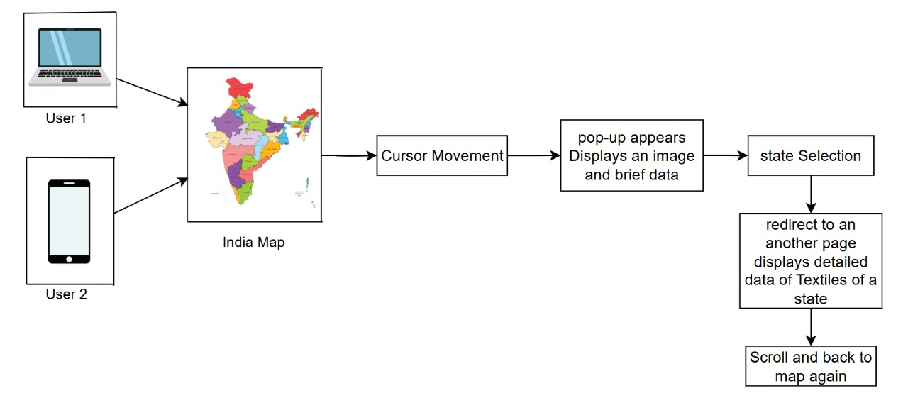

Fig 4.1: Architecture

This system architecture consists of multiple interconnected components, each with a specific role to provide functionality, scalability, and efficiency. Below is a detailed explanation of its key elements:

**1.User Devices**

* User 1 (Laptop/Desktop)
* User 2 (Mobile Device/Tablet)

Both types of users can access the web application via their browser. The UI is built to be At the heart of the application is a clickable map of India. Each state on the map is:

Individually responsive, ensuring compatibility with various screen sizes and input methods (mouse, touch, etc.).

**2.** **India Map Interface**

* interactive
* Styled with hover or touch highlights
* Tagged with metadata representing the textile traditions of that region

This interface serves as the **entry point to textile exploration**.

**3.Cursor Movement**

Hovering the cursor over a state triggers an event (displays a popup). This interaction is used to signal the user's interest in a particular region without navigating away from the map.

1. **Popup Display**

When a state is hovered over or tapped: A popup appears near the selected state. This popup includes:

* A thumbnail image representing the traditional textile
* A short description summarizing the textile’s name, origin, or uniqueness

This helps users quickly preview what each state is known for without committing to a page change.

1. **State Selection**

If the user finds the popup information interesting, they can:

* Click the state.
* This selection acts as a trigger to redirect the user to a more detailed information page about the selected state.

1. **Redirect to Detailed Page**

Upon selecting a state, the is taken to a **dedicated page** that offers in-depth insights. This page includes:

* High-resolution images of the textile(s)
* Weaving methods and tools used
* Artisans or regions involved in production
* Cultural and social significance

The page is structured to be scrollable, ensuring all content is easily viewable in a natural reading flow.

1. **Scroll and Navigation Back to Map**

Once the user has explored the detailed content:

* A “Back to Map” or Home button is provided.
* This allows users to return to the interactive map without restarting the session.
* It supports multi-state exploration, encouraging users to browse multiple textile traditions in one sitting.

**4.2 UML DIAGRAMS**

UML (Unified Modelling Language) is a standardized, general-purpose modelling language primarily used in object-oriented software engineering. Managed by the Object Management Group (OMG), UML was created with the aim of providing a universal language for designing and modelling object-oriented software systems. It facilitates effective communication of complex system designs, helping bridge the understanding gap between developers, stakeholders, and other participants in the development process.

At its core, UML is composed of two essential components: a meta-model and a notation. The meta-model defines the abstract concepts, rules, and relationships that form the basis of the language, while the notation consists of the graphical symbols and diagrams used to visually represent these concepts. These visual representations make it easier to communicate complex ideas, whether for system design or behaviour.

Though UML's primary application has been in software systems, its use is expanding beyond just coding practices. It is being adapted for business modelling, as well as for non-software systems, showcasing its versatility in various domains. The adaptability of UML enables developers to

model and represent large, intricate systems, allowing them to communicate, document, and design with greater efficiency and clarity.

UML plays a crucial role in software development, streamlining the specification, visualization, construction, and documentation processes. It improves collaboration and understanding across diverse teams involved in a project, making it an invaluable tool in the software development lifecycle. Furthermore, UML helps in reducing miscommunication, ensuring that every stakeholder has a clear understanding of the system’s design and behaviour.

In summary, UML is an essential tool in object-oriented software development, offering a set of graphical notations for expressing system designs and behaviours. Its ability to improve communication and collaboration across teams contributes to the success of complex software projects, making it indispensable for modern software engineering.

**4.2.1 USE CASE DIAGRAM**

A Use Case Diagram in the Unified Modeling Language (UML) is a type of behavioral diagram used to provide a graphical overview of a system's functionality. It illustrates the interactions between actors (users or external systems) and the use cases (goals or functions) that the system provides. The primary purpose of a use case diagram is to depict the system's intended behaviour by showing how users interact with various features, as well as the relationships and dependencies between those use cases. It is created through use-case analysis and serves as a foundational tool in the system design process.

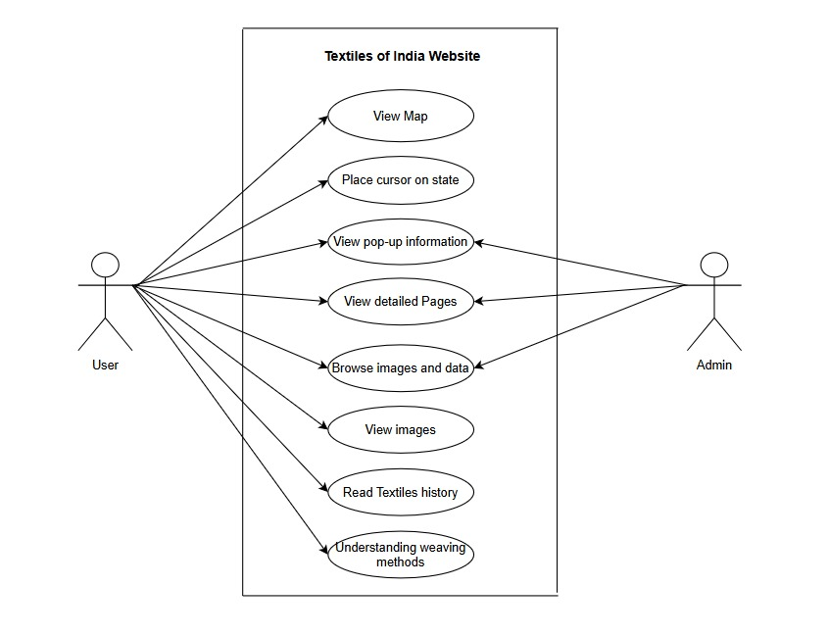

Fig 4.2.1 Use Case Diagram

The Use Case Diagram shown above presents a high-level overview of the interactions between users and the Textiles of India web application. It identifies the primary actors (User and Admin) and the various actions (use cases) they can perform on the system.

**User Use Cases:**

1. **View Map**

* The user opens the homepage, where a clickable, color-coded map of India is displayed.
* This is the entry point for exploring textile information by region.

1. **Place Cursor on State**

* The user moves their cursor (or taps on mobile) over a particular state to trigger interaction.
* This action prepares the interface to show a pop-up.

1. **View Pop-up Information**

* A small window appears showing a brief summary and an image of the state’s traditional textile(s).
* Helps the user decide whether to explore further.

1. **View Detailed Pages**: Clicking on a state redirects the user to a new page containing in-depth details, such as:

* Historical background
* Cultural significance
* Special weaving methods

**5.Browse Images and Data:** Allows users to scroll through curated data, such as:

* Types of textiles
* Regions where they are made
* GI tags

**6. View Images:** Users can visually explore various textile patterns, garments, raw materials, and tools through high-quality images.

**7. Read Textiles History**

* Offers the historical evolution of the textile from ancient times to the present.
* Supports academic and cultural learning.

1. **Understanding Weaving Methods**

* Users can access technical explanations of traditional weaving methods, sometimes with diagrams or video support.
* Appeals to enthusiasts, students, and researchers.

**Admin Use Cases:**

1. **View Pop-up Information**: Used to verify if the correct summary and images appear when a user interacts with the map.
2. **View Detailed Pages:** Admins access these pages to:

* Check formatting and correctness
* Update out-of-date info
* Ensure consistency across states

1. **Browse Images and Data**

* Admin can monitor the quality and relevance of images and textile data.
  + 1. **CLASS DIAGRAM:**

In software engineering, a class diagram in the Unified Modeling Language (UML) is a type of static structure diagram that describes the structure of a system by showing the system's classes, their attributes, operations (or methods), and the relationships among engineering, a class diagram in

the Unified Modeling Language (UML) is a type of static structure diagram that describes the structure of a system by showing the system's classes, their attributes, operations (or e classes. It explains which class engineering, a class diagram in the Unified Modeling Language (UML) is a type of static structure diagram that describes the structure of a system by showing the system's classes, their attributes, operations (or methods), and the relationships among the classes. It explains which class contains which information.

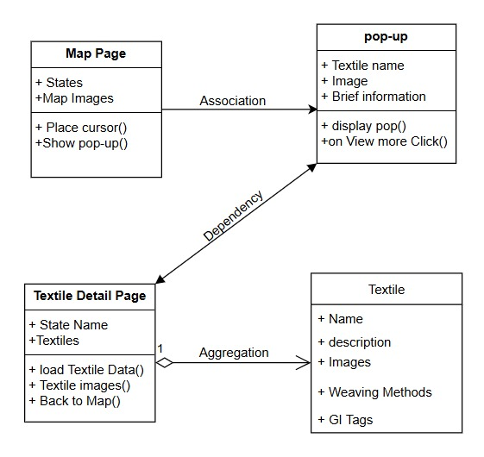

Fig 4.2.2: Class Diagram

This class diagram illustrates the structural design of the "Textiles of India" web application. It defines four main classes—Map Page, Pop-up, Textile DetailPage, and Textile—along with their attributes, methods, and relationships.

1. **Map Page Class**
2. **Attributes:**

* **States:** Represents the list of states on the map.
* **Map Images:** Stores the visual representation of the India map.

1. **Methods:**

* **placeCursor():** Detects user interaction such as cursor movement or tap on a state.
* **showPopUp():** Displays a pop-up window with brief information when a state is selected.

1. **Pop-up Class**
2. **Attributes:**

* Textile name: Name of the textile associated with the state.
* Image: A thumbnail image representing the textile.
* Brief information: Short description shown in the pop-up.

1. Methods:

* displayPop(): Displays the pop-up on the screen.
* onViewMoreClick(): Handles clicks on the "View More" option to show detailed information.

1. **Textile Detail Page Class**
2. **Attributes:**

* **State Name:** Name of the selected state.
* **Textiles:** A collection of textile data objects.

1. **Methods:**

* **loadTextileData():** Loads full data about textiles from the selected state.
* **textileImages():** Manages the display of multiple images.
* **backToMap():** Allows the user to return to the main map view.

1. **Textile Class**
2. **Attributes:**

* **Name**: Name of the textile.
* **Description:** Full description of the textile.
* **Images:** A set of images representing the textile.
* **Weaving Methods:** Describes the techniques used in producing the textile.
* **GI Tags:** Information about Geographical Indications if applicable.

**Relationships Between Classes:**

1. **Map Page → pop-up (Association):** The map page shows the pop-up when the user hovers over a state to display brief textile information.
2. **pop-up → Textile Detail Page (Dependency):** The pop-up depends on the textile detail page to show more detailed data when a user clicks on a state.
3. **Textile Detail Page ◇── Textile (Aggregation):** The detail page contains multiple textile entries, each with detailed info like images, weaving methods, and GI tags.
   * 1. **SEQUENCE DIAGRAM**

Sequence diagrams are a type of UML (Unified Modeling Language) diagram that visually represent the interactions between objects or components in a system over time. They focus on the order and timing of messages or events exchanged between different system elements. The diagram captures how objects communicate with each other through a se Sequence diagrams are a type of UML (Unified Modeling Language) diagram represent the interactions between objects or components in a system over time. They focus on the order and timing of messages or events exchanged between different system elements. The diagram captures how rise of messages, providing a Sequence diagrams are a type of UML (Unified Modeling Language) diagram represent the interactions between objects or components in a system over time. They focus on the order and timing of messages or events exchanged between different system elements. The diagram captures how objects communicate with each other through a series of messages, providing a clear view of the sequence of operations or processes.

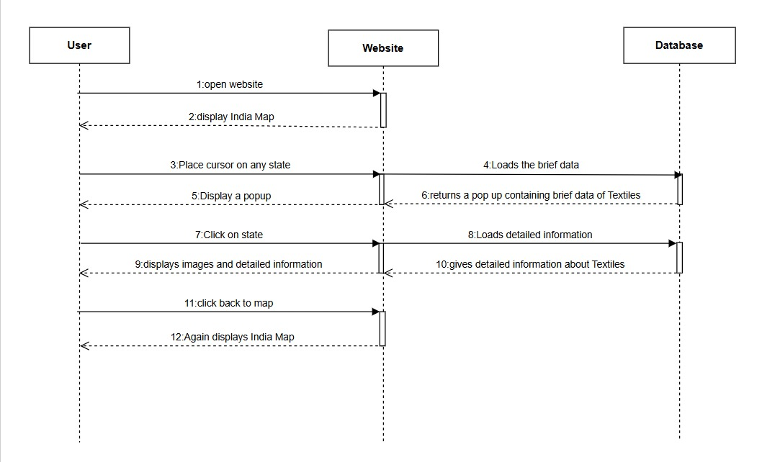

Fig 4.2.3: Sequence Diagram

This sequence diagram shows the interaction between a User, the Website, and the Database when browsing textile information on the *Textiles of India* website. Here's a step-by-step explanation of the flow:

**Participants:**

* **User –** The person interacting with the website.
* **Website –** The front-end system that handles user actions and displays data.
* **Database –** The back-end data source that stores textile details.

**Steps:**

1. **User → Website**: The user accesses the Textiles of India website.
2. **Website → User**: The homepage loads and shows the interactive map of India.
3. **User → Website**: The user hovers the mouse over a specific state on the map.
4. **Website → Database**: The website queries the database for a brief overview of textiles for the selected state.
5. **Website → User**: A pop-up is triggered in response to the hover action.
6. **Database → Website**: The database sends a brief textile summary which is shown in the pop-up.
7. **User → Website**: The user clicks the state to explore more details.
8. **Website → Database**: A request is made to retrieve full textile information from the database.
9. **Website → User**: The detailed page is rendered with images and extensive textile descriptions.
10. **Database → Website**: Data sent includes weaving methods, GI tags, etc.
11. **User → Website**: The user navigates back from the detail page to the map.
12. **Website → User**: The website reloads the interactive map interface.
    * 1. **Activity diagram:**

Activity diagrams are graphical representations of workflows of stepwise activities and actions with support for choice, iteration, and concurrency. In the Unified Modelling Language, activity diagrams can be used to describe the business and operational step- by step workflows of components in a system. An activity diagram shows the overall flow of control.

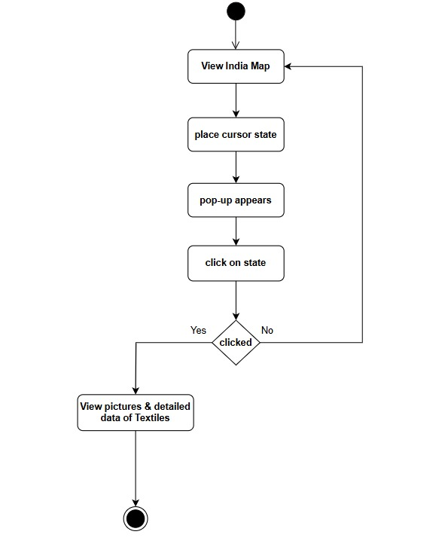

Fig.4.2.4: Activity Diagram

This activity diagram represents the user's interaction flow on the *Textiles of India* website.

1. **Start Node**: The user begins the activity (black filled circle).
2. **View India Map**: The user sees the map of India upon opening the site.
3. **Place Cursor State**: The user places the cursor over a specific state on the map.
4. **Pop-up Appears**: A popup showing brief textile information for that state is displayed.
5. **Click on State**: The user is given an option to click on the state for more information
6. **Decision Node (Clicked?)**:

* **Yes**: Leads to the next step.
* **No**: Loops back to viewing the India Map.

1. **View Pictures & Detailed Data of Textiles**: If clicked, the user is shown detailed textile images and descriptions.
2. **End Node**: The process ends (black circle with an outline).

This diagram outlines a simple and user-focused navigation flow, combining interactive map elements with conditional branching.

* + 1. **Deployment Diagram:**

Deployment Diagram: Deployment diagram represents the deployment view of a system. It is related to the component diagram. Because the components are deployed using the deployment diagrams. A deployment diagram consists of nodes. Nodes are nothing but physical hardware’s u Deployment diagram represents the deployment view of a system. It is related to the component diagram. Because the components are deployed using the deployment diagrams. A deployment diagram consists of nodes. Nodes are said to deploy the application.

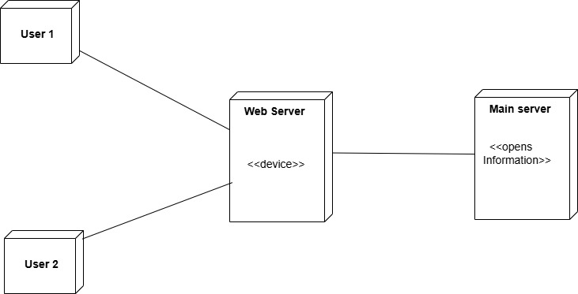

Fig 4.2.5: Deployment Diagram

**Components**

1. **User 1 and User 2**

* These represent clients or end users who interact with the system through a user interface (e.g., a browser**).**
* They connect to the Web Server to request or access information.

1. **Web Server (<<device>>)**

* Acts as an intermediate device that handles incoming requests from users.
* It processes requests, may perform some logic, and then communicates with the Main Server to fetch or update data.
* Labelled <<device>>, indicating it's a hardware node capable of running software components

1. **Main Server (<<Opens Information>>)**

* A central data-handling system responsible for storing or managing detailed information.
* The stereotype <<Opens Information>> likely indicates it hosts the main application or database that holds the core data.

**Flow of Communication**

1. **User 1 and User 2** send requests (e.g., open page, view textile info) to the Web Server.
2. The **Web Server** receives the requests and processes them.
3. If needed, it forwards the request to the **Main Server** to access or update the actual data.
4. The **Main Server** responds, and the **Web Server** returns the information to the users.

**CHAPTER-5**

**IMPLEMENTATION**

**5.1 Module Split-Up:**

1. **User Module**

**Purpose**: Allows users to interactively explore textile information of different Indian states.

**Functionality**:

* **Map Interaction**: The user moves the cursor over a state on the map.
* **Pop-up Trigger**: A pop-up with brief information appears.
* **Detailed View**: By clicking "View More", the user is directed to a page displaying:
* Textile images
* Loads webpages for detailed state-wise textile data.
* **Navigation**: After viewing, the user can click “Back to Map” to return and explore another state.

1. **Admin Module**

**Purpose**: Responsible for managing content and data shown to users.

**Functionality:**

* **Data Collection:** Gathers high-quality images and detailed textile-related information for each Indian state.
* **Content Management**: Updates or edits the data and ensures accuracy and richness of visual/textual content.

1. **Server Module**

**Purpose:** Acts as the backend that supports user and admin operations.

**Funtionality:**

* **User Requests Handling**:
* Displays the map and pop-ups.
* Loads webpages for detailed state-wise textile data.
* **Data Delivery**: Communicates with databases or storage to retrieve content uploaded by the admin and presents it to users in real-time.

**5.2 Technologies Used:**

* **Frontend:** HTML, CSS, JavaScript
* **Backend:** NodeJS
* **Database:** MySQL
* **Platform:** Web and mobile-based support
* **Other Services:** UML tools for design (use case, sequence diagrams, etc.)

**CHAPTER-6**

**RESULTS**

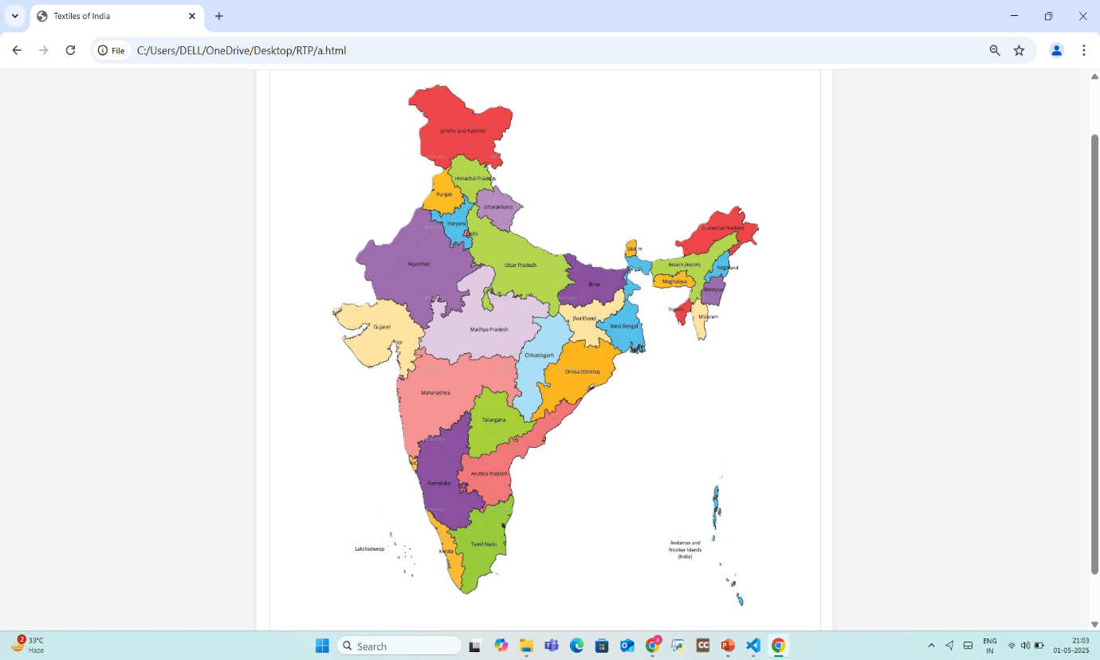Fig: 6.1 Interactive India Map

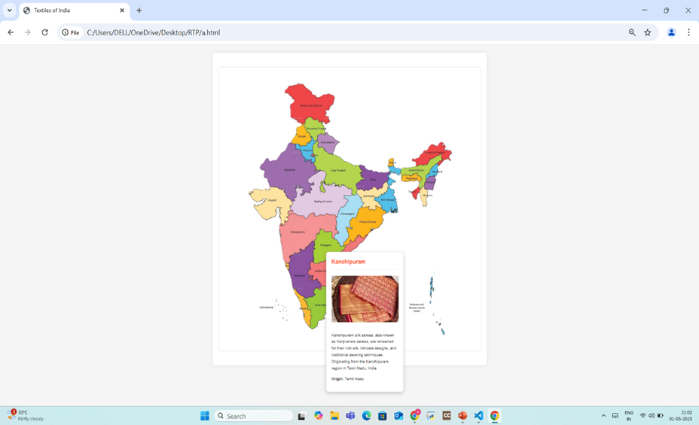

Fig: 6.2.1 Pop up of the state Tamil Nadu

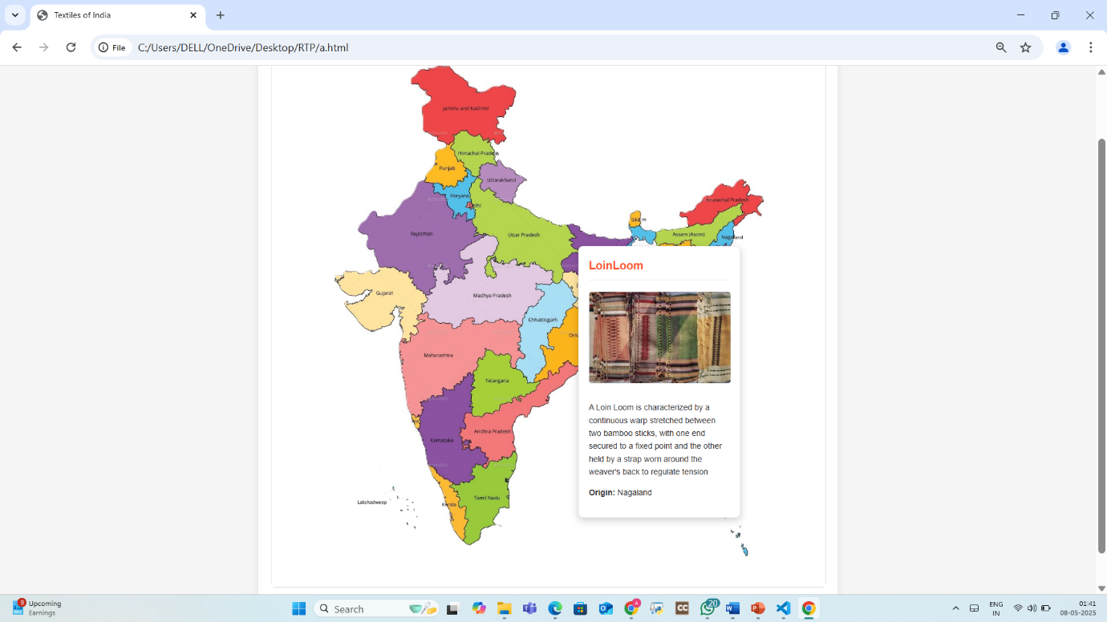

Fig:6.2.2 Pop up of the state Nagaland

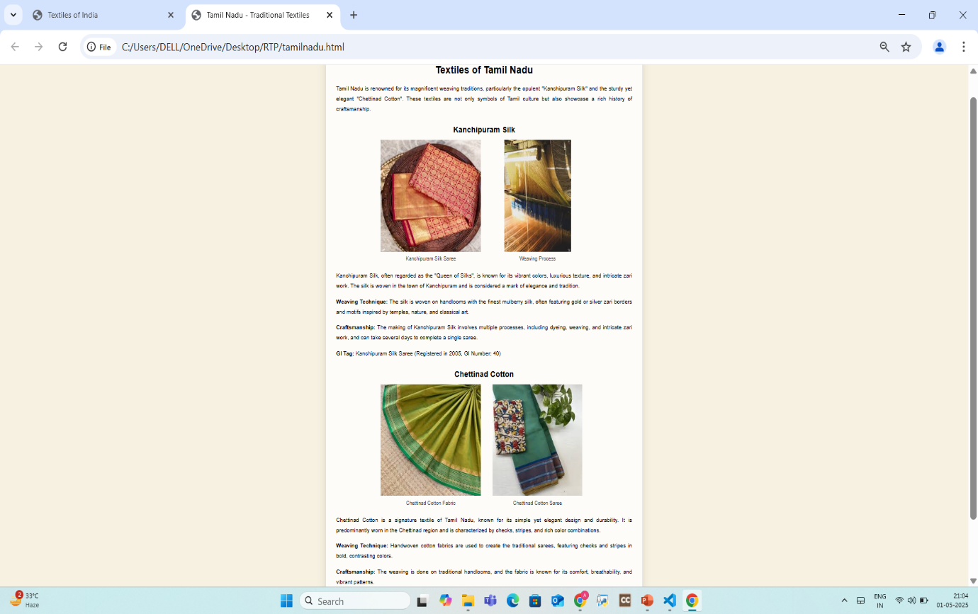

Fig: 6.3.1 Detailed page about textiles of Tamil Nadu

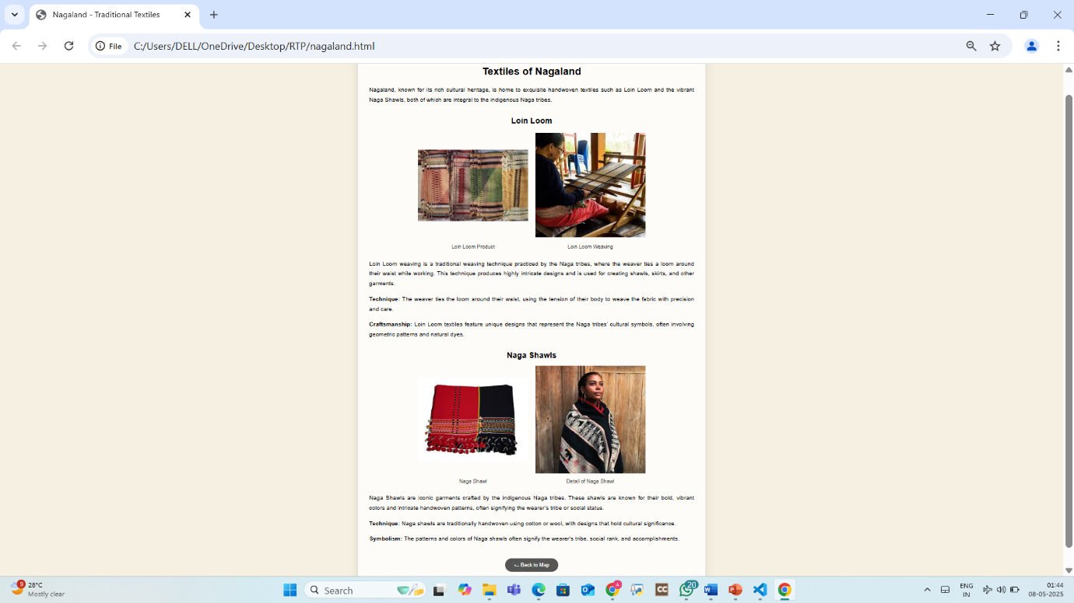

Fig: 6.3.2 Detailed page about textiles of Nagaland

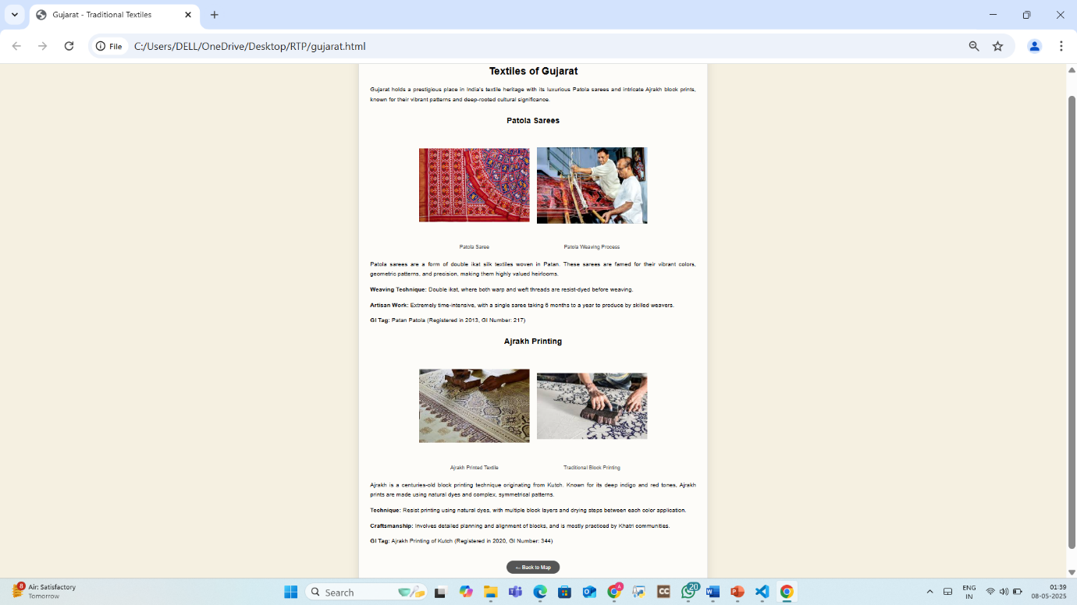

Fig: 6.3.3 Detailed page about textiles of Gujarat

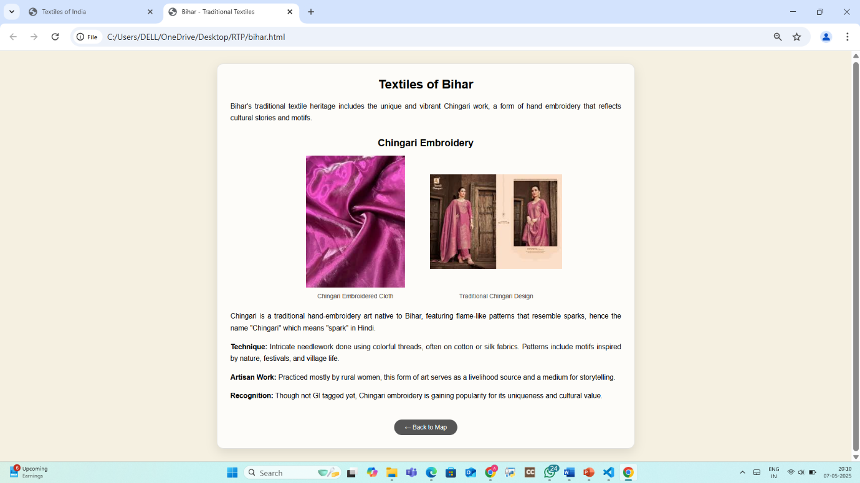

Fig: 6.3.4 Detailed page about textiles of Bihar

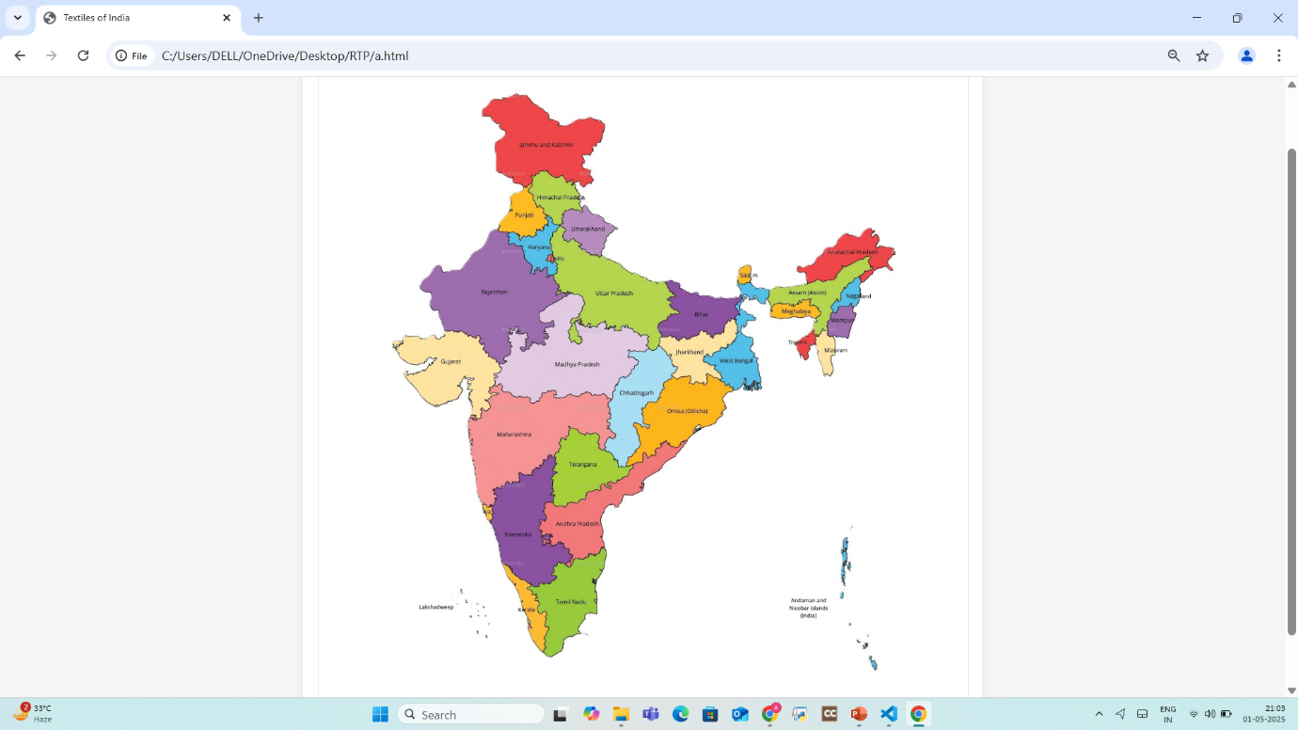

Fig: 6.4 Redirected India Map on clicking “back to map”

**CHAPTER-7**

**TESTING**

**Test Cases**

**Test Case 1: User Map Interaction**

* Input: Mouse hover or click on a state
* **Expected:** Display popup with textile info.

**Test Case 2: Detailed Textile Information View**

* Input: Click on and State
* Expected: Load new page showing images, history, and weaving techniques of the selected state

**Test Case 3: Return to Map Navigation**

* Input: Scroll and click “Back to Map”
* Expected: User is redirected to the interactive map

**Test Case 4: Admin Upload Textile Data**

* Input: Textile info (text and images) submission for a state
* Expected**:** Data is stored and reflected on the user side

**Test Case 5: Invalid State Request Handling**

* Input: Request with an invalid or missing state ID
* Expected: Display of “State not found” error message

**CHAPTER-8**

**CONCLUSION**

This web-based platform offers an engaging way to explore India’s rich textile heritage through an interactive map, showcasing the unique textiles of all 29 states. Users can hover over states to view popups with brief descriptions and click on states for detailed pages with images, history, and weaving techniques. The project promotes cultural preservation, providing an accessible educational resource for museums, schools, and tourism platforms. Future enhancements could include artisan stories, and e-commerce features to support local crafts and expand user engagement.

**CHAPTER-9**

**FUTURE ENHANCEMENT**

In the future, this project envisions expanding into a complete e-commerce platform that enables users to purchase traditional Indian textiles directly from local artisans. Features such as user login, personalized profiles, product listings categorized by state, secure payment gateways, and real-time order tracking will be integrated to enhance the shopping experience. An admin dashboard will be introduced to manage inventory, orders, and user activity, while a dedicated seller portal will allow regional artisans to upload products, track sales, and interact with customers. This transformation aims to promote Indian craftsmanship, support local weavers, and preserve the country’s rich textile heritage through a sustainable digital marketplace.

**CHAPTER-10**

**REFERENCES**

1. **Dhamija, J.** **(2005). *Handwoven Fabrics of India***. Wiley Eastern.  
This work provides foundational knowledge on the historical evolution, weaving techniques, and regional diversity of Indian textiles.

**2. Mehta, R. (2019). *Sustainable Textiles****: An Indian Perspective*. In *Sustainable Textiles*. Mehta discusses eco-friendly practices and sustainability challenges in traditional Indian textile production.

**3. Ministry of Textiles, Government of India**. *National Handloom Development Programme (NHDP)*. This source covers government policies and initiatives supporting handloom weavers and their economic empowerment.

**4. Khadi and Village Industries Commission (KVIC) *Official Website*.**KVIC provides information about khadi production, rural employment initiatives, and the support given to village industries in India.

**5. Crafts Council of India. *Preserving Indian Crafts*.**This source focuses on grassroots initiatives for preserving traditional textile crafts and supporting artisans in India.

**6. UNESCO. (2021). *Handmade for the 21st Century:*** *Safeguarding Traditional Indian Textile Heritage*. UNESCO’s report discusses global efforts to preserve India’s intangible textile heritage and safeguard traditional handloom practices.

**7. India Handloom Brand. *Official Website*.** Ministry of Textiles, Government of India. The India Handloom Brand promotes authentic handloom products and certifies genuine Indian weaves, ensuring quality and cultural preservation.

**8. National Institute of Fashion Technology (NIFT).** *Publications on Indian Textiles*. NIFT provides academic research and technical insights on weaving methods, textile design, and the cultural significance of regional textiles in India.

**CHAPTER-11**

**SAMPLE CODE**

**Index.html**

<!DOCTYPE html>

<html lang="en">

<head>

    <meta charset="UTF-8">

    <meta name="viewport" content="width=device-width, initial-scale=1.0">

    <title>Textiles of India</title>

    <style>

        body {

            font-family: 'Arial', sans-serif;

            margin: 0;

            padding: 0;

            background-color: #f5f5f5;

            color: #333;

            line-height: 1.6;

        }

        header {

            background: linear-gradient(135deg, #FF9933, #FF5733);

            color: white;

            text-align: center;

            padding: 30px 0;

box-shadow: 0 4px 12px rgba(0,0,0,0.1);

            position: relative;

            overflow: hidden;

        }header::before {

            content: "";

            position: absolute;

            top: 0;

            left: 0;

            right: 0;

            bottom: 0;

            background: url('data:image/svg+ml;utf8,<svg xmlnsx="http://www.w3.org/2000/svg" viewBox="0 0 100 100" preserveAspectRatio="none"><path fill="rgba(255,255,255,0.1)" d="M0,0 L100,0 L100,100 L0,100 Z" /></svg>');

            opacity: 0.1;

        }h1 {

            margin: 0;

            font-size: 2.5em;

            position: relative;

            text-shadow: 1px 1px 3px rgba(0,0,0,0.2);

        }  .container {

            max-width: 1100px;

            margin: 30px auto;

            padding: 25px;

            background-color: white;

            border-radius: 10px;

            box-shadow: 0 0 15px rgba(0,0,0,0.08);

        }   .map-container {

            position: relative;

            width: 100%;

            margin: 30px 0;

            border-radius: 8px;

            border: 1px solid #e0e0e0;

        }.india-map {

            width: 100%;

            height: auto;

            display: block;

            transition: transform 0.3s ease;

        }.hover-area {

            position: absolute;

            cursor: pointer;

            transition: all 0.3s ease;

            z-index: 5;

            background-color:transparent;

            border-radius: 4px;

            opacity: 1;

        }   .hover-area:hover {

            opacity: 1;

        }

        .popup {

      position: absolute;

            width: 280px;

            background-color: white;

            border-radius: 10px;

            box-shadow: 0 5px 15px rgba(0,0,0,0.2);

            padding: 20px;

            z-index: 100;

            display: none;

            animation: fadeIn 0.2s ease-out;

            border: 1px solid #eee;

            pointer-events: none; /* Prevent popup from interfering with hover */

        }   @keyframes fadeIn {

            from { opacity: 0; transform: translateY(10px); }

            to { opacity: 1; transform: translateY(0); }

     }

        .popup h3 {

            margin-top: 0;

            color: #FF5733;

            border-bottom: 2px solid #f0f0f0;

            padding-bottom: 10px;

            font-size: 1.4em;

        }

      .popup img {

            width: 100%;

            height: 180px;

            object-fit: cover;

            border-radius: 6px;

            margin-bottom: 12px;

            border: 1px solid #eee;

        } footer {

            text-align: center;

            padding: 25px;

            background: linear-gradient(135deg, #333, #222);

            color: white;

            margin-top: 30px;

            font-size: 0.9em;

        }footer p {

            margin: 0;

        } .intro-text {

            font-size: 1.1em;

            margin-bottom: 25px;

            color: #444;

        }

    .dance-overview {

            background-color: #f9f9f9;

            padding: 20px;

            border-radius: 8px;

            margin-top: 30px;

            border-left: 4px solid #FF9933;

        } .dance-overview h2 {

            margin-top: 0;

            color: #FF5733;

        }@media (max-width: 768px) {

            .container {

                padding: 15px;

                margin: 15px;

            }  h1 {

                font-size: 1.8em;

            } .popup {

                width: 90%;

                left: 5% !important;

                right: 5% !important;

                position: fixed;

                top: 50% !important;

                transform: translateY(-50%);

            }}

    </style>

</head>

<body>

<div class="container">

<div class="map-container">

            <img src="indiamap6.jpg" alt="India Map" class="india-map" id="indiaMap" onerror="this.src='indiamap6.jpg'">

<!-- Hover areas for each state -->

 <div class="hover-area" style="top: 79%; left: 35%; width: 8%; height: 12%;" data-dance="Kanchipuram" data-url="tamilnadu.html"></div> <!-- Tamil Nadu -->

            <div class="hover-area" style="top: 27%; left: 31%; width: 5%; height: 6%;" data-dance="PunjaDurries" data-url="haryana.html"></div> <!-- Tamil Nadu -->

            <div class="hover-area" style="top: 69%; left: 25%; width: 3%; height: 3%;" data-dance="Kunbi" data-url="goa.html"></div> <!-- Goa -->

            <div class="hover-area" style="top: 23%; left: 39%; width: 5%; height: 6%;" data-dance="Thulma" data-url="utharakhand.html"></div> <!-- UttaraKhand -->

            <div class="hover-area" style="top: 21%; left: 28%; width: 6%; height: 6%;" data-dance="Khes" data-url="punjab.html"></div> <!-- Panjab -->

            <div class="hover-area" style="top: 18%; left: 33%; width: 6%; height: 6%;" data-dance="ChambaRumal" data-url="himachalpradesh.html"></div> <!-- Himachal Pradesh -->

            <div class="hover-area" style="top: 30%; left: 38%; width: 13%; height: 11%;" data-dance="Banarasi" data-url="UP.html"></div> <!-- Uttar Pradesh -->

            <div class="hover-area" style="top: 79%; left: 29%; width: 5%; height: 12%;" data-dance="KasavuMundu" data-url="kerala.html"></div> <!-- Kerala -->

            <div class="hover-area" style="top: 66%; left: 35%; width: 10%; height: 12%;" data-dance="Kalankari" data-url="andrapradesh.html"></div> <!-- Andhra Pradesh -->

            <div class="hover-area" style="top: 50%; left: 52%; width: 12%; height: 10%;" data-dance="Bomkai" data-url="odisha.html"></div> <!-- Odisha -->

            <div class="hover-area" style="top: 39%; left: 79%; width: 4%; height: 4%;" data-dance="SapheeLanphee" data-url="manipur.html"></div> <!-- Manipur -->

            <div class="hover-area" style="top: 35%; left: 70%; width: 10%; height: 3%;" data-dance="MugaSilk" data-url="assam.html"></div> <!-- Assam -->

            <div class="hover-area" style="top: 7%; left: 27%; width: 16%; height: 12%;" data-dance="Raffal" data-url="jammukashmir.html"></div> <!-- Jammu & Kashmir -->

            <div class="hover-area" style="top: 58%; left: 36%; width: 8%; height: 10%;" data-dance="Pochampally" data-url="telangana.html"></div> <!-- Telangana -->

            <div class="hover-area" style="top: 66%; left: 28%; width: 8%; height: 15%;" data-dance="MysoreSilk" data-url="karnataka.html"></div> <!-- Karnataka -->

            <div class="hover-area" style="top: 53%; left: 21%; width: 16%; height: 13%;" data-dance="Paithani" data-url="maharashtra.html"></div> <!-- Maharashtra -->

            <div class="hover-area" style="top: 48%; left: 45%; width: 7%; height: 12%;" data-dance="KosaSilk" data-url="chattisghar.html"></div> <!-- Chhattisgarh -->

            <div class="hover-area" style="top: 42%; left: 31%; width: 16%; height: 10%;" data-dance="BaghPrinting" data-url="madhyapradesh.html"></div> <!-- Madhya Pradesh -->

            <div class="hover-area" style="top: 43%; left: 12%; width: 16%; height: 10%;" data-dance="Patola" data-url="gujarat.html"></div> <!-- Gujarat -->

            <div class="hover-area" style="top: 32%; left: 15%; width: 23%; height: 10%;" data-dance="Bandhani" data-url="rajasthan.html"></div> <!-- Rajasthan -->

            <div class="hover-area" style="top: 43%; left: 54%; width: 8%; height: 6%;" data-dance="TussarSilk" data-url="jharkhand.html"></div> <!-- Jharkhand -->

            <div class="hover-area" style="top: 44%; left: 61%; width: 7%; height: 6%;" data-dance="Jamdani" data-url="westbengal.html"></div> <!-- West Bengal -->

            <div class="hover-area" style="top: 37%; left: 54%; width: 9%; height: 5%;" data-dance="Chingariweaves" data-url="bihar.html"></div> <!-- Bihar -->

            <div class="hover-area" style="top: 43%; left: 77%; width: 4%; height: 6%;" data-dance="Puanchei" data-url="mizoram.html"></div> <!-- Mizoram -->

            <div class="hover-area" style="top: 42%; left: 73%; width: 3%; height: 5%;" data-dance="Lasingphee" data-url="tripura.html"></div> <!-- Tripura -->

            <div class="hover-area" style="top: 38%; left: 69%; width: 7%; height: 3%;" data-dance="EriSilk" data-url="meghalaya.html"></div> <!-- Meghalaya -->

            <div class="hover-area" style="top: 35%; left: 81%; width: 3%; height: 3%;" data-dance="LoinLoom" data-url="nagaland.html"></div> <!-- Nagaland -->

            <div class="hover-area" style="top: 25%; left: 74%; width: 17%; height:9%;" data-dance="Galo" data-url="arunachalpradesh.html"></div> <!-- Arunachal Pradesh -->

            <div class="hover-area" style="top: 32%; left: 65%; width: 2%; height: 5%;" data-dance="Lepcha" data-url="sikkim.html"></div> <!-- Sikkim -->

k

<!-- Popup Container -->

            <div class="popup" id="dancePopup">

                <h3 id="popupTitle">Dance Form</h3>

                <img id="popupImage" src="" alt="Dance Form Image">

                <p id="popupDescription">Description will appear here.</p>

                <p id="popupOrigin"><strong>Origin:</strong> <span></span></p>

            </div>

        </div> </div>

    <script>

        // Dance form data with placeholder images

        const danceForms = {

            Kanchipuram: {

                title: "Kanchipuram",

                image: "images/TN1.jpg",

                description: "Kanchipuram silk sarees, also known as Kanjivaram sarees, are renowned for their rich silk, intricate designs, and traditional weaving techniques. Originating from the Kanchipuram region in Tamil Nadu, India",

                origin: "Tamil Nadu"

            },

 LoinLoom: {

            title: "LoinLoom",

            image: "images/N2.jpg",

            description: "A Loin Loom is characterized by a continuous warp stretched between two bamboo sticks, with one end secured to a fixed point  and the other held by a strap worn around the weaver's back to regulate tension",

    origin: "Nagaland"

},

 Patola: {

            title: "Patola",

            image: "images/GJ1.jpg", // Example image

            description: "Patola is a renowned double ikat silk fabric, traditionally woven in Patan, Gujarat, India. It's known for its intricate and colorful designs, created by resist-dyeing both the warp and weft threads before weavings.",

            origin: "Gujarat"

            },

Chingariweaves: {

            title: "Chingariweaves",

            image: "images/B1.jpg", // Example image

            description: "Chingari weaves is a textile term, specifically referring to a type of handloom weave that creates a spark-like or spark effect on fabric.",

            origin: "Bihar"

            },

 };

      // Get DOM elements

        const hoverAreas = document.querySelectorAll('.hover-area');

        const popup = document.getElementById('dancePopup');

        const popupTitle = document.getElementById('popupTitle');

        const popupImage = document.getElementById('popupImage');

        const popupDescription = document.getElementById('popupDescription');

        const popupOrigin = document.querySelector('#popupOrigin span');

  const indiaMap = document.getElementById('indiaMap');

        // Add fallback for images

        popupImage.onerror = function() {

            this.src = 'data:image/svg+xml;utf8,<svg xmlns="http://www.w3.org/2000/svg" viewBox="0 0 100 100" fill="%23f0f0f0"><rect width="100" height="100"/><text x="50" y="50" font-family="Arial" font-size="10" text-anchor="middle" fill="%23999">Image not available</text></svg>';

        };

        // Function to position popup near hover area

        function positionPopup(area) {

            const mapRect = document.querySelector('.map-container').getBoundingClientRect();

            const areaRect = area.getBoundingClientRect()

// Calculate center of hover area

            const centerX = areaRect.left - mapRect.left + (areaRect.width / 2);

            const centerY = areaRect.top - mapRect.top + (areaRect.height / 2);

            // Adjust position to prevent overflow

            let left = centerX;

            let top = centerY;

           if (left > mapRect.width / 2) {

                left -= 300; // position to the left

            } else {

                left += 20; // position to the right

            }

            if (top > mapRect.height / 2) {

                top -= 220; // position above

            } else {

                top += 20; // position below

            }

            // Ensure popup stays within map container

            left = Math.max(20, Math.min(left, mapRect.width - 320));

            top = Math.max(20, Math.min(top, mapRect.height - 320));

            popup.style.left = left + 'px';

            popup.style.top = top + 'px';

**}**

        // Add hover events to each area

        hoverAreas.forEach(area => {

            area.addEventListener('mouseenter', function() {

                const danceForm = this.getAttribute('data-dance');

                const data = danceForms[danceForm];

                // Set popup content

                popupTitle.textContent = data.title;

                popupImage.src = data.image;

                popupImage.alt = data.title;

                popupDescription.textContent = data.description;

                popupOrigin.textContent = data.origin;

                // Position and show popup

                positionPopup(this);

                popup.style.display = 'block';

            });

            area.addEventListener('mouseleave', function() {

                popup.style.display = 'none';

            });

             // New: handle click to open dance page

    area.addEventListener('click', function () {

        const url = this.getAttribute('data-url');

        if (url) {

            window.open(url, '_blank');

        }

    });

        });

        // Hide popup when mouse leaves map container

        document.querySelector('.map-container').addEventListener('mouseleave', function() {

            popup.style.display = 'none';

        });

    </script>

</body>

</html>

Tamilnadu.html

<!DOCTYPE html>

<html lang="en">

<head>

  <meta charset="UTF-8">

  <title>Tamil Nadu - Traditional Textiles</title>

  <style>

    * {

      margin: 0;

      padding: 0;

      box-sizing: border-box;

    }

    body {

      background: url('https://www.transparenttextures.com/patterns/wood-mosaic.png');

      background-color: #f7f1e1; /* Light beige */

      font-family: 'Poppins', sans-serif;

      display: flex;

      justify-content: center;

      align-items: center;

      min-height: 100vh;

      padding: 30px;

    }

    .card {

      background: #ffffffcc; /* Semi-transparent white */

      border-radius: 15px;

      box-shadow: 0 8px 24px rgba(0, 0, 0, 0.1);

      padding: 30px;

      width: 100%;

      max-width: 950px;

      color: #000;

      text-align: center;

      border: 1px solid #e0e0e0;

    } .card h1 {

      margin-bottom: 20px;

      font-size: 28px;

      color: #000;

    }

    .card h3 {

      margin: 30px 0 15px;

      font-size: 22px;

      color: #000;

    }    .image-row {

      display: flex;

      gap: 20px;

      justify-content: center;

      margin-bottom: 25px;

      flex-wrap: wrap;

    }figure {

      text-align: center;

      margin: 0;

    }figure img {

      width: 300px;

      height: 300px;

      object-fit: contain;

      transition: transform 0.3s ease;

    }

    figure img:hover {

      transform: scale(1.05);

    }

    figcaption {

      font-size: 14px;

      margin-top: 8px;

      color: #444;

    }

    .card p {

      font-size: 16px;

      line-height: 1.7;

      text-align: justify;

      color: #000;

      margin-bottom: 15px;

    }back-button {

      margin-top: 25px;

      display: inline-block;

      padding: 10px 24px;

      background: #555;

      color: #fff;

      text-decoration: none;

      border-radius: 25px;

      font-size: 14px;

      transition: 0.3s ease;

    }

    .back-button:hover {

      background: #333;

    }

  </style>

</head>

<body>

<div class="card">

    <h1>Textiles of Tamil Nadu</h1>

    <p>Tamil Nadu is renowned for its magnificent weaving traditions, particularly the opulent "Kanchipuram Silk" and the sturdy yet elegant "Chettinad Cotton". These textiles are not only symbols of Tamil culture but also showcase a rich history of craftsmanship.</p>

    <h3>Kanchipuram Silk</h3>

    <div class="image-row">

      <figure>

        <img src="images/TN1.jpg" alt="Kanchipuram Silk Saree">

        <figcaption>Kanchipuram Silk Saree</figcaption>

      </figure>

      <figure>

        <img src="images/TN3.jpg" alt="Kanchipuram Weaving">

        <figcaption>Weaving Process</figcaption>

      </figure>

    </div>

    <p>Kanchipuram Silk, often regarded as the "Queen of Silks", is known for its vibrant colors, luxurious texture, and intricate zari work. The silk is woven in the town of Kanchipuram and is considered a mark of elegance and tradition.</p>

    <p><b>Weaving Technique:</b> The silk is woven on handlooms with the finest mulberry silk, often featuring gold or silver zari borders and motifs inspired by temples, nature, and classical art.</p>

    <p><b>Craftsmanship:</b> The making of Kanchipuram Silk involves multiple processes, including dyeing, weaving, and intricate zari work, and can take several days to complete a single saree.</p>

    <p><b>GI Tag:</b> Kanchipuram Silk Saree (Registered in 2005, GI Number: 40)</p>

    <h3>Chettinad Cotton</h3>

    <div class="image-row">

      <figure>

        <img src="images/TN4.jpg" alt="Chettinad Cotton Fabric">

        <figcaption>Chettinad Cotton Fabric</figcaption>

      </figure>

      <figure>

        <img src="images/TN2.jpg" alt="Chettinad Cotton Saree">

        <figcaption>Chettinad Cotton Saree</figcaption>

      </figure>

    </div>

    <p>Chettinad Cotton is a signature textile of Tamil Nadu, known for its simple yet elegant design and durability. It is predominantly worn in the Chettinad region and is characterized by checks, stripes, and rich color combinations.</p>

    <p><b>Weaving Technique:</b> Handwoven cotton fabrics are used to create the traditional sarees, featuring checks and stripes in bold, contrasting colors.</p>

    <p><b>Craftsmanship:</b> The weaving is done on traditional handlooms, and the fabric is known for its comfort, breathability, and vibrant patterns.</p>

    <p><b>GI Tag:</b> Chettinad Cotton (Registered in 2005, GI Number: 2)</p>

    <a href="a.html" class="back-button">← Back to Map</a>

  </div>

</body>

</html>

**Gujarat.html**

<!DOCTYPE html>

<html lang="en">

<head>

  <meta charset="UTF-8">

  <title>Gujarat - Traditional Textiles</title>

  <style>

    * {

      margin: 0;

      padding: 0;

      box-sizing: border-box;

    }

    body {

      background: url('https://www.transparenttextures.com/patterns/wood-mosaic.png');

      background-color: #f5f0e1;

      font-family: 'Poppins', sans-serif;

      display: flex;

      justify-content: center;

      align-items: center;

      min-height: 100vh;

      padding: 30px;

    }

    .card {

      background: #ffffffcc;

      border-radius: 15px;

      box-shadow: 0 8px 24px rgba(0, 0, 0, 0.1);

      padding: 30px;

      width: 100%;

      max-width: 950px;

      color: #000;

      text-align: center;

      border: 1px solid #e0e0e0;

    }

    .card h1 {

      margin-bottom: 20px;

      font-size: 28px;

      color: #000;

    }

    .card h3 {

      margin: 30px 0 15px;

      font-size: 22px;

      color: #000;

    }

    .image-row {

      display: flex;

      gap: 20px;

      justify-content: center;

      margin-bottom: 25px;

      flex-wrap: wrap;

    }

    figure {

      text-align: center;

      margin: 0;

    }

    figure img {

      width: 300px;

      height: 300px;

      object-fit: contain;

      transition: transform 0.3s ease;

    }

    figure img:hover {

      transform: scale(1.05);

    }

    figcaption {

      font-size: 14px;

      margin-top: 8px;

      color: #444;

    }

    .card p {

      font-size: 16px;

      line-height: 1.7;

      text-align: justify;

      color: #000;

      margin-bottom: 15px;

    }

    .back-button {

      margin-top: 25px;

      display: inline-block;

      padding: 10px 24px;

      background: #555;

      color: #fff;

      text-decoration: none;

      border-radius: 25px;

      font-size: 14px;

      transition: 0.3s ease;

    }

    .back-button:hover {

      background: #333;

    }

  </style>

</head>

<body>

  <div class="card">

    <h1>Textiles of Gujarat</h1>

    <p>Gujarat holds a prestigious place in India’s textile heritage with its luxurious Patola sarees and intricate Ajrakh block prints, known for their vibrant patterns and deep-rooted cultural significance.</p>

    <h3>Patola Sarees</h3>

    <div class="image-row">

      <figure>

        <img src="images/GJ1.jpg" alt="Patola Saree">

        <figcaption>Patola Saree</figcaption>

      </figure>

      <figure>

        <img src="images/GJ3.jpg" alt="Patola Weaving">

        <figcaption>Patola Weaving Process</figcaption>

      </figure>

    </div>

    <p>Patola sarees are a form of double ikat silk textiles woven in Patan. These sarees are famed for their vibrant colors, geometric patterns, and precision, making them highly valued heirlooms.</p>

    <p><b>Weaving Technique:</b> Double ikat, where both warp and weft threads are resist-dyed before weaving.</p>

    <p><b>Artisan Work:</b> Extremely time-intensive, with a single saree taking 6 months to a year to produce by skilled weavers.</p>

    <p><b>GI Tag:</b> Patan Patola (Registered in 2013, GI Number: 217)</p>

    <h3>Ajrakh Printing</h3>

    <div class="image-row">

      <figure>

        <img src="images/GJ2.jpg" alt="Ajrakh Print Fabric">

        <figcaption>Ajrakh Printed Textile</figcaption>

      </figure>

      <figure>

        <img src="images/GJ4.jpg" alt="Ajrakh Block Printing">

        <figcaption>Traditional Block Printing</figcaption>

      </figure>

    </div>

    <p>Ajrakh is a centuries-old block printing technique originating from Kutch. Known for its deep indigo and red tones, Ajrakh prints are made using natural dyes and complex, symmetrical patterns.</p>

    <p><b>Technique:</b> Resist printing using natural dyes, with multiple block layers and drying steps between each color application.</p>

    <p><b>Craftsmanship:</b> Involves detailed planning and alignment of blocks, and is mostly practiced by Khatri communities.</p>

    <p><b>GI Tag:</b> Ajrakh Printing of Kutch (Registered in 2020, GI Number: 344)</p>

    <a href="a.html" class="back-button">← Back to Map</a>

  </div>

</body>

</html>

**CHAPTER-12**

**DATASET**

**Dataset Used**

* **Textile Data:** Names, types, techniques, materials, and cultural significance of traditional textiles from each Indian state.
* **State Data:** Names, map coordinates, and links between states and their respective textile traditions.
* **Image Data:** High-resolution images of each textile type showcasing patterns, weaving methods, and regional uniqueness.
* **Admin Data:** Admin profiles and credentials for managing textile entries and media uploads.

The database structure likely includes:

* users table
* states table
* textiles table
* images table
* admin table
* textile_history table
* materials_used table